Cloud ML Infrastructure Lab
Proposed by Jack Yang

1. Big Picture
Lab title: Lab 5: Kubernetes-Based Model-Tuning and Inference Pipeline.
This lab asks students to build a terminal-based cloud AI workflow using Kubernetes. Students are required to develop a mature pipeline such that it coordinates fine-tuning jobs, inference jobs or sessions, and system logs. The students are expected to explore the use of StatefulSet, Job, Deployment, and Service. At the end, a complete set of configuration YAML files, a Docker container, and a video showing successful execution of different jobs should be submitted to GitHub.

2. Architecture
The architecture should distinguish temporary compute from persistent state. Training and inference are one-time compute tasks, so they should run as Kubernetes Jobs. The logging system is stateful, so it should be represented by a StatefulSet with a mounted Persistent Volume using a PostgreSQL database. Instead of one-shot jobs, it should also be able to mount an inference session using Deployment such that it can run the inference multiple times.
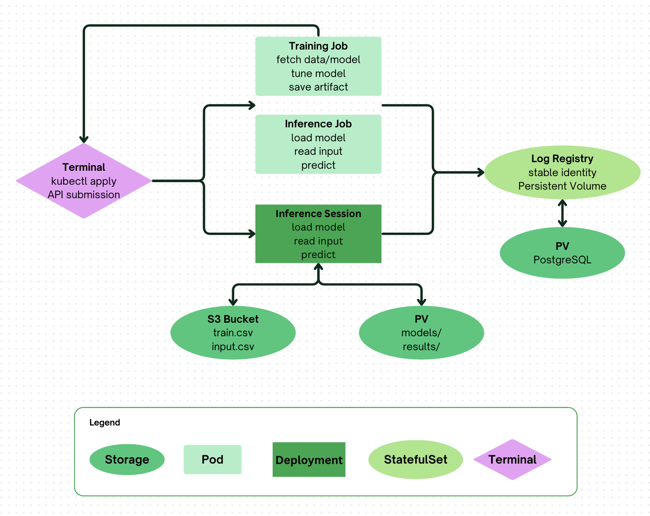
Figure 1. Proposed terminal-based Kubernetes AI workflow.

3. Learning Objectives
- Explain the difference among stateless compute, stateful cloud infrastructure, and one-time jobs.
- Create different Kubernetes apps for different tasks.
- Use a StatefulSet and Persistent Volume to preserve system logs.
- Use ConfigMaps and Secrets to configure the cloud environment safely.
- Debug a cloud AI workflow using terminal commands, pod logs, and storage inspection.

4. Student Workflow
- Test Python scripts locally to get a big idea of how those scripts work.
- Build a Docker image that contains all of the scripts.
- Extend the scripts such that they can interact with cloud storage systems.
- Test the configurations in the Kubernetes network.
- Set up PV and PVC for the PostgreSQL database.
- Add logging functions for scripts.
- Complete and demo.

5. What Students Develop vs. What Instructors Provide
Instructors should provide the following material to students:
File | Specification
train.py | A partially developed training interface with training dataset and storage location as argument
inference.py | A partially developed inference interface with model location and input vector as arguments
training.csv | Sample dataset for training model
input.csv | Sample test vector for inference
pv.yaml | A skeleton of setting up Persistent Volume
pvc.yaml | A skeleton of setting up Persistent Volume Claim
statefulset.yaml | A skeleton of creating a StatefulSet on the cloud
job.yaml | A skeleton of creating a Kubebernetes Job

6. Grading Rubric
Category | Points | Full-credit expectation
Pipeline Architecture & RBAC | 20 | Custom API pod running with a restricted ServiceAccount and RoleBindings capable of triggering K8s Jobs on demand.
Stateful Persistence & Logging | 20 | Postgres StatefulSet with proper PV/PVC mounts. API correctly logs training runs and inference operations into Postgres. Data persists after pod crashes/deletions.
Model Fine-Tuning & Storage | 20 | Completed K8s Job that handles data fetching, model tuning, and artifact writing to persistent storage.
Dynamic API | 20 | Functional FastAPI endpoint capable of structured parsing/inference and dynamically executing compute tasks within the cluster.
Comprehensive Video Demo | 20 | Video showing terminal execution, dynamic job creation via API, storage volume verification, pod teardown/recovery, and database log queries.

7. Extensions
Several parts are flexible and can be explored by the students.
- The storage location: Students can choose either to set up a persistent volume or to use an Amazon S3 bucket to store the trained models.
- The fine-tuning data: Students can summarize their own training text or use provided simple training text. This can help students visualize the influence of the dataset on the tuning speed and accuracy.
- The job submission: can be done in the terminal or by setting up an API listening for incoming requests. The second method will require more than the class material. Students need to understand how to submit a Kubernetes app to the Kubelet by granting a service account to an API. Some helpful libraries may include Pydantic for requesting JSON form and FastAPI for quick app and api building.
- The request submission: Students can either use deterministic submission to an API or develop their own API (AI agent) to parse the job request submission. In the past experiments, the medium-sized language model (local) was able to parse the request but was not accurate enough to execute on the cloud. So, students can write manual parsing or to use a large language model API (remote) for parsing.

