Cloud ML Architecture Lab
Proposed by Jack Yang

1. Big Picture
Lab title: Lab 6: Kubernetes-Based Machine Learning Training and Inference Pipeline.
This lab asks students to build a terminal-based cloud ML workflow using Kubernetes. Students are required to upload a training dataset and inference input to an S3 bucket, submit a Kubernetes Training Job through YAML, save the trained model to persistent model storage, and then submit an Inference Job that loads the saved model and produces predictions. At the end, students will submit a Docker repository and a video showing how Kubernetes works as required.

2. Architecture
The architecture should distinguish temporary compute from persistent state. Training and inference are one-time compute tasks, so they should run as Kubernetes Jobs. The model registry or model storage component is stateful, so it should be represented by a StatefulSet with a mounted Persistent Volume using a PostgreSQL database.
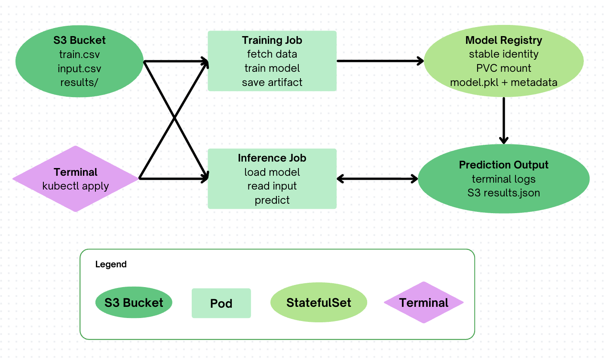
Figure 1. Proposed terminal-based Kubernetes ML workflow.

3. Learning Objectives
- Explain the difference between stateless compute and stateful cloud infrastructure.
- Create Kubernetes Jobs for training and inference tasks.
- Use a StatefulSet and Persistent Volume to preserve trained model artifacts.
- Use ConfigMaps and Secrets to configure cloud workloads safely.
- Debug a cloud ML workflow using terminal commands, pod logs, and storage inspection.

4. Student Workflow
- Upload train.csv and input.csv to an S3 bucket.
- Deploy the Model Registry StatefulSet, which mounts a Persistent Volume at /models.
- Submit train.yaml using kubectl apply. The Training Job fetches train.csv, trains a simple ML model, saves model.pkl, and writes model_info.json.
- Submit inference.yaml. The Inference Job loads model.pkl from persistent storage, downloads the inference vector from S3, predicts the result, and writes the result to logs and/or S3.
- Delete the model-registry pod and show that Kubernetes recreates it while the model files still exist.
- Rerun inference to prove that persistent model storage survived pod recreation.

5. What Students Develop vs. What Instructors Provide
Instructors should provide the following material to students:
File | Specification
train.py | A fully developed training interface with training dataset as argument
inference.py | A fully developed inference interface with model location and input vector as arguments
training.csv | Sample dataset for training model
Input.csv | Sample test vector for inference
pv.yaml | A skeleton of setting up Persistent Volume
pvc.yaml | A skeleton of setting up Persistent Volume Claim
statefulset.yaml | A skeleton of creating a StatefulSet on the cloud

6. Grading Rubric
Category | Points | Full-credit expectation
S3 Data Setup | 5 | Correct S3 structure for training data, inference input, and optional results output.
Minikube Configuration | 10 | Working local cluster with proper networking and Docker integration.
Postgres Functionality | 20 | Ability to create tables and store model in the StatefulSet
Persistent Volume Setup | 20 | Correctly configured and mounted PV/PVC with proper YAML files; when a pod is deleted and restored, the model stored in the pod should persist.
StatefulSet Implementation | 20 | Proper pod management and deployment using StatefulSet configuration.
Train and Inference Pod | 10 | Proper deployment of pod submission using Deployment configuration.
Video Demonstration | 15 | Show kubectl commands, logs, model persistence, and inference result all run successfully within the cluster

7. Summary Recommendation
The strongest version of the lab is a terminal-based Kubernetes ML pipeline. Students should use S3 for data, Kubernetes Jobs for training and inference, and a StatefulSet with a Persistent Volume for persistent model artifacts. This design naturally builds on the previous labs while adding a new layer of difficulty: students must reason about system architecture, batch compute, durable model storage, configuration, secret management, and reproducibility. It is more educational than another frontend/backend assignment because it teaches how cloud infrastructure supports the machine learning lifecycle.
Note: This summary is based on the proposed workflow discussed in the conversation and on the course progression represented by the existing Labs 1-5 materials.

