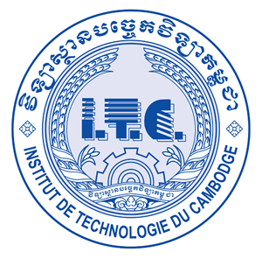

**Institute of Technology of Cambodia**

Department of Information and Communication Engineering

Student Name: Sun Setthika

ID: e20191121

Course: Internet Programming

Lecturer: Hok Tin

2022 – 2023

# Git url:

# Ex1:

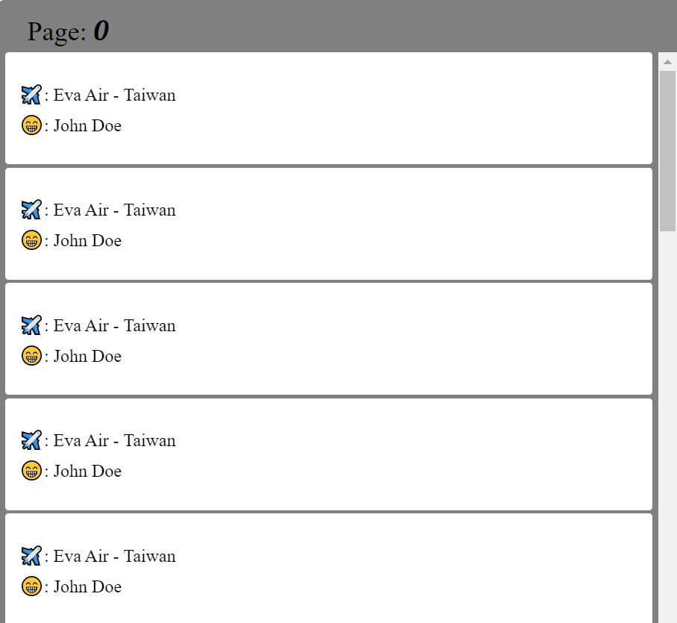

# EX2:

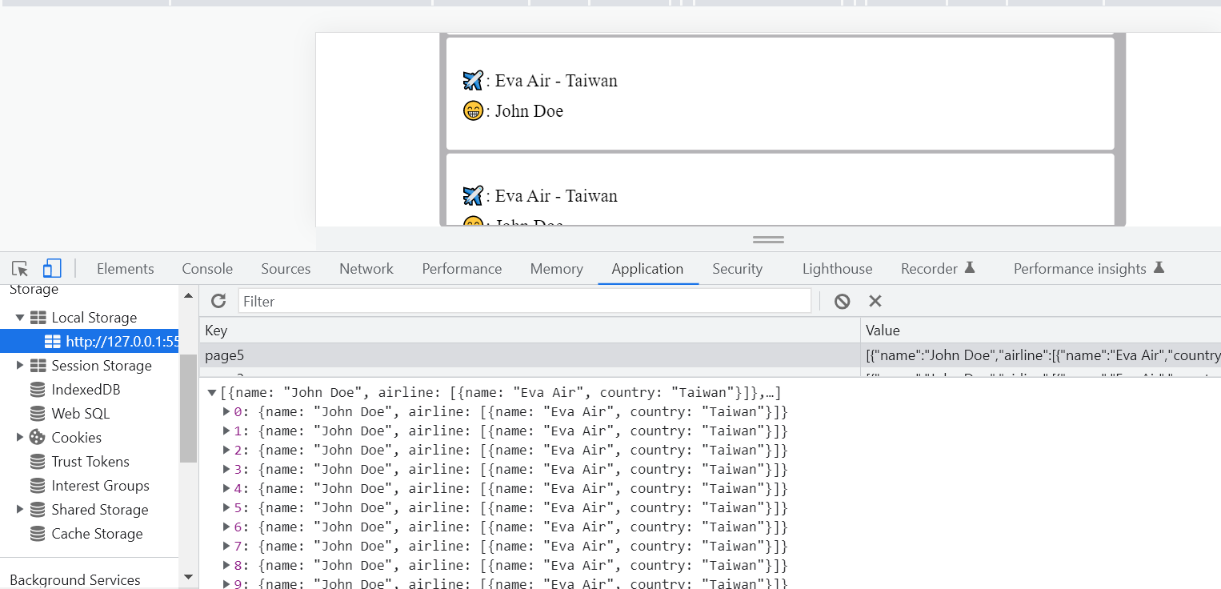

# EX3:

