BÁO CÁO THỰC HÀNH VLAN
Môn học: Thiết kế và cài đặt mạng
Họ và tên: Trần Thiếu Hiệp
MSSV: 65130979
Lớp: 65.TTMMT

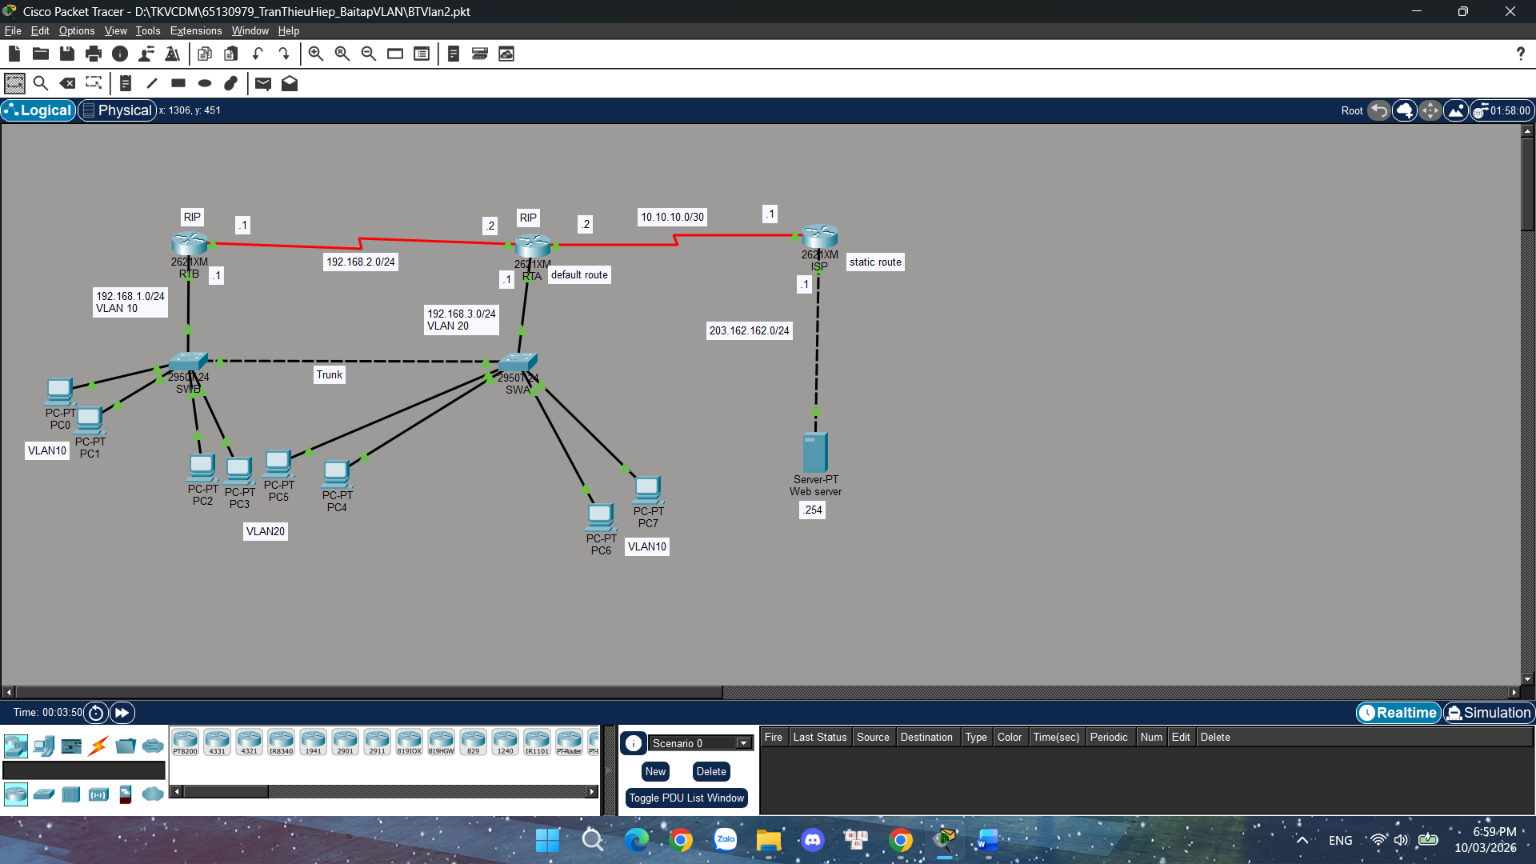

Cấu hình Router và Switch – Bài VLAN
Switch SWA:
enable
configure terminal

vlan 10
name VLAN10

vlan 20
name VLAN20

interface fastEthernet0/3
switchport mode access
switchport access vlan 20

interface fastEthernet0/4
switchport mode access
switchport access vlan 20

interface fastEthernet0/5
switchport mode access
switchport access vlan 10

interface fastEthernet0/2
switchport mode trunk

end

Switch SWB:

enable
configure terminal

vlan 10
name VLAN10

vlan 20
name VLAN20

interface fastEthernet0/3
switchport mode access
switchport access vlan 10

interface fastEthernet0/4
switchport mode access
switchport access vlan 10

interface fastEthernet0/5
switchport mode access
switchport access vlan 20

interface fastEthernet0/6
switchport mode access
switchport access vlan 20

interface fastEthernet0/1
switchport mode trunk

interface fastEthernet0/2
switchport mode trunk

end

Router RTB:
enable
configure terminal

interface fastEthernet0/0
no shutdown

interface fastEthernet0/0.10
encapsulation dot1Q 10
ip address 192.168.1.1 255.255.255.0

interface serial0/0
ip address 192.168.2.1 255.255.255.252
clock rate 64000
no shutdown

router rip
version 2
network 192.168.1.0
network 192.168.2.0
no auto-summary

end

Router RTA:
enable
configure terminal

interface fastEthernet0/0
no shutdown

interface fastEthernet0/0.20
encapsulation dot1Q 20
ip address 192.168.3.1 255.255.255.0

interface serial0/0
ip address 192.168.2.2 255.255.255.252
no shutdown

interface serial0/1
ip address 10.10.10.2 255.255.255.252
no shutdown

router rip
version 2
network 192.168.2.0
network 192.168.3.0
no auto-summary

ip route 0.0.0.0 0.0.0.0 10.10.10.1

end

Router ISP:
enable
configure terminal

interface serial0/0
ip address 10.10.10.1 255.255.255.252
no shutdown

interface fastEthernet0/0
ip address 203.162.162.1 255.255.255.0
no shutdown

ip route 192.168.0.0 255.255.0.0 10.10.10.2

end

