BÁO CÁO THỰC HÀNH VLAN
Môn học: Thiết kế và cài đặt mạng
Họ và tên: Trần Thiếu Hiệp
MSSV: 65130979
Lớp: 65.TTMMT

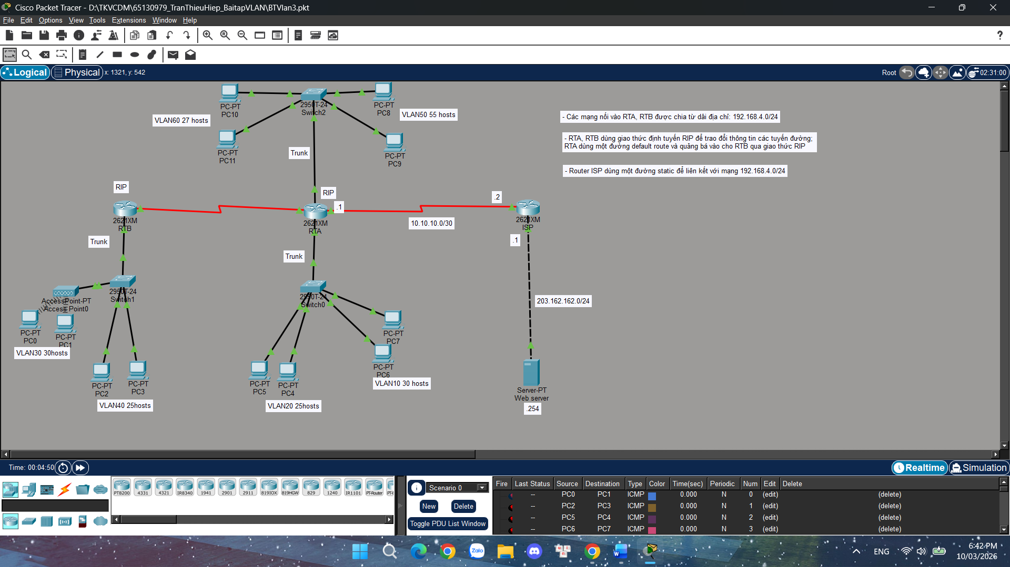

Cấu hình Router và Switch – Bài VLAN
Switch0:
enable
conf t
vlan 10
vlan 20

interface fa0/5
switchport mode access
switchport access vlan 10

interface fa0/6
switchport mode access
switchport access vlan 10

interface fa0/3
switchport mode access
switchport access vlan 20

interface fa0/4
switchport mode access
switchport access vlan 20

interface fa0/1
switchport mode trunk

Switch1:
enable
conf t
vlan 30
vlan 40

interface fa0/3
switchport mode access
switchport access vlan 30

interface fa0/5
switchport mode access
switchport access vlan 40

interface fa0/6
switchport mode access
switchport access vlan 40

interface fa0/1
switchport mode trunk

Switch2:
enable
conf t
vlan 50
vlan 60

interface fa0/2
switchport mode access
switchport access vlan 50

interface fa0/3
switchport mode access
switchport access vlan 50

interface fa0/4
switchport mode access
switchport access vlan 60

interface fa0/5
switchport mode access
switchport access vlan 60

interface fa0/1
switchport mode trunk

Router RTA:
enable
conf t

interface fa0/0
no shutdown

interface fa0/0.10
encapsulation dot1Q 10
ip address 192.168.10.1 255.255.255.0

interface fa0/0.20
encapsulation dot1Q 20
ip address 192.168.20.1 255.255.255.0

interface fa0/1
no shutdown

interface fa0/1.50
encapsulation dot1Q 50
ip address 192.168.50.1 255.255.255.0

interface fa0/1.60
encapsulation dot1Q 60
ip address 192.168.60.1 255.255.255.0

interface s0/1
ip address 10.10.10.1 255.255.255.252
no shutdown

interface s0/0
ip address 192.168.4.1 255.255.255.0
no shutdown

Router RTB:
enable
conf t

interface fa0/0
no shutdown

interface fa0/0.30
encapsulation dot1Q 30
ip address 192.168.30.1 255.255.255.0

interface fa0/0.40
encapsulation dot1Q 40
ip address 192.168.40.1 255.255.255.0

interface s0/1
ip address 192.168.4.2 255.255.255.0
no shutdown

Router ISP:
enable
conf t

interface s0/0
ip address 10.10.10.2 255.255.255.252
no shutdown

interface fa0/0
ip address 203.162.162.1 255.255.255.0
no shutdown

