**NAME : Sunitha**

**REG NO : 611419104090**

**COLLEGE : MAHENDRA ENGINEERING COLLEGE FOR WOMEN**

*#libraries* import pandas as pd import numpy as np

import matplotlib.pyplot as plt %matplotlib inline

*#load dataset*

df = pd.read_csv(r"/content/Churn_Modelling.csv") df.head(10)

RowNumber CustomerId Surname CreditScore Geography Gender Age

\

1. 1 15634602 Hargrave 619 France Female 42
2. 2 15647311 Hill 608 Spain Female 41
3. 3 15619304 Onio 502 France Female 42
4. 4 15701354 Boni 699 France Female 39
5. 5 15737888 Mitchell 850 Spain Female 43
6. 6 15574012 Chu 645 Spain Male 44
7. 7 15592531 Bartlett 822 France Male 50
8. 8 15656148 Obinna 376 Germany Female 29
9. 9 15792365 He 501 France Male 44
10. 10 15592389 H? 684 France Male 27

Tenure Balance NumOfProducts HasCrCard IsActiveMember \ 0 2 0.00 1 1 1

1. 1 83807.86 1 0 1
2. 8 159660.80 3 1 0
3. 1 0.00 2 0 0
4. 2 125510.82 1 1 1
5. 8 113755.78 2 1 0
6. 7 0.00 2 1 1
7. 4 115046.74 4 1 0
8. 4 142051.07 2 0 1
9. 2 134603.88 1 1 1

# EstimatedSalary Exited 0 101348.88 1

1. 112542.58 0
2. 113931.57 1
3. 93826.63 0
4. 79084.10 0
5. 149756.71 1
6. 10062.80 0
7. 119346.88 1
8. 74940.50 0 9 71725.73 0 df.info()

<class 'pandas.core.frame.DataFrame'> RangeIndex: 10000 entries, 0 to 9999

Data columns (total 14 columns):

# Column Non-Null Count Dtype

--- ------ -------------- ----- 0 RowNumber 10000 non-null int64 1 CustomerId 10000 non-null int64

1. Surname 10000 non-null object
2. CreditScore 10000 non-null int64 4 Geography 10000 non-null object 5 Gender 10000 non-null object
3. Age 10000 non-null int64
4. Tenure 10000 non-null int64 8 Balance 10000 non-null float64 9 NumOfProducts 10000 non-null int64

10 HasCrCard 10000 non-null int64 11 IsActiveMember 10000 non-null int64 12 EstimatedSalary 10000 non-null float64 13 Exited 10000 non-null int64 dtypes: float64(2), int64(9), object(3) memory usage: 1.1+ MB

*#Visualizations #Univariate Analysis* import seaborn as sns sns.kdeplot(df['CreditScore'])

<matplotlib.axes._subplots.AxesSubplot at 0x7fc4a0cd2790>

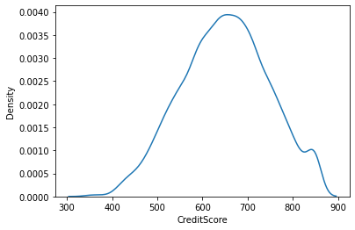

*#Bi - Variate Analysis*

plt.bar(df.CustomerId, df.CreditScore) plt.title('CreditScore') plt.xlabel('CustomerId') plt.ylabel('CreditScore')

Text(0, 0.5, 'CreditScore')

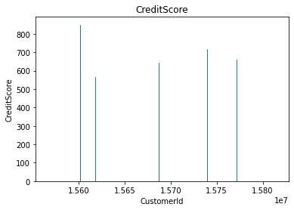

sns.lmplot(x='Tenure', y='Balance', data=df ,hue='Exited',size=8)

/usr/local/lib/python3.7/dist-packages/seaborn/regression.py:581: UserWarning: The `size` parameter has been renamed to `height`; please update your code. warnings.warn(msg, UserWarning)

<seaborn.axisgrid.FacetGrid at 0x7fc4a149e2d0>

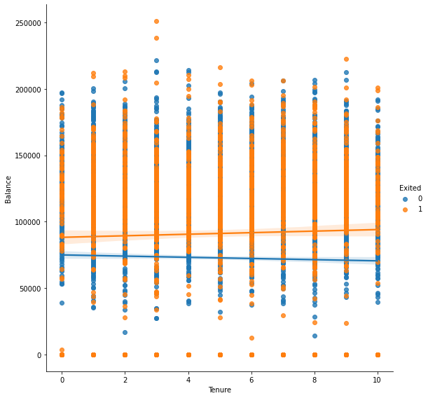

*#Multi - Variate Analysis* ax =

df[["CreditScore","Age","Tenure","Balance"]].plot(figsize=(80,40)) ax.legend(loc='center left', bbox_to_anchor=(1, 0.5));

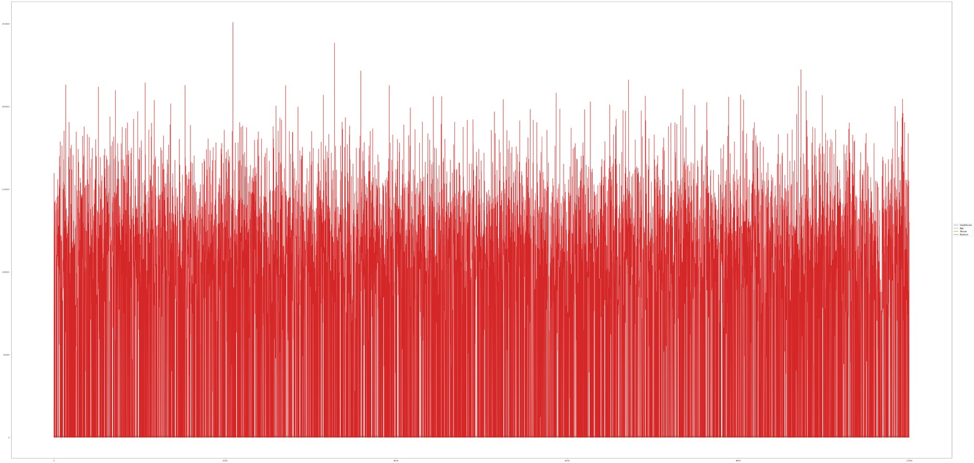

df.isnull().sum()

RowNumber 0

CustomerId 0 Surname 0

CreditScore 0 Geography 0

Gender 0 Age 0 Tenure 0 Balance 0 NumOfProducts 0

HasCrCard 0

IsActiveMember 0 EstimatedSalary 0 Exited 0 dtype: int64

plt.figure(figsize=(15,13)) sns.heatmap(df.corr(),annot=True,cmap='BuPu') plt.show()

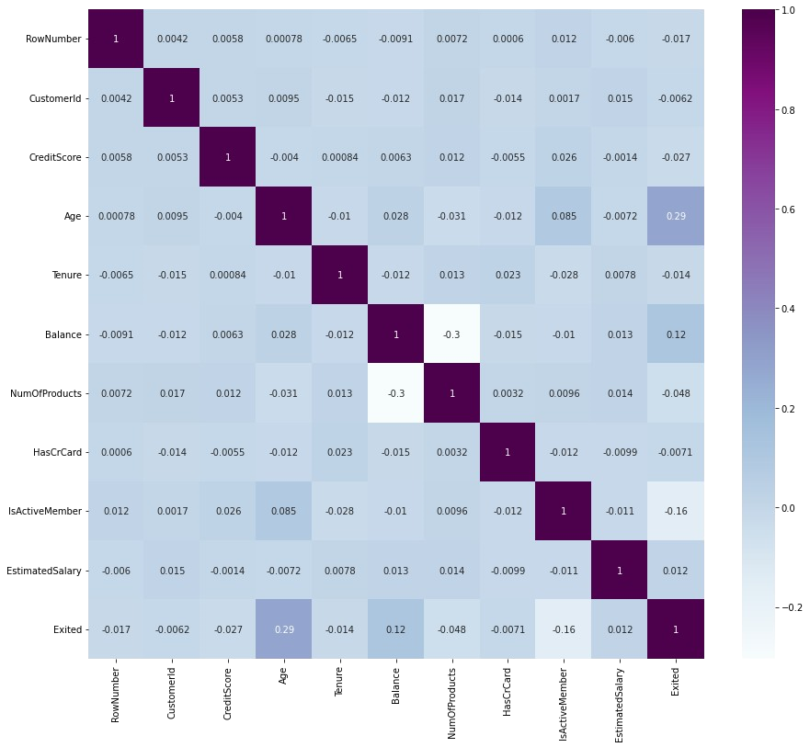

df.drop(['RowNumber', 'CustomerId','Surname'],axis=1,inplace=True) df.head()

CreditScore Geography Gender Age Tenure Balance

NumOfProducts \

1. 619 France Female 42 2 0.00

1

1. 608 Spain Female 41 1 83807.86

1

1. 502 France Female 42 8 159660.80

3

1. 699 France Female 39 1 0.00

2

1. 850 Spain Female 43 2 125510.82 1

# HasCrCard IsActiveMember EstimatedSalary Exited 0 1 1 101348.88 1

1 0 1 112542.58 0

# 1 0 113931.57 1

# 0 0 93826.63 0

4 1 1 79084.10 0 df.info()

<class 'pandas.core.frame.DataFrame'> RangeIndex: 10000 entries, 0 to 9999

Data columns (total 11 columns):

# Column Non-Null Count Dtype

--- ------ -------------- -----

0 CreditScore 10000 non-null int64 1 Geography 10000 non-null object 2 Gender 10000 non-null object

1. Age 10000 non-null int64
2. Tenure 10000 non-null int64 5 Balance 10000 non-null float64 6 NumOfProducts 10000 non-null int64

7 HasCrCard 10000 non-null int64 8 IsActiveMember 10000 non-null int64 9 EstimatedSalary 10000 non-null float64 10 Exited 10000 non-null int64 dtypes: float64(2), int64(7), object(2) memory usage: 859.5+ KB df["Geography"].unique()

array(['France', 'Spain', 'Germany'], dtype=object) df["Gender"].unique()

array(['Female', 'Male'], dtype=object) geo=pd.get_dummies(df["Geography"],drop_first=False) geo.head()

France Germany Spain 0 1 0 0

1. 0 0 1
2. 1 0 0
3. 1 0 0 4 0 0 1

gen=pd.get_dummies(df["Gender"],drop_first=False) df=pd.concat([df, geo,gen], axis=1) df

CreditScore Geography Gender Age Tenure Balance NumOfProducts \

1. 619 France Female 42 2 0.00

1

1. 608 Spain Female 41 1 83807.86

1

1. 502 France Female 42 8 159660.80

3

1. 699 France Female 39 1 0.00

2

1. 850 Spain Female 43 2 125510.82

1

... ... ... ... ... ... ... ...

1. 771 France Male 39 5 0.00

2

1. 516 France Male 35 10 57369.61

1

1. 709 France Female 36 7 0.00

1

1. 772 Germany Male 42 3 75075.31

2

1. 792 France Female 28 4 130142.79 1

HasCrCard IsActiveMember EstimatedSalary Exited France Germany \

1. 1 1 101348.88 1 1

0

1. 0 1 112542.58 0 0

0

1. 1 0 113931.57 1 1

0

1. 0 0 93826.63 0 1

0

1. 1 1 79084.10 0 0

0

... ... ... ... ... ... ...

1. 1 0 96270.64 0 1

0

1. 1 1 101699.77 0 1

0

1. 0 1 42085.58 1 1

0

1. 1 0 92888.52 1 0

1

1. 1 0 38190.78 0 1 0

Spain Female Male

1. 0 1 0
2. 1 1 0
3. 0 1 0
4. 0 1 0
5. 1 1 0 ... ... ... ...
6. 0 0 1
7. 0 0 1
8. 0 1 0
9. 0 0 1
10. 0 1 0

[10000 rows x 16 columns]

df.drop(["Geography","Gender"], axis=1, inplace=True) df.head()

CreditScore Age Tenure Balance NumOfProducts HasCrCard \ 0 619 42 2 0.00 1 1 1 608 41 1 83807.86 1 0

2 502 42 8 159660.80 3 1 3 699 39 1 0.00 2 0 4 850 43 2 125510.82 1 1

IsActiveMember EstimatedSalary Exited France Germany Spain Female \

1. 1 101348.88 1 1 0 0

1

1. 1 112542.58 0 0 0 1

1

1. 0 113931.57 1 1 0 0

1

1. 0 93826.63 0 1 0 0

1

1. 1 79084.10 0 0 0 1 1

Male

1. 0
2. 0
3. 0
4. 0 4 0

x=df.drop('Exited',axis=1) x

CreditScore Age Tenure Balance NumOfProducts HasCrCard \ 0 619 42 2 0.00 1 1 1 608 41 1 83807.86 1 0 2 502 42 8 159660.80 3 1 3 699 39 1 0.00 2 0 4 850 43 2 125510.82 1 1 ... ... ... ... ... ... ...

9995 771 39 5 0.00 2 1 9996 516 35 10 57369.61 1 1 9997 709 36 7 0.00 1 0 9998 772 42 3 75075.31 2 1

9999 792 28 4 130142.79 1 1

IsActiveMember EstimatedSalary France Germany Spain Female

Male

1. 1 101348.88 1 0 0 1

0

1. 1 112542.58 0 0 1 1

0

1. 0 113931.57 1 0 0 1

0

1. 0 93826.63 1 0 0 1

0

1. 1 79084.10 0 0 1 1

0

... ... ... ... ... ... ... ...

1. 0 96270.64 1 0 0 0

1

1. 1 101699.77 1 0 0 0

1

1. 1 42085.58 1 0 0 1

0

1. 0 92888.52 0 1 0 0

1

1. 0 38190.78 1 0 0 1 0

[10000 rows x 13 columns] y=df['Exited'] y

1. 1
2. 0
3. 1
4. 0
5. 0 ..
6. 0
7. 0
8. 1
9. 1
10. 0

Name: Exited, Length: 10000, dtype: int64 df.shape (10000, 14)

x.shape (10000, 13)

y.shape (10000,)

from sklearn.model_selection import train_test_split

x_train,x_test, y_train,y_test = train_test_split(x,y, test_size=0.2,random_state=0) x_train.shape (8000, 13) x_test.shape (2000, 13) y_test.shape (2000,)

from sklearn.preprocessing import StandardScaler sc = StandardScaler() x_train = sc.fit_transform(x_train) x_train

array([[ 0.16958176, -0.46460796, 0.00666099, ..., 1.74309049,

1.09168714, -1.09168714],

[-2.30455945, 0.30102557, -1.37744033, ..., -0.57369368,

-0.91601335, 0.91601335],

[-1.19119591, -0.94312892, -1.031415 , ..., -0.57369368,

1.09168714, -1.09168714],

...,

[ 0.9015152 , -0.36890377, 0.00666099, ..., -0.57369368,

-0.91601335, 0.91601335],

[-0.62420521, -0.08179119, 1.39076231, ..., 1.74309049,

1.09168714, -1.09168714],

[-0.28401079, 0.87525072, -1.37744033, ..., -0.57369368,

1.09168714, -1.09168714]]) x_test = sc.transform(x_test)

x_test

array([[-0.55204276, -0.36890377, 1.04473698, ..., -0.57369368,

1.09168714, -1.09168714],

[-1.31490297, 0.10961719, -1.031415 , ..., -0.57369368,

1.09168714, -1.09168714],

[ 0.57162971, 0.30102557, 1.04473698, ..., 1.74309049,

1.09168714, -1.09168714],

...,

[-0.74791227, -0.27319958, -1.37744033, ..., 1.74309049,

-0.91601335, 0.91601335],

[-0.00566991, -0.46460796, -0.33936434, ..., -0.57369368,

-0.91601335, 0.91601335],

[-0.79945688, -0.84742473, 1.04473698, ..., -0.57369368,

-0.91601335, 0.91601335]])