User:
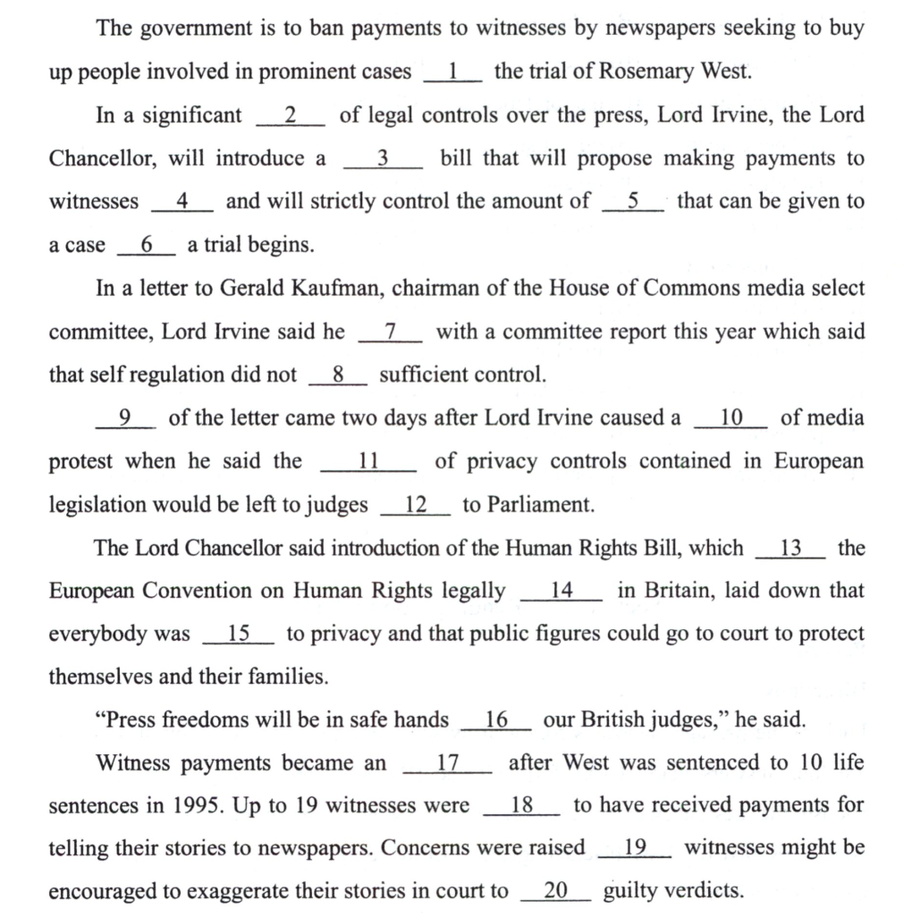
请对这段文字进行逐句翻译，中英对照，保留文章中挖空的地方，使用下划线代替

Kimi:
The government is to ban payments to witnesses by newspapers seeking to buy up people involved in prominent cases __1__ the trial of Rosemary West.
政府将禁止报纸向涉及重大案件（尤其是罗丝玛丽・韦斯特审判案）的证人支付费用。
In a significant __2__ of legal controls over the press, Lord Irvine, the Lord Chancellor, will introduce a __3__ bill that will propose making payments to witnesses __4__ and will strictly control the amount of __5__ that can be given to a case __6__ a trial begins.
在对新闻媒体实施法律管控的（显著的____），大法官欧文勋爵将提出一项（____）法案，该法案将建议（禁止向证人支付费用____），并将在审判开始（前____）严格控制可以给予案件的资金数额。
In a letter to Gerald Kaufman, chairman of the House of Commons media select committee, Lord Irvine said he __7__ with a committee report this year which said that self-regulation did not __8__ sufficient control.
在给下议院媒体特别委员会主席杰拉尔德・考夫曼的一封信中，欧文勋爵表示，他（对今年委员会的一份报告表示支持____），该报告称自我监管未能（提供足够的控制____）。
__9__ of the letter came two days after Lord Irvine caused a __10__ of media protest when he said the __11__ of privacy controls contained in European legislation would be left to judges __12__ to Parliament.
这封信的（发出时间____）恰逢欧文勋爵在两天前引发（一场媒体抗议浪潮____），当时他表示，欧洲法律中包含的（隐私控制措施的范围____）将交由法官（而非议会____）来决定。
The Lord Chancellor said introduction of the Human Rights Bill, which __13__ the European Convention on Human Rights legally __14__ in Britain, laid down that everybody was __15__ to privacy and that public figures could go to court to protect themselves and their families.
大法官表示，《人权法案》的引入（使欧洲人权公约在英国具有法律效力____），该法案规定每个人都有（隐私权____），公众人物可以诉诸法院来保护自己及其家人。
“Press freedoms will be in safe hands __16__ our British judges,” he said.
“只要交给我们的英国法官来处理，新闻自由就将得到保障（____），”他说。
Witness payments became an __17__ after West was sentenced to 10 life sentences in 1995. Up to 19 witnesses were __18__ to have received payments for telling their stories to newspapers. Concerns were raised __19__ witnesses might be encouraged to exaggerate their stories in court to __20__ guilty verdicts.
证人支付问题在1995年韦斯特被判10项无期徒刑后成为一个（严重问题____）。有多达19名证人（据称____）因向报纸讲述他们的故事而获得支付。人们担心（证人可能会被鼓励在法庭上夸大其词以促成定罪结果____）。
- [A] as to：关于
[B] for instance：例如
[C] in particular：尤其、特别
[D] such as：诸如
- [A] tightening：加强、强化
[B] intensifying：加剧、增强
[C] focusing：聚焦
[D] fastening：固定
- [A] sketch：草稿
[B] rough：粗糙的、临时的
[C] preliminary：初步的
[D] draft：草案
- [A] illogical：不合逻辑的
[B] illegal：非法的
[C] improbable：不可能的
[D] improper：不恰当的
- [A] publicity：公众关注度、曝光
[B] penalty：惩罚
[C] popularity：受欢迎程度
[D] peculiarity：奇特之处
- [A] since：因为
[B] if：如果
[C] before：在……之前
[D] as：随着
- [A] sided：支持（某一方）
[B] shared：分享
[C] comply：遵守
[D] agreed：同意
- [A] present：提供
[B] offer：提供
[C] manifest：表现
[D] indicate：表明
- [A] Release：发布
[B] Publication：发表
[C] Printing：印刷
[D] Exposure：曝光
- [A] storm：风暴、抗议浪潮
[B] rage：愤怒
[C] flare：爆发
[D] flash：闪光
- [A] translation：翻译
[B] interpretation：解读
[C] exhibition：展览
[D] demonstration：演示
- [A] better than：优于
[B] other than：除了
[C] rather than：而不是
[D] sooner than：比……更早
- [A] changes：改变
[B] makes：使
[C] sets：设定
[D] turns：转变
- [A] binding：有约束力的
[B] convincing：令人信服的
[C] restraining：限制的
[D] sustaining：维持的
- [A] authorized：授权的
[B] credited：被记入的
[C] entitled：有权的
[D] qualified：有资格的
- [A] with：与……在一起
[B] to：给、对
[C] from：来自
[D] by：通过
- [A] impact：影响
[B] incident：事件
[C] inference：推断
[D] issue：问题
- [A] stated：声明
[B] remarked：评论
[C] said：说
[D] told：告诉
- [A] what：什么
[B] when：何时
[C] which：哪一个
[D] that：那个
- [A] assure：确保（通常用于向某人保证某事）
[B] confide：倾诉
[C] ensure：确保（通常用于表达采取措施以保证某事发生）
[D] guarantee：保证（通常指以某种形式承诺某事）

