User:
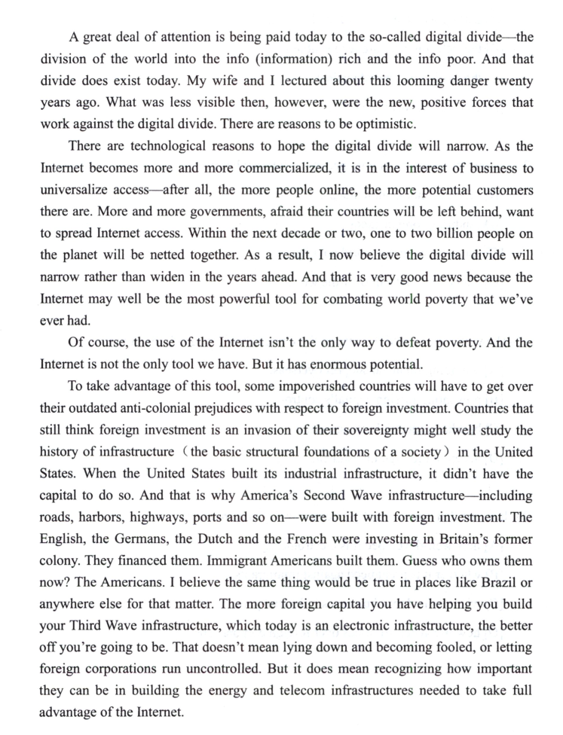
请对这段文字进行逐句翻译，中英对照

Kimi:
以下是这段英文的逐句中英对照翻译：
原文：
A great deal of attention is being paid today to the so-called digital divide—the division of the world into the info (information) rich and the info poor. And that divide does exist today.
翻译：
如今，人们非常关注所谓的“数字鸿沟”——即世界被划分为信息富有者和信息贫困者。这种鸿沟确实存在。

原文：
- My wife and I lectured about this looming danger twenty years ago.What was less visible then, however, were the new, positive forces that work against the digital divide.
翻译：
二十年前，我和妻子就曾就这一迫在眉睫的危险发表过演讲。然而，当时还不太明显的是，一些新兴的积极力量正在对抗数字鸿沟。

原文：
There are reasons to be optimistic.
翻译：
我们有理由保持乐观。

原文：
There are technological reasons to hope the digital divide will narrow.
翻译：
从技术角度来看，我们有理由期待数字鸿沟将会缩小。

原文：
- As the Internet becomes more and more commercialized, it is in the interest of business to universalize access—after all, the more people online, the more potential customers there are.
翻译：
随着互联网日益商业化，普及网络接入符合商业利益——毕竟，上网的人越多，潜在客户就越多。

原文：
More and more governments, afraid their countries will be left behind, want to spread Internet access.
翻译：
越来越多的政府担心本国落后，也希望推动互联网的普及。

原文：
Within the next decade or two, one to two billion people on the planet will be netted together.
翻译：
在未来一二十年内，全球将有一到二十亿人被网络连接起来。

原文：
As a result, I now believe the digital divide will narrow rather than widen in the years ahead.
翻译：
因此，我现在相信，未来数字鸿沟将会缩小而不是扩大。

原文：
And that is very good news because the Internet may well be the most powerful tool for combating world poverty that we’ve ever had.
翻译：
这是一个非常好的消息，因为互联网很可能是我们对抗世界贫困的最有力工具。

原文：
Of course, the use of the Internet isn’t the only way to defeat poverty. And the Internet is not the only tool we have. But it has enormous potential.
翻译：
当然，使用互联网并不是战胜贫困的唯一方式，互联网也不是我们唯一的工具，但它具有巨大的潜力。

原文：
To take advantage of this tool, some impoverished countries will have to get over their outdated anti-colonial prejudices with respect to foreign investment.
翻译：
为了利用这一工具，一些贫困国家必须摒弃他们对外国投资那种过时的反殖民偏见，尊重外商投资。

原文：
Countries that still think foreign investment is an invasion of their sovereignty might well study the history of infrastructure (the basic structural foundations of a society) in the United States.
翻译：
那些仍然认为外国投资是对其主权侵犯的国家，不妨研究一下美国基础设施建设的历史（即社会的基本结构基础）。

原文：
When the United States built its industrial infrastructure, it didn’t have the capital to do so.
翻译：
当年美国在建设其工业基础设施时，并没有足够的资本。

原文：
And that is why America’s Second Wave infrastructure—including roads, harbors, highways, ports and so on—were built with foreign investment.
翻译：
因此，美国的第二波基础设施——包括公路、港口、高速公路、码头等——都是由外国投资建设的。

原文：
The English, the Germans, the Dutch and the French were investing in Britain’s former colony.
翻译：
英国人、德国人、荷兰人和法国人都在投资英国的前殖民地。

原文：
They financed them. Immigrant Americans built them. Guess who owns them now? The Americans.
翻译：
他们提供了资金，移民来的美国人建设了这些设施。猜猜现在谁拥有它们？美国人。

原文：
I believe the same thing would be true in places like Brazil or anywhere else for that matter.
翻译：
我相信，在巴西或任何其他地方，情况也会是一样的。

原文：
- The more foreign capital you have helping you build your Third Wave infrastructure, which today is an electronic infrastructure, the better off you’re going to be.
翻译：
你拥有越多的外国资本来帮助你建设第三波基础设施——也就是当今的电子基础设施——你就会越受益。

原文：
That doesn’t mean lying down and becoming fooled, or letting foreign corporations run uncontrolled.
翻译：
这并不意味着你要任人摆布、被愚弄，或让外国公司肆意妄为。

原文：
But it does mean recognizing how important they can be in building the energy and telecom infrastructures needed to take full advantage of the Internet.
翻译：
但这确实意味着要认识到，外国资本在建设能源和电信基础设施方面的重要性，这些基础设施是充分利用互联网所必需的。

25. Digital divide is something
数字鸿沟是一个____
[A] getting worse because of the Internet.
因互联网而日益恶化的事物。
[B] the rich countries are responsible for.
富裕国家应为之负责的事物。
[C] the world must guard against.
全世界必须警惕的事物。
[D] considered positive today.
如今被视为积极的事物。

26. Governments attach importance to the Internet because it
各国政府重视互联网，是因为它____
[A] offers economic potentials.
具有经济潜力。
[B] can bring foreign funds.
能够带来外资。
[C] can soon wipe out world poverty.
能够很快消除世界贫困。
[D] connects people all over the world.
把全球人民联系在一起。

27. The writer mentioned the case of the United States to justify the policy of
作者提到美国的例子，是为了支持____的政策
[A] providing financial support overseas.
向海外提供财政支持。
[B] preventing foreign capital’s control.
防止外资控制。
[C] building industrial infrastructure.
建设工业基础设施。
[D] accepting foreign investment.
接受外国投资。

28. It seems that now a country’s economy depends much on
现在看来，一个国家的经济在很大程度上取决于____
[A] how well-developed(发达) it is electronically.
其电子化程度有多高。
[B] whether it is prejudiced against immigrants.
是否对移民存在偏见。
[C] whether it adopts America’s industrial pattern.
是否采纳美国的工业模式。
[D] how much control it has over foreign corporations.
其对外国公司的控制力度有多大。

