User:
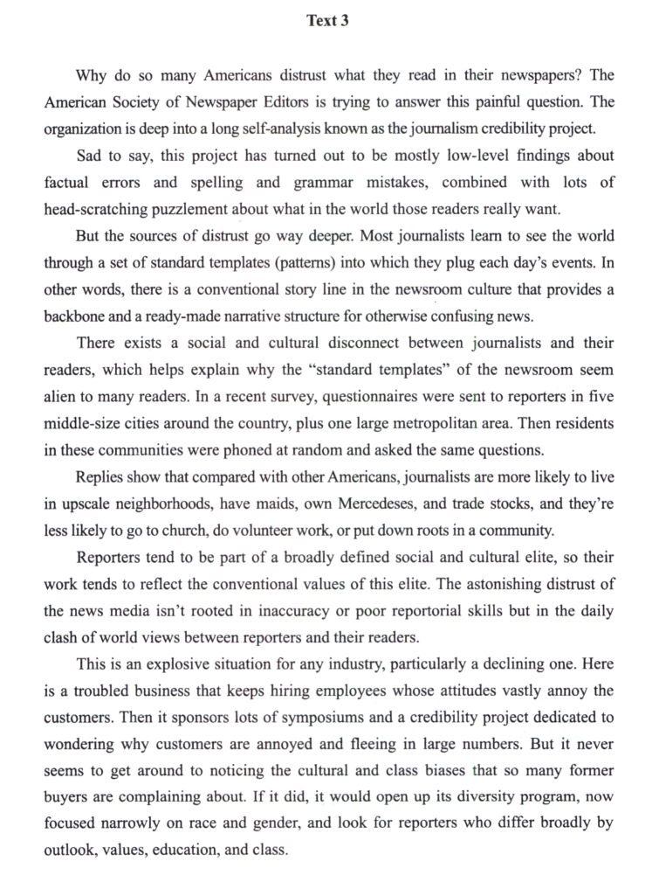
请对这段文字进行逐句翻译，中英对照

Kimi:
Text 3
Why do so many Americans distrust what they read in their newspapers?
为什么这么多美国人不相信他们在报纸上读到的内容？
The American Society of Newspaper Editors is trying to answer this painful question.
美国报纸编辑协会正试图回答这个令人痛心的问题。
The organization is deep into a long self-analysis known as the journalism credibility project.
该组织正在进行一项名为新闻业可信度项目的长期自我剖析。
- Sad to say, this project has turned out to be mostly low-level findings about factual errors and spelling and grammar mistakes, combined with lots of head-scratching puzzlement about what in the world those readers really want.
遗憾的是，这个项目大多只发现了一些事实性错误、拼写和语法错误等低级问题，同时还对读者究竟想要什么感到困惑不解。
But the sources of distrust go way deeper.
然而，不信任的根源要深得多。
Most journalists learn to see the world through a set of standard templates (patterns) into which they plug each day’s events.
大多数记者通过一组标准的模板（模式）来观察世界，他们将每天发生的事件套用到这些模板中。
In other words, there is a conventional story line in the newsroom culture that provides a backbone and a ready-made narrative structure for otherwise confusing news.
换句话说，在新闻编辑室文化中存在一种传统的叙事主线，为那些原本令人困惑的新闻提供了一个骨架和现成的叙事结构。
There exists a social and cultural disconnect between journalists and their readers, which helps explain why the “standard templates” of the newsroom seem alien to many readers.
记者与读者之间存在着一种社会和文化的脱节，这有助于解释为什么新闻编辑室的“标准模板”在许多读者看来显得陌生。
In a recent survey, questionnaires were sent to reporters in five middle-size cities around the country, plus one large metropolitan area.
在最近的一项调查中，调查问卷被发送到了全国五个中等城市的记者以及一个大都市地区的记者手中。
Then residents in these communities were phoned at random and asked the same questions.
然后，这些社区的居民被随机拨打电话，并被问到同样的问题。
Replies show that compared with other Americans, journalists are more likely to live in upscale neighborhoods, have maids, own Mercedeses, and trade stocks, and they’re less likely to go to church, do volunteer work, or put down roots in a community.
回复显示，与其他美国人相比，记者更有可能住在高档社区，雇有女佣，拥有梅赛德斯奔驰车，并且买卖股票；而他们去教堂做礼拜、做志愿者工作或在一个社区扎根的可能性则较小。
Reporters tend to be part of a broadly defined social and cultural elite, so their work tends to reflect the conventional values of this elite.
记者往往是广义上定义的社会和文化精英的一部分，因此他们的工作往往反映了这种精英阶层的传统价值观。
- The astonishing distrust of the news media isn’t rooted in inaccuracy or poor reportorial skills but in the daily clash of world views between reporters and their readers.
人们对新闻媒体的惊人不信任并不是源于不准确或糟糕的报道技巧，而是源于记者与读者之间世界观的日常碰撞。
This is an explosive situation for any industry, particularly a declining one.
这种情况对任何一个行业来说都是爆炸性的，尤其是对一个正在衰退的行业。
Here is a troubled business that keeps hiring employees whose attitudes vastly annoy the customers.
这里有这样一个陷入困境的行业，它不断地雇佣那些其态度极大地惹恼顾客的员工。
Then it sponsors lots of symposiums and a credibility project dedicated to wondering why customers are annoyed and fleeing in large numbers.
然后，该行业赞助了许多研讨会和一个致力于探讨为什么顾客感到恼怒并大批流失的可信度项目。
- But it never seems to get around to noticing the cultural and class biases that so many former buyers are complaining about.
但它似乎从未注意到许多前顾客所抱怨的文化和阶级偏见。
If it did, it would open up its diversity program, now focused narrowly on race and gender, and look for reporters who differ broadly by outlook, values, education, and class.
如果它注意到了这一点，就会拓宽目前仅专注于种族和性别的多元化项目，寻找在 outlook（视野）、价值观、教育和阶级方面有广泛差异的记者。
- What is the passage mainly about?
文章主要讲了什么？
- [A] needs of the readers all over the world
- [A] 全球读者的需求
- [B] causes of the public disappointment about newspapers
- [B] 公众对报纸失望的原因
- [C] origins of the declining newspaper industry
- [C] 媒体行业衰退的起源
- [D] aims of a journalism credibility project
- [D] 一个新闻公信力项目的宗旨

30
The results of the journalism credibility project turned out to be
新闻公信力项目的成果结果如何？
- [A] quite trustworthy.
- [A] 相当可信
- [B] somewhat contradictory.
- [B] 略显矛盾
- [C] very illuminating.
- [C] 非常启发性
- [D] rather superficial.
- [D] 相当肤浅

31
The basic problem of journalists as pointed out by the writer lies in their
作家指出记者的基本问题在于他们的：
- [A] working attitude.
- [A] 工作态度
- [B] conventional lifestyle.
- [B] 传统生活方式
- [C] world outlook.
- [C] 世界观
- [D] educational background.
- [D] 教育背景

32
Despite its efforts, the newspaper industry still cannot satisfy the readers owing to its
尽管努力，报纸行业仍然无法让读者满意，原因在于：
- [A] failure to realize its real problem.
- [A] 没有意识到真正的问题
- [B] tendency to hire annoying reporters.
- [B] 倾向于雇佣令人恼火的记者
- [C] likeliness to do inaccurate reporting.
- [C] 倾向于做出不准确的报道
- [D] prejudice in matters of race and gender.
- [D] 在种族和性别问题上的偏见

