User:
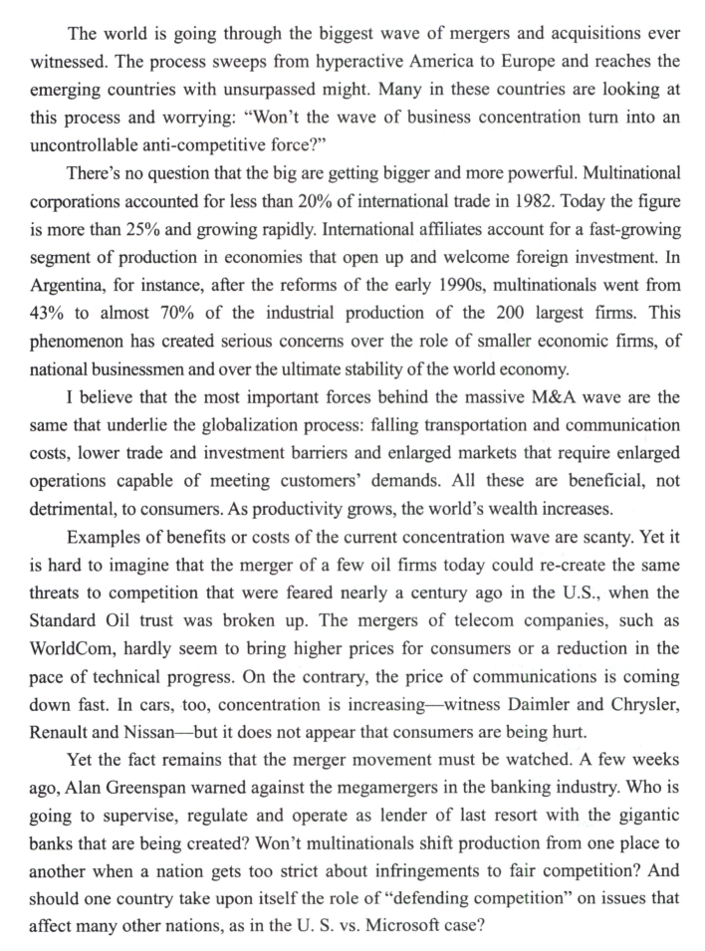
请对这段文字进行逐句翻译，中英对照

Kimi:
以下是对这段文字的逐句翻译，中英对照：
- The world is going through the biggest wave of mergers and acquisitions ever witnessed.
世界正在经历有史以来最大规模的并购浪潮。
The process sweeps from hyperactive America to Europe and reaches the emerging countries with unsurpassed might.
这一浪潮从极其活跃的美国席卷至欧洲，并以无与伦比的力量扩展到新兴国家。
Many in these countries are looking at this process and worrying: “Won’t the wave of business concentration turn into an uncontrollable anti-competitive force?”
这些国家中的许多人正在审视这一过程，并担忧：“这种企业集中化浪潮是否将演变成一种无法控制的反竞争力量？”
There’s no question that the big are getting bigger and more powerful.
毫无疑问，大企业正变得更大、更强大。
Multinational corporations accounted for less than 20% of international trade in 1982. Today the figure（数值） is more than 25% and growing rapidly.
1982年，跨国公司仅占国际贸易的不到20%。如今这一比例已超过25%，并且还在迅速增长。
International affiliates account for a fast-growing segment of production in economies that open up and welcome foreign investment.
在那些开放并欢迎外国投资的经济体中，跨国子公司占据了生产领域中增长最快的部分。
In Argentina, for instance（例如）, after the reforms of the early 1990s, multinationals went from 43% to almost 70% of the industrial production of the 200 largest firms.
以阿根廷为例，在20世纪90年代初的改革后，跨国公司从占该国200家最大工业企业总产量的43%上升到近70%。
This phenomenon has created serious concerns over the role of smaller economic firms, of national businessmen and over the ultimate stability of the world economy.
这种现象引起了人们对小型经济公司、民族商人的作用和世界经济的最终稳定的严重关切。
- I believe that the most important forces behind the massive M&A wave are the same that underlie the globalization process: falling transportation and communication costs, lower trade and investment barriers and enlarged markets that require enlarged operations capable of meeting customers’ demands.
我认为，推动这股大规模并购浪潮的最重要力量与全球化进程背后的驱动因素是相同的：运输和通信成本的下降、贸易和投资壁垒的减少，以及扩大后的需求市场要求企业具备满足客户需求的更大规模运营能力。
All these are beneficial, not detrimental, to consumers.
所有这些对消费者来说是有益的，而非有害。
As productivity grows, the world’s wealth increases.
随着生产力的提高，世界的财富也在增加。
Examples of benefits or costs of the current concentration wave are scanty.
关于当前企业集中化浪潮的益处或代价的例子并不充分。
- Yet it is hard to imagine that the merger of a few oil firms today could re-create the same threats to competition that were feared nearly a century ago in the U.S., when the Standard Oil trust was broken up.
然而，很难想象如今几家石油公司的合并会重现近一个世纪前美国拆分标准石油公司信托时所担忧的竞争威胁。
- The mergers of telecom companies, such as WorldCom, hardly seem to bring higher prices for consumers or a reduction in the pace of technical progress.
像WorldCom这样的电信公司合并，似乎并没有给消费者带来更高的价格，也没有减缓技术进步的步伐。
On the contrary, the price of communications is coming down fast.
相反，通信价格正在迅速下降。
In cars, too, concentration is increasing—witness Daimler and Chrysler, Renault and Nissan—but it does not appear that consumers are being hurt.
在汽车行业，集中化也在增加——例如戴姆勒与克莱斯勒的合并、雷诺与日产的联盟——但似乎消费者并未受到损害。
Yet the fact remains that the merger movement must be watched.
然而，事实仍然是，并购浪潮必须受到关注。
A few weeks ago, Alan Greenspan warned against the megamergers in the banking industry.
几周前，艾伦·格林斯潘警告了银行业的巨型合并。
- Who is going to supervise, regulate and operate as lender of last resort with the gigantic banks that are being created?
谁将对这些正在形成的巨型银行进行监督、监管，并作为最后贷款人进行操作？
Won’t multinationals shift production from one place to another when a nation gets too strict about infringements to fair competition?
当一个国家对公平竞争的违规行为过于严格时，跨国公司是否会将生产从一个地方转移到另一个地方？
And should one country take upon itself the role of “defending competition” on issues that affect many other nations, as in the U.S. vs. Microsoft case?
一个国家是否应该在影响许多其他国家安全的问题上，像美国诉微软案那样，承担起“捍卫竞争”的角色？
33. What is the typical trend of businesses today?
如今商业的典型趋势是什么？
[A] to take in more foreign funds
[A] 吸引更多外国资金
[B] to invest more abroad
[B] 更多地向海外投资
[C] to combine and become bigger
[C] 合并与变大
[D] to trade with more countries
[D] 与更多国家进行贸易

34. According to the author, one of the driving forces behind M&A wave is
根据作者，推动并购浪潮的一个驱动力是：
[A] the greater customer demands.
[A] 更大的客户需求。
[B] a surplus supply for the market.
[B] 市场供应过剩。
[C] a growing productivity.
[C] 生产力的提升。
[D] the increase of the world’s wealth.
[D] 世界财富的增加。

35. From Paragraph 4 we can infer that
从第四段可以推断出：
[A] the increasing concentration is certain to hurt consumers.
[A] 企业集中化一定会损害消费者。
[B] WorldCom serves as(作为) a good example of both benefits and costs.
[B] WorldCom 是益处与代价的一个好例子。
[C] the costs of the globalization process are enormous.
[C] 全球化进程的成本巨大。
[D] the Standard Oil trust might have threatened competition.
[D] 标准石油公司可能对竞争构成威胁。

36. Toward the new business wave, the writer’s attitude can be said to be
对于这股新的商业浪潮，作者的态度可以被描述为：
[A] optimistic.
[A] 乐观的。
[B] objective.
[B] 客观的。
[C] pessimistic.
[C] 悲观的。
[D] biased.
[D] 有偏见的。

