User:
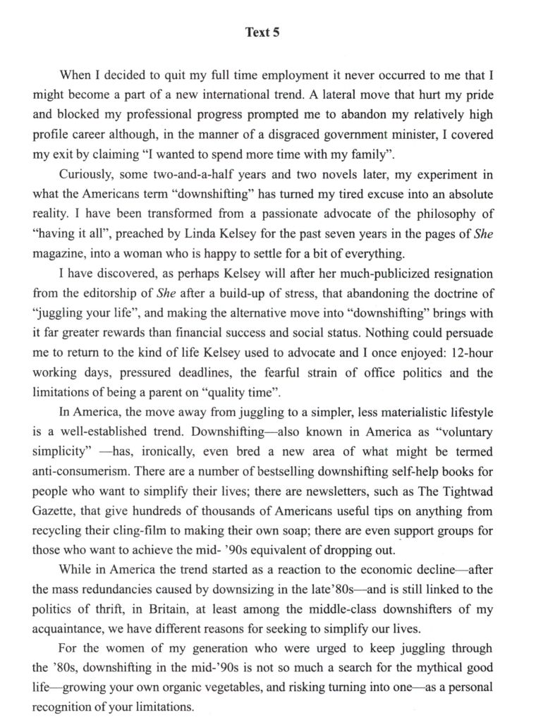
请对这段文字进行逐句翻译，中英对照

Kimi:
好的，我将对这段文字进行逐句翻译，中英对照如下：
When I decided to quit my full time employment it never occurred to me that I might become a part of a new international trend. 当我决定辞去全职工作时，我从未想过自己可能会成为一种新的国际趋势的一部分。
- A lateral move that hurt my pride and blocked my professional progress prompted me to abandon my relatively high profile career although, in the manner of a disgraced government minister, I covered my exit by claiming “I wanted to spend more time with my family”. 一次横向调动伤害了我的自尊，阻碍了我的职业发展，促使我放弃了我相对备受瞩目的职业生涯，尽管我像一位声名狼藉的政府部长一样，用“我想花更多时间和家人在一起”来掩盖我的离职。
Curiously, some two-and-a-half years and two novels later, my experiment in what the Americans term “downshifting” has turned my tired excuse into an absolute reality. 奇怪的是，在两年半和两部小说之后，我在美国人称之为“降档”的实验，把我的疲惫借口变成了绝对的现实。
- I have been transformed(使改观) from a passionate advocate of the philosophy of “having it all”, preached by Linda Kelsey for the past seven years in the pages of She magazine, into a woman who is happy to settle for a bit of everything. 我从一个热情的倡导者，倡导琳达·凯尔西在过去七年里在《她》杂志上宣扬的“拥有一切”的哲学，变成了一个满足于拥有一点点一切的女人。
- I have discovered, as perhaps Kelsey will after her much-publicized resignation from the editorship of She after a build-up of stress(压力的增长), that abandoning the doctrine of “juggling your life”, and making the alternative(可替代的) move into “downshifting” brings with it far greater rewards than financial success and social status. 我发现，也许就像凯尔西因压力过大而公开辞去《她》杂志编辑一职后所发现的那样，放弃“平衡生活”的教条，转而选择“降档”，带来的回报远远超过经济成功和社会地位。
Nothing could persuade me to return to the kind of life Kelsey used to advocate and I once enjoyed: 12-hour working days, pressured deadlines, the fearful strain of office politics and the limitations of being a parent on “quality time”. 没有什么能说服我回到凯尔西曾经倡导、我也曾享受的那种生活：12小时的工作日、紧张的截止日期、可怕的办公室政治压力以及作为父母在“优质时间”上的限制。
In America, the move away from juggling to a simpler, less materialistic lifestyle is a well-established trend. 在美国，从平衡生活转向更简单、不那么物质主义的生活方式是一种已确立的趋势。
Downshifting—also known in America as “involuntary simplicity” —has, ironically, even bred a new area of what might be termed(被称为) anti-consumerism. 讽刺的是，降档——在美国也被称为“非自愿简约”——甚至催生了一个新的领域，可以称之为反消费主义。
There are a number of bestselling downshifting self-help books for people who want to simplify their lives; there are newsletters, such as The Tightwad Gazette, that give hundreds of thousands of Americans useful tips on anything from recycling their cling-film to making their own soap; there are even support groups for those who want to achieve the mid-’90s equivalent of dropping out. 有许多畅销的降档自助书籍，为那些想要简化生活的人提供帮助；还有一些新闻通讯，比如《吝啬鬼公报》，为数十万美国人提供从回收保鲜膜到自制肥皂的实用技巧；甚至还有支持小组，为那些想要实现90年代中期相当于退出社会的人提供帮助。
- While in America the trend started as a reaction to the economic decline—after the mass redundancies caused by downsizing in the late’80s—and is still linked to the politics of thrift, in Britain, at least among the middle-class downshifters of my acquaintance, we have different reasons for seeking to simplify our lives. 虽然在美国，这一趋势始于对经济衰退的反应——在80年代末因裁员导致大规模失业之后——并且仍然与节俭政治相关，但在英国，至少在我的中产阶级降档熟人中，我们有不同理由寻求简化生活。
For the women of my generation who were urged(怂恿，鼓励) to keep juggling through the ’80s, downshifting in the mid-’90s is not so much a search for the mythical good life—growing your own organic vegetables, and risking turning into one—as a personal recognition of your limitations. 对于我们这一代被鼓励在80年代继续平衡生活的女性来说，90年代中期的降档与其说是在寻找神话般的好生活——自己种植有机蔬菜，并冒着变成一个这样的风险——不如说是一种对自身局限性的个人认识。

37.Which of the following is true according to paragraph 1? 根据第1段，以下哪项是正确的？
[A] Full-time employment is a new international trend. [A] 全职就业是一种新的国际趋势。
[B] The writer was compelled(强迫) by circumstances to leave her job. [B] 作者是被环境所迫才离职的。
[C] “A lateral move” means stepping out of full-time employment. [C] “横向调动”意味着退出全职工作。
[D] The writer was only too eager to spend more time with her family. [D] 作者非常渴望花更多时间和家人在一起。
38．The writer’s experiment shows that downshifting 作者的实验表明，降档
[A] enables her to realize her dream. [A] 使她能够实现自己的梦想。
[B] helps her mold a new philosophy of life. [B] 帮助她塑造了一种新的人生哲学。
[C] prompts her to abandon her high social status. [C] 促使她放弃了自己的高社会地位。
[D] leads her to accept the doctrine of She magazine. [D] 使她接受了《她》杂志的教条。
39．“Juggling one’s life” probably means living a life characterized by “平衡生活”可能意味着过一种以……为特征的生活
[A] non-materialistic lifestyle. [A] 非物质主义的生活方式。
[B] a bit of everything. [B] 什么都有一点。
[C] extreme stress. [C] 极度压力。
[D] anti-consumererism. [D] 反消费主义。
40.According to the passage, downshifting emerged in the U.S. as a result of 根据这篇文章，降档在美国出现是由于
[A] the quick pace of modern life. [A] 现代生活的快节奏。
[B] man’s adventurous spirit. [B] 人的冒险精神。
[C] man’s search for mythical experiences. [C] 人对神秘体验的追求。
[D] the economic situation. [D] 经济状况。

