User:
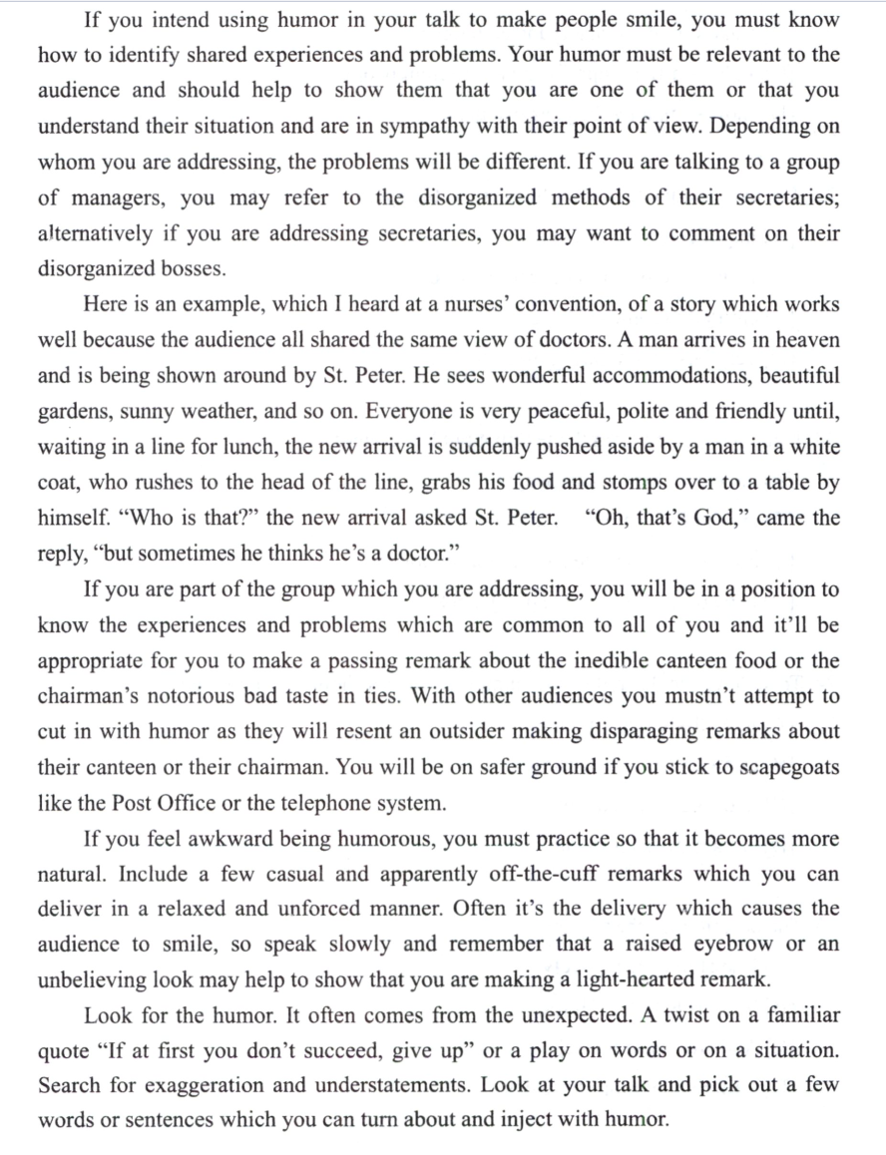
请对这段文字进行逐句翻译，中英对照

Kimi:
- If you intend using humor in your talk to make people smile, you must know how to identify shared experiences and problems.
如果你想在演讲中运用幽默来逗大家一笑，就必须学会如何识别大家共有的经历和问题。
Your humor must be relevant to the audience and should help to show them that you are one of them or that you understand their situation and are in sympathy with their point of view.
你的幽默必须与听众相关，应该帮助他们看到你和他们是一伙的，或者你理解他们的处境，并且认同他们的观点。
- Depending on whom you are addressing(对…讲话), the problems will be different.
根据你所面对的对象不同，问题也会不同。
If you are talking to a group of managers, you may refer to the disorganized methods of their secretaries; alternatively if you are addressing secretaries, you may want to comment on their disorganized bosses.
如果你和一群经理交谈，你可以提到他们秘书的不守秩序；反过来，如果你面对的是秘书们，你可能会对她们那些不守秩序的老板发表一番评论。
Here is an example, which I heard at a nurses’ convention, of a story which works well because the audience all shared the same view of doctors.
这里有一个我从一次护士大会上听到的例子，这个故事之所以能奏效是因为听众对医生的看法是一致的。
A man arrives in heaven and is being shown around by St. Peter. He sees wonderful accommodations, beautiful gardens, sunny weather, and so on. Everyone is very peaceful, polite and friendly until, waiting in a line for lunch, the new arrival is suddenly pushed aside by a man in a white coat, who rushes to the head of the line, grabs his food and stomps over to a table by himself.
一个男人来到了天堂，正在由圣彼得带领参观。他看到了美好的住处、美丽的花园、晴朗的天气等等。每个人都非常平和、礼貌和友好，直到他在排队吃午饭时，突然被一个穿白大褂的男人推到一边，那个男人冲到队伍的最前面，抓起食物，独自跺着脚走到一张桌子旁。
“Who is that?” the new arrival asked St. Peter.
“那个人是谁？”新来的人问圣彼得。
- “Oh, that’s God,” came the reply, “but sometimes he thinks he’s a doctor.”
“哦，那是上帝，”圣彼得回答，“但他有时以为自己是个医生。”
If you are part of the group which you are addressing, you will be in a position to know the experiences and problems which are common to all of you and it’ll be appropriate for you to make a passing remark(随口一提) about the inedible canteen food or the chairman’s notorious bad taste in ties.
如果你是你要讲话的群体中的一员，你就会了解大家共有的经历和问题，那么对你来说，对食堂里难以下咽的食物或者主席在领带品味上的臭名昭著发表几句评论也是很合适的。
With other audiences you mustn’t attempt to cut in with humor as they will resent an outsider making disparaging remarks about their canteen or their chairman.
对于其他的听众，你就不能试图用这种幽默来插话了，因为他们会对一个外人对他们食堂或者主席说三道四（诋毁）感到愤慨。
- You will be on safer ground if you stick to scapegoats like the Post Office or the telephone system.
如果你把目标锁定在像邮政部门或电话系统这类大家公认的出气筒上，会更为稳妥。
If you feel awkward being humorous, you must practice so that it becomes more natural.
如果你觉得讲幽默很尴尬，那就必须练习，直到它变得自然。
- .Include a few casual and apparently off-the-cuff remarks which you can deliver in a relaxed and unforced manner.
加入一些随意的、看似即兴的评论，你可以用一种放松而不做作的方式表达（传递）出来。
Often it’s the delivery which causes the audience to smile, so speak slowly and remember that a raised eyebrow or an unbelieving look may help to show that you are making a light-hearted remark.
通常，正是表达方式让观众会心一笑，所以讲慢一点，记住一个上扬的眉毛或者一个不相信的表情都可能表明你在说一句轻松的俏皮话。
Look for the humor. It often comes from the unexpected.
寻找幽默吧，它常常来自出乎意料的地方。
A twist on a familiar quote “If at first you don’t succeed, give up” or a play on words or on a situation.
比如对一句熟悉的格言来个巧妙的改写，“如果第一次不成功，就放弃吧”，或者来个文字游戏或者情境游戏。
Search for exaggeration and understatement.
找找夸张或者轻描淡写。
Look at your talk and pick out a few words or sentences which you can turn about and inject with humor.
看看你的演讲稿，挑出几个词语或者句子，把它们改头换面，注入幽默感。

21.To make your humor work, you should 使你的幽默奏效，你应该
[A] take advantage of different kinds of audience. [A] 利用不同类型的观众。
[B] make fun of the disorganized people. [B] 恶搞那些不守秩序的人。
[C] address different problems to different people. [C] 针对不同的人提出不同的问题。
[D] show sympathy for your listeners. [D] 对你的听众表示同情。
22.The joke about doctors implies that, in the eyes of nurses, they are 关于医生的笑话暗示了在护士眼中，他们是
[A] impolite to new arrivals. [A] 对新来者不礼貌。
[B] very conscious of their godlike role. [B] 非常清楚自己上帝般的角色。
[C] entitled to some privileges. [C] 有权享受一些特权。
[D] very busy even during lunch hours. [D] 甚至在午休时间都很忙。
23.It can be inferred from the text that public services 从文本中可以推断出公共服务
[A] have benefited many people. [A] 让很多人受益。
[B] are the focus of public attention. [B] 是公众关注的焦点。
[C] are an inappropriate subject for humor. [C] 不适合作为幽默的主题。
[D] have often been the laughing stock. [D] 常常成为笑柄。
24.To achieve the desired result, humorous stories should be delivered 为了达到预期的效果，幽默故事应该以这样的方式讲述
[A] in well-worded language. [A] 用措辞精妙的语言。
[B] as awkwardly as possible. [B] 尽可能笨拙地。
[C] in exaggerated statements. [C] 通过夸张的表述。
[D] as casually as possible. [D] 尽可能随意地。
25.The best title for the text may be 本文的最佳标题可能是
[A] Use Humor Effectively [A] 有效使用幽默
[B] Various Kinds of Humor [B] 各种各样的幽默
[C] Add Humor to Speech [C] 在演讲中加入幽默
[D] Different Humor Strategies [D] 不同的幽默策略

