User:
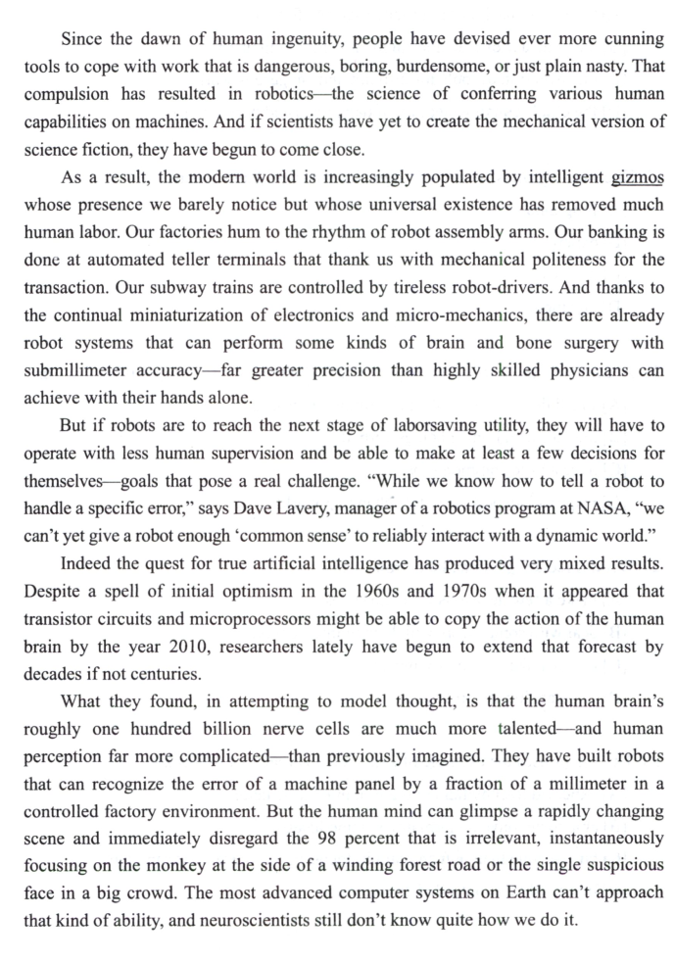
请对这段文字进行逐句翻译，中英对照

Kimi:
- Since the dawn of human ingenuity, people have devised ever more cunning tools to cope with work that is dangerous, boring, burdensome, or just plain nasty.
自从人类开始具备创造力以来，人们一直在设计越来越巧妙的工具，用以应对那些危险、枯燥、繁重或令人厌恶的工作。
That compulsion has resulted in robotics—the science of conferring various human capabilities on machines.
这种追求（冲动）促使了机器人学的诞生——一门赋予机器以人类各种能力的科学。
And if scientists have yet to create the mechanical version of science fiction, they have begun to come close.
尽管科学家尚未创造出科幻作品中的机械版本，但他们已经开始接近这一目标。
- As a result, the modern world is increasingly populated by intelligent gizmos whose presence(存在) we barely notice but whose universal existence has removed much human labor.
因此，现代社会充斥（占据）着我们几乎注意不到的智能装置，但它们的普遍存在已经取代了大量的体力劳动。
Our factories hum to the rhythm of robot assembly arms.
我们的工厂中，机器人装配臂的节奏让工厂运转不息（繁忙）。
Our banking is done at automated teller terminals that thank us with mechanical politeness for the transaction.
我们的银行业务在自动取款机上完成，这些机器用机械化的礼貌感谢我们完成交易。
Our subway trains are controlled by tireless robot-drivers.
我们的地铁由不知疲倦的机器人司机控制。
And thanks to the continual miniaturization of electronics and micro-mechanics, there are already robot systems that can perform some kinds of brain and bone surgery with submillimeter accuracy—far greater precision than highly skilled physicians can achieve with their hands alone.
而得益于电子设备和微型机械的持续小型化，已经有机器人系统能够以亚毫米级的精度完成（执行）一些脑部和骨骼手术——其精准度远超仅凭双手操作的高技能医生。
- But if robots are to reach the next stage of laborsaving utility, they will have to operate with less human supervision and be able to make at least a few decisions for themselves—goals that pose a real challenge.
但如果机器人要达到下一个节省劳动力的阶段，它们必须能够在较少的人类监督下运行，并能够至少为自己做出一些决策——而这些目标构成了一项真正的挑战。
- “While we know how to tell a robot to handle a specific error,” says Dave Lavery, manager of a robotics program at NASA, “we can’t yet give a robot enough ‘common sense’ to reliably interact with a dynamic world.”
“虽然我们知道如何让机器人处理特定的错误，”NASA机器人项目负责人Dave Lavery表示，“但我们还无法赋予机器人足够的‘常识’，使其能够可靠地与动态世界进行互动。”
Indeed the quest for true artificial intelligence has produced very mixed results.
事实上，真正人工智能的探索产生了非常喜忧参半的结果。
Despite a spell of initial optimism in the 1960s and 1970s when it appeared that transistor circuits and microprocessors might be able to copy the action of the human brain by the year 2010, researchers lately have begun to extend that forecast by decades if not centuries.
尽管在20世纪60年代和70年代曾有一段初期乐观的时期，当时人们认为晶体管电路和微处理器可能在2010年前就能复制人脑的运作方式，但研究人员最近开始将这一预测延长数十年甚至数百年。
What they found, in attempting to model thought, is that the human brain’s roughly one hundred billion nerve cells are much more talented—and human perception far more complicated—than previously imagined.
在试图模拟思维的过程中，他们发现，人脑大约1000亿个神经元远比之前想象的更有能力，而人类感知的复杂性也远远超乎想象。
They have built robots that can recognize the error of a machine panel by a fraction(分数) of a millimeter in a controlled factory environment.
他们已经制造出可以在控制的工厂环境中识别机械面板毫米级误差的机器人。
- But the human mind can glimpse a rapidly changing scene and immediately disregard the 98 percent that is irrelevant, instantaneously focusing on the monkey at the side of a winding forest road or the single suspicious face in a big crowd.
但人类的大脑能够一瞥快速变化的场景，立即忽略掉98%的无关信息，瞬间聚焦在蜿蜒森林路边的一只猴子，或一大群人中那张可疑的面孔上。
The most advanced computer systems on Earth can’t approach that kind of ability, and neuroscientists still don’t know quite how we do it.
地球上最先进的计算机系统都无法接近这样的能力，而神经科学家至今仍不知道我们是如何做到这一点的。

26.Human ingenuity was initially demonstrated in
人类的聪明才智最初体现在以下几个方面
[A] the use of machines to produce science fiction.
[A] 利用机器生产科幻作品。
[B] the wide use of machines in manufacturing industry.
[B] 机器在制造业中的广泛使用。
[C] the invention of tools for difficult and dangerous work.
[C] 为困难和危险的工作发明工具。
[D] the elite’s cunning tackling of dangerous and boring work.
[D] 精英们巧妙地处理危险和枯燥的工作。
27.The word “gizmos” (line 1, Paragraph 2) most probably means
第2段第1行中的“gizmos”这个词很可能意味着
[A] programs.
[A] 程序。
[B] experts.
[B] 专家。
[C] devices.
[C] 装置。
[D] creatures.
[D] 生物。
28.According to the text, what is beyond man’s ability now is to design a robot that can
根据这篇文章，现在超出人类能力的是设计一个能做到这些的机器人
[A] fulfill delicate tasks like performing brain surgery.
[A] 完成像进行脑部手术这样的精细任务。
[B] interact with human beings verbally.
[B] 通过语言与人类互动。
[C] have a little common sense.
[C] 具备一点常识。
[D] respond independently to a changing world.
[D] 独立应对不断变化的世界。
29.Besides reducing human labor, robots can also
除了减少人类劳动，机器人还可以
[A] make a few decisions for themselves.
[A] 自己做一些决定。
[B] deal with some errors with human intervention.
[B] 在人类干预下处理一些错误。
[C] improve factory environments.
[C] 改善工厂环境。
[D] cultivate human creativity.
[D] 培养人类创造力。
30.The author uses the example of a monkey to argue that robots are
作者用猴子的例子来论证机器人
[A] expected to copy human brain in internal structure.
[A] 被期望在内部结构上模仿人脑。
[B] able to perceive abnormalities immediately.
[B] 能够立即察觉异常。
[C] far less able than human brain in focusing on relevant information.
[C] 在关注相关信息方面远不如人脑。
[D] best used in a controlled environment.
[D] 最适合在受控环境中使用。

