User:
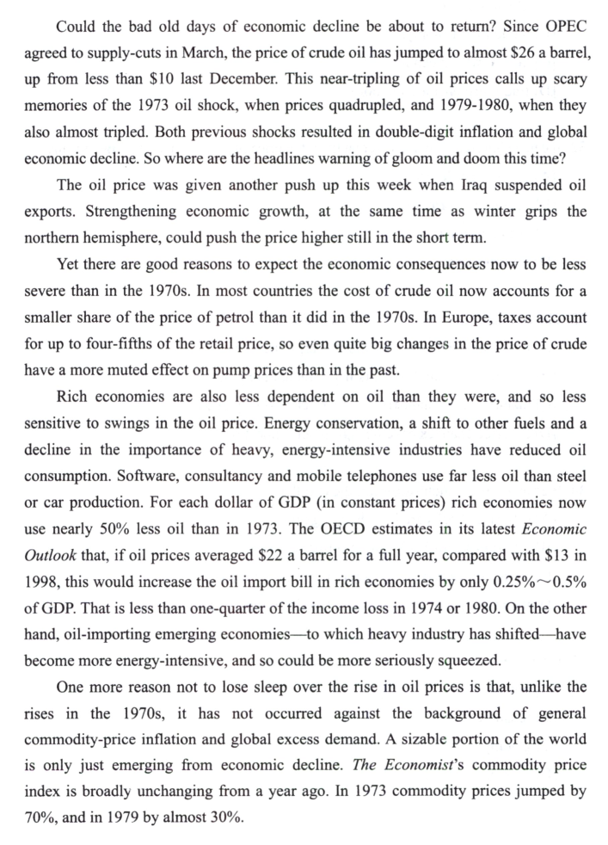
请对这段文字进行逐句翻译，中英对照

Kimi:
Could the bad old days of economic decline be about to return?
经济衰退的黑暗旧日是否即将卷土重来？
- Since OPEC agreed to supply-cuts in March, the price of crude oil has jumped to almost $26 a barrel, up from less than $10 last December.
自3月石油输出国组织(OPEC)达成减产协议以来，原油价格已飙升至每桶近26美元，而去年12月时还不足10美元。
This near-tripling of oil prices calls up scary memories of the 1973 oil shock, when prices quadrupled, and 1979-1980, when they also almost tripled.
油价接近三倍的增长让人回想起1973年石油危机的可怕回忆，当时油价翻了四倍，以及1979-1980年，油价同样几乎翻了三倍的可怕记忆。
Both previous shocks resulted in double-digit inflation and global economic decline.
此前两次石油冲击都导致了两位数的通货膨胀和全球经济衰退。
So where are the headlines warning of gloom and doom this time?
那么，这次为什么没有关于经济前景暗淡的头条新闻呢？
The oil price was given another push up this week when Iraq suspended oil exports.
本周，伊拉克暂停石油出口，进一步推高了油价。
Strengthening economic growth, at the same time as winter grips the northern hemisphere, could push the price higher still in the short term.
与此同时，随着冬季笼罩北半球，经济的强劲增长可能在短期内进一步推高油价。
- Yet there are good reasons to expect the economic consequences now to be less severe than in the 1970s.
然而，有充分的理由预期，此次油价上涨的经济后果将比20世纪70年代要轻微得多。
In most countries the cost of crude oil now accounts for a smaller share(较小的份额) of the price of petrol than it did in the 1970s.
在大多数国家，原油成本在汽油价格中所占的比例，现在比20世纪70年代要小得多。
- In Europe, taxes account for up to four-fifths of the retail price, so even quite big changes in the price of crude have a more muted(温和的) effect on pump prices than in the past.
在欧洲，税收占汽油零售价格的五分之四，因此，即使原油价格发生较大变化，对加油站价格的影响也比过去小得多。
- Rich economies are also less dependent on oil than they were, and so less sensitive to swings in the oil price.
富裕经济体对石油的依赖程度也比过去低得多，因此对油价波动的敏感度也较低。
Energy conservation, a shift to other fuels and a decline in the importance of heavy, energy-intensive industries have reduced oil consumption.
节能、燃料多样化（转向其他燃料）以及能源密集型重工业重要性的下降，都减少了石油消费。
Software, consultancy and mobile telephones use far less oil than steel or car production.
软件、咨询和移动电话行业使用的石油远少于钢铁或汽车制造业。
For each dollar of GDP (in constant prices) rich economies now use nearly 50% less oil than in 1973.
按不变价格计算，每生产一美元的GDP，富裕经济体现在使用的石油比1973年少了近50%。
The OECD estimates in its latest Economic Outlook that, if oil prices averaged $22 a barrel for a full year, compared with $13 in 1998, this would increase the oil import bill in rich economies by only 0.25%~0.5% of GDP.
经合组织在其最新《经济展望》中估计，如果油价全年平均为每桶22美元（而1998年为13美元），这将使富裕经济体的石油进口账单仅增加GDP的0.25%至0.5%。
That is less than one-quarter of the income loss in 1974 or 1980.
这一比例还不到1974年或1980年收入损失的四分之一。
On the other hand, oil-importing emerging economies—to which heavy industry has shifted—have become more energy-intensive, and so could be more seriously squeezed.
另一方面，石油进口的新兴经济体——重工业已向这些国家转移——变得更加能源密集型，因此可能受到更严重的挤压。
One more reason not to lose sleep over the rise in oil prices is that, unlike the rises in the 1970s, it has not occurred against the background of general commodity-price inflation and global excess demand.
还有一个不必为油价上涨失眠的原因是，与20世纪70年代的油价上涨不同，这次上涨并没有发生在普遍商品价格上涨和全球需求过剩的背景下。
A sizable portion of the world is only just emerging from economic decline.
世界相当一部分地区刚刚从经济衰退中走出来。
The Economist’s commodity price index is broadly unchanged from a year ago.
《经济学人》的商品价格指数与一年前相比基本没有变化。
In 1973 commodity prices jumped by 70%, and in 1979 by almost 30%.
1973年商品价格上涨了70%，1979年上涨了近30%。

31. 最近油价上涨的主要原因是
[A] global inflation.
[A] 全球通胀。
[B] reduction in supply.
[B] 供应减少。
[C] fast growth in economy.
[C] 经济快速增长。
[D] Iraq’s suspension of exports.
[D] 伊拉克暂停出口。

---

32. It can be inferred from the text that the retail price of petrol will go up dramatically(剧烈地) if
32. 从文中可以推断出，汽油的零售价格会大幅上涨，如果
[A] price of crude rises.
[A] 原油价格上涨。
[B] commodity prices rise.
[B] 商品价格上升。
[C] consumption rises.
[C] 消费增加。
[D] oil taxes rise.
[D] 油税增加。
---
33. The estimates in Economic Outlook show that in rich countries
33. 《经济展望》中的估算显示，在富裕国家
[A] heavy industry becomes more energy-intensive.
[A] 高耗能工业变得更加能源密集型。
[B] income loss mainly results from fluctuating crude oil prices.
[B] 收入损失主要源于原油价格波动。
[C] manufacturing industry has been seriously squeezed.
[C] 制造业已受到严重挤压。
[D] oil price changes have no significant impact on GDP.
[D] 油价变化对GDP没有显著影响。
---
34. We can draw a conclusion from the text that
34. 从文中我们可以得出结论
[A] oil-price shocks are less shocking now.
[A] 油价冲击现在已没那么令人震惊。

[B] inflation seems irrelevant to oil-price shocks.
[B] 通胀似乎与油价冲击无关。
[C] energy conservation can keep down the oil prices.
[C] 节能可以抑制油价。
[D] the price rise of crude leads to the shrinking of heavy industry.
[D] 原油价格上涨导致高耗能工业萎缩。
---
35. From the text we can see that the writer seems
35. 从文中我们可以看出作者似乎
[A] optimistic.
[A] 乐观的。
[B] sensitive.
[B] 敏感的。
[C] gloomy.
[C] 悲观的。
[D] scared.
[D] 害怕的。

