1) What is the purpose of using pull-up resistors in GPIO inputs, and how are they configured on the ATmega328 (internal and external)?

The purpose of a pull-up resistor is to prevent the state of a pin from randomly reading high or low. Instead it ensures that the default state of the input pin is always pulled towards high u unless there is a button that, when pressed and is also connected to ground, will cause it to read low.
This can be achieved externally by taking a resistor and connecting it to both the voltage and a switch which when in off state, ensures that the input connection is also connected to the voltage through a resistor. Or internally where there is a pull-up resistor mechanism built into the micro controller but has the same effect.
However to enable the pull-up resistor mechanism internally, it isn’t as simple as connecting a resistor to the voltage source and to the input pin through means of a switch or something like that. There is a built in mechanism that can be enabled via software that can do this for you but we need to understand how it works before we use it.

Basically to activate the pull up resistor, you would first need to write 0 into the data direction register for the corresponding bit and write 1 into that same port register for the bit to basically say “Hey let’s make the default state high”. The mechanism through which this works is the combination of an AND gate and a transistor that when activated connects the GPIO pin to a voltage source. The AND gate that takes the inverted value of the data direction register bit and the port bit as an input, and sends the resulting value to a transistor which will then activate and create a connection between the voltage source and the gpio pin. The transistor is only active if 0 is written to the data direction bit because the inverted value for this is 1, and if the port register bit for the pin is also 1, that outputs a value of 1 which activates the transistor.
2) Using GPIO and ATMega328p datasheet, design the embedded system to turn on LEDS using an external switch:

Part A)
- Design a circuit in the box below and describe your design.
  - One input switch
    - Switch 1(port B2) button pushed without floading – push button → logical high
  - Two LEDs with 220 Ohm
    - LED1(port B 0) – Logical High → led ON
    - LED 2(port B 1) – Logical High → led ON
Since the arduino maps directly to the ATMega328p, I’m going to use wokwi to design this hardware. Here is what know, input is bit 2 of port b and output is bit 0 and 1 of port b. So that would make PB0, PB1 the outputs and PB2 the input.

On the arduino nano , the D8 pin corresponds to PB0, D9 pin corresponds to PB1 and the D10 pin corresponds to PB2.
Let’s start by connecting the input. We know that when the button is pushed the input pin needs to be reading high. To achieve this, we can use a pulldown resistor connected to the button on the same side as the input pin and then connect the voltage source to the other side of the button. Here is a picture of the connections with d10 being the input pin which corresponds to pb2.

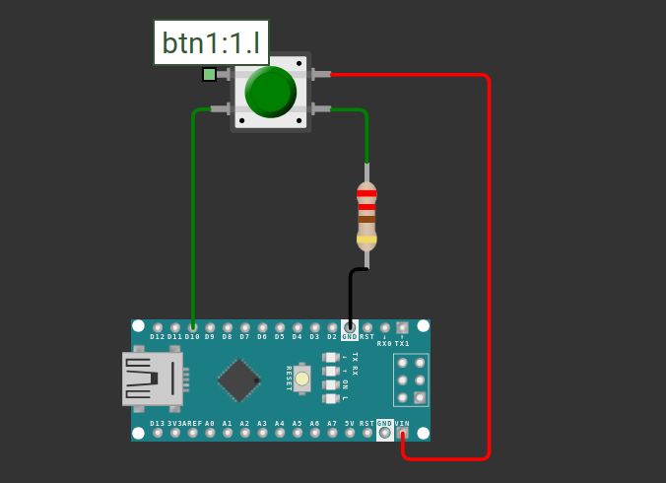

Next let’s handle the output. We need two leds, one connecting to d9 and the other to d8 which corresponds to pb1 and pb0 respectively. We then need a resistor for each connecting to ground. Here is the resulting circuit.

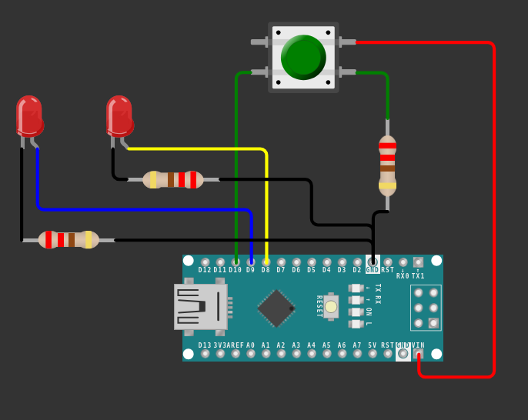

Part B)
In order to access the registers, such as DDRx or PORTx in Microcontroller, how to use the pointer and variable? Explain the principle of accessing registers in C using a pointer with example codes.

So each register such as any data direction register(DDRx) or Port Register(Portx) are have a specific address that we can use a pointer to point to. If we want to access the contents of a register, we just simply deference the pointer pointing to the address and it will have access to the contents of the register at the address that we are pointing to. Here is some example code written in c showing that we are pointing to the port b data direction register and then de-referencing it to change a specific bit in that register.

First we declare the pointer globally
Next we assign it to an address
Then we can modify the contents of the register at the register by dereferencing the pointer.
*portDDRB &= 0; //set all bits in the data direction register to 0

Part C)
Write a code (based on circuit design from 4.a): When the switch is pushed, LED1 is on and LED 2 is off; When switch 1 is released, LED1 is on, and LED 2 is off.
The code for the program is in the following wokwi link:

https://wokwi.com/projects/442584461353817089

