## AutoIt

**OVERVIEW**

AutoIt v3 is a freeware automation language for Microsoft Windows. It has a BASIC-like syntax. AutoIt is a very small and standalone application with no reliance on massive runtimes like .NET or VB. All you need to run AutoIt scripts are the main AutoIt executable (AutoIt3.exe) and the script. Scripts can also be encoded into standalone executables with the built-in script compiler Aut2Exe.

**FEATURES**

1. Easy to learn.
2. Simulates keystrokes.
3. Simulates mouse movements.
4. Scripts can be compiled into standalone executable.
5. Windows management.
6. Windows control.
7. Detailed help file and large community-based supports forums.

**INSTALLATION**

To install AutoIt first download the AutoIt exe file from the below location.

<https://www.autoitscript.com/site/autoit/downloads/>

**Step 1:** Click on download at AutoIt Full installation.

**Step 2:** Click on AutoIt Exe file.

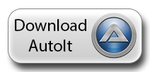

**Step 3:** The setup wizard screen will be displayed. The version of AutoIt that we are installing will also be displayed. Click ‘Next’ to proceed.

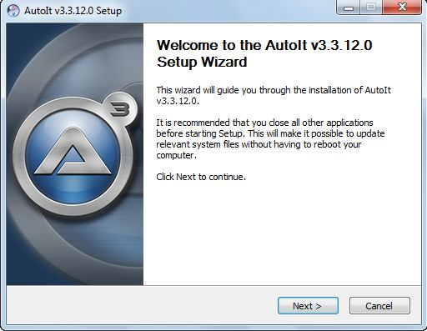

**Step 4:** The license Agreement Screen will be displayed next. If you want to continue installation click on ‘I Agree’ Button to accept the terms of the agreement.

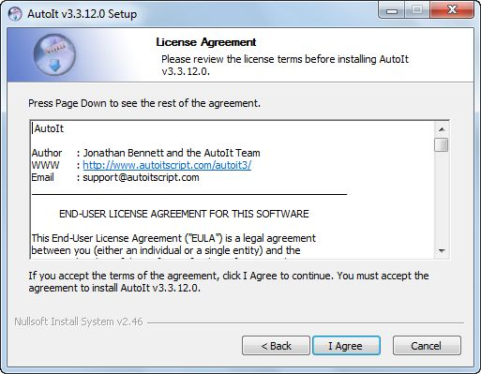

**Step 5:** If running on 64-bit OS, it’ll ask to choose from two options. Choose the recommendated one and click ‘Next’.

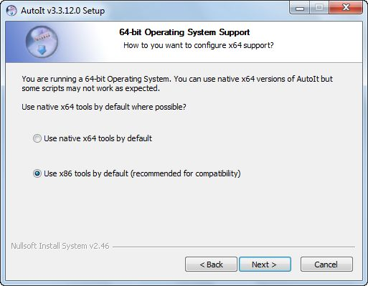

**Step 6:** Next it’ll ask to select a default option when you double-click on the *.au3(AutoIt file extension) files. Two options will be displayed.

1. Run the script.
2. Edit the script.

Choose the one you prefer and click on ‘Next’.

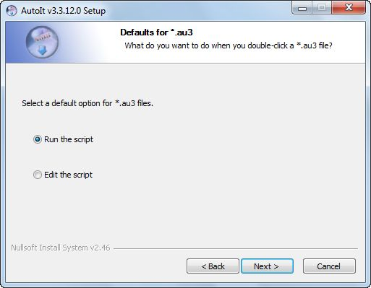

**Step 7:** Next step is for choosing the componets. Choose all and click on ‘Next’. This will download all the AutoIt examples which will help in writing scripts.

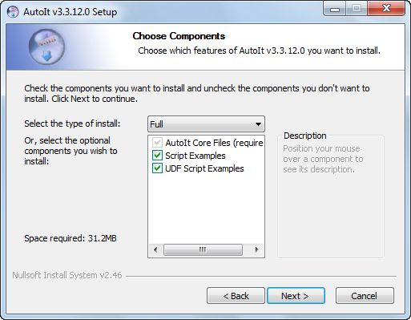

**Step 8:** Next step is to choose the location to install AutoIt. By default ‘program files’ will be choosen as the destination. We can change it, if we want. Click on ‘Install’ button to complete the installation.

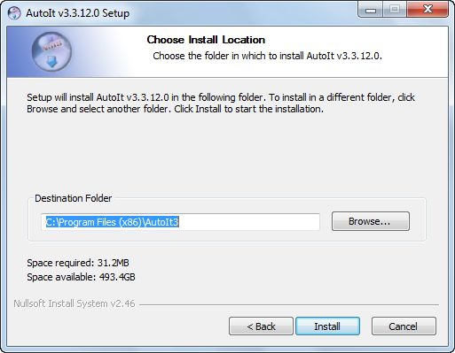

Next a message “AutoIt has been installed successfully on your computer” will be displayed. Click on ‘Finish’ button.

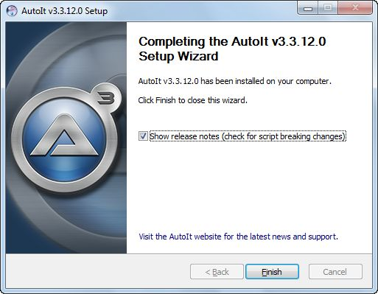

**RECORDING OF AUTOIT SCRIPT**

AutoIt also has a recording feature. For that we need to use its extension called AutoIt Script Editor. To install AutoIt Script Editor download it from the below location.

<https://www.autoitscript.com/site/autoit/downloads/>

**STEP 1:** Click on the below file.



**STEP 2:** A new page will open, click on the top most link of ‘**SciTE4AutoIt3.exe**‘ and follow the process until the installation is finished.

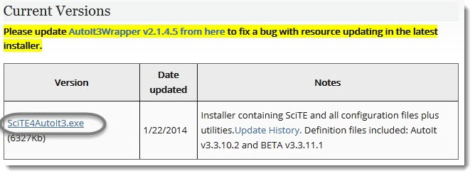

After installation, ‘AutoIt Help’ window will open. Just type ‘commands’ on the search text field of the Help. It will give all commands you can use in you test.

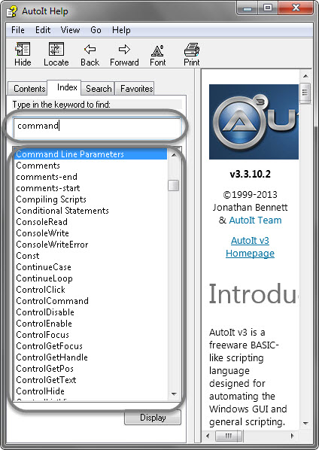

**FILE UPLOAD**

Uploading of file in Selenium using AutoIt consists of the following steps.

**STEP 1:** Identify the windows control

**STEP 2:** Build an AutoIt script

**STEP 3:** Compile the .au3 file and convert it to .exe file

**STEP 4:**  Call the .exe file into the Selenium Test case.

**STEP 1: IDENTIFY THE WINDOWS CONTROL**

1. Navigate to [Registration](http://demoqa.com/registration/) of **“demoqa.com”** page.
2. Click on **‘Browse’** button of profile picture column. It will open a windows box for file upload.
3. Open the **‘SciTE Script Editor’** from AutoIt folder. It will open an editor window where we can write the automation script of AutoIt.
4. As the first step we need to click on the **‘Edit’** field of the upload file windows box. To get the command for the focus on the edit field, open **‘ControlFocus’** in AutoIt help or just type **‘ControlFocus’** in **‘SciTE Script Editor’**. It is mentioned that we need parameters ‘title’, ‘text’ and ‘ControlID’. To obtain these we need help to identify windows object. To identify the objects, open the windows info tool **‘Au3Info’** from AutoIt folder.
5. Drag the **‘Finder tool’** box to the object to be inspected. The ‘windows info tool’ populates all the information needed to use the method.

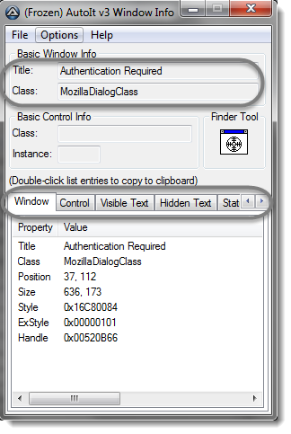

**STEP 2: BUILD AN AUTOIT SCRIPT USING IDENTIFIED WINDOWS CONTROL**

With all the information from ‘windows info tool’ write the first command **ControlFocus(“title”,”text”, controlID)** in **‘SciTE Script Editor’**.

* **“title”** is provided in the info tool.
* **“text”** is optional, can be left blank.
* **controlID** is (Classname + Class Instance).

The Next command is **ControlSetText(“title”,”text”, controlID,”new text”).** It is used for setting the text on the edit field. In **“new text”** we must provide the location of the file to be uploaded.

The third command is **ControlClick(“title”,”text”, controlID).** It is used for click action.

The final script will be like:

ControlFocus("File Upload","","Edit1")

ControlSetText("File Upload","","Edit1",”c:\selenium\test.jpg”)

ControlClick("File Upload","","Button1")

**STEP 3: COMPILE THE .au3 SCRIPT AND CONVERT IT TO .exe file**

Now save the script in **.au3** format. The next step is to convert it into **.exe** format. For that We need to right click on the .au3 file and select **“Compile Script”.**

**STEP 4: CALL THE .exe FILE INTO THE SELENIUM TEST CASE**

Once complilation is done, an .exe file will be created with the same name as the .au3 file in the same location. That .exe file has to be called in the selenium test script.

* Open Eclipse and write the code
* When selenium clicks on **‘browse’**, file uploader box opens.
* Then we need to call the AutoIt script, the control immediately is transferred to AutoIt in order to upload a file and then control send back to selenium.

The test case will look like this :

**package Test;**

**import java.io.IOException;**

**import org.openqa.selenium.By;**

**import org.openqa.selenium.WebDriver;**

**import org.openqa.selenium.firefox.FirefoxDriver;**

**public class File_upload {**

**public static void main(String[] args) throws AWTException, IOException**

**{**

**WebDriver driver = new FirefoxDriver();**

**driver.manage().window().maximize();**

**driver.get("**[**http://demoqa.com/**](http://demoqa.com/)**");**

**driver.findElement(By.id("menu-item-374")).click();**

**driver.findElement(By.xpath(".//*[@id='profile_pic_10']")).click();**

**Runtime.getRuntime().exec("C:\\AutoIt\\file.exe");**

**}**

The line **Runtime.getRuntime().exec("C:\\AutoIt\\file.exe");** will call AutoIt script in Selenium and upload file.

* **Runtime** class allows the script to interface with the environment in which the script is running.
* **getRuntime()** gets the current runtime associated with the process.
* **exec()** executes the AutoIt script.