# Platform Cache

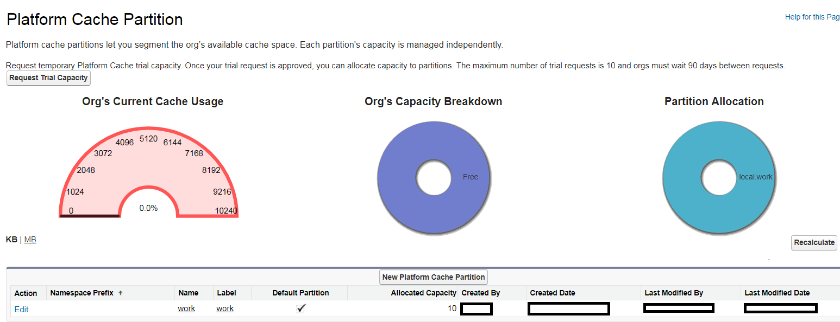

# Custom Metadata Types

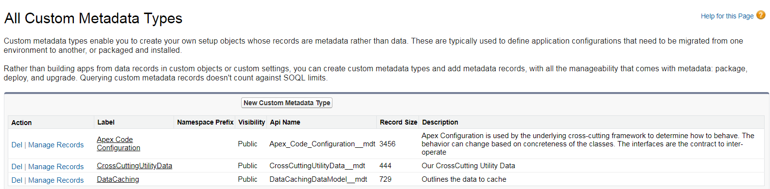

## Apex Code Configuration



## Example of Production Environment

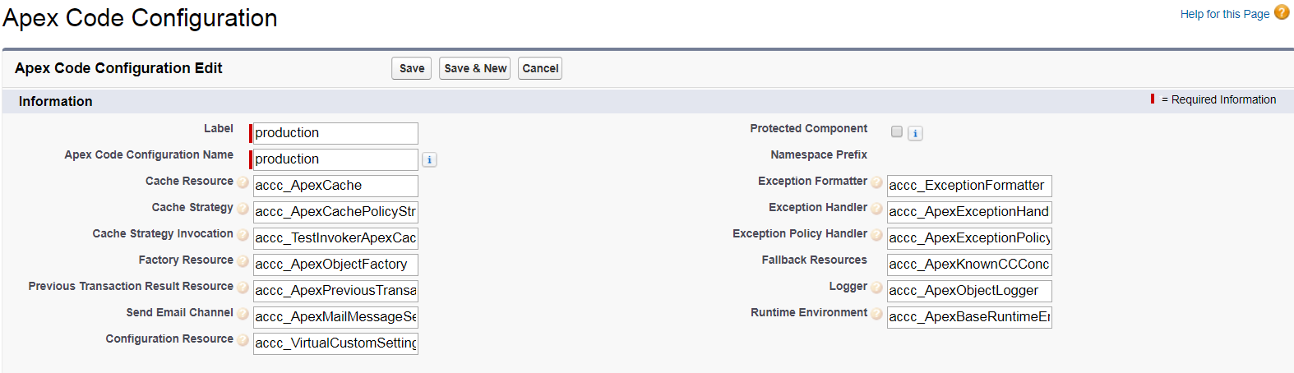

### Example of Debug Environment

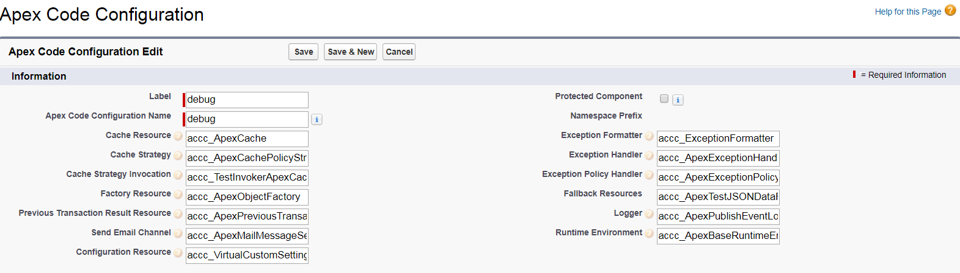

## Cross-Cutting Utilities

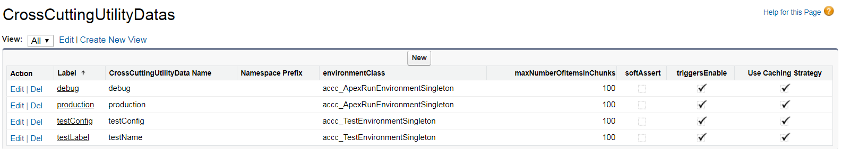

## Data Caching