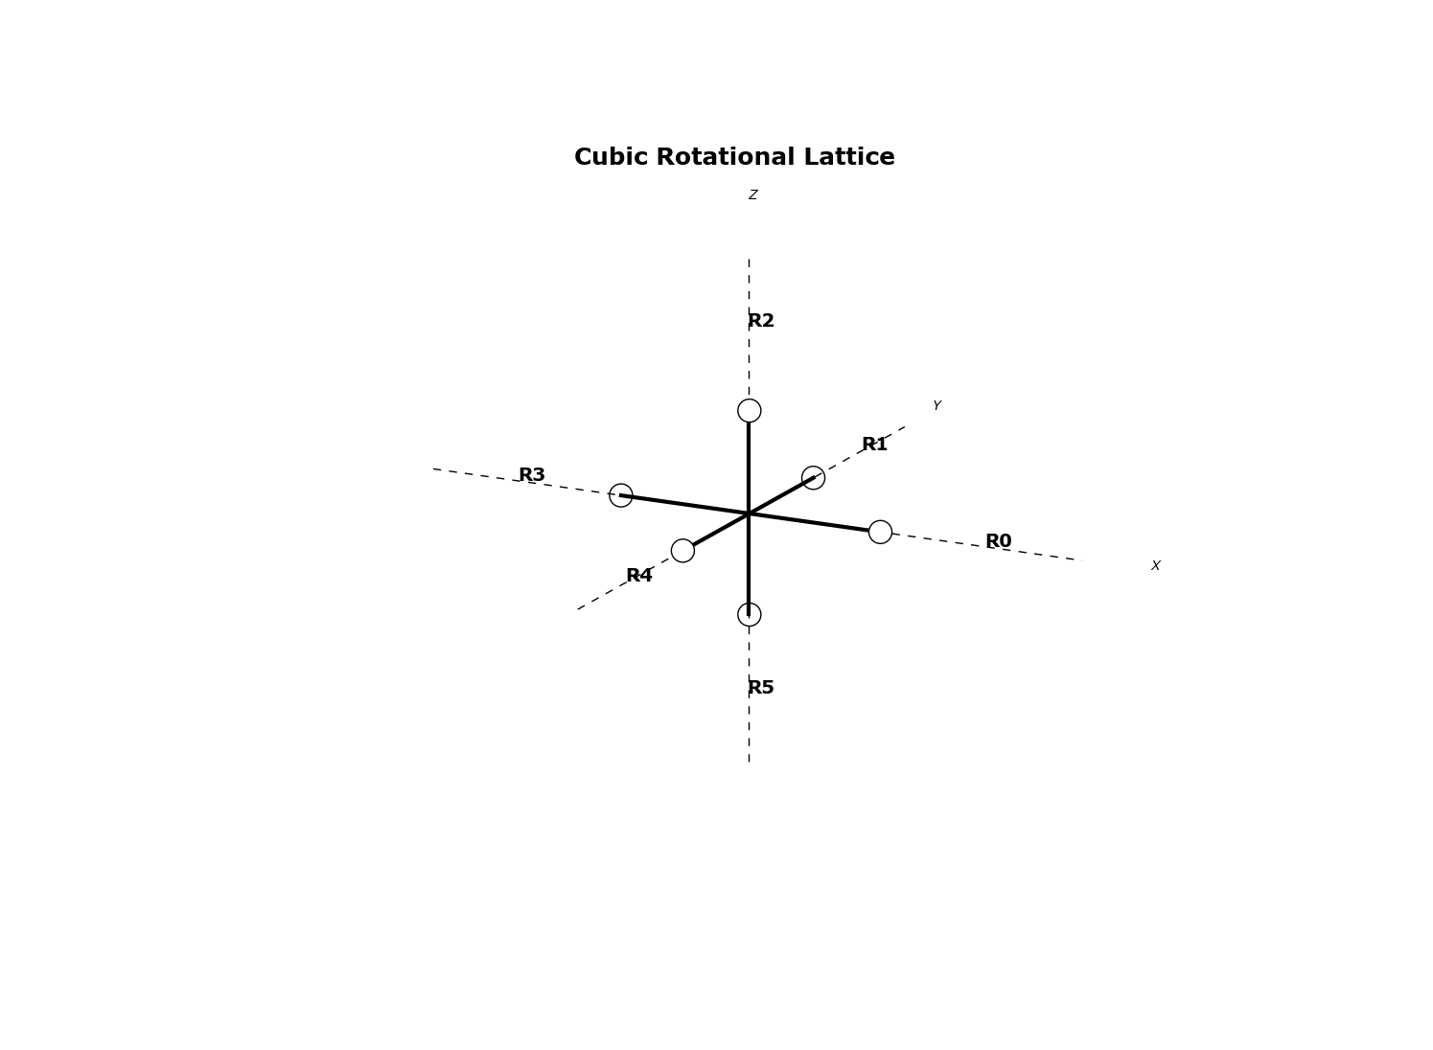
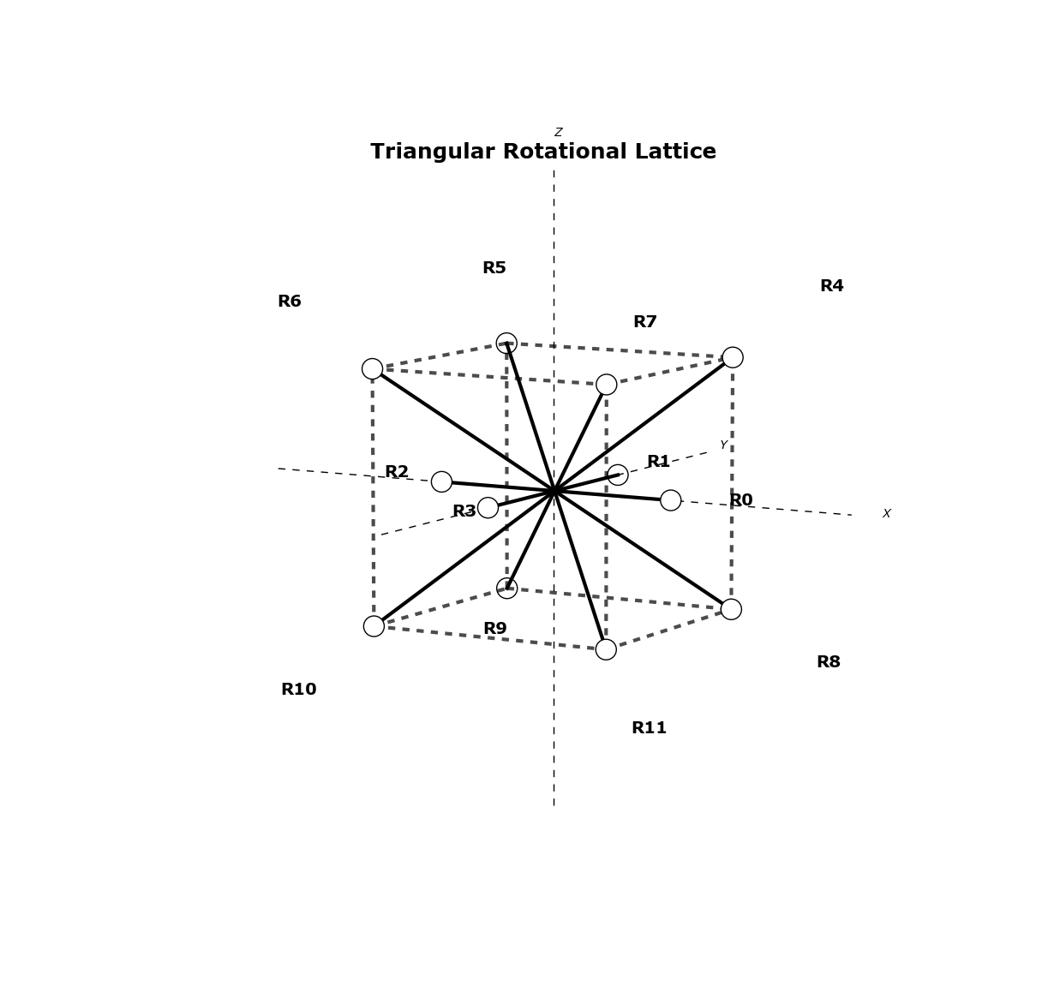
Marathon v0.9.3 Manual
April 6, 2013

Introduction
Marathon is a Python script designed to iteratively rotate molecules read from Protein Data Bank files. All rotations along a given lattice are performed for each branch in a molecule and the results are printed to output files. Plotting of the iterations is also provided. Currently rotations along a cubic and face centered cubic (triangular) lattices are supported. The program ensures that no immediate bond overlap will occur. It can optionally print the overlapping bonds to a file. The script is also able to iteratively calculate the Root Mean Square Distance (RMSD) of the molecule and print this to a file.

Usage
The script is intended to be run from the command line, using the Python interpreter version 2.7+.

Requirements
Marathon requires Python v2.7, as well as the python packages numpy and (Optional for plotting) matplotlib. To install the requirements it is advised to use the python easy_install or the more recent pip, ie:
pip install numpypip install matplotlib
There is optionally a requirements.txt file provided. When installing on a new system or a virtual environment, this file can be used with pip to install all necessary packages
pip install -r requirements.txt

Mac OSX
A good article detailing how to best install numpy and matplotlib on Mac OS-X is here. If interactive plotting is needed, use the QtAgg backend in your matplotlibrc file.

Program Execution
This guide assumes that python and the script requirements are installed and available on the system path.Furthermore, it assumes that the marathon.py script is also available in the path or the current working directory. The program is executed with arguments and options, as given
usage: marathon.py [-h] [-v] [-o OUTPUT] [-c] [-t] [-p] [-i] [-r] [-d] [--print-skips] args [args ...]Program to parse a PDB file, identify isolation loops, and permute molecularrotations around those loops and write back to a set of PDB filespositional arguments: args One or more filenames or directoriesoptional arguments: -h, --help show this help message and exit -v, --verbose Print details to console -o OUTPUT, --output OUTPUT Output new PDB files to this directory -c, --cubic Rotate around a cubic structure (default), i.e. 90 deg -t, --triangular Roatate around a triangular structure, i.e. 45 deg -p, --plot Plot the rotated molecules in a `plots` subfolder -i, --interactive Plot figures interactively -r, --rmsd Calculate the root means square distance of each iteration and save all values to a file -d, --detailed Save the iteration names with detailed information for each branch and rotation number, otherwise just use the iteration counter as a name --print-skips Print the skipped rotation iteration names to a file in the output directory
For example, to iterate cubic rotations on a single file mymol.pdb and output to a local directory output_dir, one can simply execute::
python marathon.py -o output_dir mymol.pdb
This will save .pdb files in the output_dir/mymol/rotations directory corresponding to each rotation iteration.
By default, the iterations are simply numbered incrementally from 1. If more detailed iteration names are required, the -d or --detailed flags are available which will save the filenames in a more detailed manner stating the exact rotation matrix on each branch that was applied for that iteration, this takes a form [B?R?], where '?' are the branch number and roation number, accordingly.
The script can optionally calculate the root mean square distance for each iteration. This is done by calling the -r or --rmsd flags during program execution. This will create a file rmsd.txt in the output directory and append the iteration name and rmsd for that iteration. The script min_rmsd.py can read this file to output the iterations with the minimum values.
The --print-skips flag saves the names of any rotations which would lead to a bond overlap at a flexible joint to a file interfering.iterations.txt in the output directory.

Plotting
Marathon also has simple plotting functionality, capable of plotting a molecule in 3D space. This is accomplished using the python matplotlib package. The plots are signaled using the -p or --plot flag upon program execution
python marathon.py -o output_dir -p mymol.pdb
Optionally, the -i or --interactive flags can be given and the program will display each plot using matplotlib's interactive plot viewer. This is useful for getting immediate feedback as to what rotations are being performed. The interactive flag renders the plot flag unneccesary.

Configuration
If the interactive plotting is being used, there may be some required local configuration of the matplotlib backend that is used to render the plots to a screen. This is achieved by including a matplotlibrc file in the working directory locally or in a Users home folder for a more global implementation. More on matplotlibrc files can be found here and more on graphics backends can be found here.

Methodology
This section describes the algorithm that marathon uses to rotate a given molecule. It describes the file format used, definitions of flexible points and subsequent branches, rotation lattices presently supported, branch rotations, and rotation branch overlap detection.

PDB File format
The molecules are read and written using the [.pdb] file format as specified by the World Wide Protein Data Bank.
Marathon currently uses a module from the pymmlib package to read and write the molecules using this format. Relevant information parsed from these files for the purpose of the script are the atom ids, positions and element label, and the bond connections between the atoms

Branches and Flexible Points
This script defines a flexible point as any nitrogen (N) atom in the molecule sharing bonds with only carbon (C) atoms and at least 2 of them. This applies to any atom along a chain that does not occupy and end point. A flexible point may have 2 or more bonds attached to it, the set of flexible point and bonding atom represents a unique branch in the molecule. The unique branches and the subsequent chain of atoms along that branch are what are rotated for each rotation iteration. The vector that is made by the flexible point and the bond atom is called a branch vector. This branch vector serves as the reference vector for all rotations.

Branch Rotation

Unit Rotations
Each branch is allowed to be rotated to direct itself along a specified vector. The exact vector is depedent on the the lattice that is being used, i.e. cubic or triangular, as well as the unique iteration being applied. When a rotation occurs, all of the decendent atoms are also rotated accordingly. These so called unit rotations are applied iteratively throughout the molecule until a given set of unit rotations have been applied.
The exact rotations which are used for each branch for each iteration are dependent on the rotation latticethat is being applied.

Cubic Lattice
A cubic lattice is the set of 90 degree rotations that a branch can undergo in 3D space. For the unit branch shown in Figure 1, there are 6 unique rotations that can be performed relative to the branch vector.
cubic unit rotation lattice. There are 6 rotations per branch

Triangular Lattice
This lattice is similar to the body centered cubic structure as seen in Figure 2. There are 4 rotations along the xy plane, and 8 rotations towards the vertices of an imaginary cube, giving 12 unique rotations.
Triangular (i.e. body centre cubic) unit rotation lattice. There are 12 unique rotations per branch

Overlap Detection
Before the entire branch is rotated during an iteration, the new bond direction is compared against all other bond vectors at that flexible point which has already been rotated.If any of these rotated bond vectors are in line with the new bond direction. an overlap is signalled and the entire rotation iteration is skipped, and the rotation iteration name is optionally printed to a file.

Permutations over the Lattice
A given lattice has number of unique vectors for a branch to point. In the cubic lattice case, there are 6. Each branch can be rotated to face along any one of these vectors. Over the entire molecule made up of branches, this results in a maximum number of expected permutations

