Name___________________________ID______________________Group_____________________

**Tutorial 2 Basic abstraction and classical ADT**

**Part 1:** From the Java code (appeared in the lecture)

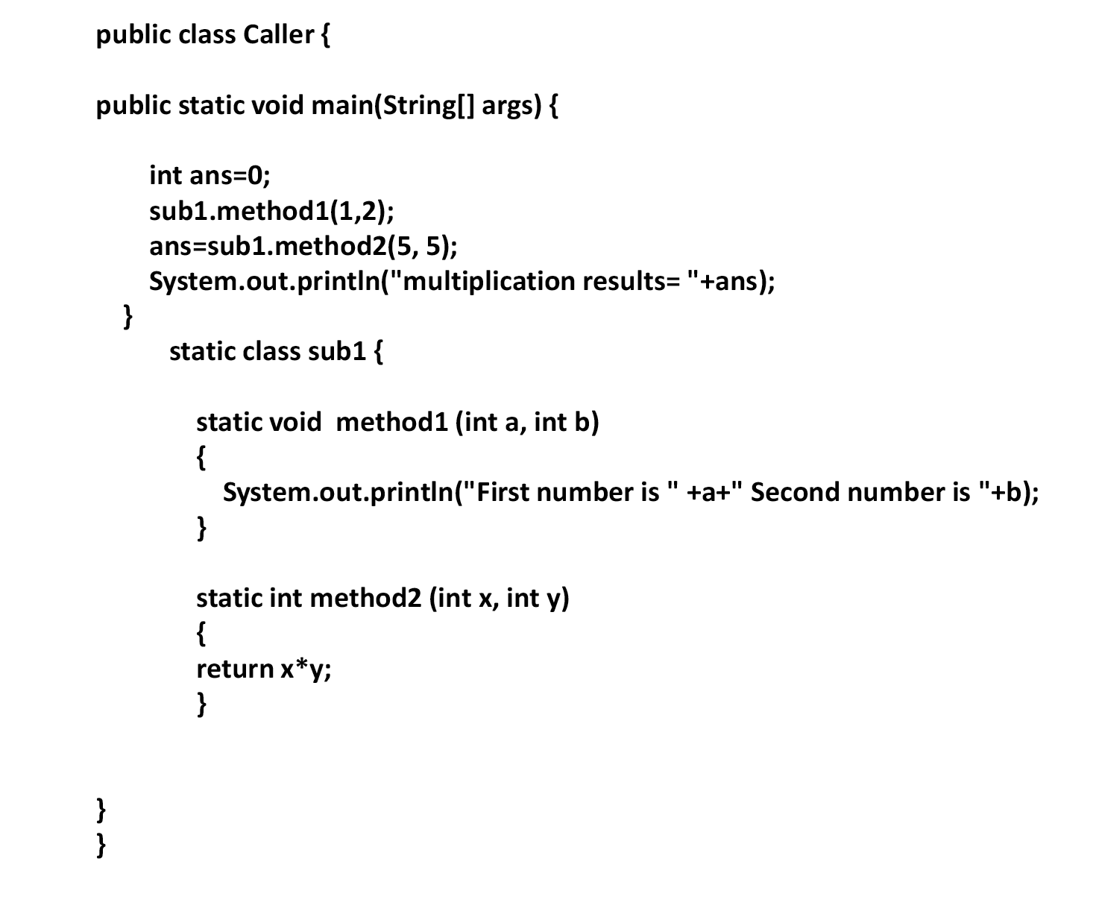

1. Implement the method call “sumToEven”, in which the method return a summation result only in even. User will require to supply 2 integer as inputs. If a summation is already in Even, the method will return the value straightaway. However, if the summation result produce an odd number, it will need further modification to the “next to” even number.
2. Demonstrate how the new feature is used in the main method.

**Part 2:** First, implement a Java program that declare an array that contains that following values {343, 474, 755, 366}. Second, implement a method that calculate minimum value (the method takes only 1 input as array data type and return integer as output). Last, print the minimum value to the console.

**Part 3:**

|  |  |  |
| --- | --- | --- |
| 1 | 3 | 4 |
| 3 | 4 | 5 |

From the table above, create two of the two-dimension array that store the values represent in the table (i.e., the table presents the array location its value). Then, create another array call “myAnswer” to store the sum of the arrays. Last, add the two arrays and print the result to the console.

**[PLEASE WRITE ALL THE ANSWER IN A NEW PAGE AND SUBMIT TO THE GOOGLE CLASSROOM UNDER TUTORIAL 2**