**Java Modeling Practice**

1. **A modeling quiz from Singtel which is attached as below.**



1. **The practice uploaded to github**

[**https://github.com/SunTaoA/JavaModeling.git**](https://github.com/SunTaoA/JavaModeling.git)

1. **Test results**
2. **Modeling output:**

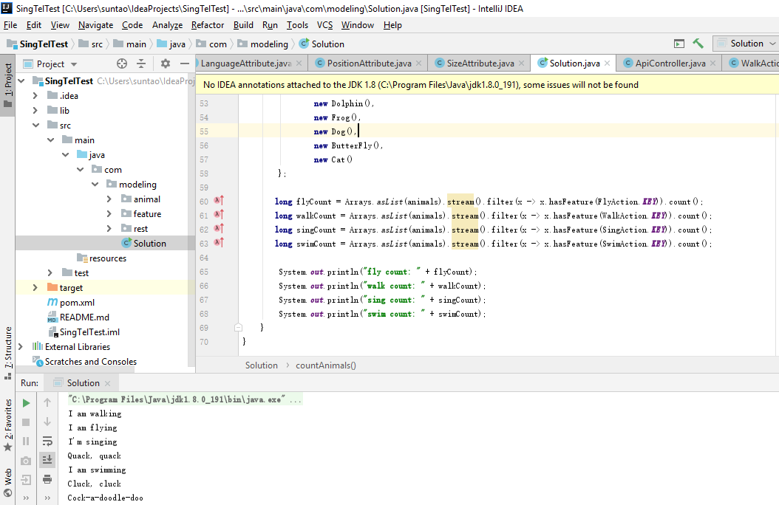

1. **Unit testing:**

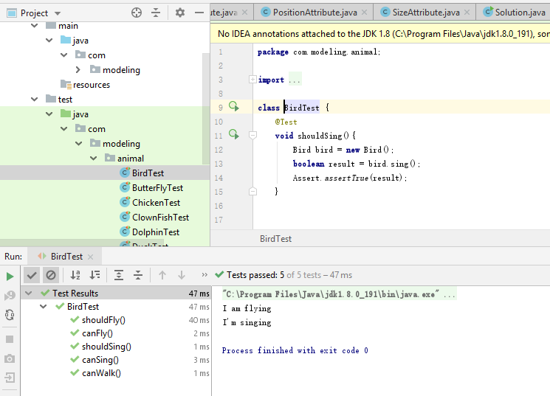

1. **RESTful API test results**

