Istio Service Mesh Getting Started Lab
Name：SunYining | STU_NO：202383930018 | Exp：7

Part1-Objectives
1.Understand the basic architecture and core features of Istio service mesh (traffic management, observability, security).
2.Master the installation of Istio, automatic sidecar injection, and Gateway API configuration.
3.Deploy the Bookinfo sample application and experience Istio’s traffic routing (different reviews versions) and observability (Kiali dashboard).
4.Become familiar with command-line tools such as kubectl and istioctl.

Part2. Experimental Environment
Operating System: Windows 11
Kubernetes: Minikube (using Docker as driver)
Istio: 1.28.1 (manually downloaded Windows ZIP package)
Tools: PowerShell, kubectl, istioctl
Browser: Chrome/Edge (for accessing the application and Kiali)

Part3. Experimental Steps and Results
Downloaded istio-1.28.1-win.zip from GitHub Releases and extracted it to D:\下载\istio-1.28.1-win\istio-1.28.1.
Entered the extracted directory and added the bin folder to the system PATH.
Verification:
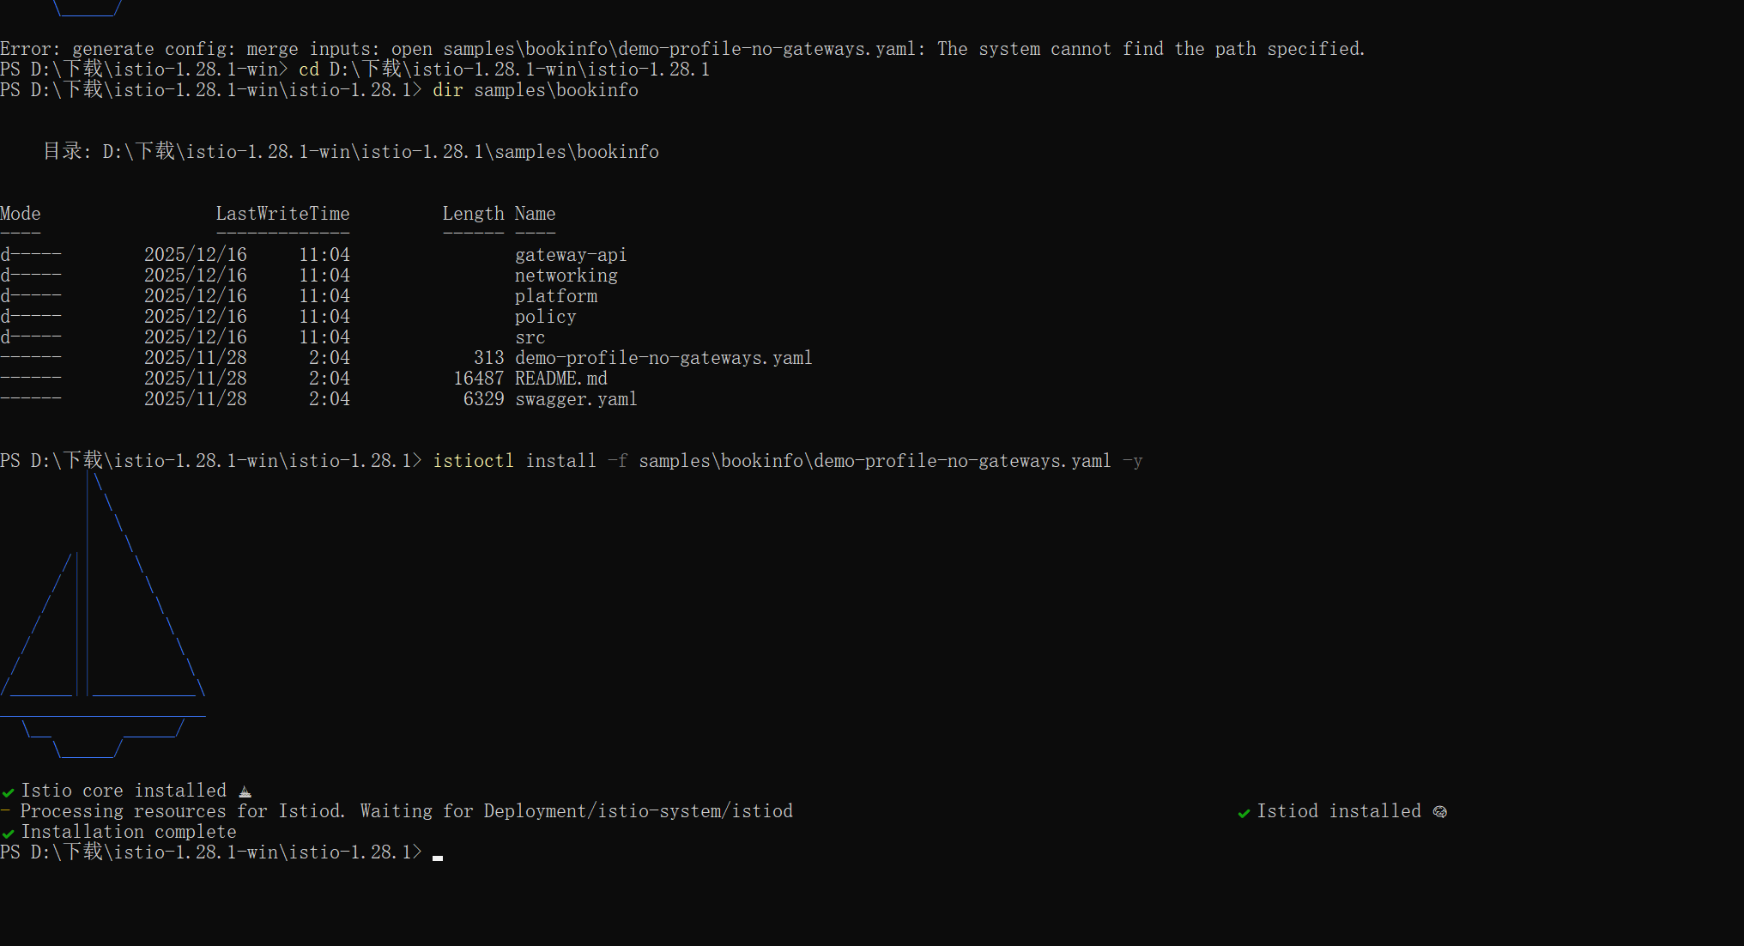

Output showed version 1.28.1.
Installing Gateway API CRDs: Successfully created multiple CustomResourceDefinitions
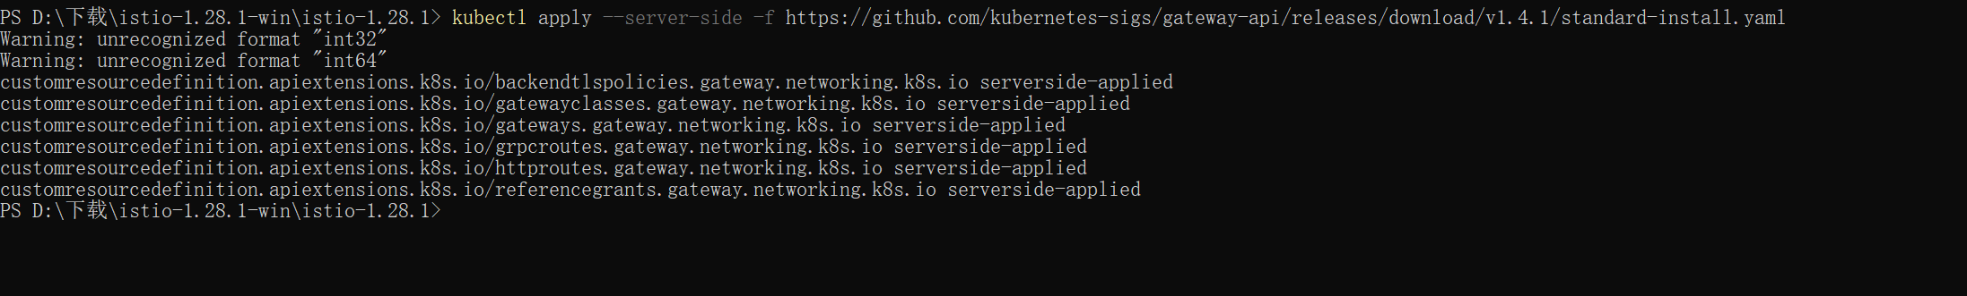
Deploying Bookinfo Application: Shows successful creation of all Services, ServiceAccounts, and Deployments (including three versions of reviews: v1/v2/v3) via kubectl apply.
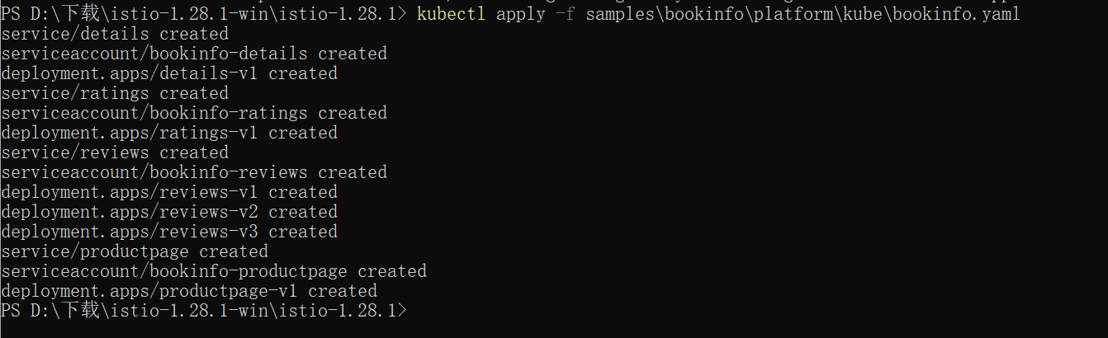
Viewing Services: Lists internal services (details, productpage, ratings, reviews) with ClusterIP type.
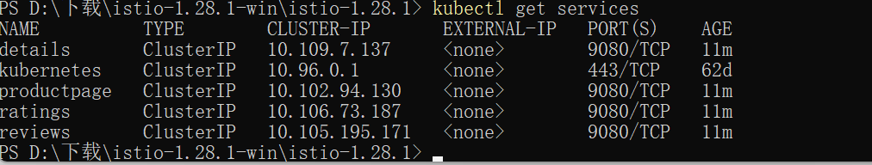
Pods Status: All Pods are 2/2 Running, confirming successful automatic Istio sidecar injection.

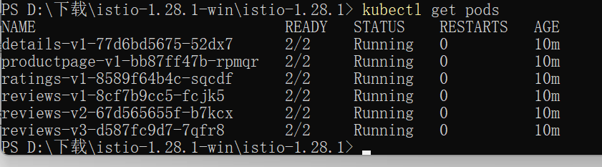
Internal Validation: Curl from ratings Pod to productpage returns , proving internal communication works.

Creating Gateway: Successfully created bookinfo-gateway and annotated it to use ClusterIP.

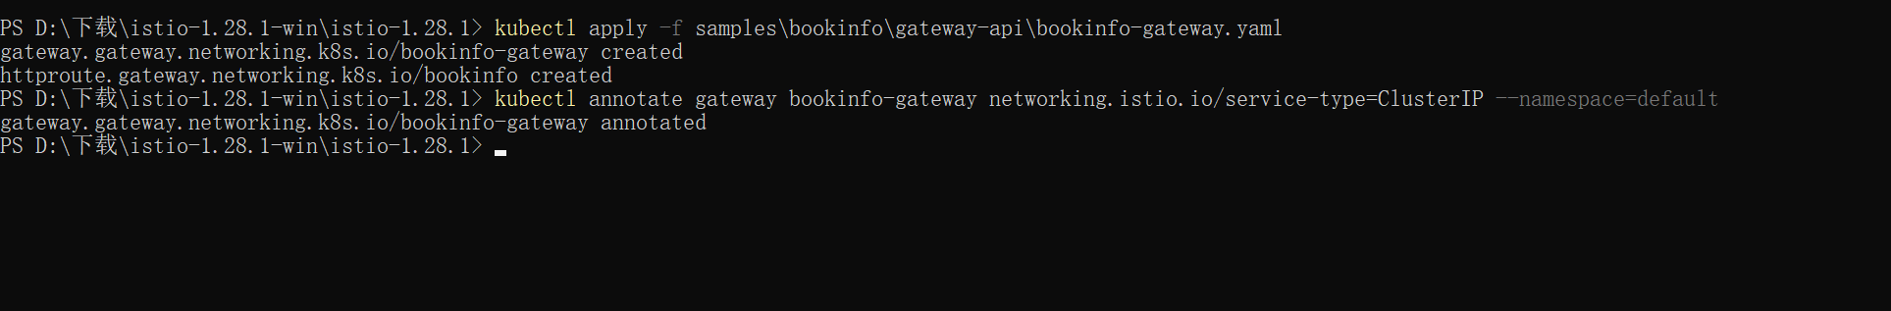
Port Forwarding: kubectl port-forward running normally, mapping the service to local port 8080.

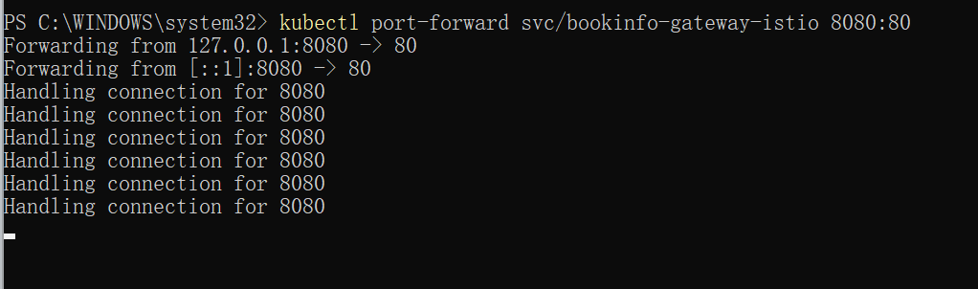

Browser Access: Bookinfo application displayed successfully with red stars in reviews section (reviews-v3 version); refreshing shows version switching.

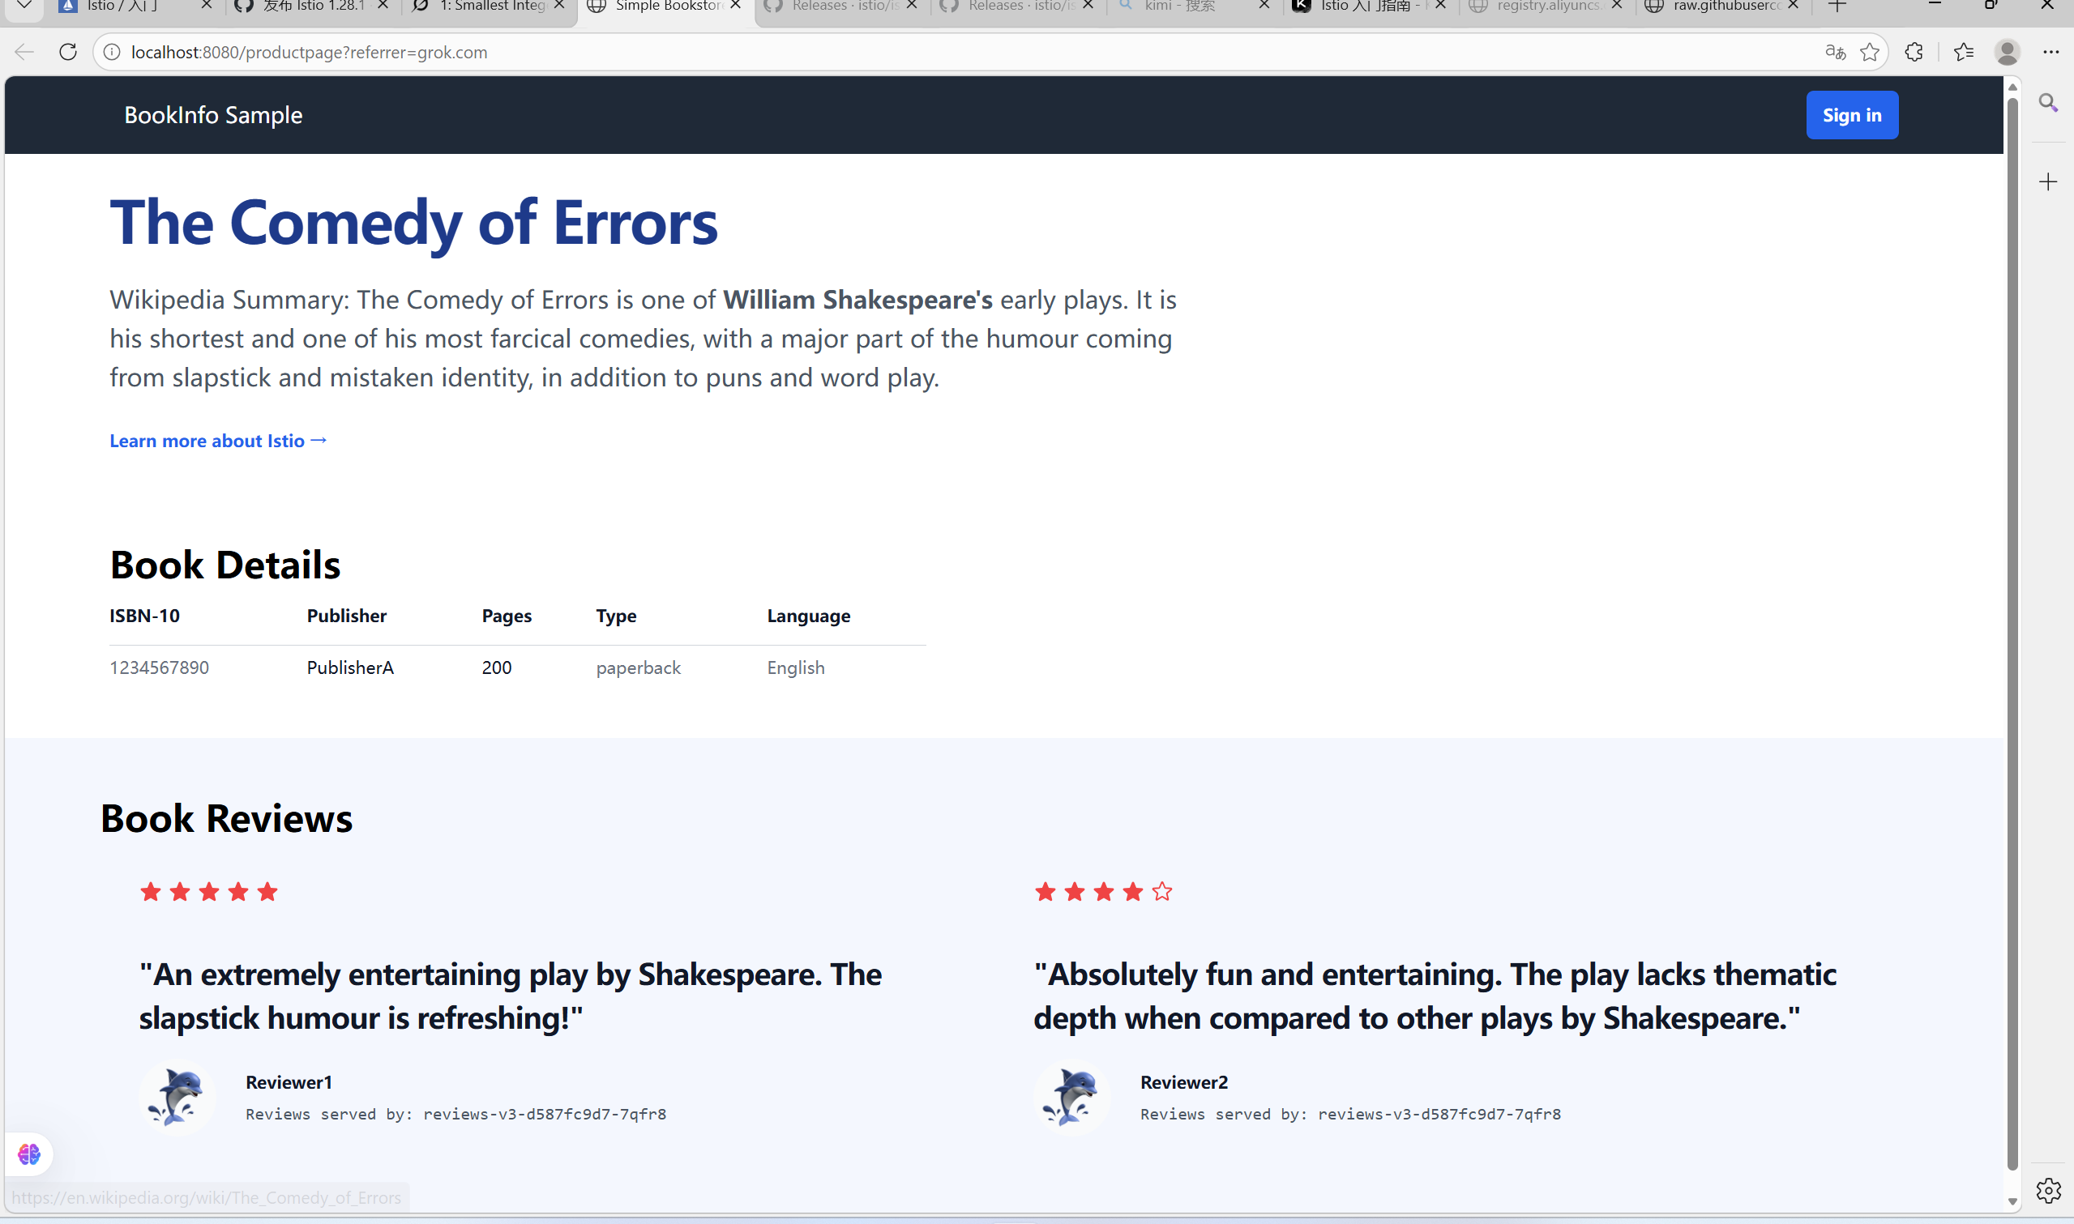
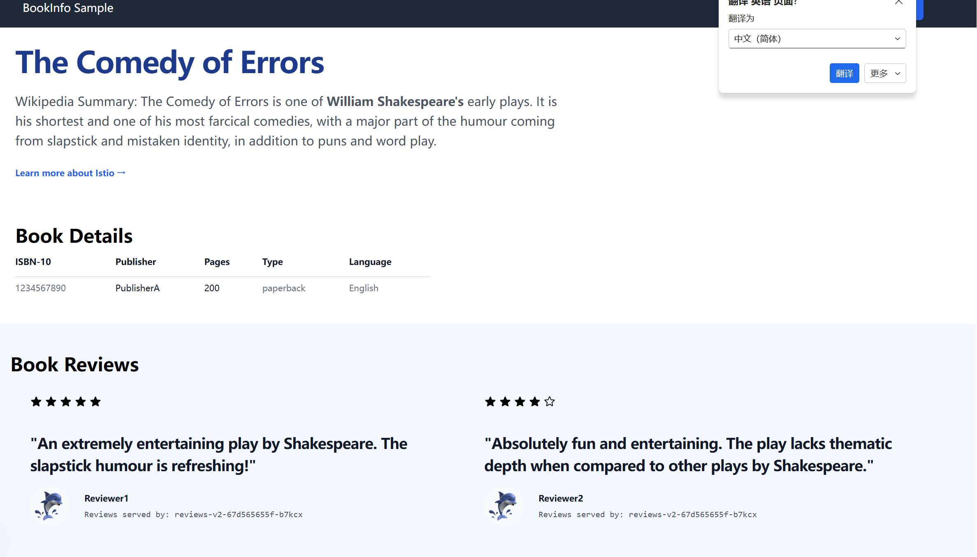

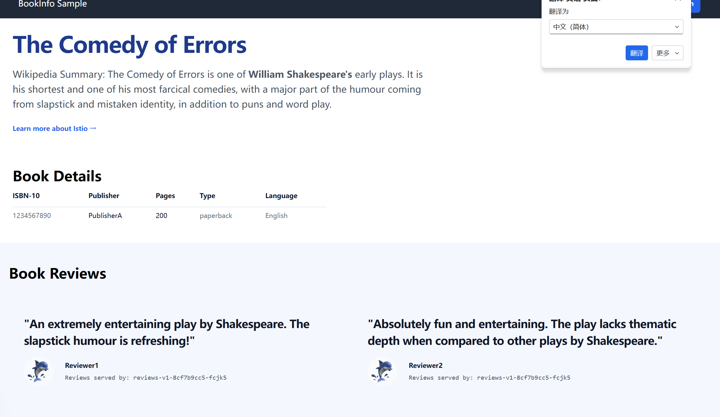

5. Conclusion
This experiment successfully installed and ran Istio in a Windows + Minikube environment and deployed the Bookinfo sample application. The service was exposed via Gateway API and accessed successfully in the browser. Refreshing the page demonstrated switching between different versions of the reviews service, verifying Istio’s traffic management capabilities. The Kiali dashboard provided an intuitive view of the service mesh topology.
Issues encountered and resolutions:
1.PowerShell does not support Linux commands (e.g., grep); replaced with Select-String.
2.Sidecar Init container permission issues under Minikube Docker driver; resolved by allocating more resources and waiting patiently.
3.Network issues causing some online installations to fail; switched to reliable release YAML files.
Through this lab, I gained a deep understanding of Istio’s automatic sidecar proxy injection, traffic routing, and observability mechanisms, laying a solid foundation for further study of advanced features such as VirtualService, DestinationRule, and fault injection.

