Using Minikube to Create a Cluster

Installing Required Software

1.Install Chocolatey Package Manager
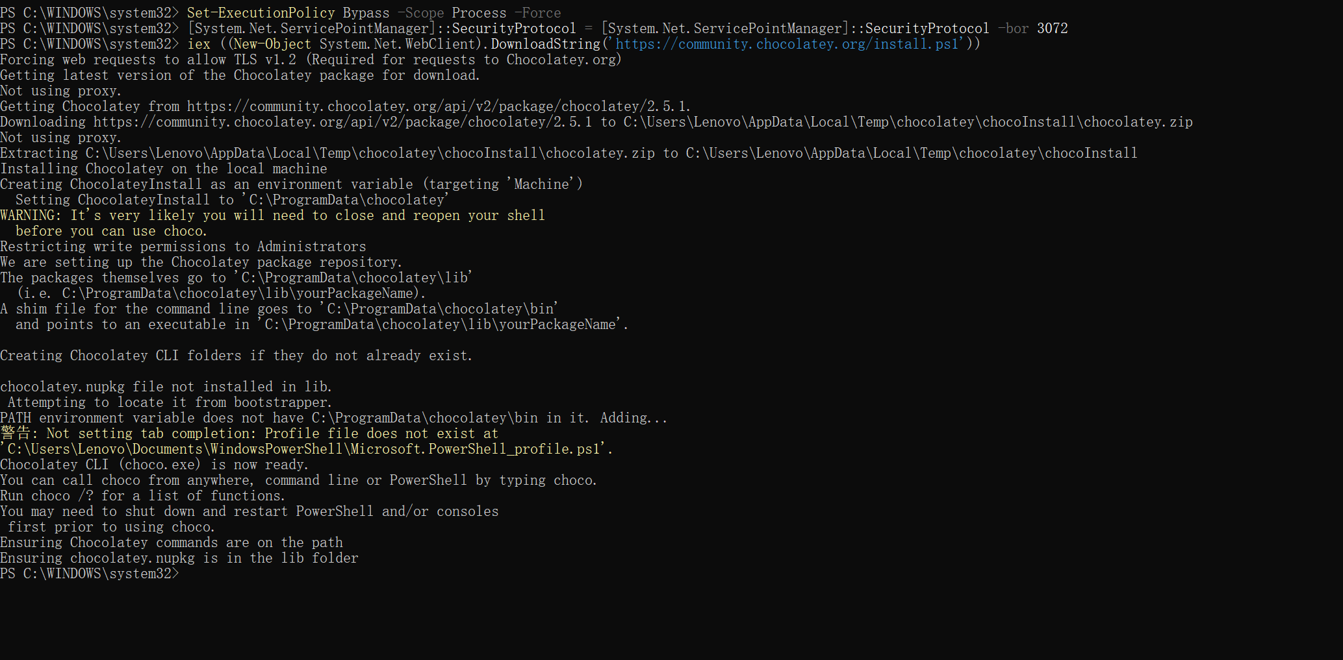
As shown in the figure, the Chocolatey package manager has been successfully installed in Windows PowerShell (run as administrator). The command-line interface displays the complete process of downloading, configuring, and setting environment variables. The log finally confirms 'Chocolatey CLI (choco.exe) is now ready,' indicating that the installation has been successfully completed and is ready for subsequent use with Minikube and kubectl.

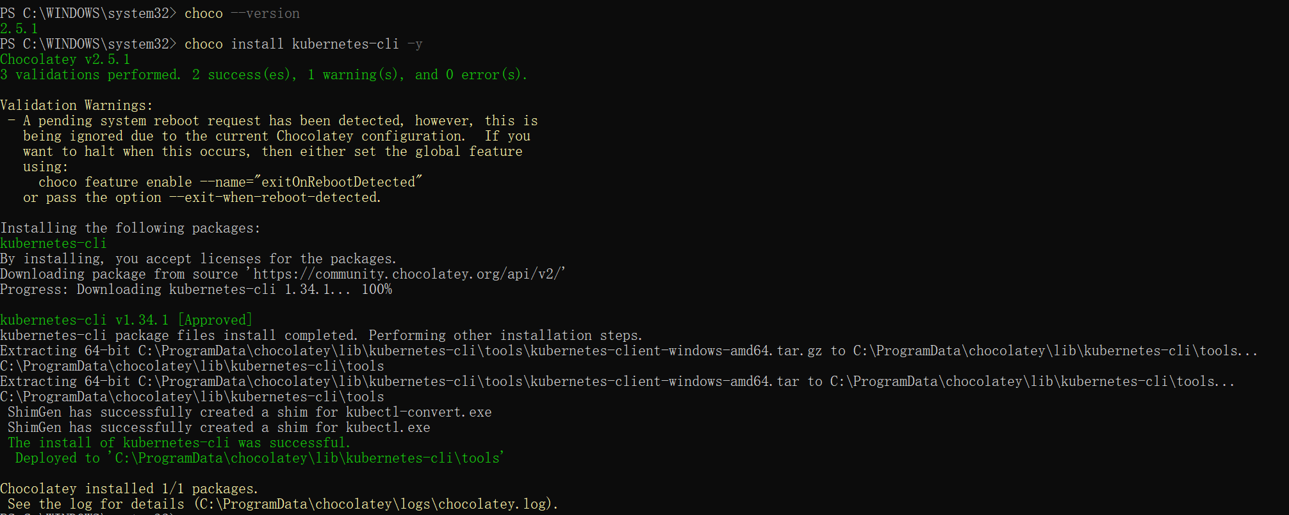
The image confirms the Chocolatey version is 2.5.1 and shows the successful execution of the choco install kubernetes-cli -ycommand. Kubernetes CLI (kubectl) v1.34.1 was downloaded smoothly. The installer extracted the archive to the specified directory and successfully created command-line shims for kubectl.exeand kubectl-convert.exe, indicating the kubectl toolset is now ready.
