Istio Traffic Management Experiment Report
Name：SunYining | STU_NO：202383930018 | Exp：8
Experiment Purpose:
Through four traffic management tasks in Istio's official documentation, gain hands-on experience with Istio's advanced traffic control capabilities, including traffic shifting, request routing, fault injection, and circuit breaking. Understand the application scenarios of these features in microservices architectures, such as version migration, canary releases, chaos testing, and stability assurance.
Experiment Environment:
1.Kubernetes cluster (assuming the latest version of Istio is installed)
2.Bookinfo sample application (for the first three experiments)
3.httpbin and fortio (for the circuit breaking experiment)

Experimental Steps and Results

Part1.Traffic Shifting
This experiment demonstrates how to use weight-based routing to gradually migrate traffic from an older version (reviews:v1) to a new version (reviews:v3), enabling uninterrupted canary releases or version migrations.
Install Istio
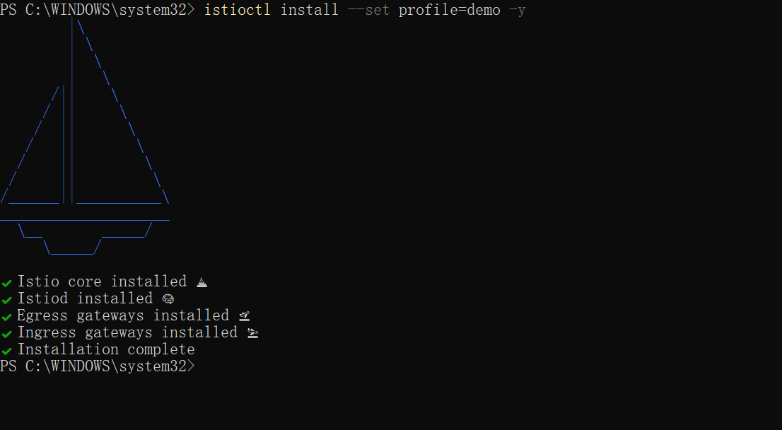
Enable automatic sidecar injection in default namespace
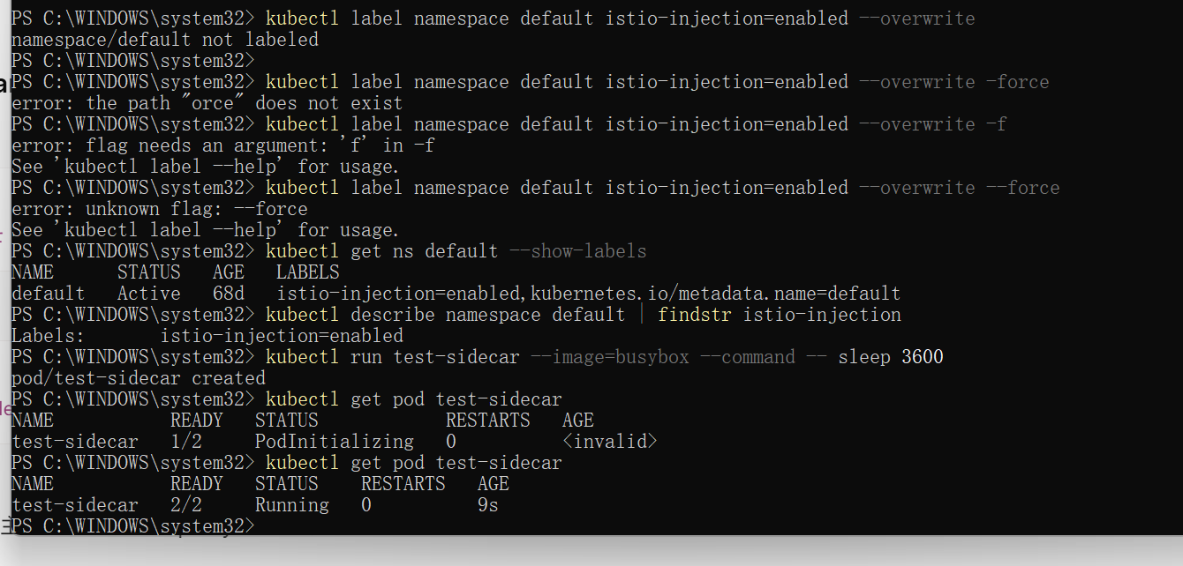

Deploy Bookinfo sample application
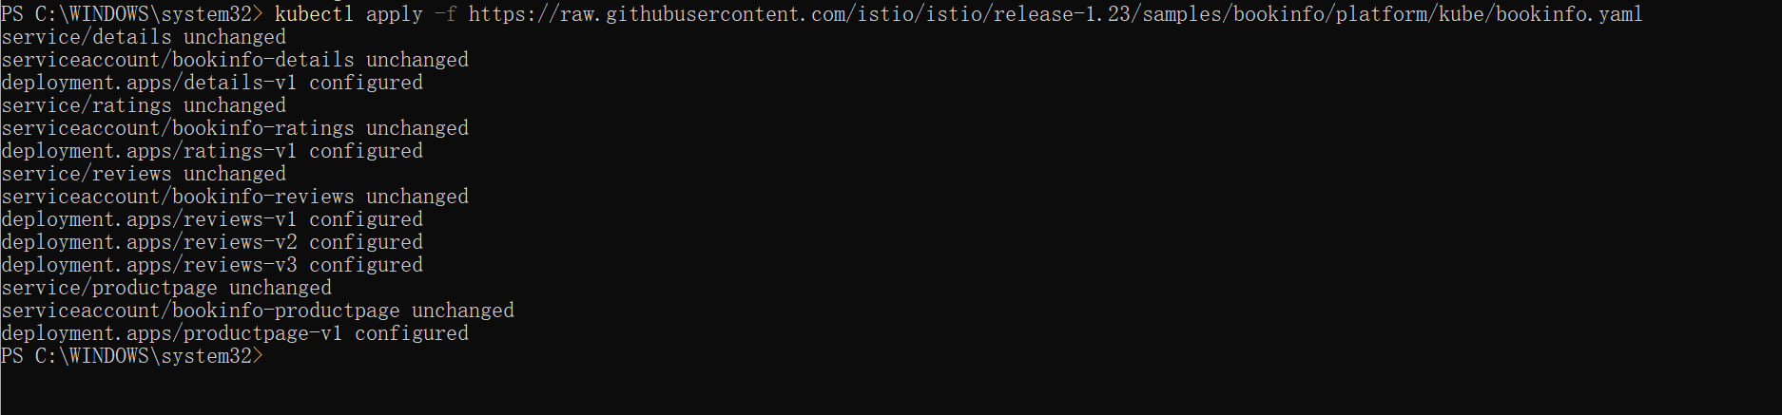Deploy Istio Gateway (for external access)
Map port 80 (in-cluster) of the Istio Ingress Gateway to local port 8080, access the app via http://localhost:8080. PowerShell outputs "Forwarding from 127.0.0.1:8080 -> 80", indicating the port forwarding is successful.
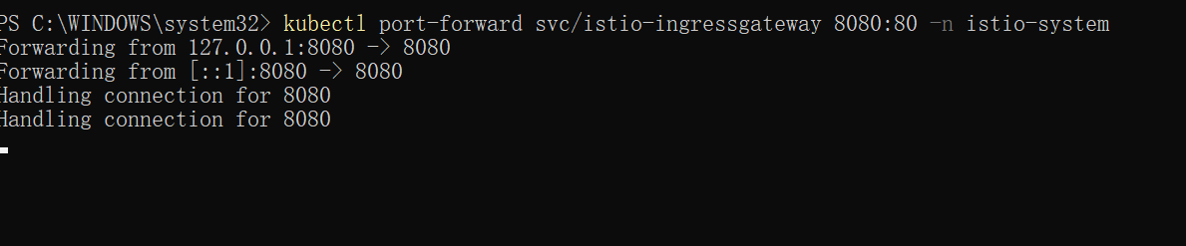
Open the Bookinfo page in your browser
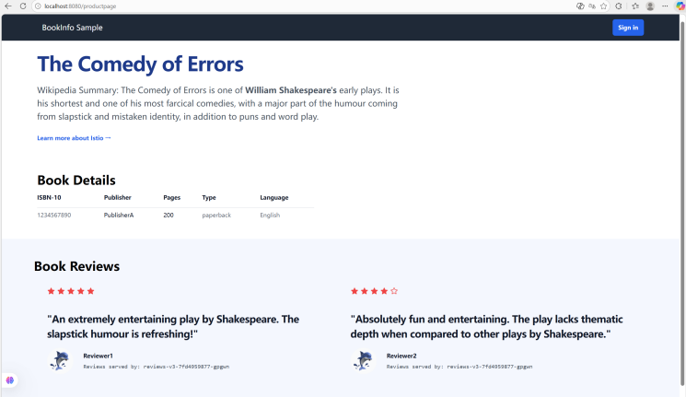

The "review section" of the page has no red star ratings, which means all traffic is routed to reviews:v1 (old version).
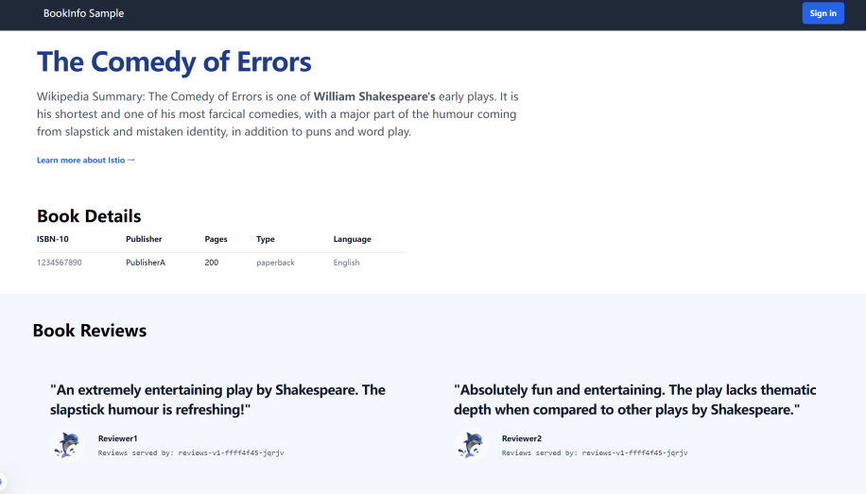

Update the routing rule to allocate 50% of traffic to reviews:v1 and 50% to reviews:v3 (the new version displays star ratings).

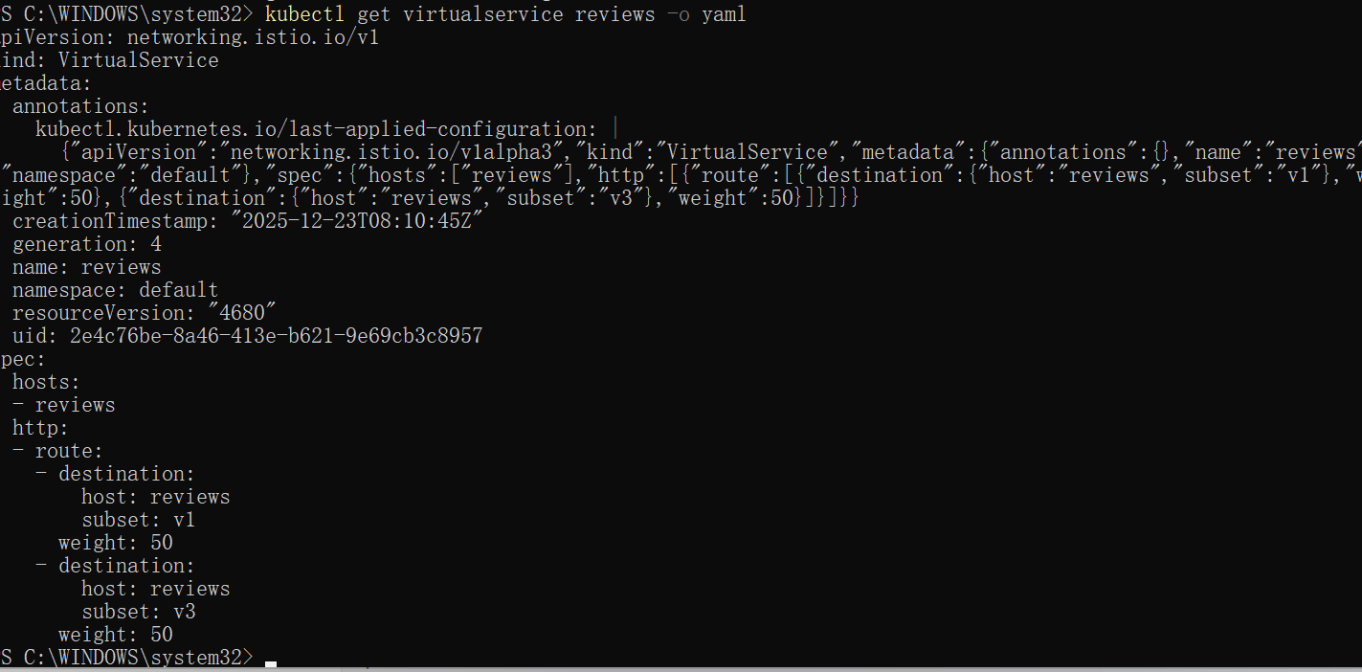

Wait a few seconds for the new rules to propagate and then confirm the rule was replaced:
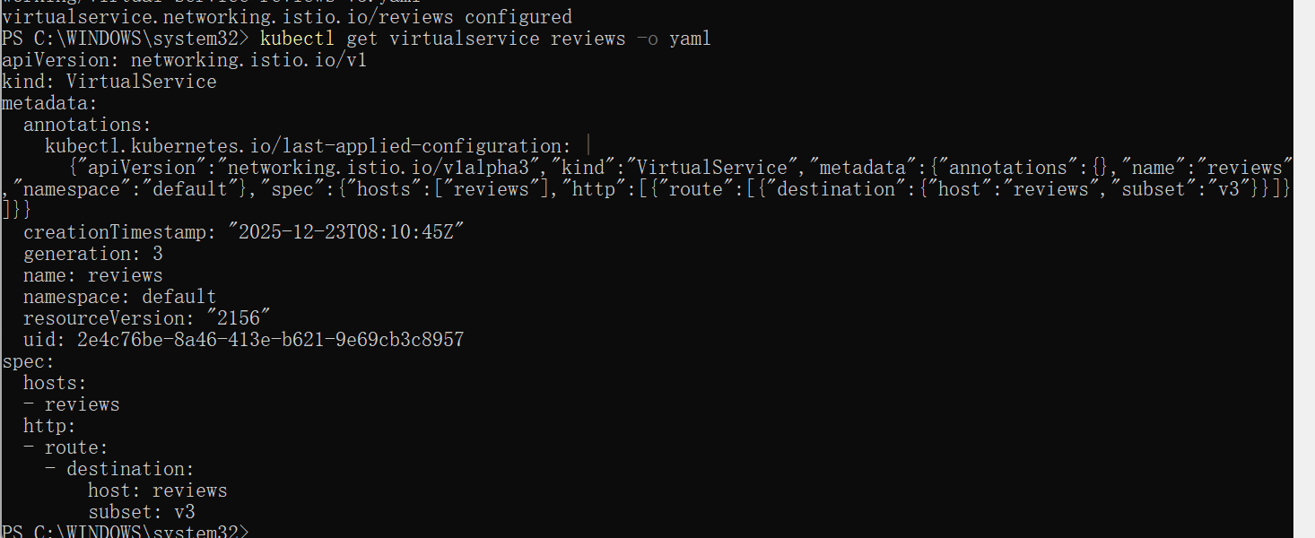

Part2Request Routing
1. Execute kubectl get crd to check if the CRD resources of Gateway API exist in the cluster, and use 2>$null to hide error prompts when they do not exist;
2. If the CRD does not exist, pull the experimental CRD configuration of Gateway API version v1.4.0 from the Kubernetes official repository and install it in server-side apply mode.
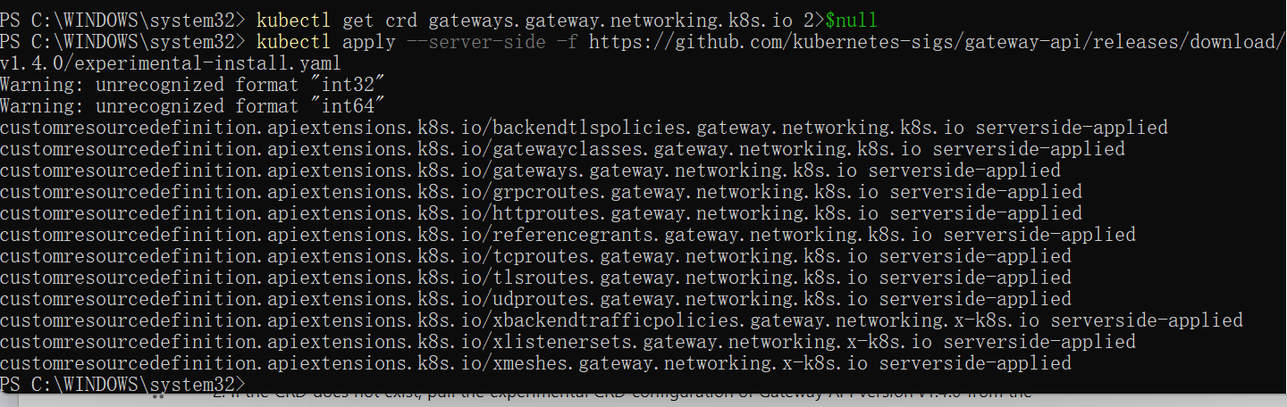
After executing the command, PowerShell outputs a series of prompts such as customresourcedefinition.apiextensions.k8s.io/... serverside-applied, indicating that the CRD resources of Gateway API have been successfully installed in the cluster.

Install Istio Core Components
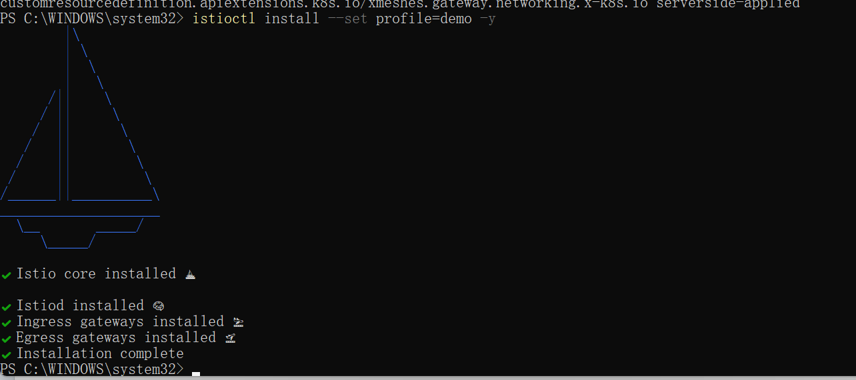
Deploy Bookinfo Sample 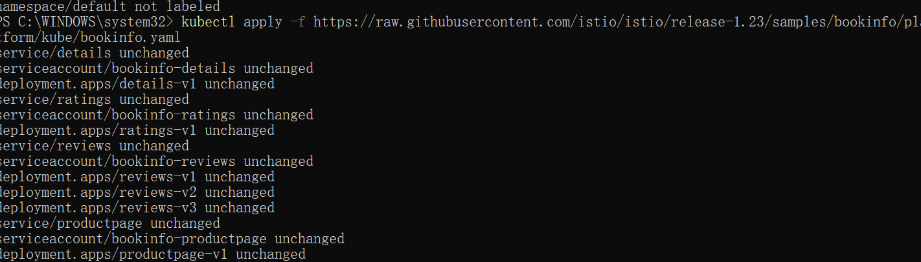

Pull the Bookinfo configuration file from the Istio official repository to deploy a complete microservice application including productpage, reviews (v1/v2/v3), details, and ratings.

Deploy Ingress Gateway & Port Forwarding
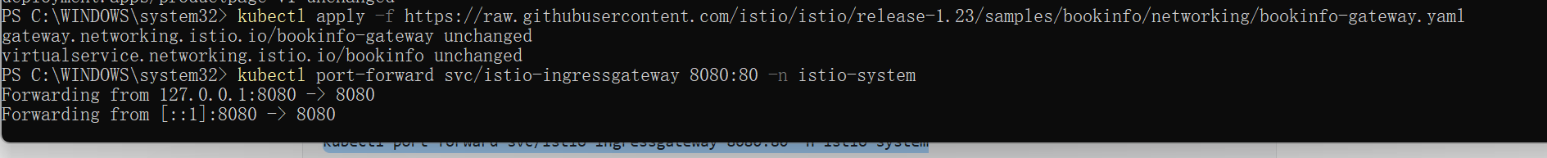
Map port 80 of the Istio Ingress Gateway in the cluster to local port 8080, access the app via http://localhost:8080.

Create Istio VirtualService resources to configure routing rules for four microservices (productpage, reviews, details, ratings), routing all traffic to their respective v1 versions.

kubectl get virtualservices -o yaml: View the detailed configuration of all VirtualServices in YAML format to confirm that the routing target of each microservice is subset: v1
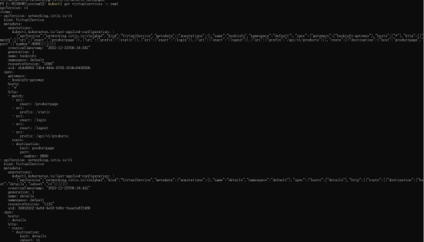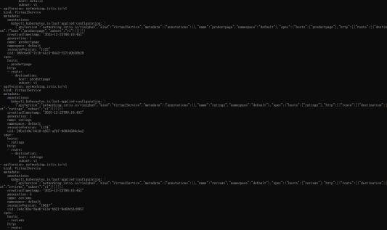

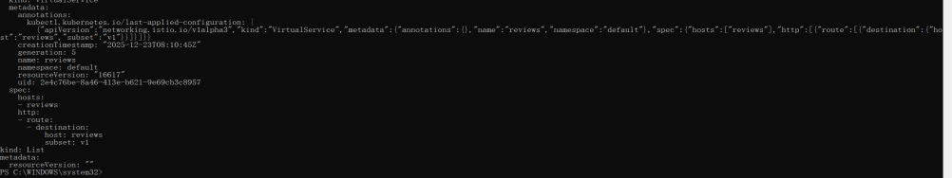

kubectl get destinationrules -o yaml: View the DestinationRule configuration to confirm that the v1 version subset of each microservice is defined (e.g., subset v1 of reviews corresponds to the label version: v1).
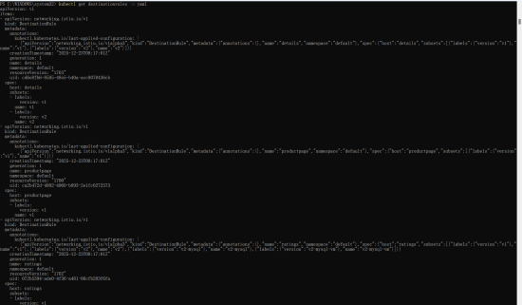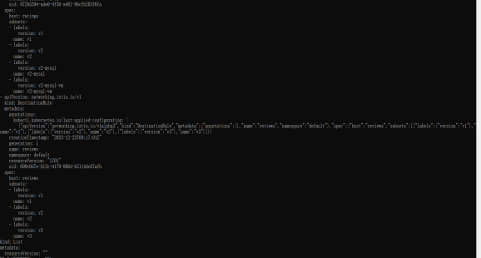
In the VirtualService configuration, spec.http.route.destination.subset of each microservice is v1; the DestinationRule configuration includes the version subset definition of each microservice.
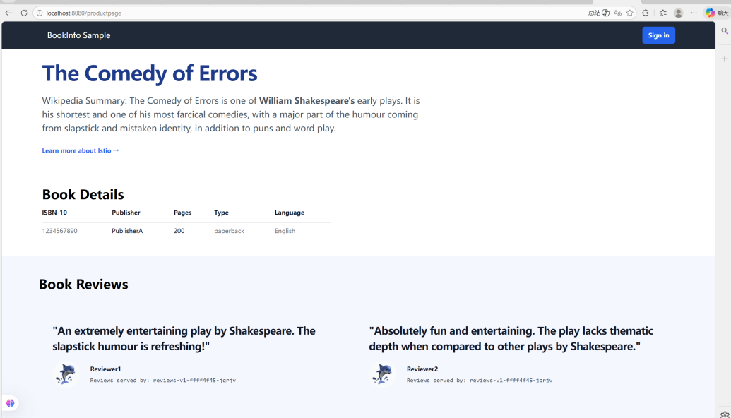
The "review section" of the page has no star ratings at all times because the reviews:v1 version does not call the ratings star service, and all traffic is routed to the v1 version.

Update the VirtualService rule of reviews to add matching conditions based on HTTP request headers: when the value of the request header end-user is jason, traffic is routed to reviews:v2; traffic from other users is still routed to reviews:v1. (The reviews:v2 version supports the star rating function)
PowerShell outputs virtualservice.networking.istio.io/reviews configured, indicating the routing rule of reviews has been updated successfully.
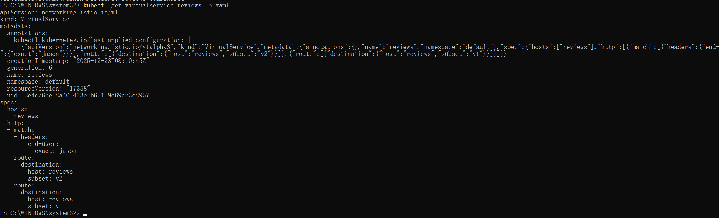
View the VirtualService configuration of reviews in YAML format to confirm that it includes the request header matching rule (end-user: exact: jason), the corresponding routing target (v2), and the default routing target (v1).

Visit http://localhost:8080/productpage, click the "Sign in" button in the upper right corner of the page, and log in by entering the username jason (any password is acceptable); Refresh the page and observe the display effect of the review section; Click the "Sign out" button, log in as an anonymous user (or another username, such as tom), refresh the page again, and observe the display effect of the review section.
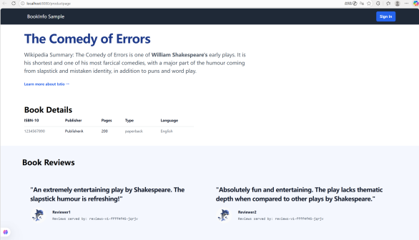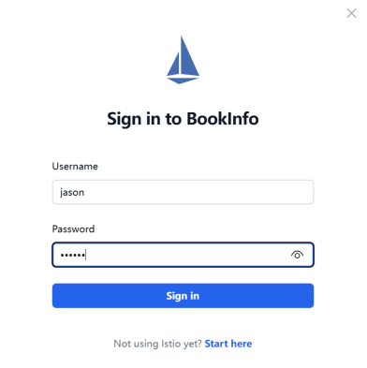

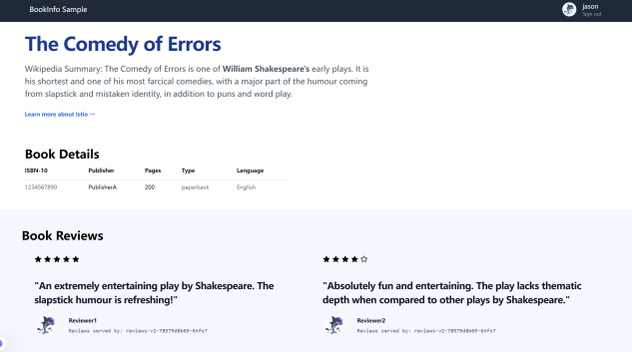
.Log in as jason: The review section displays star ratings (traffic is routed to reviews:v2); 2. Log in as other users/anonymous: The review section has no star ratings (traffic is routed to reviews:v1).

Part3Fault Injection
Configure Application Version Routing
1. Apply VirtualService rules to route all microservice traffic to the v1 version by default;
2. Add a supplementary rule: route requests from user jason to the reviews:v2 version (this version calls the ratings service).

Inject HTTP Delay Fault
Create Delay Fault Rule
Create a VirtualService rule for the ratings service: when the request header end-user is jason, 100% of requests will be injected with a 7-second fixed delay to simulate a slow service response scenario.

Verify Rule
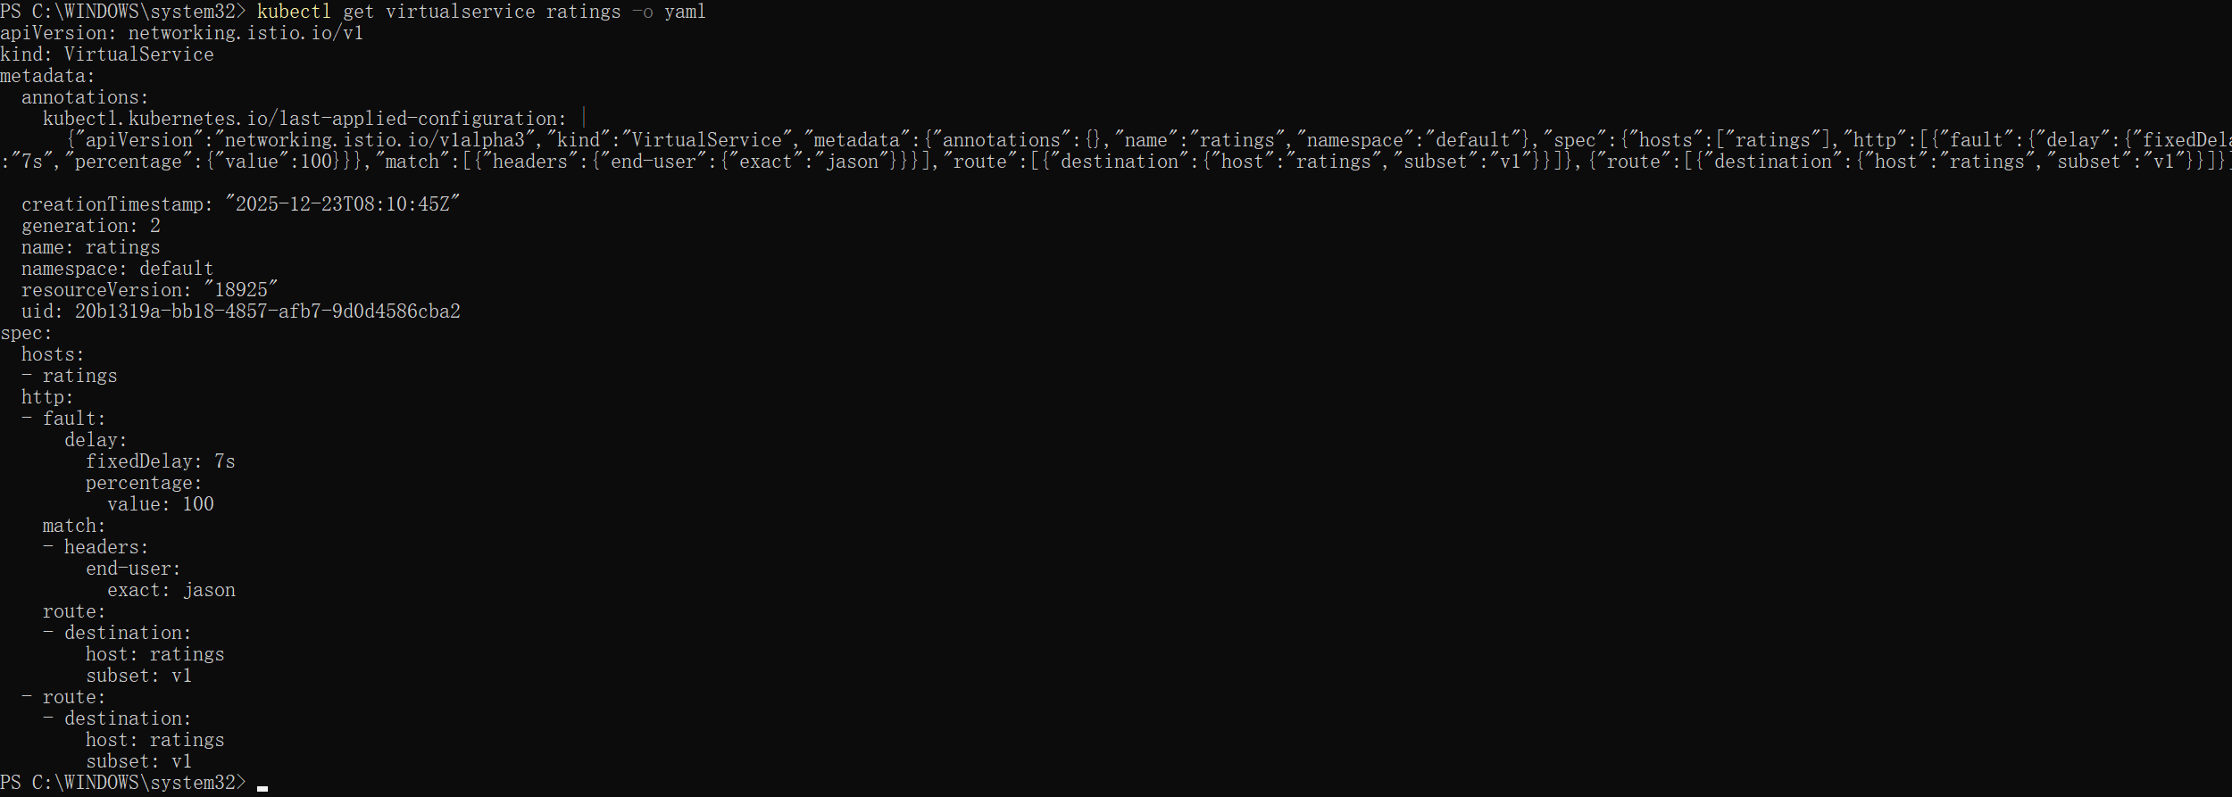

Test Delay Fault Effect
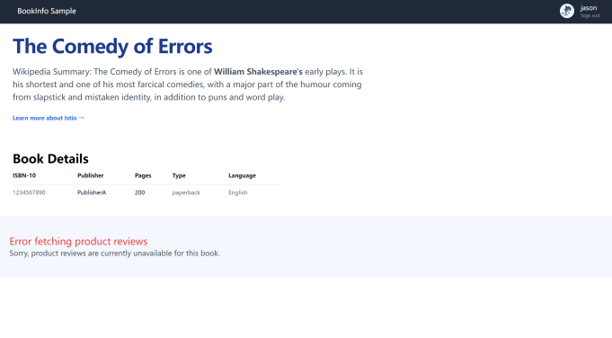
1. The review section displays the error message: "Error fetching product reviews";
2. The page loading time is about 6 seconds (not the expected 7 seconds, because the timeout of productpage to reviews is 6 seconds).

Update the VirtualService rule for the ratings service: when the request header end-user is jason, 100% of requests will be injected with an HTTP 500 error to simulate a service interruption scenario.
Test Abort Fault Effect

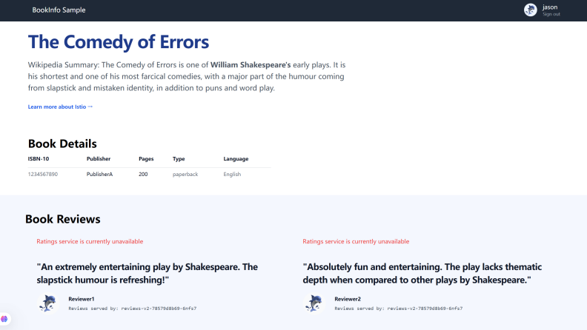
This is the page after user jason logs in. The review section displays "Ratings service is currently unavailable", indicating that the HTTP 500 abort fault for the ratings service has taken effect.Meanwhile, the review content loads normally (only the ratings service is unavailable), which aligns with the logic that reviews:v2 calls ratings but is injected with an abort fault.
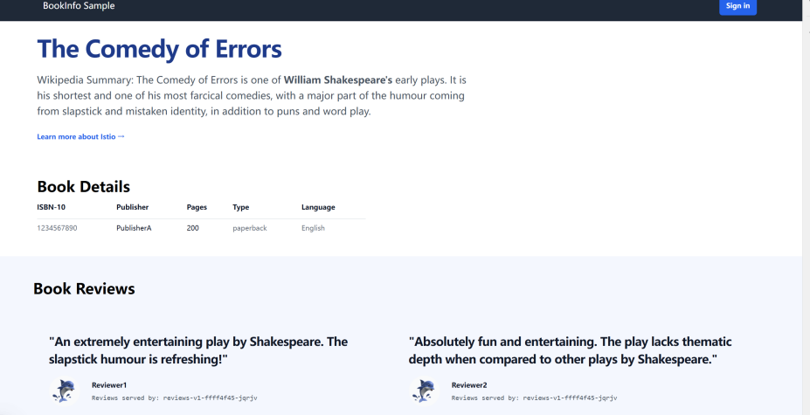
Other users: No errors in the review section (traffic is routed to reviews:v1, which does not call the ratings service).

Part4 Circuit Breaking

Deploy httpbin Sample Service
The default namespace has the istio-injection=enabled label, and Istio Sidecar is automatically injected when the Pod is created;

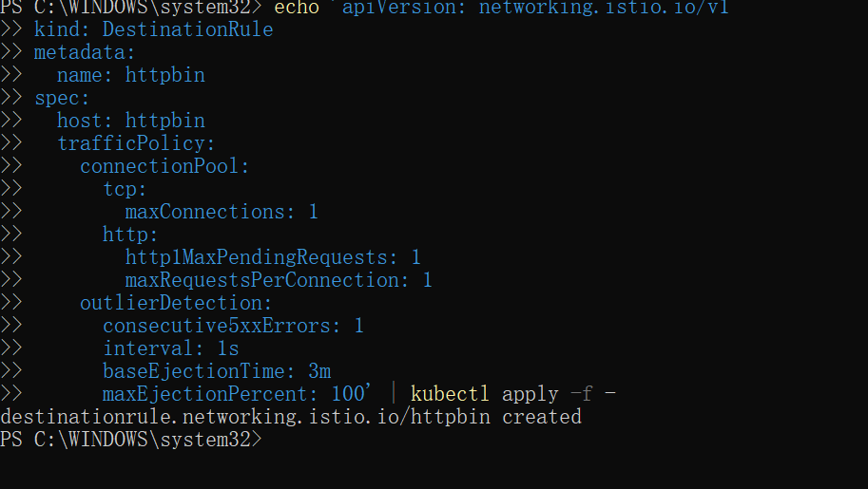
Get Fortio Pod name

Retrieve the client Pod name and initiate testing: 2 concurrent connections (- c 2), send 20 requests (- n 20)
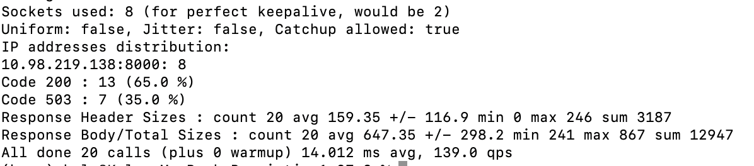
In the returned statistical information, in addition to Code 200, a certain proportion of Code 503 will also appear
Some requests did not reach the httpbin backend Pod, but were directly rejected by the Envoy Sidecar of the client (Fortio) according to the circuit breaker rule.

Summary
Through this lab exercise, we gained hands-on experience with Istio's traffic management features, including traffic shifting, request routing, fault injection, and circuit breaking. These features have broad applications in microservices architectures, significantly improving system reliability and maintainability. We found that Istio's traffic management tools are not only powerful but also flexible and easy to use, meeting the diverse needs of complex business scenarios.
In practical applications, these features can help us better manage service version deployments and migrations, enhance system fault tolerance, and stability. Moving forward, we plan to further explore Istio's advanced features, such as security and observability, to comprehensively optimize our microservices architecture.

