Knative Lab Report

Purpose
The objective of this experiment is to gain hands-on experience in building, deploying, and managing serverless cloud-native applications using Knative on a Kubernetes cluster. The focus is on mastering the core features of Knative Serving and Knative Eventing, including automatic scaling (scale-to-zero), traffic routing, custom domain configuration, and the local development workflow of Knative Functions, thereby understanding the role and advantages of Knative in serverless architectures.

Environment
Minikube
Kubernetes v1.34.0
Docker

Steps

1. Install Knative Serving
Start Minikube
Start Minikube with the specified resources and Kubernetes version to provide a runtime environment for the subsequent Knative installation and application deployment.

Install Knative Serving Component
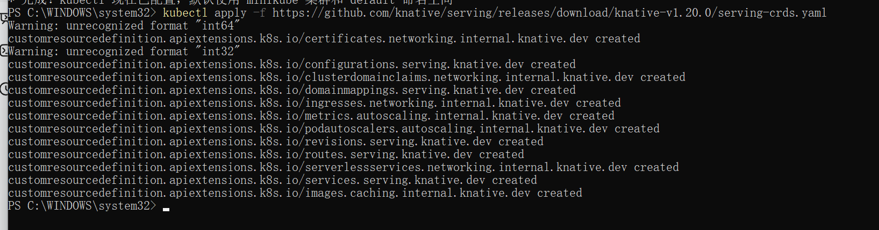

Install the required Custom Resource Definitions (CRDs) for Knative Serving to lay the foundation for subsequent component installation.
Install Core Components
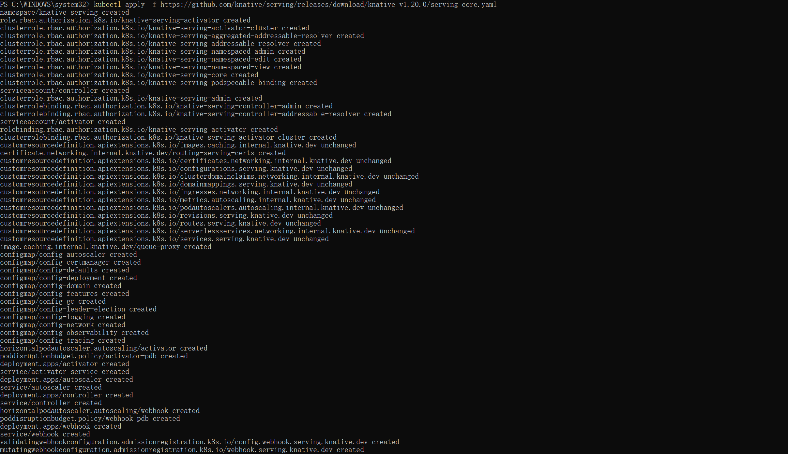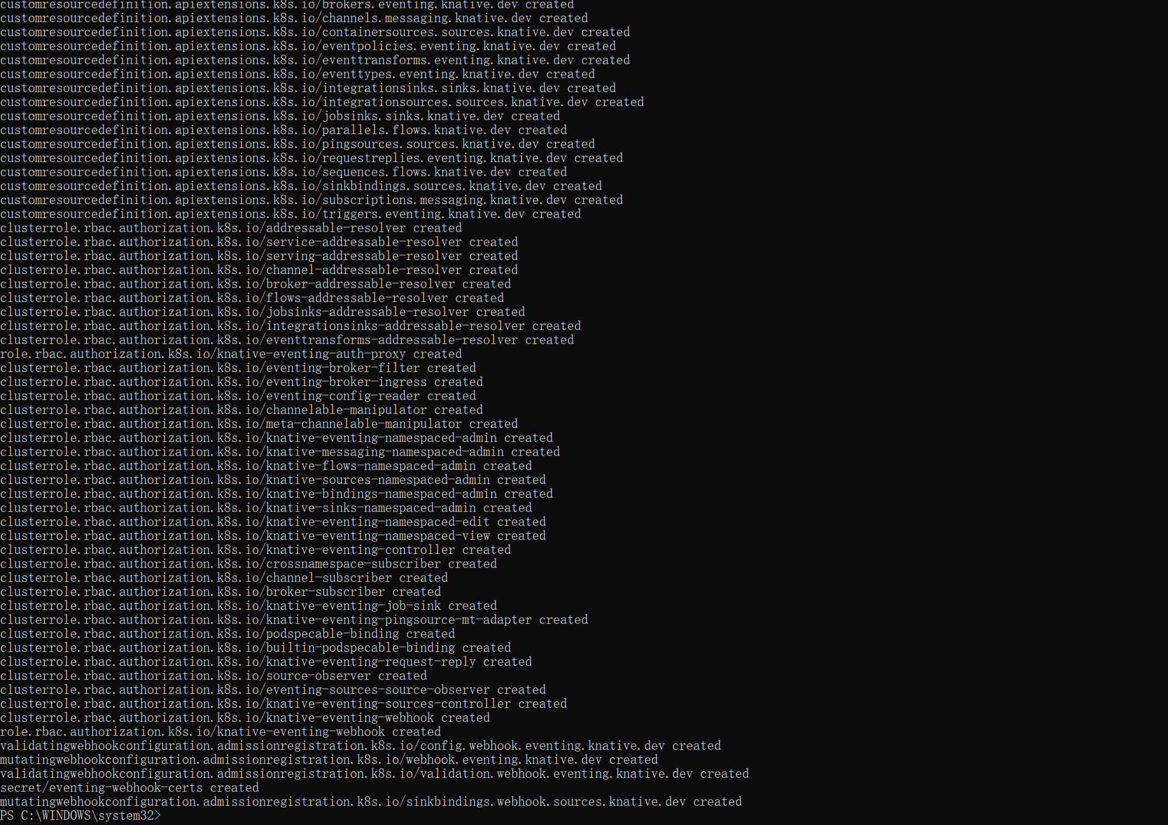
Deploy the core components of Knative Serving to enable it to run and manage serverless applications on Kubernetes.
Install Kourier Networking Plugin
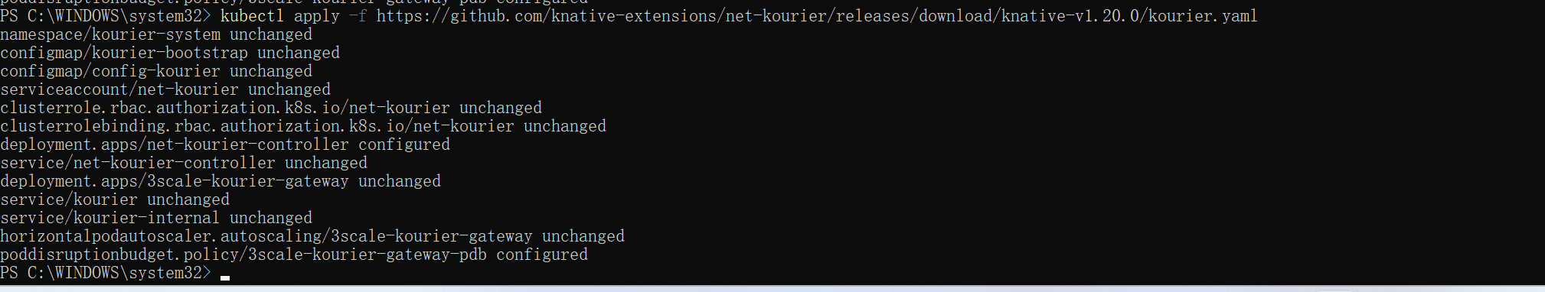

Install the Kourier networking plugin to provide network support for Knative Serving.

Monitor the Knative components until all of the components show a of or . You can do this by running the following command and inspecting the output:STATUSRunningCompleted
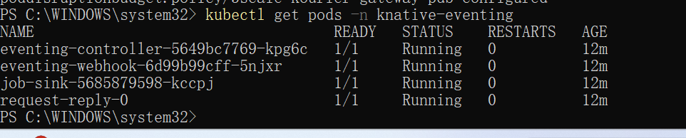
Configure Knative to Use Kourie
Configure Knative Serving to use Kourier as the default networking plugin.
Get External IP or CNAME
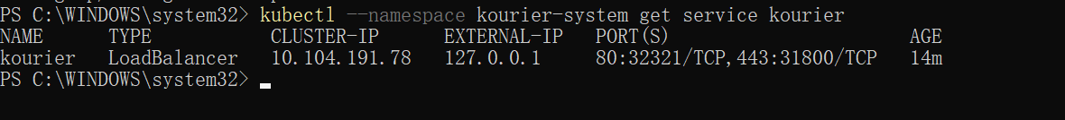
Get the external IP or CNAME of the Kourier service for subsequent DNS configuration.

Verify Installation
Check Components Status
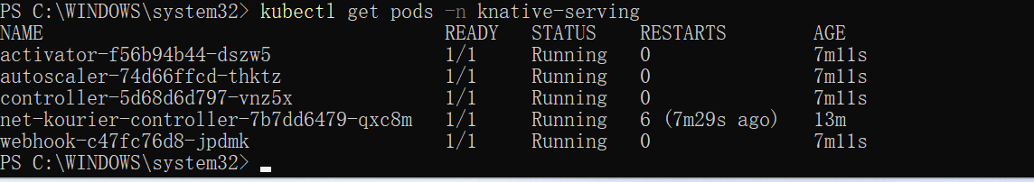
Monitor the Knative components until all show a status of Running or Completed to ensure successful installation.

Configure DNS
Use Default Domain (sslip.io)
Configure Knative to use sslip.io as the default DNS suffix to simplify application access.
No DNS Configuration (Access Using curl)
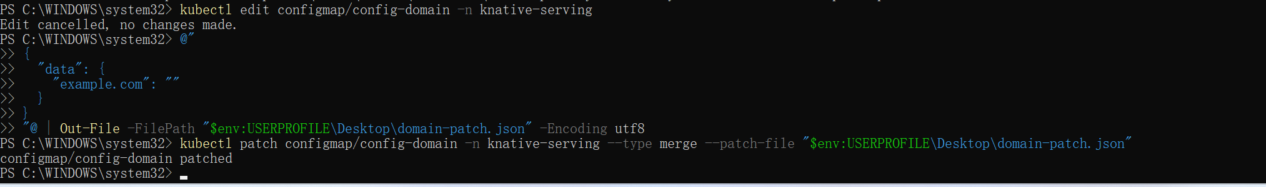
Configure Knative to use a domain reachable from outside the cluster, suitable for cases where the default DNS method cannot be used.
Get Application URL

Get the application's URL for subsequent access testing

Access the Knative Service using curl via the Magic DNS URL, successfully returning “Hello Knative!”, verifying routing and application availability.

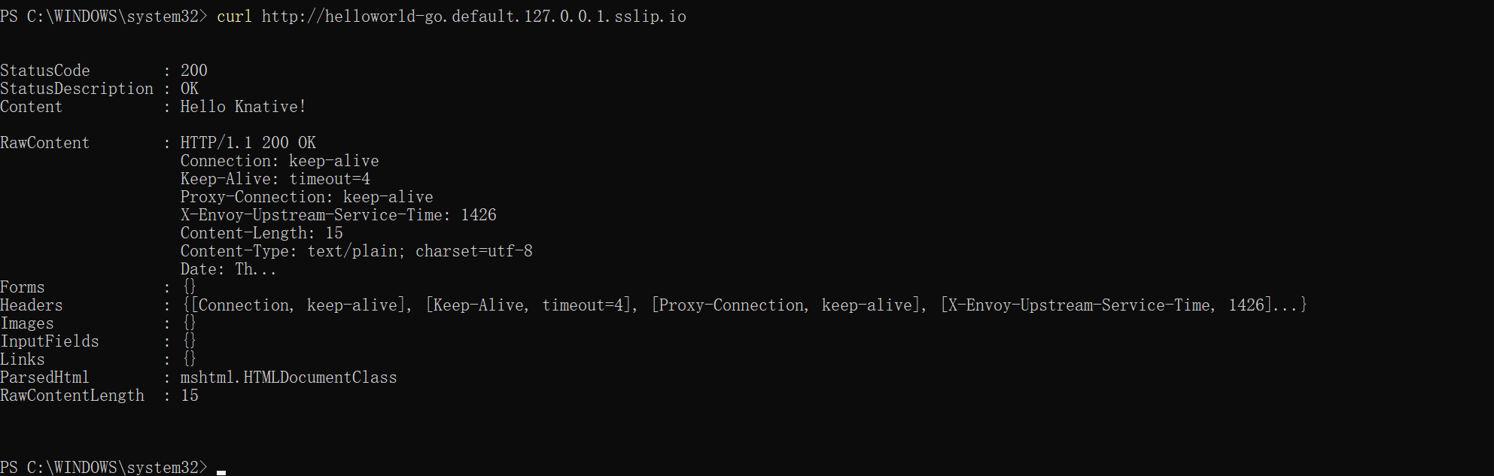
Access the application using the curl command to verify the DNS configuration.

The following commands install the KafkaChannel and run event routing in a system namespace. The namespace is used by default.knative-eventing

Install the Kafka controller by running the following command:
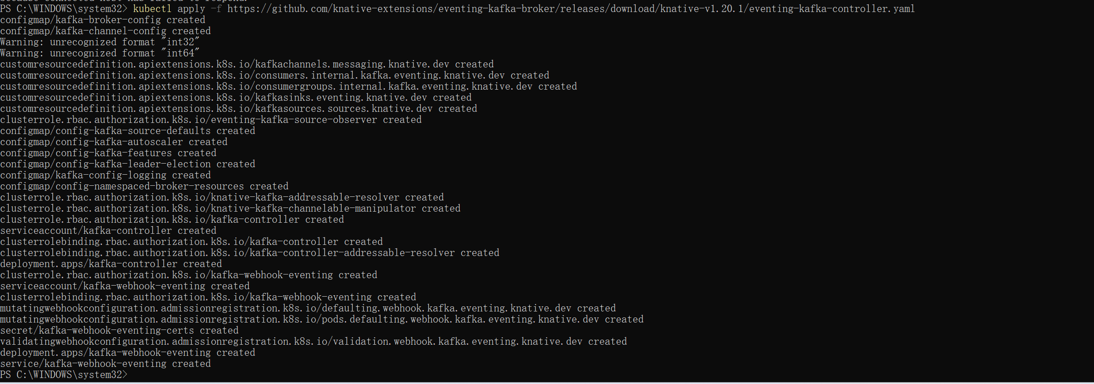
Install the KafkaChannel data plane by running the following command:

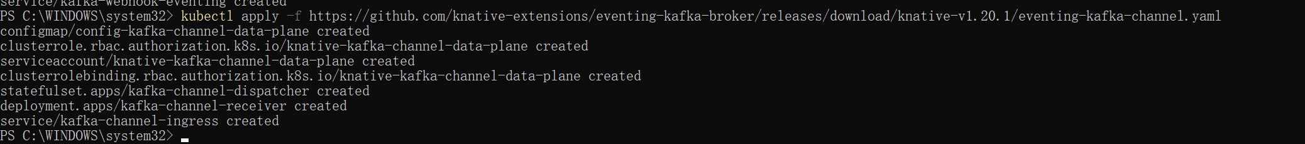
Monitor the Knative components until all of the components show a of or . You can do this by running the following command and inspecting the output
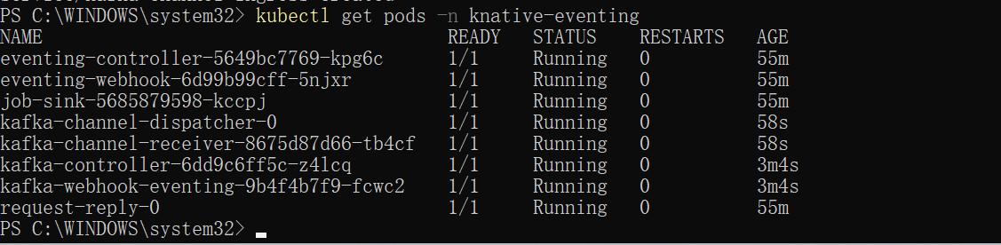

I created a Go function project using the func CLI and experienced the local development workflow of Knative Functions.
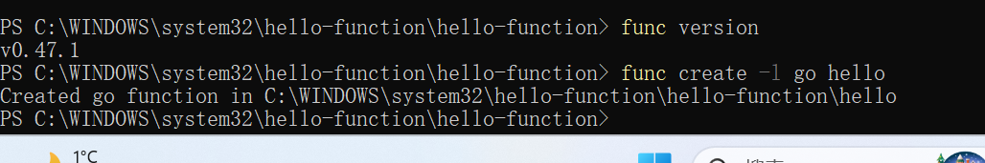

Eventing
Create a PingSource event source with a single-line command, sending a message containing “Hello Eventing!” to the helloworld-go service every 2 minutes.
Check the PingSource status, showing READY=True, indicating that the event source has successfully connected to the target Knative Service.
View the logs of the helloworld-go service, showing a request received every 2 minutes from the PingSource, proving that Knative Eventing event flow is functioning properly.
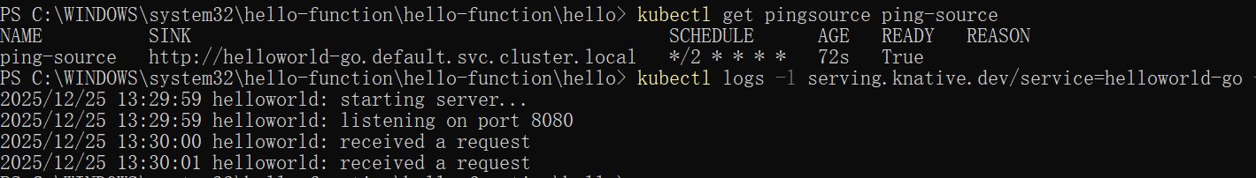
Experiment Summary
In this experiment, Knative Serving components were successfully installed and run on a local Kubernetes cluster (Minikube or similar). By deploying the sample application helloworld-go, the creation of Knative Services, automatic scaling (including scale-to-zero), and routing access based on Magic DNS were verified. The application was successfully accessed using the curl command, returning the correct response. Additionally, the func CLI tool for Knative Functions was installed, and the func create command was successfully executed to create a Go function project, completing the initial experience of local function development (without deploying to the cluster). During the custom domain configuration (config-domain), challenges such as JSON patch escaping issues in PowerShell and ConfigMap merge type conflicts were encountered, which were ultimately resolved using methods like --patch-file and kubectl edit. Overall, this experiment deepened the understanding of the Knative serverless platform, mastered its core operational processes, and demonstrated the feasibility of rapidly validating serverless applications in a local environment.

