1.****Check if your processor supports Intel/AMD virtualization technology. Enable Intel virtualization technology in BIOS if possible.****

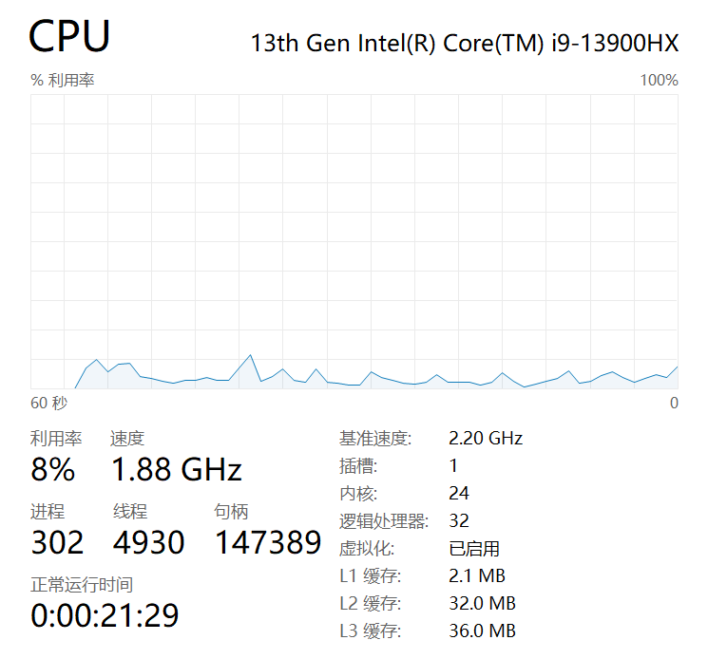

The status on my computer shows as "Enabled"

**2. Cloud technology is almost everywhere today. What do you think is the fundamental reason behind its success? List three advantages and three disadvantages of cloud technology.​​**

Answer:​​

The fundamental reason for the success of cloud technology lies in its ability to provide on-demand, scalable, and cost-efficient computing resources without the need for significant upfront investment in physical infrastructure. This flexibility allows businesses and individuals to access powerful computing capabilities remotely, enabling rapid innovation, collaboration, and scalability.

Advantages:​​

1.Scalability: Resources can be quickly scaled up or down based on demand, allowing organizations to handle traffic spikes without over-provisioning hardware.

2.Cost Efficiency:Users pay only for the resources they use, reducing capital expenditure on hardware and maintenance.

3.Accessibility and Collaboration: Cloud services can be accessed from anywhere with an internet connection, facilitating remote work and global collaboration.

Disadvantages:​​

1.Security Risks: Storing data on third-party servers may expose it to potential breaches, unauthorized access, or compliance issues.

2.Network Dependency: Consistent performance requires a stable and high-speed internet connection; outages can disrupt access to critical services.

3.Performance Variability:In multi-tenant environments, resource sharing can lead to inconsistent performance due to "noisy neighbors" or infrastructure limitations.

**3. In virtualization, what is the main function of a hypervisor?​​**

Answer:​​

The hypervisor (or virtual machine monitor) is a software layer that enables virtualization by abstracting and managing physical hardware resources. Its primary functions include:

1.Creating and running virtual machines (VMs).

2.Allocating physical resources (CPU, memory, storage, network) to VMs.

3.Ensuring isolation between VMs for security and stability.

4.Providing a platform for VMs to operate independently of the underlying hardware.

**4. What is a virtual machine (VM)?​​**

A virtual machine (VM) is a software-based emulation of a physical computer. It runs an operating system and applications as if it were a standalone physical machine, but it shares the underlying hardware resources of the host system through the hypervisor. Each VM has its own virtualized hardware, including CPU, memory, storage, and network interfaces.

**5. What are the benefits of using virtual machines?**​​

Answer:​​

1.Isolation: VMs operate independently, so issues in one VM (e.g., crashes or malware) do not affect others or the host system.

2.Portability:VMs can be easily migrated between physical hosts with compatible hypervisors, enabling load balancing and disaster recovery.

3.Cost Savings:Server consolidation reduces the number of physical machines needed, lowering hardware, energy, and maintenance costs.

4.Rapid Deployment:Pre-configured VM templates can be quickly cloned or deployed, saving time in setting up environments.

5.Environment Consistency:Development, testing, and production environments can be identical, reducing configuration errors.

**6. List five use cases for virtual machines.​​**

Answer:​​

1.Development and Testing:Developers use VMs to create isolated environments for coding, testing, and debugging without affecting their primary systems.

2.Server Consolidation: Multiple physical servers are merged into a single host running several VMs, improving resource utilization.

3.Disaster Recovery:VMs can be backed up and restored quickly on different hardware, minimizing downtime.

4.Legacy System Support: Older operating systems or applications can run on VMs without requiring dedicated outdated hardware.

5.Cloud Computing:Cloud providers (e.g., AWS, Azure) use VMs to offer scalable computing resources to users.

**7. In virtualization, what is a guest operating system?**​​

**a) The main operating system running on the physical machine**

**b) An operating system installed on a virtual machine**

**c) An operating system running on a remote server**

**d) An operating system running on a mobile device**

Answer:​​

b) An operating system installed on a virtual machine.

Explanation:The guest OS is the operating system running inside a VM, independent of the host OS (which manages the physical hardware).

**8. What does VM isolation mean?​​**

**a) VMs can communicate directly with physical hardware.**

**b) VMs share the same resources and cannot be isolated.**

**c) VMs run independently and are isolated from each other and the host system.**

**d) VMs can only be accessed locally.**

Answer:​​

c) VMs run independently and are isolated from each other and the host system.

Explanation:Isolation ensures that each VM operates in a secure, separate environment, preventing interference or unauthorized access between VMs.

**9. What is the benefit of VM portability?​​**

**a) It allows easy communication between VMs.**

**b) It ensures faster boot times for VMs.**

**c) It enables VMs to migrate between different physical machines with compatible hypervisors.**

**d) It reduces the need for hardware virtualization.**

Answer:​​

c) It enables VMs to migrate between different physical machines with compatible hypervisors.

Explanation:Portability allows VMs to be moved across hosts for maintenance, load balancing, or disaster recovery without service interruption.

**10. What is the purpose of cloning a virtual machine?​​**

Answer:​​

Cloning a VM creates an identical copy of the original virtual machine. This is useful for:

Rapidly deploying multiple VMs with consistent configurations (e.g., in classrooms or large-scale testing).

Backup and recovery: Clones serve as backups to restore systems quickly in case of failures.

Testing new software or configurations without risking the original VM.