****Lab 4: Installation and Usage of Docker and Gitea****

Ran wsl --install in PowerShell to install Ubuntu subsystem and created a user account. Docker Desktop is running andreadyforcontainer 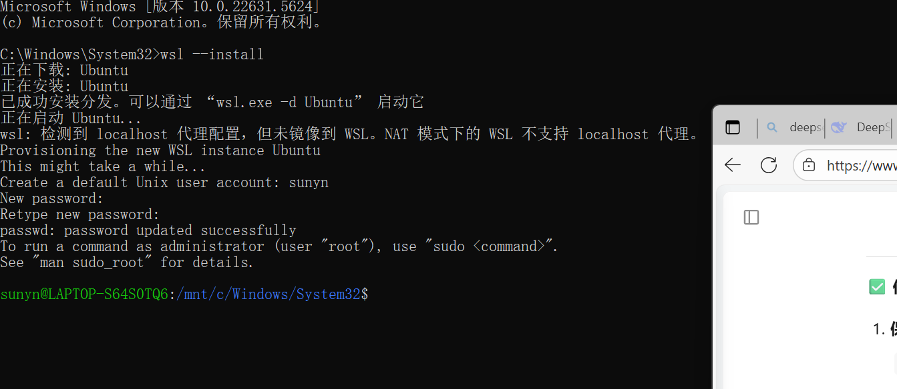

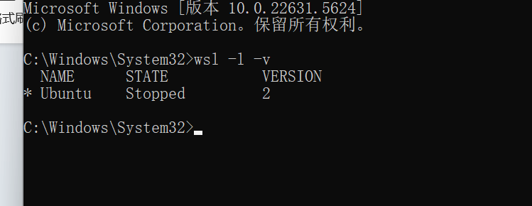

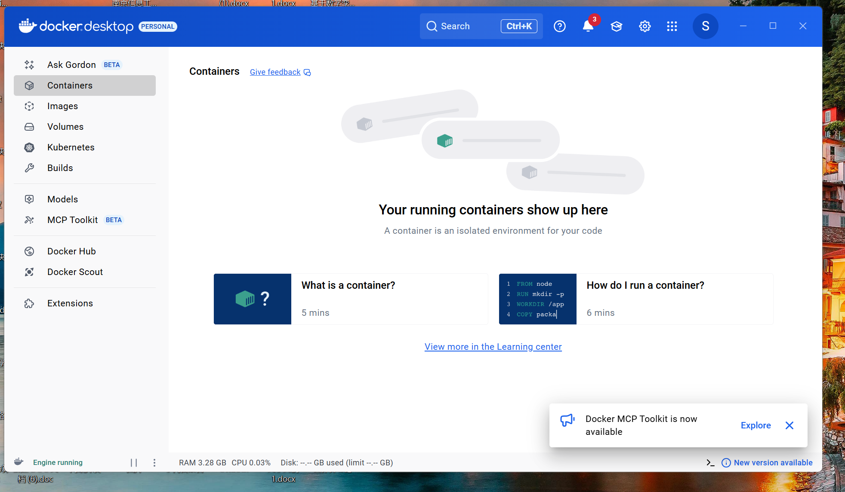

Navigated to C:\gitea, ran docker-compose up, successfully pulled images and started Gitea container, accessible at localhost:3000.

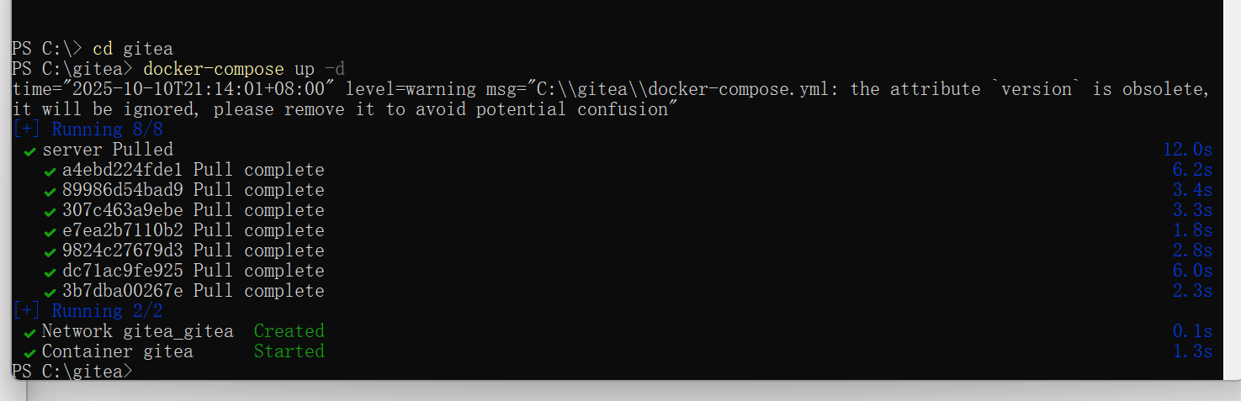

Accessed http://localhost:3000 in the browser to open the Gitea setup page for configuring admin and database settings.

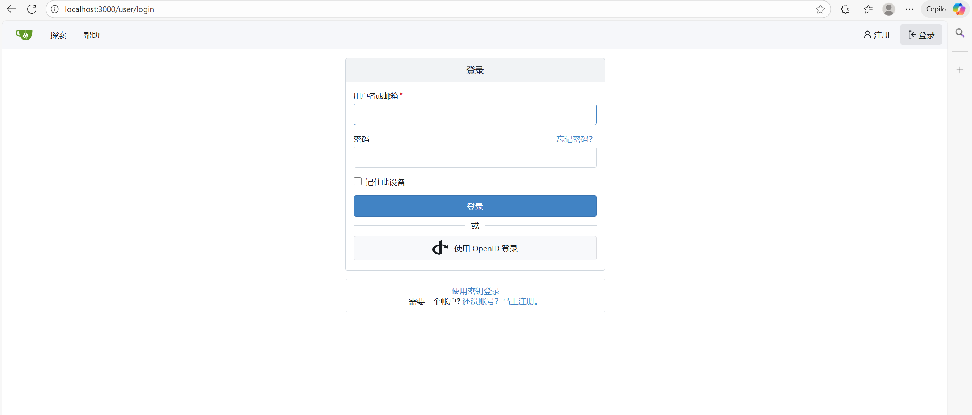

Completed Gitea initialization by setting site information and admin account credentials.

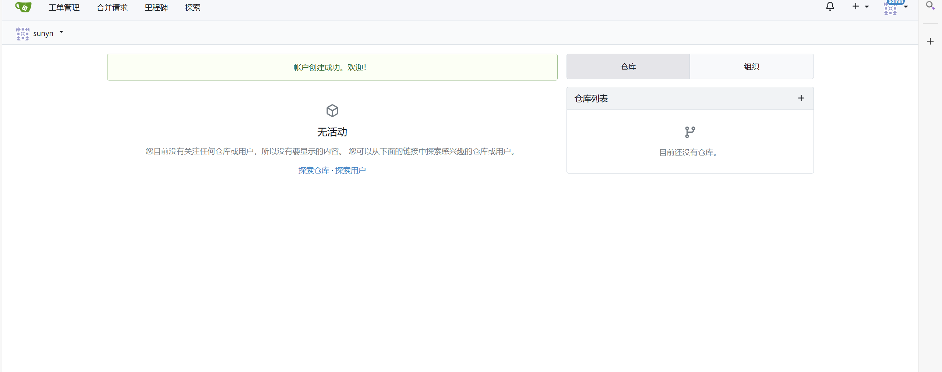

# (a).

Navigated to Gitea admin panel → repository settings to confirm Git LFS is enabled, fulfilling requirement (a).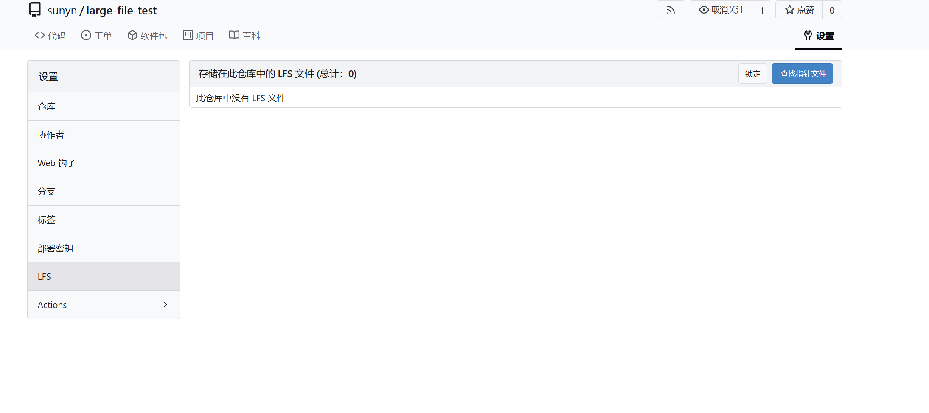

# （b）

Cloned the empty repo, enabled LFS with git lfs track, created a 1.5GB test file, and pushed it successfully, confirming LFS functionality.

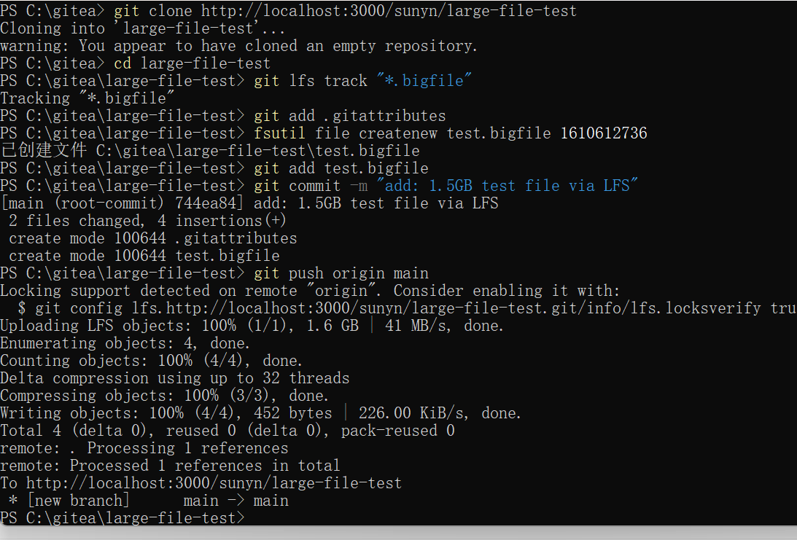

Viewed the LFS file list in the Gitea web interface, confirming the 1.5GB file was uploaded, fulfilling requirement (b).

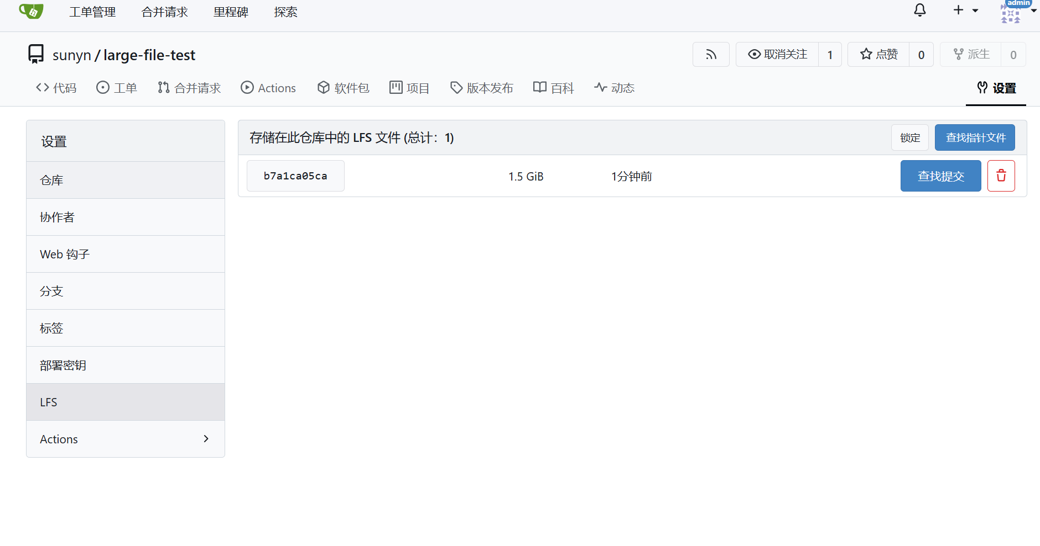

# （c）

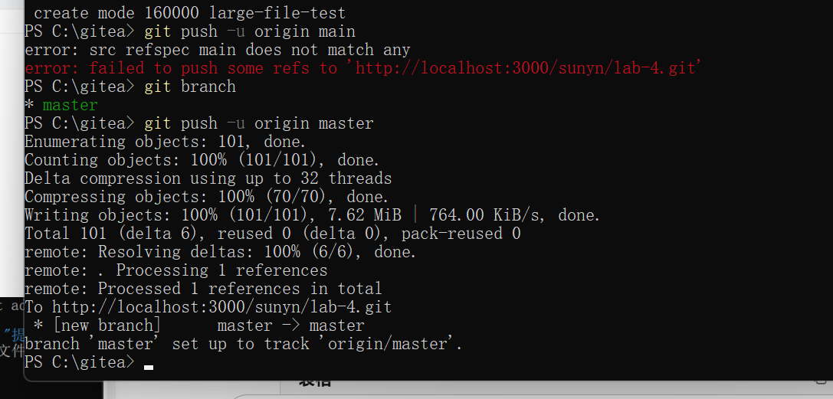

Created a new repo lab-4 and committed the lab report (lab4.docx) to the repository, completing requirement (c).

