Tutorial

Teaching Assistant

1. How to open MATLAB in lab A506?

**Step 1**, double click “Computer” on the desktop, which is



**Step 2**, go to folder “C:\Program Files\MATLAB\R2016a\bin”, then double click “matlab.exe”

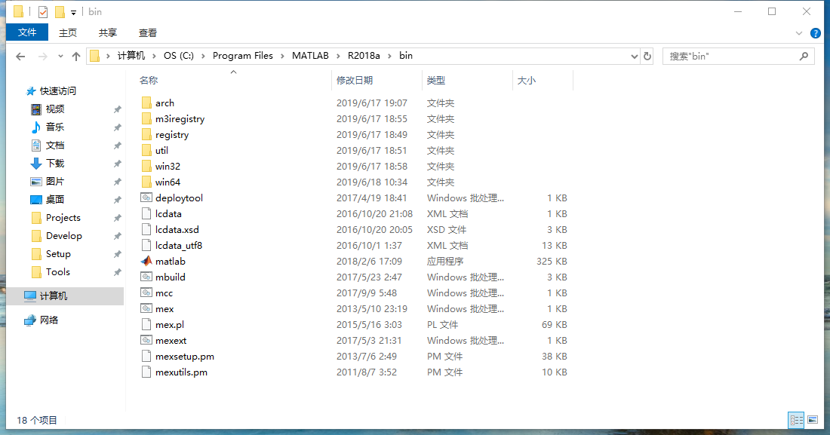

**Note**: this image is taken on author’s computer with a higher version of MATLAB, it will be changed to the real one on the lab computer after the first class.

1. How to change MATLAB UI language to English?

**Step 1**, open MATLAB and click “Preferences” button, which is

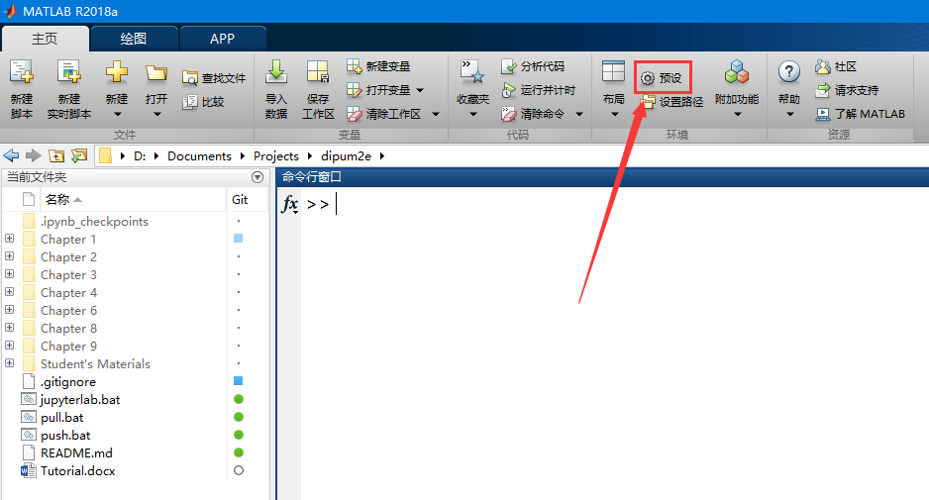

**Step 2**, in the pop-up window, click “General”, which is

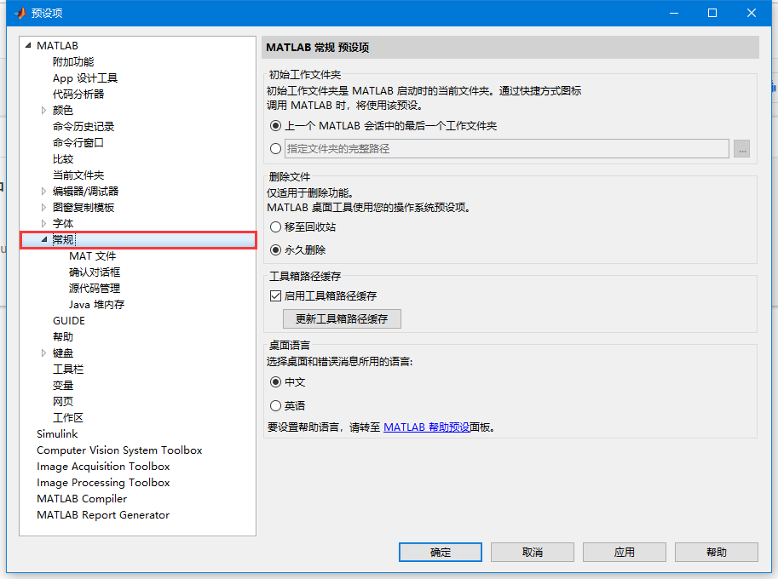

**Step 3**, click “English” in the right window and click “OK” below.

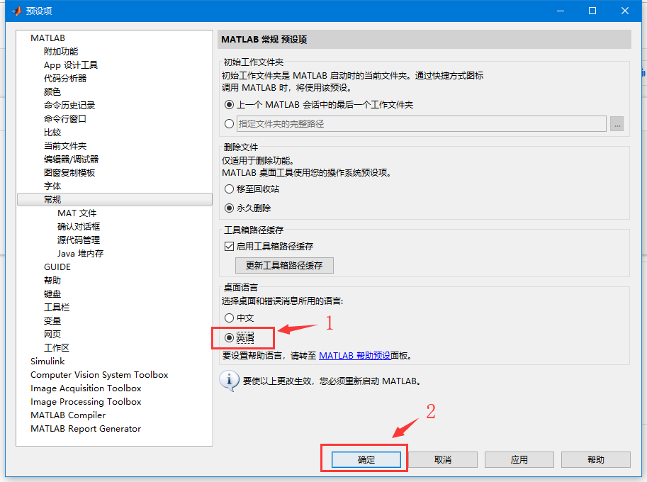

**Step 4**, restart MATLAB to take effect.

1. How to use experimental materials in MATLAB?

**Step 1**, download course materials in QQ group.

**Step 2**, unzip them to a folder, here is an example of “D:\dipum2e”.

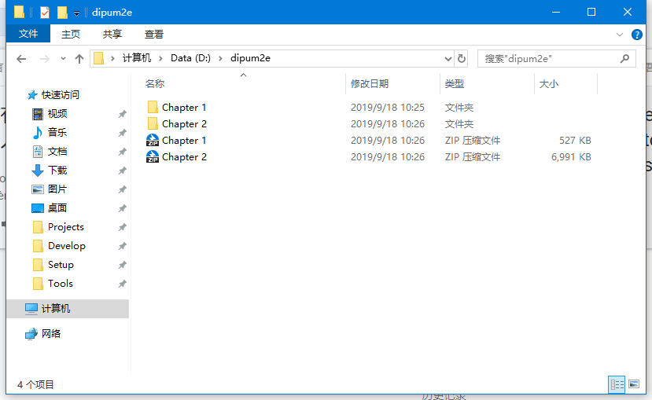

**Attention**: *the computer in lab A506 has a restore system, and the files in the C drive will be restored after rebooting, your personal files will be deleted. Please save personal files in the D drive, which will be saved after rebooting.*

**Step 3**, open the folder in MATLAB, here is an example of “Chapter 1”.

**Step 3.1**, navigate to “D:\dipum2e”

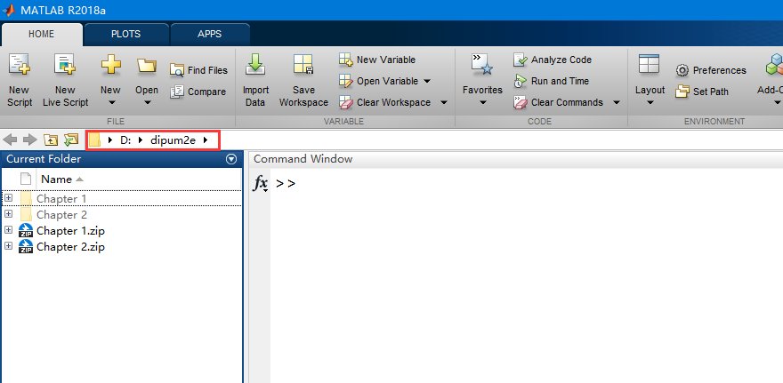

**Step 3.2**, double click “Chapter 1” to make it your current folder