1. Write a shell script that displays a list of all the

files in the current directory.

Sol:

#!/bin/sh

echo $(ls -l)

2. Write a shell script to echo the string length of

the given string as argument.

Sol:

Using command line arguments

#!/bin/sh

for i in $*

do

echo "${#i}"

done

#### Output:

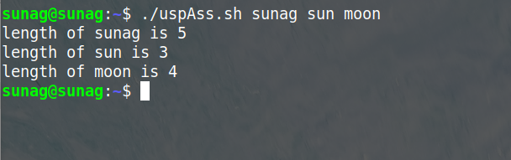

3. Write a shell script to find the factorial of given

Integer.

Sol:

echo "enter number"

read num

x=num

fact=1

while [ $num -gt 1 ]

#for i in {1..$(num + 1)}

do

fact=$((fact * num))

num=$((num - 1))

done

echo factorial of $x $fact

Output:

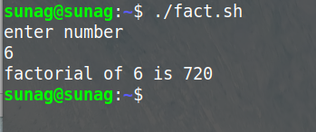

4. Write a shell script that lists all files in a

directory.

Sol:

#!/bin/sh

echo Enter path of directory to get its files

read p

ls $p

Output:

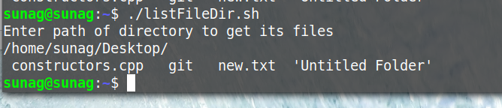

1. Write a shell script if a directory exists or not.

Sol:

#!/bin/sh

echo enter path of directory

read x

if [ -d "$x" ]

then

echo yes directory exist

else

echo no directory does not exist

Fi

Output:

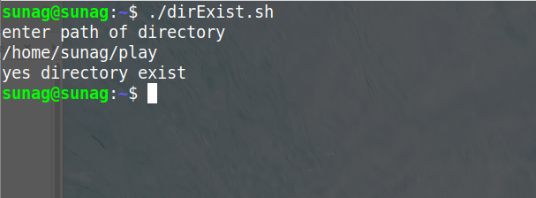

1. Write a shell script to depict case statement

Sol:

#!/bin/sh

echo enter a number to check +ve or -ve

read num

case $((num > 0)) in

0)

echo negative number

;;

1)

echo positive number

;;

*)

echo neither

;;

esac

Output:

