**B.M.S College of Engineering**

**P.O. Box No.: 1908 Bull Temple Road,**

**Bangalore-560 019**

**DEPARTMENT OF INFORMATION SCIENCE & ENGINEERING**



**Course – Unix System Programming**

**Course Code – 19IS4PWUSP**

**AY 2019-20**

**Report on Unix System Programming Project**

**Automating Stock price**

Submitted by

Sunag P,1BM19IS162

Sumith Hegde, 1BM19IS161

Venkatesh C, 1BM19IS177

Submitted to

[Sandeep Varma N](mailto:sandeepvarma.ise@bmsce.ac.in)

**B.M.S College of Engineering**

**P.O. Box No.: 1908 Bull Temple Road,**

**Bangalore-560 019**

**DEPARTMENT OF INFORMATION SCIENCE & ENGINEERING**



**CERTIFICATE**

Certified that the Project has been successfully presented at **B.M.S College Of Engineering** by **Sunag P , Sumith Hegde and Venkatesh C** bearing USN: **1BM19IS162,1BM19IS161 and 1BM19IS177**in partial fulfillment of the requirements for the IV Semester degree in **Bachelor of Engineering in Information Science & Engineering**of **Visvesvaraya Technological University, Belgaum** as a part of project for the course **Unix System Programming(**19IS4PWUSP**)** during academic year 2019-2020.

**Faculty Name –** [Sandeep Varma N](mailto:sandeepvarma.ise@bmsce.ac.in)

**Designation – Assistant Professor**

**Department of ISE, BMSCE**

**Table of Contents**

**Abstract**

**1. Introduction ……………………………………………………………………………….**

**2. Problem Statement …………………………………………………………………….**

**3. APIs Used in Project ……………………..…………………………………………….**

**4. Implementation/Code ……………………………………………….……………….**

**5. Conclusion…………………………………………………………………………………….**

**6.Snapshots …………………………………………………………………………………….**

**Abstract :-**

Investing in the stock market is very closely related to the ups and downs of stock prices.Predicting stock market movements is a well-known problem of interest. Now-a- days social media is perfectly representing the public sentiment and opinion about current events.

In this report we have discussed about a Shell Script based project that automates the stock price details based on NIFTY50 website from time to time and keeps track of the stocks bought by the user and automatically notifies the user if there are drastic fluctuations in the stock prices.

**Introduction:-**

The development of stock prices is an important indicator for investors to find out market behavior. Investment grade announcements are often associated as one of the events that can affect stock price fluctuations.

Many online trading platforms provide analysis of stocks, which helps the users to find the

status of the stock market. This also helps them predict the situation of stocks in upcoming

days and shape their decisions .

Notifying the fluctuations in the price at the right time becomes very crucial and helps them in making the right decision .

Our project does the same by sending email and whats app messages from time to time and keeps track of the stocks bought by the user and automatically notifies the user if there are drastic fluctuations in the stock prices.

**Problem Statement :-**

Requirement of a tool to get updates about stock prices periodically and quickly update the user whenever there are notable fluctuations so as to help users in making suitable decisions.

**APIs Used :-**

● CRONTAB

It is a time based job-scheduler in unix like computer operating system.We use

this to automate the task of updating prices of stocks.

● CURL

curl is a command-line tool for getting or sending files using URL syntax

From all the data obtained from the output of curl, only necessary information can be extracted for further use.

● SMTPLIB

The SMTPLIB is used for sending the clients notification about the price

fluctuations through emails.

● PYWHATKIT

Python API for sending the clients notification about the price

fluctuations through WhatsApp.

**Implementation/code :-**

Complete code of our implementation can be found at

[OUR GITHUB Repo](https://github.com/SunagP/Stock-Automation_ShellScript-)

**Results/Snapshots:-**

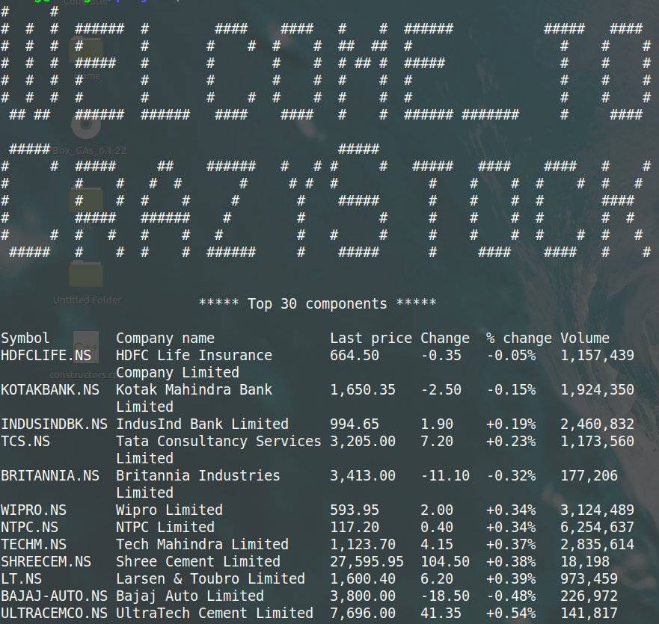

Fig-1 Welcome page

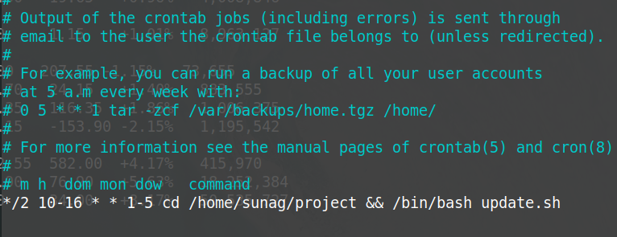

Fig-2 Automatic updation of stock price every 2 minutes using crontab

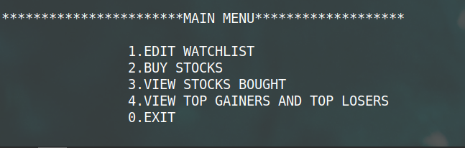

Fig-3 Main menu

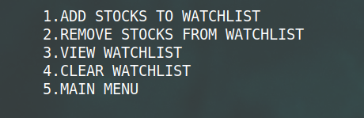

Fig-4 Menu under edit watch-list

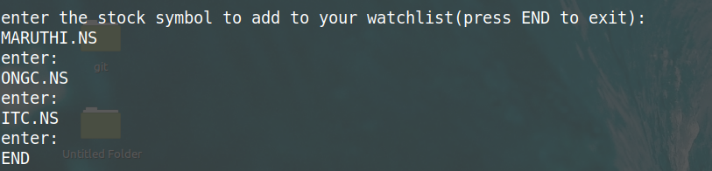

Fig-5 Adding stocks to Watch-list

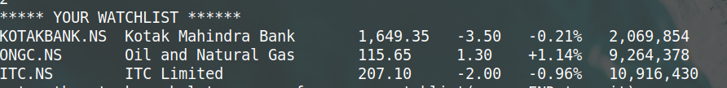

Fig-6 View watch-list

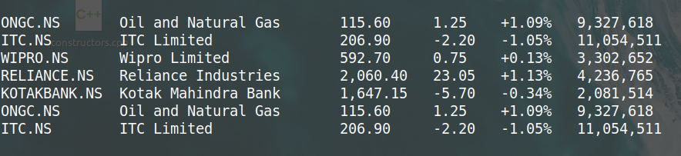

Fig-7 Bought stocks

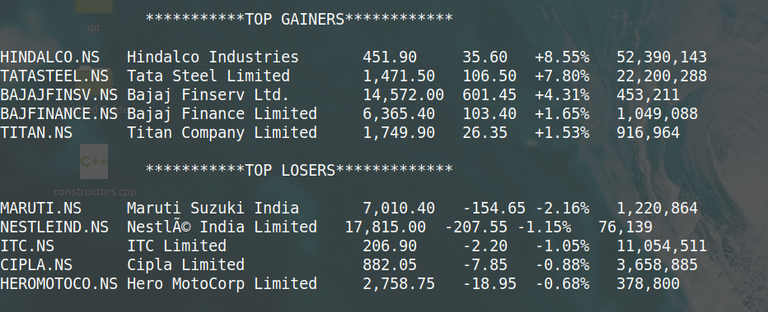

Fig-8 top gainers and top losers