Lab-6
June 23, 2021

- Create a child thread to display the message 10 times “Child Thread” and “Parent Thread” using thread class
class child extends Thread
{
public void run()
{
for(int i=0;i<10;i++)
{
System.out.println(i+" child Thread");
}
}
}

public class childThread
{
public static void main(String args[])
{

child c = new child();

c.start();
try{
c.join();
}
catch(Exception e)
{
System.out.println(e);
}

for(int i=0;i<10;i++)
{
System.out.println(i+" parent Thread");
}
}
}

Output:

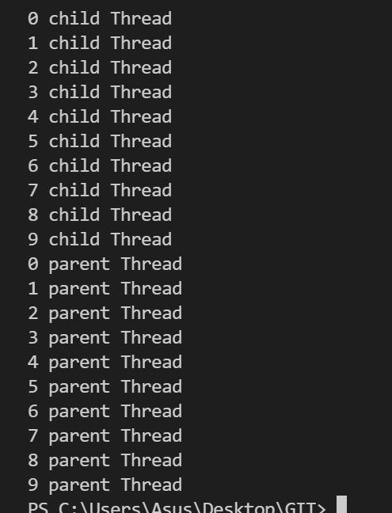

- Create a child thread to display the message 10 times “Child Thread” and “Parent Thread” using
runnable interface

class child2 implements Runnable
{
public void run()
{
for(int i=0;i<10;i++)
{
System.out.println(i+" child Thread");
}
}
}

public class childThread
{
public static void main(String args[])
{

child2 t = new child2();
Thread c = new Thread(t);

c.start();
try{
c.join();
}
catch(Exception e)
{
System.out.println(e);
}

for(int i=0;i<10;i++)
{
System.out.println(i+" parent Thread");
}
}
}

Output:

3) Develop a program to create three child threads that performs the following operations i) The first thread displays numbers which are multiples of 10 from 1 to 100. ii) The second thread displays all even numbers from 1 to 100. iii) The third thread displays numbers
which are multiples of 5 between 1 and100.
- For the above program, by calling the appropriate methods ensure that the main thread is the last to execute and display whether the threads are alive. Hint : use isalive() and join().

class multen extends Thread
{
public void run()
{
for(int i=1;i<=100;i++)
{
if(i%10==0)
System.out.println("Multiple of 10 - "+i);
}
}
}

class even extends Thread
{
public void run()
{
for(int i=1;i<=100;i++)
{
if(i%2==0)
System.out.println("even number - "+i);
}
}
}

class mulfive extends Thread
{
public void run()
{
for(int i=1;i<=100;i++)
{
if(i%5==0)
System.out.println("Multiple of 5 - "+i);
}
}
}

public class threeThread
{
public static void main(String args[])
{
multen obj1 = new multen();
even obj2 = new even();
mulfive obj3 = new mulfive();

obj1.start();
obj2.start();
obj3.start();

System.out.println("Thread 1 IS "+obj1.isAlive());
System.out.println("Thread 2 IS "+obj2.isAlive());
System.out.println("Thread 3 IS "+obj3.isAlive());

try{
obj1.join();
obj2.join();
obj3.join();
}
catch(Exception e)
{
System.out.println(e);
}
System.out.println("main is the last to execute");

}
}

Output:
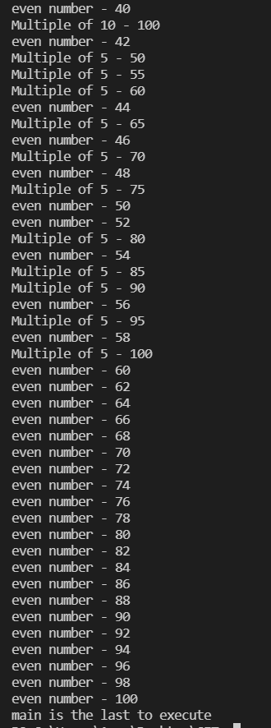

- Write a program to implement a dynamic growable queue using generics.

Code:
import java.util.Scanner;
import java.util.ArrayList;
class queue<T>
{
ArrayList<T> q=new ArrayList<T>();
int currentSize=0;
void enqueue(T a)
{
q.add(a);
currentSize++;
}
void dequeue()
{
if(q.isEmpty()==true)
{
System.out.println("queue is empty cant dequeue");
}
else
{
System.out.println(q.get(0)+" is dequed");
q.remove(0);
currentSize--;
}
}
}
class QueueGrowable
{
public static void main(String[] args)
{
queue<Integer> S=new queue<Integer>();
queue<Double> S2=new queue<Double>();
queue<String> S3=new queue<String>();
Scanner sc=new Scanner(System.in);
int x,y;
System.out.println("enter 1 for integer");
System.out.println("enter 2 for double");
System.out.println("enter 3 for string");
y=sc.nextInt();
if(y==1){
do
{
System.out.println("enter 0 to exit");
System.out.println("enter 1 to enqueue");
System.out.println("enter 2 to dequeue");
// System.out.println("enter 3 to display top element");
x=sc.nextInt();

switch(x)
{
case 1 : int n;
System.out.println("enter element to be pushed:");
n=sc.nextInt();
S.enqueue(n);
break;
case 2 : S.dequeue();
break;
// case 3 : S2.displayTop();
// break;
case 0 : break;
}
} while(x>0);
}
if(y==2){
do
{
System.out.println("enter 0 to exit");
System.out.println("enter 1 to enqueue");
System.out.println("enter 2 to dequeue");
// System.out.println("enter 3 to display top element");
x=sc.nextInt();

switch(x)
{
case 1 : double n;
System.out.println("enter element to be pushed:");
n=sc.nextDouble();
S2.enqueue(n);
break;
case 2 : S2.dequeue();
break;
// case 3 : S2.displayTop();
// break;
case 0 : break;
}
} while(x>0);
}
if(y==3){
do
{
System.out.println("enter 0 to exit");
System.out.println("enter 1 to enqueue");
System.out.println("enter 2 to dequeue");
// System.out.println("enter 3 to display top element");
x=sc.nextInt();

switch(x)
{
case 1 :
String n;
System.out.println("enter element to enqueue:");
n=sc.next();
S3.enqueue(n);
break;
case 2 : S3.dequeue();
break;
// case 3 : S3.displayTop();
// break;
case 0 : break;
}
} while(x>0);
}

}
}

Output:
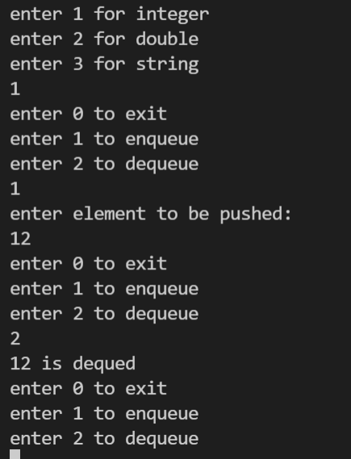

6)Consider a Bus reservation system that allows online reservations to its customers. Suppose there are two transactions of reservation for a particular seat simultaneously which leads to race condition. Develop a solution to avoid the unpredictable situation with a program.

class TicketBooking implements Runnable{
int ticketsAvailable=1;
public void run(){
System.out.println("Waiting to book ticket for : "+Thread.currentThread().getName());
synchronized (this) {
if(ticketsAvailable>0){
System.out.println("Booking ticket for :"+Thread.currentThread().getName());

try{
Thread.sleep(1000);
}catch(Exception e){}
ticketsAvailable--;
System.out.println("Ticket BOOKED for : "+ Thread.currentThread().getName());
System.out.println("currently ticketsAvailable = "+ticketsAvailable);
}
else{
System.out.println("Ticket NOT BOOKED for : "+
Thread.currentThread().getName());
}
}
}
}
public class busReservation {
public static void main(String args[])
{
TicketBooking obj=new TicketBooking();

Thread thread1=new Thread(obj,"Passenger 1 Thread");
Thread thread2=new Thread(obj,"Passenger 2 Thread");

thread1.start();
thread2.start();
}
}

Output:
