JAVA Lab 1

Sunag P(1BM19IS162)

1)

  Programing assigment for Java lab to be executed on 21st April 2021.   
1. Write a Java Class Student to meet the following specification:  
     The class should be able to support a 5 digit student ID, student name, marks for 3 subjects. You should have methods to set and get each of the attributes and calculate the average for the student.

Code:

package javacodes;

import java.util.Scanner;

import java.util.\*;

public class student {

    int id;

    String name;

    int m1,m2,m3;

    float avg;

    void input(){

        Scanner sc= new Scanner(System.in);    //System.in is a standard input stream

        System.out.print("Enter id : ");

        id = sc.nextInt();

        System.out.print("Enter name : ");

        name = sc.next();

        System.out.print("Enter marks in subjects 1 : ");

        m1 = sc.nextInt();

        System.out.print("Enter marks in subjects 2 : ");

        m2 = sc.nextInt();

        System.out.print("Enter marks in subjects 3 : ");

        m3 = sc.nextInt();

    }

    // void input(int id,String){

    // }

    void disp(){

        System.out.println("Student id :"+id+"\n");

        System.out.println("Student id :"+name+"\n");

        System.out.println("Average of 3 subjects :"+((m1+m2+m3)/3.0)+"\n");

    }

}

class Main{

    public static void main(String[] args){

   student s = new student();

   s.input();

   s.disp();

    }}

Output :

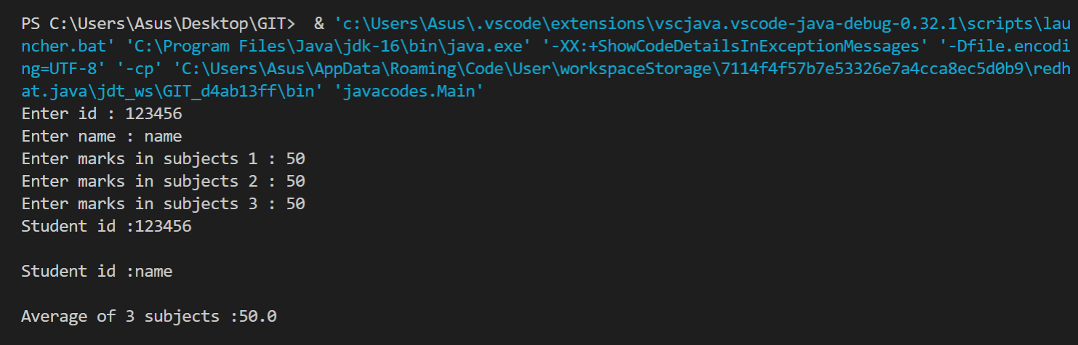

1. Design and write a class to represent a bank account that includes the following members:  
      a. Data members:  
           owner name,account number, balance amount in the account  
      b. Methods members:  
          I) to assign initial values  
         ii) to deposit an amount  
         iii) to withdraw an amount after checking balance  
         iv) to display the owner name and balance  
      Write a main method for the above class that reads in the initial values from the keyboard.

Code :

package javacodes;

import java.util.Scanner;

class bank

{

    String name,accNum;

    int bal=0;

    void read()

    {

        Scanner sc=new Scanner(System.in);

        System.out.println("Enter customer name: \n");

        name=sc.next();

        System.out.println("Enter account number: \n");

        accNum=sc.next();

    }

    void disp()

    {

        System.out.println("name: "+name);

        System.out.println("account number: "+accNum);

        System.out.println("Current Balance: "+bal);

    }

    void deposit()

    {

        Scanner sc=new Scanner(System.in);

        System.out.println("enter amount to be deposited: ");

        int d=sc.nextInt();

        bal=bal+d;

        System.out.println(d+" deposited");

    }

    void withdraw()

    {

        Scanner sc=new Scanner(System.in);

        System.out.println("enter amount to be withdrawn: ");

        int w=sc.nextInt();

        if(bal>=w)

        {

            bal=bal-w;

            System.out.println(w+" withdrawn");

        }

        else

        {

            System.out.println("low balance cannot withdraw");

        }

    }

}

class bankMain

{

    public static void main(String[] args)

    {   Scanner sc=new Scanner(System.in);

        bank b=new bank();

        b.read();

        b.disp();

        // b.deposit();

        // b.disp();

        // b.withdraw();

        // b.disp();

        int ch=1;

        while(ch!=0){

        System.out.println("Enter your choice :::\n1.Withdrawl\n2.Deposit\n3.Display\n0.Exit");

        ch=sc.nextInt();

        switch(ch){

          case 1: b.withdraw();break;

          case 2: b.deposit();break;

          case 3: b.disp();break;

          case 0:break ;

        }

    }

    }

}

Output :

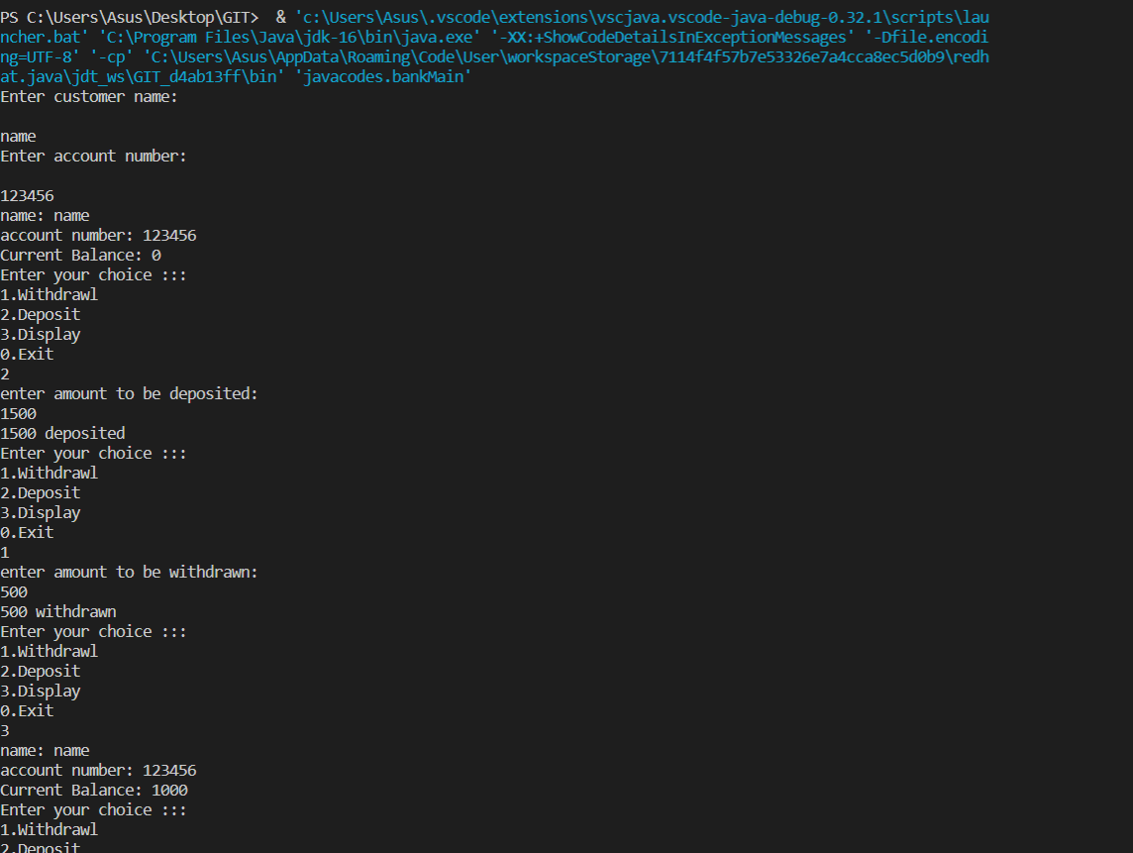

1. Design and create a class named Retail Item that holds data about an item in a retail store. The class should have the following fields:

· Description - The description field references a String object that holds a brief description of the item.

· Units - The units field is an int variable that holds the number of units currently in inventory.

· Price - The price field is a double that holds the item’s retail price.

Write appropriate mutator methods that store values in these fields, and accessor methods that return the values in these fields. Write the main method which creates one Retail Item object and invokes appropriate methods

Code:

package javacodes;

import java.util.Scanner;

import java.util.\*;

public class retail {

    Scanner sc= new Scanner(System.in);

    int unit;

    float price;

    String desc;

    retail(){

     unit = 1;

     price = 1;

    }

    void desc(){

            //System.in is a standard input stream

        System.out.println("Enter description of product :\n");

        desc = sc.next();

    }

    void input(){

        System.out.println("Enter Number of units :\n");

        unit = sc.nextInt();

        System.out.println("Enter price :\n");

        price = sc.nextFloat();

    }

    void disp(){

        System.out.println("Description of product : "+desc);

        System.out.println("Number of units : "+unit);

        System.out.println("total price : "+(unit\*price));

    }

}

class mainfun{

    public static void main(String[] args){

        retail r = new retail();

        r.disp();

        r.desc();

        r.input();

        r.disp();

    }

}

Output :

