Lab -3

May 5, 2021

1. Consider an example of declaring the examination result. Design three classes: Student, Exam and Result. The student class has data members such as those representing roll number, name etc. Create the Exam by inheriting Student class. The Exam class adds fields representing the marks scored in six subjects. Derive Result from the Exam class and it has its own fields such as total_marks. Develop a Java program for this.

Code :

import java.util.Scanner;

public class studInherit {

    String name;

    int id;

    Scanner sc = new Scanner(System.in);

    void input()

    {

      System.out.println("Enter name :");

      name  = sc.next();

      System.out.println("Enter id :");

      id = sc.nextInt();

    }

    void disp(){

        System.out.println("Name : "+name);

        System.out.println("Id : "+id);

    }

}

class exam extends studInherit{

    int m[] = new int[6];

    Scanner sc = new Scanner(System.in);

    void setmarks(){

        System.out.println("Enter marks in 6 Subjects : ");

        for(int i=0;i<6;i++){

        m[i] = sc.nextInt();

        }

    }

    void dispmarks(){

        System.out.println("marks scored in 6 Subjects : ");

        for(int i=0;i<6;i++){

       System.out.println("subject "+(i+1)+" : "+m[i]);

        }

    }

}

class result extends exam{

    int total = 0;

    void dispres(){

        for (int i =0;i<6;i++){

        total += m[i];

        }

        int avg = total/6;

        System.out.println("Total marks scored in 6 subjects : "+total);

        System.out.println("Average marks scored in 6 subjects : "+avg);

        if(avg>=90 && avg<=100)

        {

            System.out.println("Grade : S");

        }

        if(avg>=80&&avg<90)

        {

            System.out.println("Grade : A");

        }

        if(avg>=60&&avg<80)

        {

            System.out.println("Grade : B");

        }

        if(avg>=50&&avg<60)

        {

            System.out.println("Grade : C");

        }

    }

}

class testSt{

    public static void main(String[] args){

        result r = new result();

        r.input();

        r.setmarks();

        r.disp();

        r.dispmarks();

        r.dispres();

    }

}

Output:

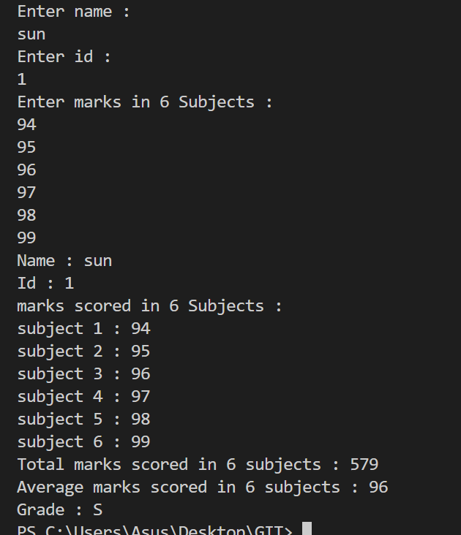

2)    Develop a Java program which demonstrates derivation of a specialized class Mango

from a base class Fruit using features of inheritance.

       Fruit class details:

                        Member variables: Unitprice, quantity

                        Method:                      totalcost: compute cost

                                                            readData: for reading member variables

                                                            display: display method

                 Mango class derived from Fruit class:

                                    Member variables:      name, taste

                                    Method:                      makeJuice: additional method

            Create a driver class and show the functionalities.

Code:

import java.util.Scanner;

public class fruits {

  int price;

  float q,t;

  Scanner sc = new Scanner(System.in);

  void read(){

      System.out.println("Enter unit price : ");

      price = sc.nextInt();

      System.out.println("Enter quantity in kg : ");

      q = sc.nextFloat();

  }

  void total(){

    t = price*q;

    System.out.println("Total amount to be paid : "+t);

  }

  void disp(){

    System.out.println("unit price : "+price);

    System.out.println("quantity required in kg : "+q);

  }

}

class mango extends fruits{

    String name,taste;

    void readm(){

        System.out.println("Enter type of mango : ");

        name = sc.next();

        System.out.println("What is the taste of it?? : ");

        taste = sc.next();

    }

    void makeJuice(){

        if(taste.equals("sweet")){

            System.out.println("Woah..! it's best suited for making juices");

            System.out.println("do you want to try it??y/n");

            String ch = sc.next();

            if(ch.equals("y")){

                System.out.println("Enter number glasses you want");

                int qu = sc.nextInt();

                System.out.println("Total bill amount :"+(qu*45));

            }

            if(ch.equals("n")){

                System.out.println("Thank you !!!");

            }

        }

        if(taste.equals("sour")){

            System.out.println("It's not best suited for making juices");

        }

        // else{

        //     System.out.println("cannot make juice with this taste");

        // }

    }

}

class testfruit{

    public static void main(String[] args){

        mango m = new mango();

        m.read();

        m.disp();

        m.total();

        m.readm();

        m.makeJuice();

    }

}

Output:

