# Lab-5

### June 2, 2021

2b. Define one class A in package apack. In class A, four variables are defined of access

modifiers default, protected, private and public. Define class B in package bpack which

extends A and write display() method which access variables of class A. Define class C

in package cpack which has one method display() in that create one object of class A

and display its variables. Define class ProtectedDemo in package dpack which

contains the main () method. Create objects of class B and C and call display method for

both these objects. Analyze the program by interpreting the access modifiers and provide

valid conclusion.

### Code:

package mypack.apack;

public class a {

    int x;

    protected int y;

    private int z;

    public int w;

    public a(){

        x=1;

        y=2;

        z=3;

        w=4;

    }

}

package mypack.bpack;

import mypack.apack.*;

public class b extends a{

    public void disp(){

        System.out.println("Class B");

        // System.out.println(" x :"+x);

        System.out.println("protected y :"+y);

        // System.out.println("z :"+z);

        System.out.println("public w :"+w);

    }

}

package mypack.cpack;

import mypack.apack.*;

import mypack.bpack.*;

public class c {

    public void disp(){

        a obj = new a();

        System.out.println("Class C");

        // System.out.println("x : "+obj.x);

        // System.out.println("y : "+obj.y);

        // System.out.println("z : "+obj.z);

        System.out.println("public w : "+obj.w);

    }

}

package mypack.dpack;

import mypack.apack.*;

import mypack.bpack.*;

import mypack.cpack.*;

public class protectedDemo {

    public static void main(String[] args) {

        b ob = new b();

        c oc = new c();

        ob.disp();

        oc.disp();

    }

}

Output:

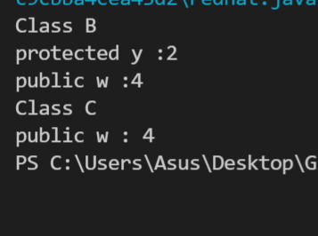

3 a. Consider a student examination database system that prints the mark sheet of the

students. Input the following from the command line student name and marks in 6

subjects. These marks should be in between 0 and 50 if the marks are not in the specified

range raise a Range Exception else find the total marks and print the percentage of the

student.

Code:

import org.w3c.dom.ranges.RangeException;

// import RangeException;

public class cmdExcep {

        public static void main(String args[]){

         String name = args[0];

         int m[] = new int[6];

         int k = 0;

         int sum=0;

        for(int i=1;i<7;i++) {

        //    if(int(args[i])>50 || args[i]<0)

         m[k]=Integer.parseInt(args[i]);

         k++;

        }

        for(int i=0;i<6;i++) {

            if(m[i]>50 || m[i]<0){

                  throw new ArithmeticException("invalid marks "+m[i]);

            }

            else{

                // for(int j=0;j<6;j++) {

                    //    if(int(args[i])>50 || args[i]<0)

                    //  m[i]=Integer.parseInt(args[i]);

                    sum+=m[i];

                    // }

                // System.out.println("Name :"+name);

                // System.out.println("percentage :"+(sum*100)/300);

            }

            }

            System.out.println("Name :"+name);

            System.out.println("percentage :"+(sum*100)/300);

        // System.out.println(args[i]);

        }

        }

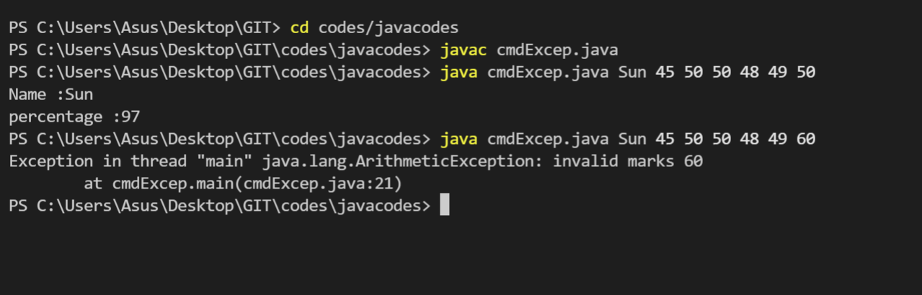

Create a class temperature with member variable temp. Implement exception handling to test if temperature is equal to zero.

Code:

import java.util.Scanner;

public class tempExcep {

        static void checkTemp(int temp) {

          if (temp == 0) {

            throw new ArithmeticException("temperature is 0");

          }

          else {

            System.out.println("temperature is "+temp);

          }

        }

        public static void main(String[] args) {

          Scanner sc = new Scanner(System.in);

          int temp = sc.nextInt();

          checkTemp(temp);

          sc.close();

        }

}

Output:

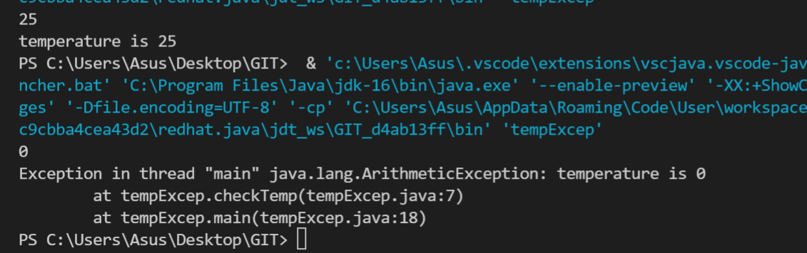

Implement a growable stack using interface and class. Interface will contain abstract methods push() and pop().

Code:

import java.util.Scanner;

import java.util.ArrayList;

interface operations

{

    void pop();

    void push(int a);

    void displayTop();

}

    class stack2 {

    ArrayList<Integer> stack=new ArrayList<Integer>();

    int currentSize=0;

    void push(int a)

    {

        stack.add(a);

        currentSize++;

    }

    void pop()

    {

        if(stack.isEmpty()==true)

        {

            System.out.println("stack is empty cant pop");

        }

        else

        {

            System.out.println(stack.get(currentSize-1)+" is poped");

            stack.remove(currentSize-1);

            currentSize--;

        }

    }

    void displayTop()

    {

        if(stack.isEmpty()==true)

        {

            System.out.println("stack is empty cant pop");

        }

        else

        {

            System.out.println(stack.get(0));

        }

    }

}

public class stack1

{

    public static void main(String[] args)

    {

        stack2 S=new stack2();

        Scanner sc=new Scanner(System.in);

        int x;

        do

        {

            System.out.println("enter 0 to exit");

            System.out.println("enter 1 to push");

            System.out.println("enter 2 to pop");

            System.out.println("enter 3 to display top element");

            x=sc.nextInt();

            switch(x)

            {

                case 1 : int n;

                         System.out.println("enter element to be pushed:");

                         n=sc.nextInt();

                         S.push(n);

                break;

                case 2 : S.pop();

                break;

                case 3 : S.displayTop();

                break;

                case 0 : break;

            }

        } while(x>0);

        sc.close();

    }

}

Output:

