### Java lab-7

June 30, 2021

1. Create a class called Library. Write a program to manipulate the book information from files by using FileInputStream and FileOutputStream.

### Code:

import java.io.*;

import java.util.Scanner;

public class library

{

public static void main(String args[])

    {

        if(args.length==0)

    {

            System.out.println("error..file name cannot be empty\n");

            return;

    }

else

{

    try( FileInputStream  fin=new FileInputStream(args[0]);

         FileOutputStream fout=new FileOutputStream(args[0]);)

{

    Scanner sc =new Scanner(System.in);

    System.out.print("Enter 0 to stop entiring to the file..\n");

    System.out.print("Enter the Bookname : ");

    String b=sc.nextLine();

    System.out.print("Enter the Author : ");

    String a=sc.nextLine();

    while(!b.equals("0") && !a.equals("0"))

    {

        String content=b+" : "+a+"\n";

        byte[] x=content.getBytes();

        fout.write(x);

        System.out.print("Enter the Bookname : ");

        b=sc.nextLine();

        System.out.print("Enter the Author : ");

        a=sc.nextLine();

    }

    System.out.println("Library contents are : ");

    int i;

    while((i=fin.read())!=-1)

        System.out.print((char)i);

        sc.close();

    }

    catch(Exception e)

    {

        System.out.println("Error Occurred ..."+e.getMessage());

    }

}

}

}

### Output:

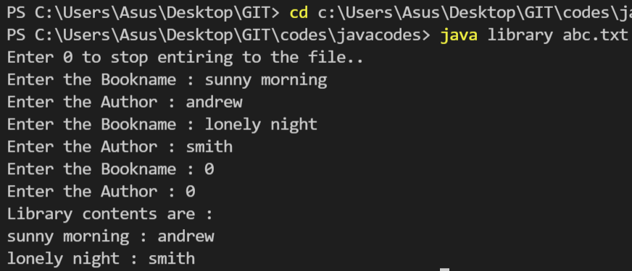

1. Comparing strings

### Code:

public class string {

    public static void main(String[] args) {

        String s1 = "hello";

        String s2 = "hello";

        s1 = "hi";

        String s3 = new String("hi");

        String s4 = new String("hi");

        System.out.println(s1);

        System.out.println(s2);

        System.out.println(s1==s2);

        System.out.println(s3==s2);

        System.out.println(s3==s4);

        // System.out.println(s1.intern());

    }

}

### Output:

