Python Exercise

1) Cell 1:mystring = "hello"
myfloat = 12.0
myint = 20

If we change the value of myfloat to 12.0, the variable myfloat will not be printed in the output.
Output:
String: hello
Integer: 2

‘hello’

2) Cell 2:
third_name = names[2]
print("The third name on the names list is %s" % third_name)
The third name on the name list is Jessica

3) Cell 3:
y_list=[“hello”,”world”]

#increasing the size of list by adding another word

y_list.append(input("enter third word to the list"))

y_list contains 3 objects

4) Cell 4:
def greeting(name):
print("hey " + name + " Welcome to the world of ML")

greeting("Amit")

hey Amit Welcome to the world of ML

5) Cell 5:
class Vehicle:
name = ""
kind = "car"
color = ""
value = 100.00
def description(self):
desc_str = "%s is a %s %s worth $%d" % (self.name, self.color, self.kind, self.value)

return desc_str
car=Vehicle()
car.name='ford'
car.color='white'
car.kind='sedan'
car.value=10000

print(car.description())
Ford is a white sedan worth $10000.00

6) Cell 6:
print(sum(np_weight_kg)/len(np_weight_kg))

90.33833333333335

LinearRegression.ipynb file

1) SKLEARN is an open source Python library that has powerful tools for data analysis and data mining.

2) X = flatdata.iloc [:].values
We will get a list of shape (40,2)
which was previously of shape(40,1).
Inside this list we will get 2d array containing area at 0th position and price at 1st position.
This data set is not valid for plotting a graph as it doesn’t have two parameters .

3) Yes, changing the test size to 25% of t otal data changes the output plot.

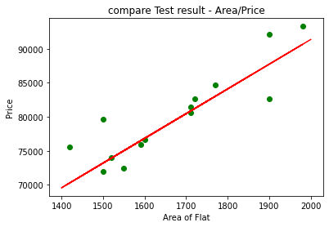
with (1/3)rd test data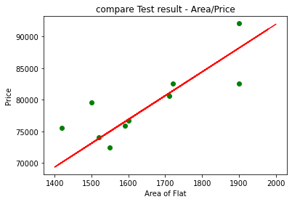 with (1/4)th of test data

4)
Because Classical data modeling can be bolstered using sklearn and Sklearn also helps in Anomaly detection for highly imbalanced datasets (99.9% to 0.1%) and also sklearn is used to divide data as test data and train data which is important aspect for machine learning and also for linear regression.

5)
plt.scatter(X_train, y_train, color = 'green')
plt.scatter(X_test, y_test, color = 'blue')
plt.plot (X_train, regressoragent.predict (X_train), color = 'red')
plt.title ('compare ENTIRE result - Area/Price')
plt.xlabel('Area of Flat')
plt.ylabel('Price')
plt.show()

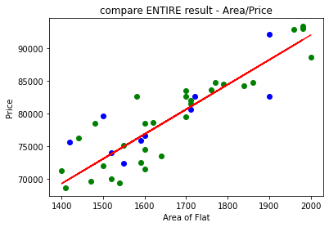
Line fits correctly.

