**ShopperShop**

**Introduction:**

ShopperShop is a Spring MVC and Spring Rest Services project.

Shoppershop is like a shopping store where different items are sold like clothes, toys, rugs etc. This Shoppershop web site is made basically for store’s employees.

Employee can check the inventory and can insert,update or delete inventory.

He can see all the categories of the items, the store sells. He can process an order as well.

The basiclly there are three tables:

‘product’ : It represents the inventory. ‘item-id’ is primary key and is autoincremented.

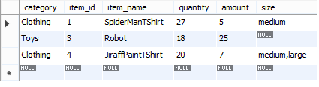

‘orderTable’: represents the order made. ‘order_no’ is primary key and is autoincremented.

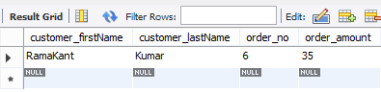

‘orderdetail’ : represents the detail of the order made. ‘order_no’ is the foreign key from ‘ordertable’. ‘item_id’ is the foreign key from the ‘product’ table.

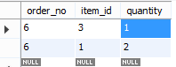



**url used for rest services:**

1. **Request method:get**

<http://localhost:8080/ShopperShop/webservices/items>

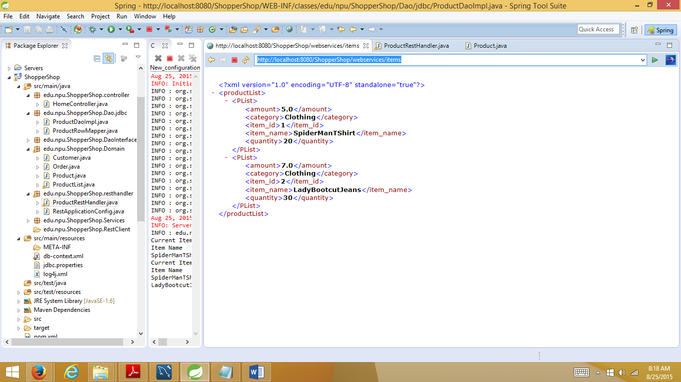

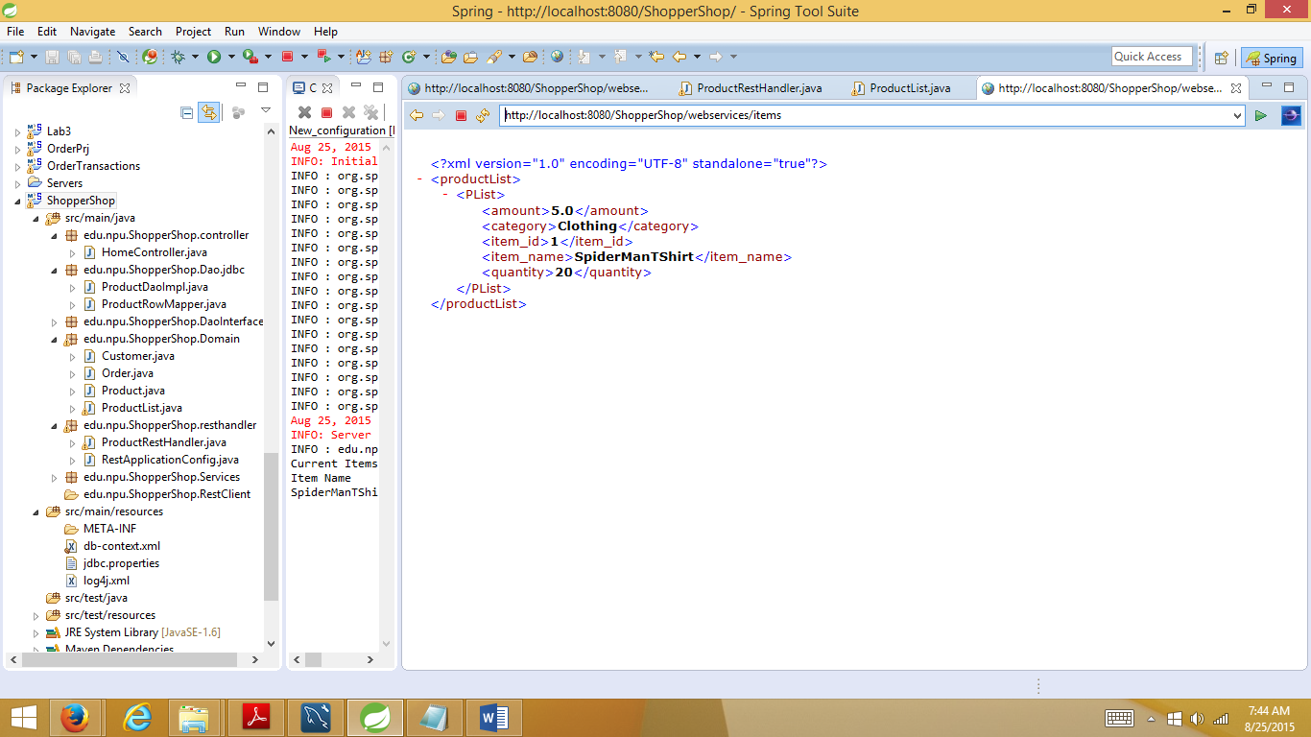

2. **Request method:post**

<http://localhost:8080/ShopperShop/webservices/insert>

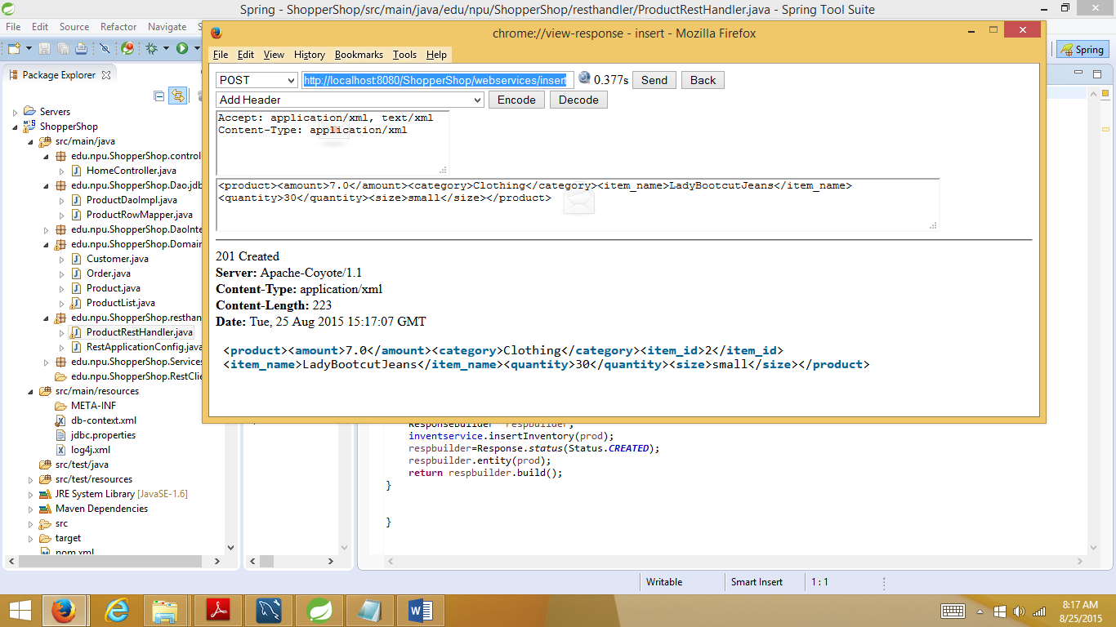

3. **Request method:delete**

<http://localhost:8080/ShopperShop/webservices/delete/2>

http://localhost:8080/ShopperShop/webservices/delete/{item_id}

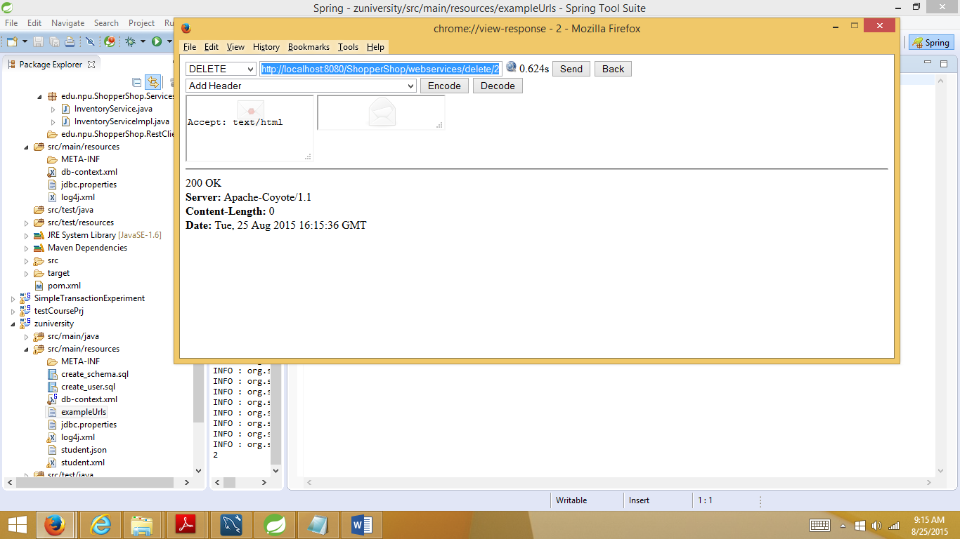

4. **for update:**

**Request method:put**

<http://localhost:8080/ShopperShop/webservices/Update/1/quantity/35>

http://localhost:8080/ShopperShop/webservices/Update/{item_id}/quantity/{quantity}

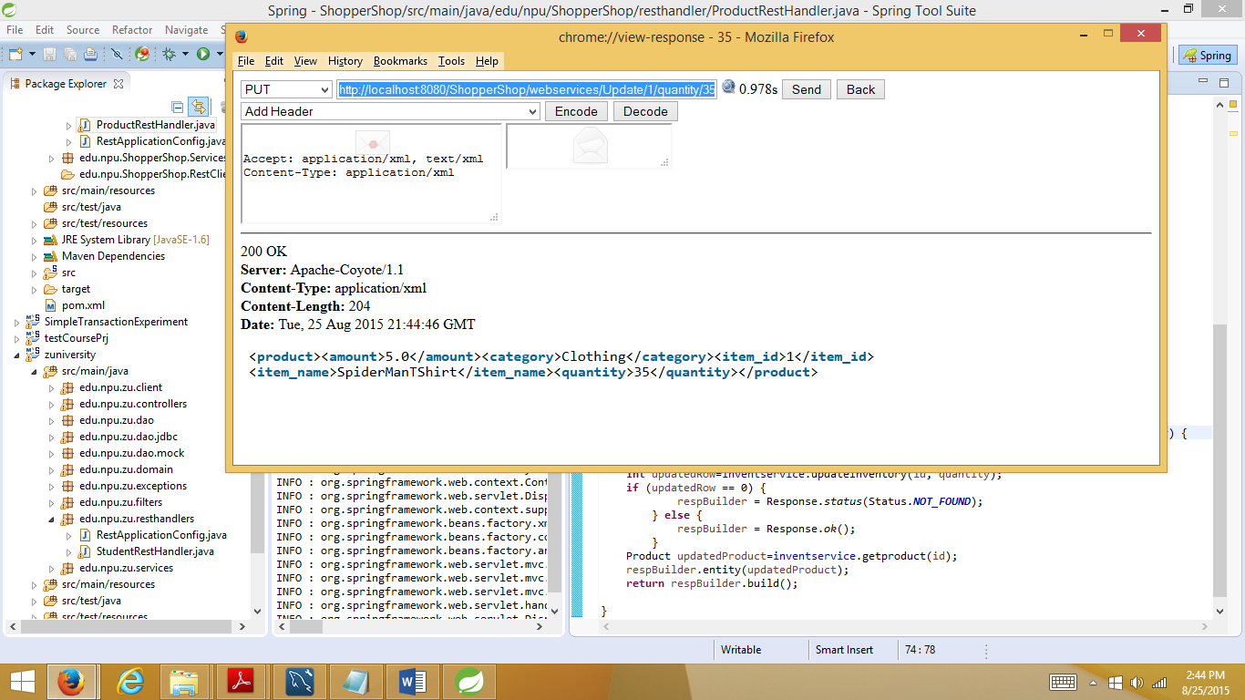

**Spring Controller :**

I have made three Controller classes:

**HomeController.java :** for home page



**OrderController.java:** for dealing with ‘orderTable’ and ‘orderdetail’ class

In this form, employee is entering the order details. Using ‘more’ button, we can order more items in a particular order.

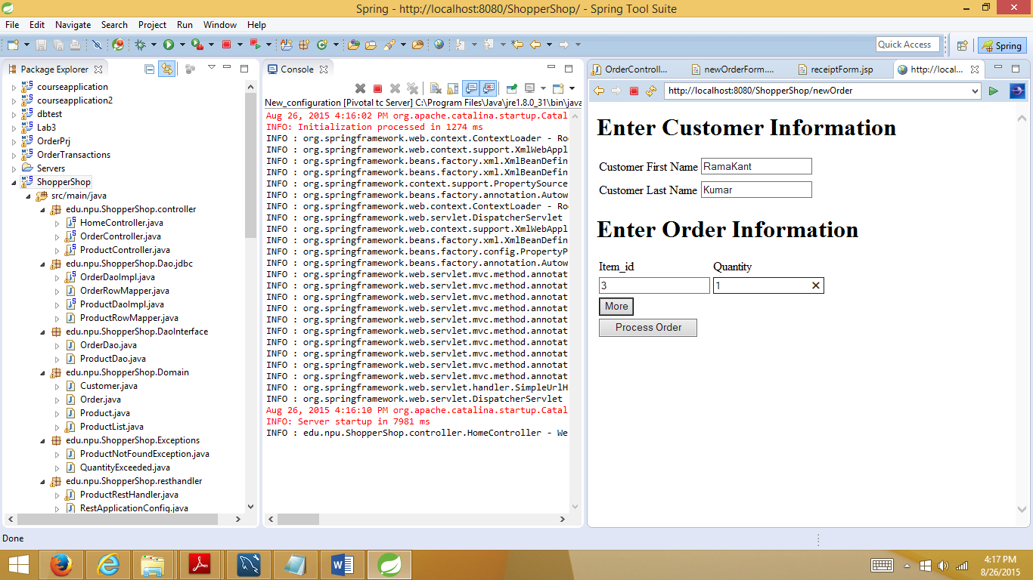

After pressing ‘more’ button

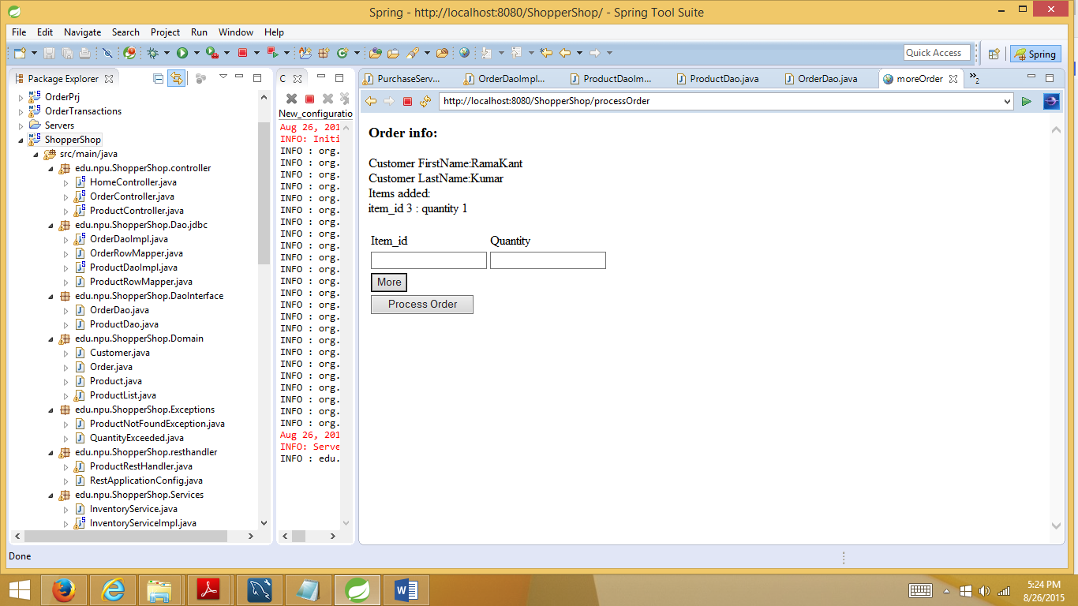

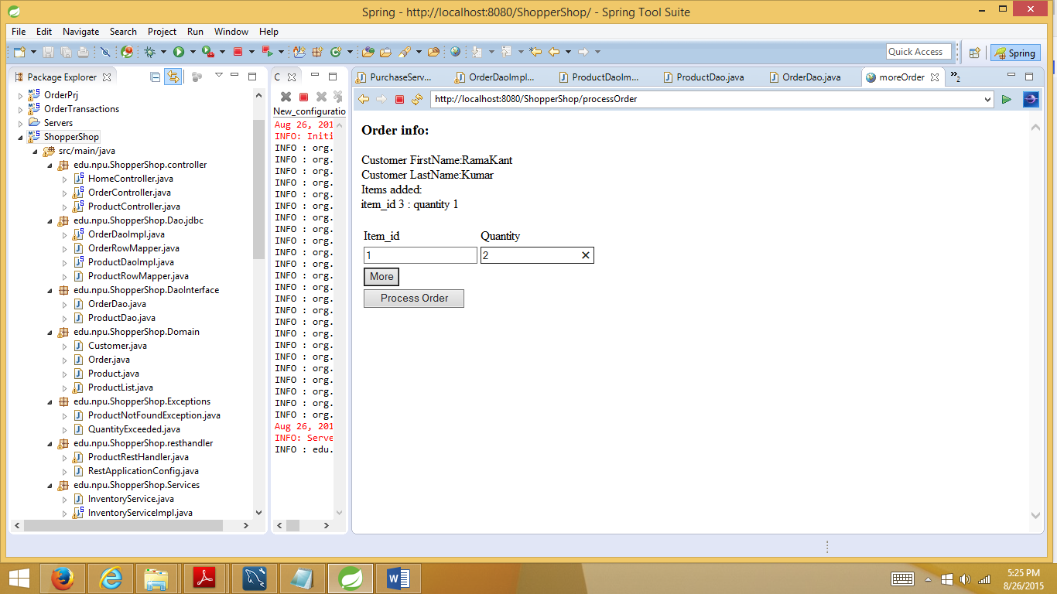

After pressing ‘Process Order’ button

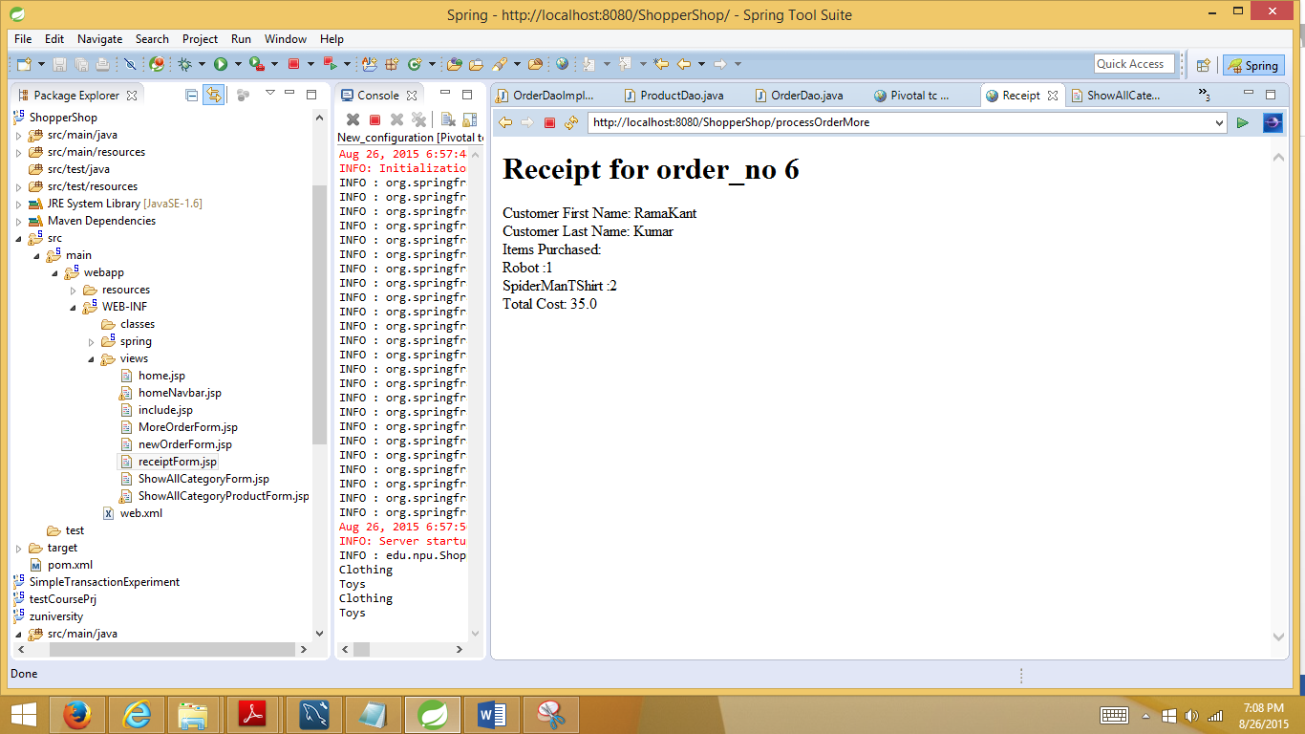

**ProductController.java:** for dealing with ‘product’ class

Shows the categories of items present in inventory:

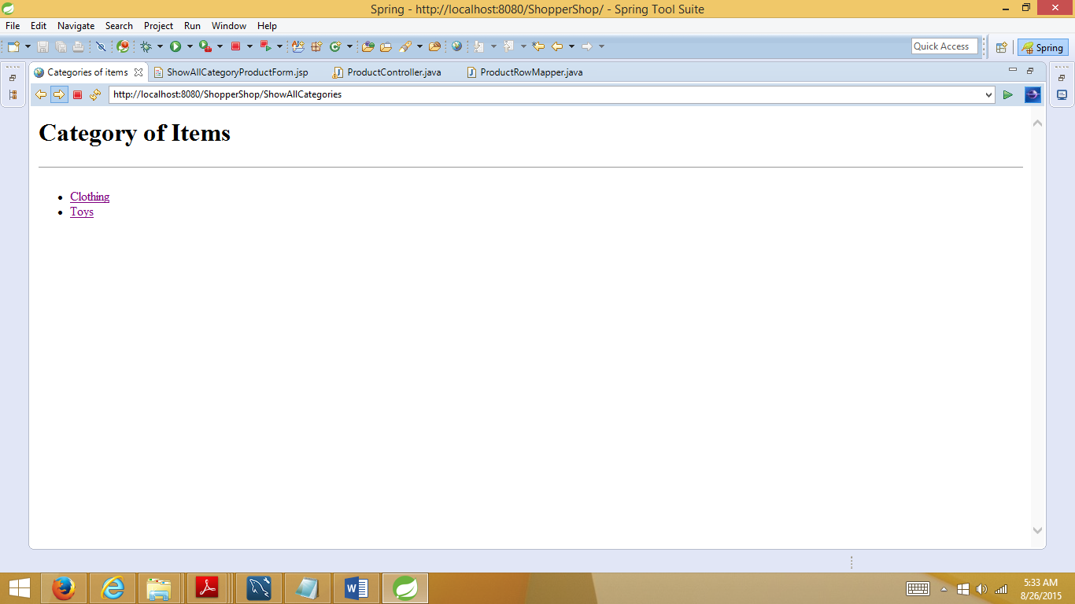

After pressing ‘Clothing’

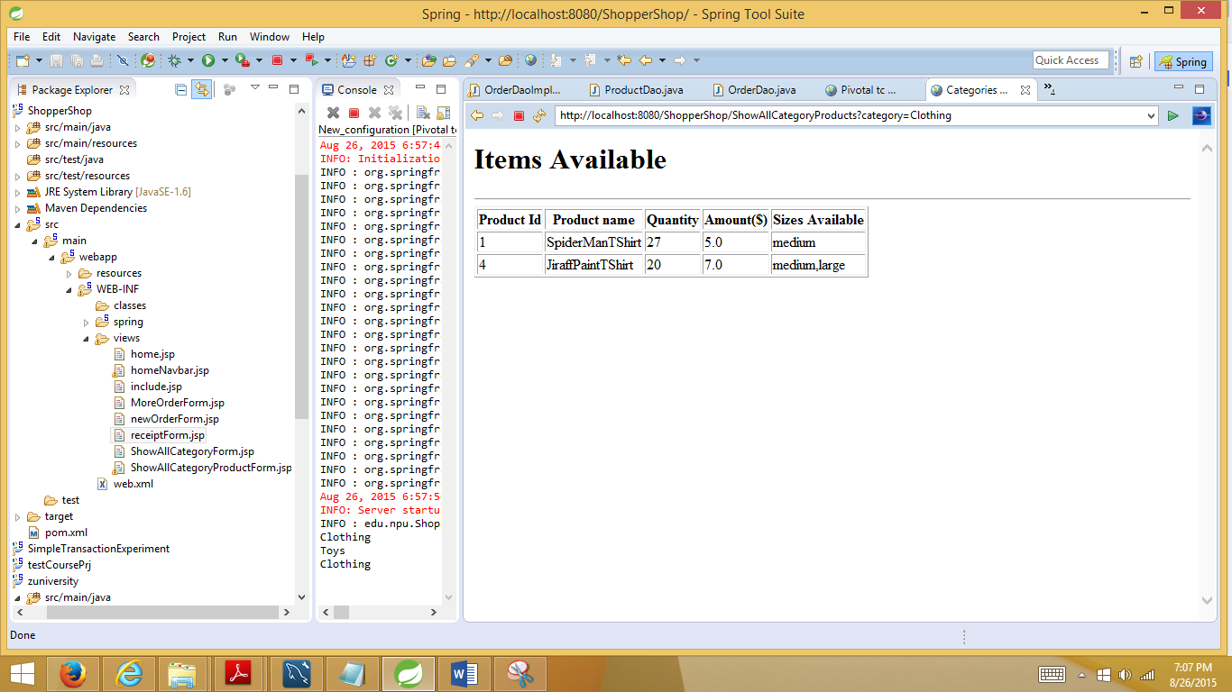

After pressing ‘toys’

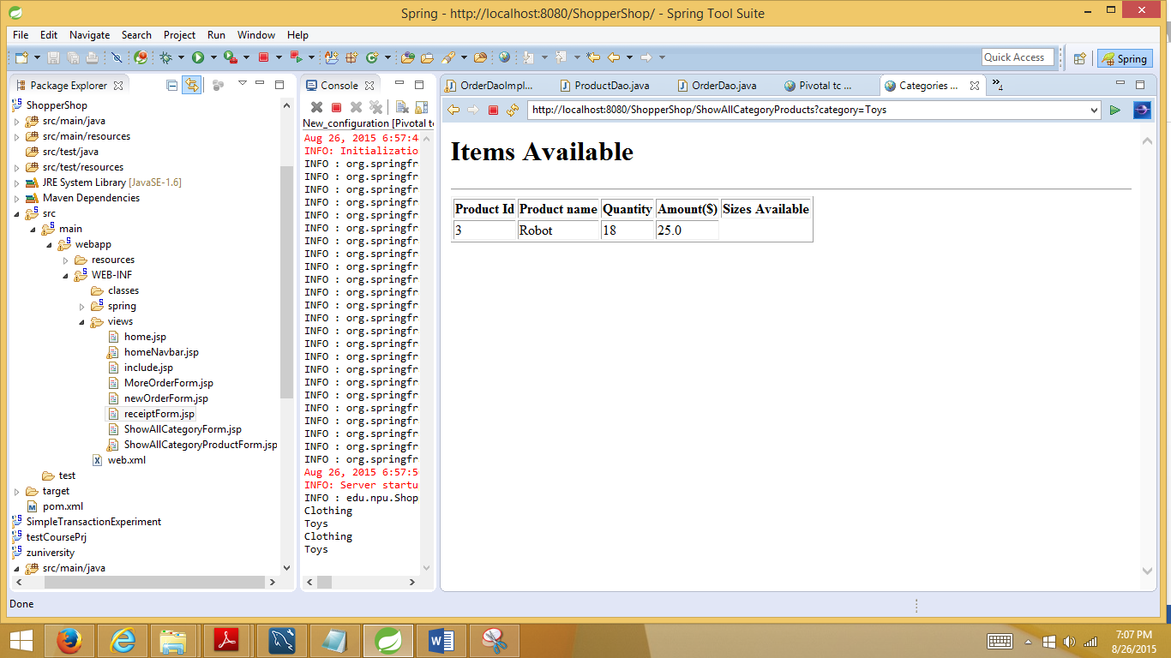

**SQL files are:**

1. ‘create_account.sql’
2. ‘Shopper.sql’

They are in src/main/resources

**Tranactional Service layer:**

@Transactional(rollbackForClassName="QuantityExceeded")

**public** **int** placeOrder(Order or)**throws** ProductNotFoundException,QuantityExceeded{

**int** order_no=orderDao.insertOrder(or); //updates orderTable and orderDetail

inventoryService.adjustInventory(or); //updates product table

**return** order_no;

}