Banking Database Management System
BY : Sunand Agarwal - 160001057
Vishal Maurya - 160001061

INTRODUCTION
The Banking Management System is an application for maintaining a person's in a Bank.
This project is a model internet banking site. This site enables the customers to perform the basic banking transactions by sitting at their office or at homes through their PCs.
The main aim of this project is to provide efficient and secure net banking facilities to the banking customer over the internet.

PROBLEM STATEMENT
* A Customer can have multiple accounts. An account can hold multiple customers, this situation is for a joint account.
* Every customer is given a passbook when creating an account which is updated whenever a transaction is made.
* Some customers may issue a cheque book too.
* The Bank also provides a unique customer_id to each customer which will serve as the Primary key.
* The Address And Name Attributes are composite.
* The phone no attribute would be multi-valued.

* The various types of account can be savings, current, joint Or Employee.
* The Registered Time include the date and time when the account was opened.

* The description of the transaction made is composite, which consists of the type, which can be deposit withdrawal or money transfer; the account number of the person who sends the money and that of who receives the money (beneficiary).
* For a particular transaction, money is either debited or credited in the account, so the other value remains null.
* Customers must make transactions which do not result in their account balance to be less than the minimum value(here, 0).
* For every transaction, balance is updated in the account entity.
* The Aadhar Card and mobile no. are linked to the account of the customers, and the Aadhar No acts as the verification of the customers.
* A customer is provided a loan only if he has an account in the bank. There must be a collateral or a Guarantor provided by the customer in order to avail the loan.
* The amount pending keeps track of the amount still to be paid to repay the full loan and the loan interest would be applied on this amount.
* An employee also has an account in the bank of type 'Employee'.

* All customers have a unique card number.

ENTITY SETS
1. The CUSTOMER provides the following details while creating an account:
# Name -> First Name, Middle Name, Last Name
# Father's Name
# Address -> Street, City, State, PIN Code
# Gender
# DOB
# Ph. No.
# Email_Id
# Aadhar No.
# A Customer Id will also be provided by the Bank which will be able to distinguish among customers.

2. ACCOUNT
# Account Number - Primary key
# Type
# Balance
# Status
# Cheque_Book_No
# Registered Time

3. TRANSACTION
# Transaction Id - Primary key
# Date
# Time
# Debit
# Credit
# Description -> Type, sender's account_number, beneficiary's account_number.

4. LOAN
# Loan No. - Primary key
# Type
# Period of Loan
# Interest Rate

5. BRANCH
# IFSC Code - Primary key
# Assets
# Address -> Street, City, State, PIN code

6. EMPLOYEE
# Employee_id - Primary key
# Name -> First Name, Middle Name, Last Name
# Address -> Street, City, State, PIN code
# Gender
# DOB
# Ph. No.
# Email_Id
# Aadhar No.
# Designation
# Salary

7. CARD_INFO
# Card No. - Primary key
# CVV
# Valid Thru
# Card_Holder
# Type
# PIN
# Status

RELATIONSHIP SETS
1. Has_Acc Relates Account and Customer entity sets. It's attributes are :
# Customer_id - Primary Key
# Account number
The relationship from Account to Customer is one to many. There is total participation of customers.

2. Acc_Trans Relates Accounts and Transaction entity sets. It's attributes are :
# Transaction_id - Primary Key
# Account number
The relationship from Account to Transaction is one to many. There is total participation of transactions.

3. is_Emp relates branch and employee entity sets. It's attributes are :
# Employee_id - Primary Key
# IFSC code
The relationship from Branch to Employee is one to many. There is total participation of employees.

4. Emp_Acc relates employee and account entity sets. It's attributes are :
# Account Number - Primary Key
# Employee_id
The relationship from Account to Employee is one to one, since each employee can have only a single account and vice-versa. There is total participation of employees.

5. Takes_Loan relates Loan and Account entity Sets. It's attributes are :
# Descriptive attributes -
* Loan Amount
* Monthly Installment
* Amount Pending
* Collateral/Guarantor
# Account Number, Loan_no - Primary Key
The relationship from Account to Loan is many to many.

6. Issue_Card relates Account and Card_Info entity sets. It's attributes are :
# Card No. - Primary Key
# Account Number
The relationship from Account to Card_Info is one to many. There is total participation of cards.

THE FOLLOWING IS THE SCHEMA REPRESENTATION OF THE ENTITY SETS:
- Customer (Customer ID, First Name, Middle Name, Last Name, S/O, Street, City, State, PIN Code, Gender, Date Of Birth, Email, Aadhar No., Account No.);
- Cust_Phone (Customer ID, Phone No.);
- Account (Account No. , Type, Balance, Status, Cheque Book No, Registered Time);
- Transaction (Transaction ID, Date, Time, Debit, Credit, Type, Sender’s Account No, Beneficiary’s Account No. , Account No.);
- Loan ( Loan No. , Type, Interest Rate, Period of Loan);
- Branch (IFSC Code , Assets, Street, City , State, PIN Code);
- Employee (Employee ID , First Name, Middle Name, Last Name, Street, City, State, PIN Code, Gender, Date Of Birth, Email, Aadhar No., Designation, Salary, IFSC Code);
- Emp_Phone (Employee ID , Phone No.);
- Card_Info ( Card No. , CVV, Valid Thru, Card Holder, Type, PIN, Account No., Status);
- Emp_Acc (Account No. , Employee ID);
- Takes_Loan ( Account No. , Loan No. , Loan Amount, Monthly Installment, Pending Amount, Collateral/Guarantor).

FOREIGN KEY CONSTRAINTS
- Customer ID in Cust_Phone references Customer.
- Account No in Transaction references Account.
- Account No in Card_Info references Account.
- Account No in Emp_Acc references Account.
- Account No in Takes_Loan references Account.
- IFSC Code in Employee references Branch.
- Employee ID in Emp_Acc references Employee.
- Employee ID in Emp_Phone references Employee.
- Loan No in Takes_Loan references Loan.

FUNCTIONAL DEPENDENCIES
- IFSC Code determines Assets of a Branch.
- Designation of an employee determines his Salary.
- Card No determines Account No.
- Loan No determines Type of Loan and Period of loan.
- Type of Loan and period of loan determines the interest rate.

ER DIAGRAM

THIS IS THE RELATIONSHIP SET BETWEEN EMPLOYEE AND BRANCH
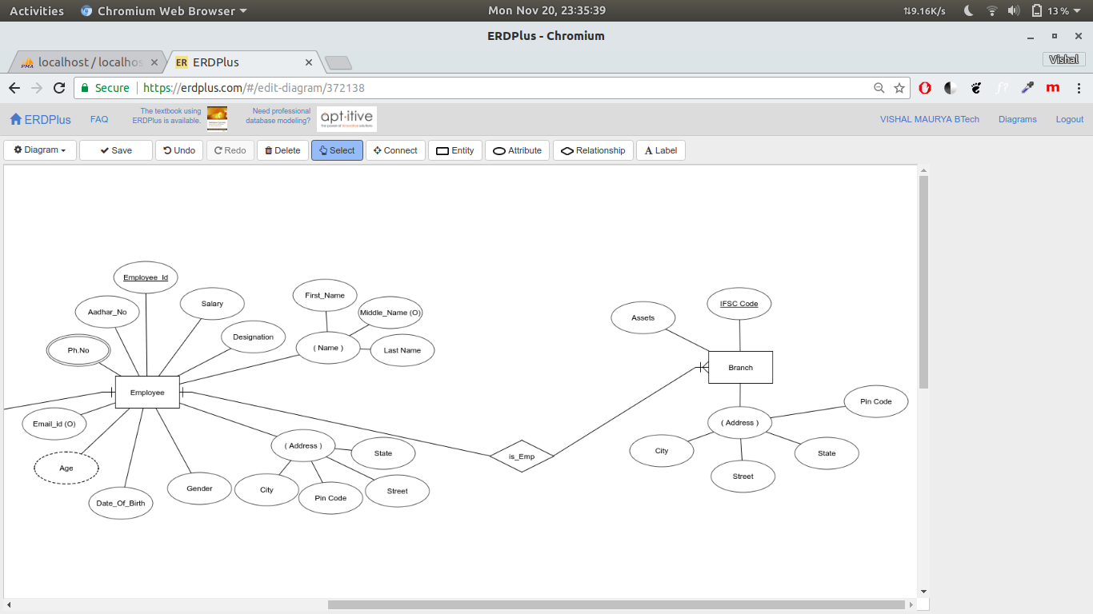

THIS IS THE RELATIONSHIP SET BETWEEN CARD_INFO AND ACCOUNTS
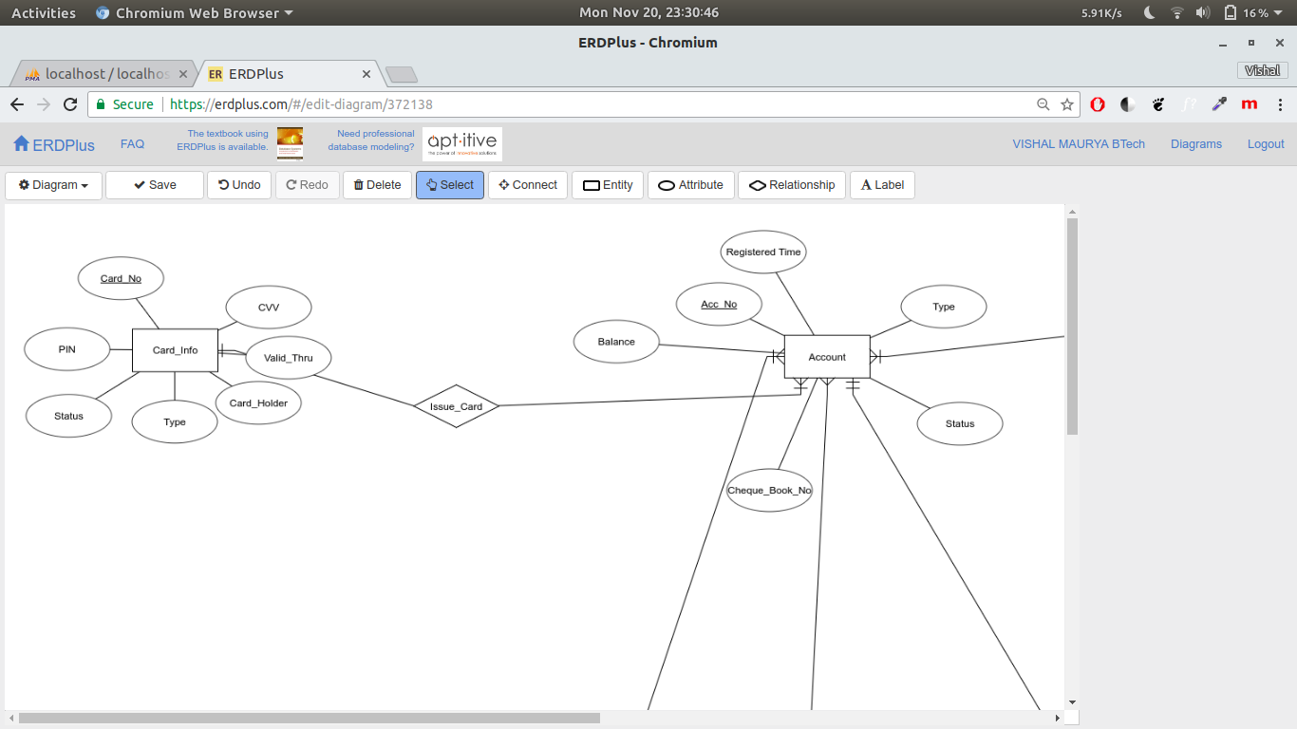

THIS IS THE RELATIONSHIP SET BETWEEN CUSTOMER AND ACCOUNT
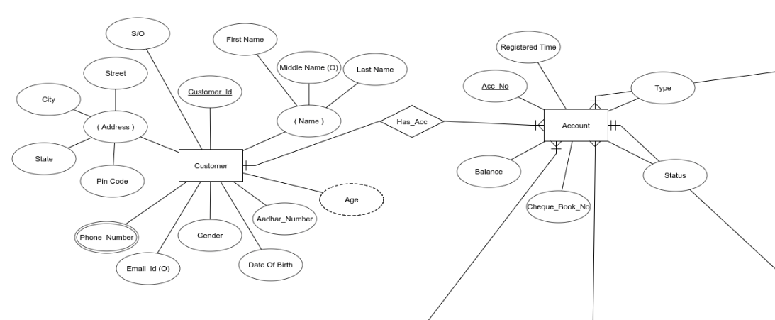

THIS IS THE RELATIONSHIP SET BETWEEN ACCOUNT AND EMPLOYEE
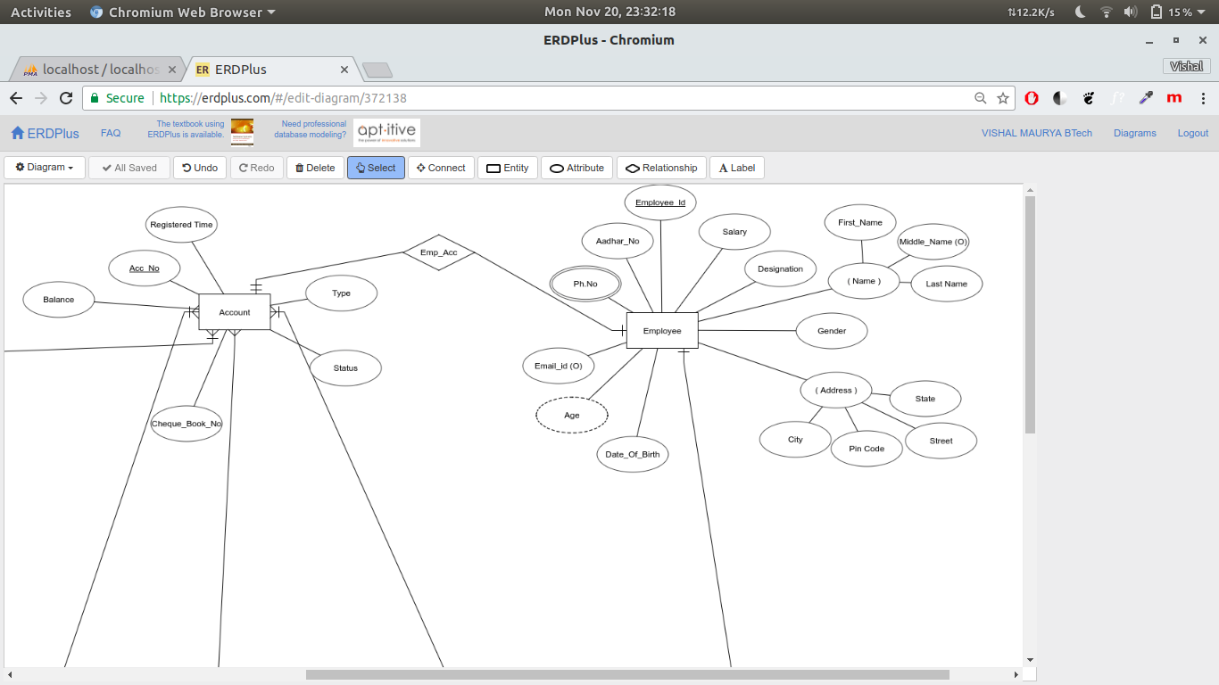

THIS IS THE RELATIONSHIP SET BETWEEN LOAN AND ACCOUNT
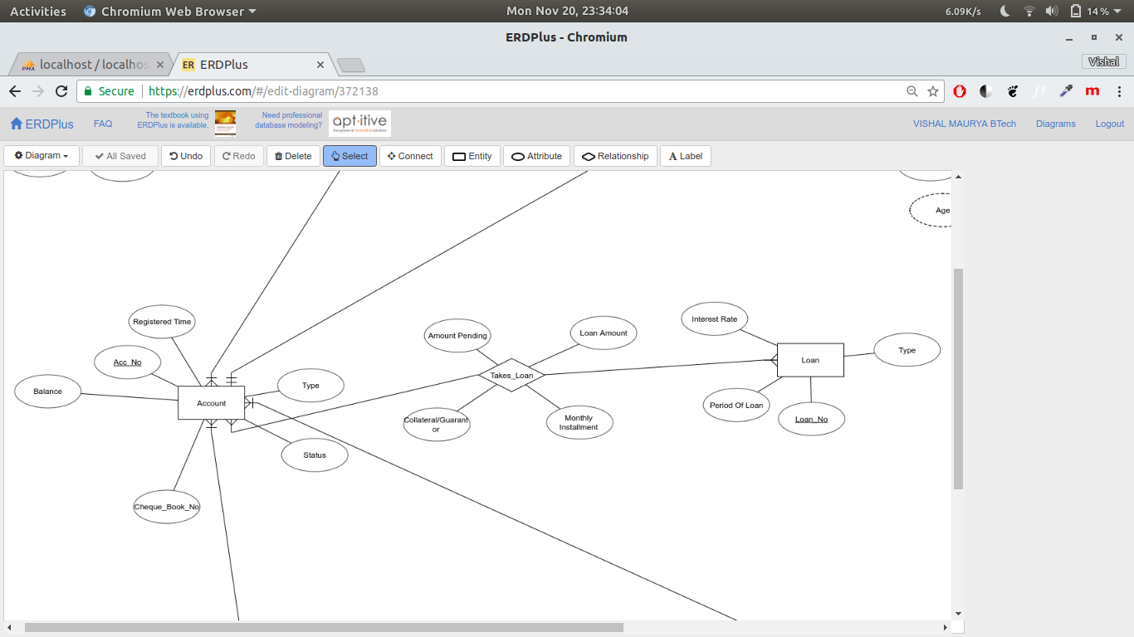
THIS IS THE RELATIONSHIP SET BETWEEN ACCOUNT AND TRANSACTION
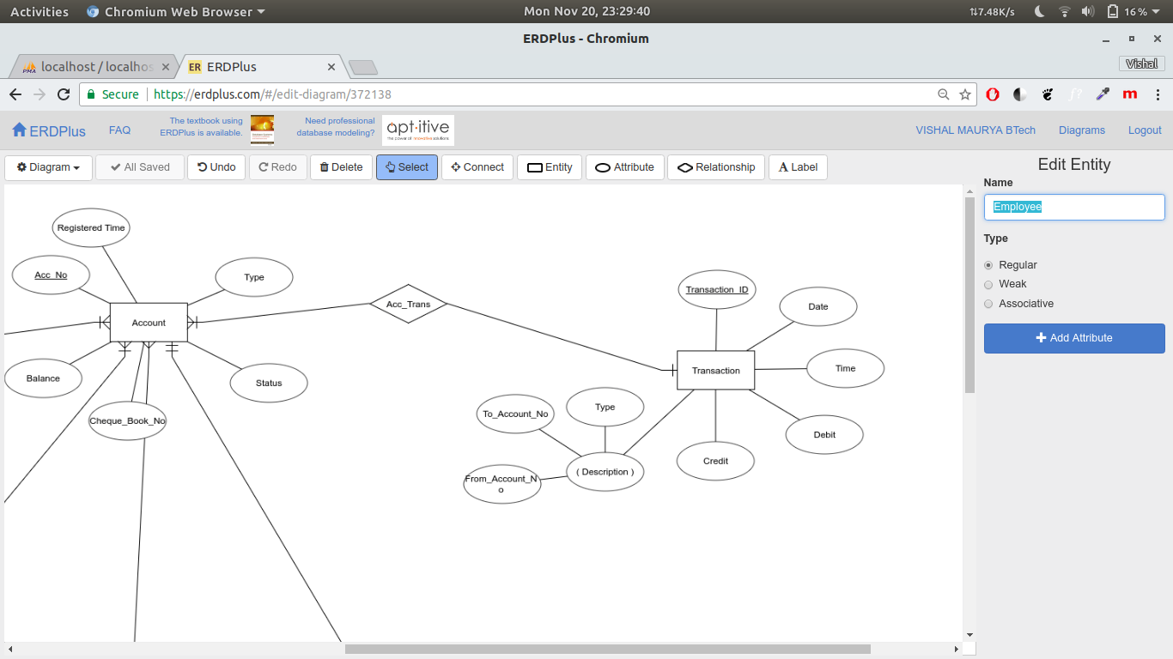

TRANSFORMATION INTO SET OF TABLES :

CREATE TABLE accounts (
Account_Number bigint PRIMARY KEY,
Type text NOT NULL,
Balance real NOT NULL,
Status text NOT NULL,
Cheque_Book_No bigint,
Registered_time datetime
);

CREATE TABLE customers (
Customer_ID int PRIMARY KEY AUTO_INCREMENT,
first_name varchar(15) NOT NULL,
middle_name varchar(15),
last_name varchar(15) NOT NULL,
Father_name varchar(25) NOT NULL,
Street varchar(25),
City varchar(15),
State varchar(15),
PIN_Code int NOT NULL,
Gender enum('M', 'F', 'O') NOT NULL,
Date_of_birth date NOT NULL,
Email varchar(25) NOT NULL UNIQUE,
Aadhar_number bigint NOT NULL UNIQUE,
Account_Number bigint NOT NULL
)

CREATE TABLE branches (
IFSC_Code varchar(15) Primary key,
Assets real NOT NULL,
Street varchar(25),
City varchar(15) NOT NULL,
State varchar(15) NOT NULL,
PIN_Code int NOT NULL
)

CREATE TABLE employees (
Employee_ID int PRIMARY KEY AUTO_INCREMENT,
first_name varchar(15) NOT NULL,
middle_name varchar(15),
last_name varchar(15) NOT NULL,
Street text,
City text,
State text,
Pin_Code int NOT NULL,
Gender enum('M','F','O') NOT NULL,
Date_Of_birth date NOT NULL,
Email varchar(25) NOT NULL UNIQUE,
Aadhar_number bigint NOT NULL UNIQUE,
Designation text NOT NULL,
Salary bigint NOT NULL,
IFSC_Code varchar(15) NOT NULL,
Foreign Key (IFSC_Code) References branches(IFSC_Code)
)

CREATE TABLE emp__phones (
Employee_ID int,
Phone_No bigint,
PRIMARY KEY(Employee_ID, Phone_No),
Foreign Key(Employee_ID) References employees (Employee_ID)
)

CREATE TABLE cust__phones (
Customer_ID int,
Phone_No bigint,
Primary Key(Customer_ID, Phone_No),
Foreign Key (Customer_ID) References customers(Customer_ID)
)

CREATE TABLE transactions
(
Transaction_ID bigint Primary key,
Date date,
Time time,
Debit real,
Credit real,
Type text NOT NULL,
Account_Number bigint NOT NULL,
Sender_Acc_No bigint,
Beneficiary_Acc_No bigint,
Foreign Key(Account_Number) References accounts (Account_Number)
)

CREATE TABLE loans
(
Loan_No bigint Primary key,
Type text NOT NULL,
Interest_Rate real NOT NULL,
Period text NOT NULL
)

CREATE TABLE takes__loan(
Account_Number bigint,
Loan_No bigint,
Loan_Amount real NOT NULL,
Monthly_Installment real NOT NULL,
Pending_Amount real NOT NULL,
Collateral_Guarantor text NOT NULL,
PRIMARY KEY(Account_Number, Loan_No),
Foreign Key(Account_Number) References accounts (Account_Number),
Foreign Key(Loan_No) References loans (Loan_No)
)

CREATE TABLE card__info (
Card_No bigint NOT NULL PRIMARY KEY,
CVV varchar(255) NOT NULL,
Valid_Thru varchar(8) NOT NULL,
Card_Holder text,
Type text NOT NULL,
PIN varchar(255) NOT NULL,
Account_Number bigint NOT NULL,
Status text NOT NULL,
Foreign Key(Account_Number) References accounts (Account_Number)
)

CREATE TABLE emp__acc (
Account_Number bigint PRIMARY KEY,
Employee_ID int,
Foreign Key(Account_Number) References accounts (Account_Number),
Foreign Key(Employee_ID) References employees (Employee_ID)
)

TRIGGERS

TO UPDATE THE BALANCE AFTER REPAYING THE LOAN.

CREATE TRIGGER updateAmtLoan
AFTER UPDATE ON takes__loan
FOR EACH ROW
BEGIN
UPDATE accounts SET balance = balance - (old.Pending_Amount - new.Pending_Amount)
WHERE Account_Number = old.Account_Number
AND
(balance - (old.Pending_Amount - new.Pending_Amount)) >= 0;
END

TO UPDATE THE BALANCE AFTER TAKING THE LOAN

CREATE TRIGGER insertAmtLoan
AFTER INSERT ON takes__loan
FOR EACH ROW
BEGIN
UPDATE accounts SET balance = balance + new.Loan_Amount;
END

FEATURES AND THE FUNCTIONS OF THE WEBSITES

This is the registration page where a customer/employee can register and create his account, after which he is logged in to his account automatically.

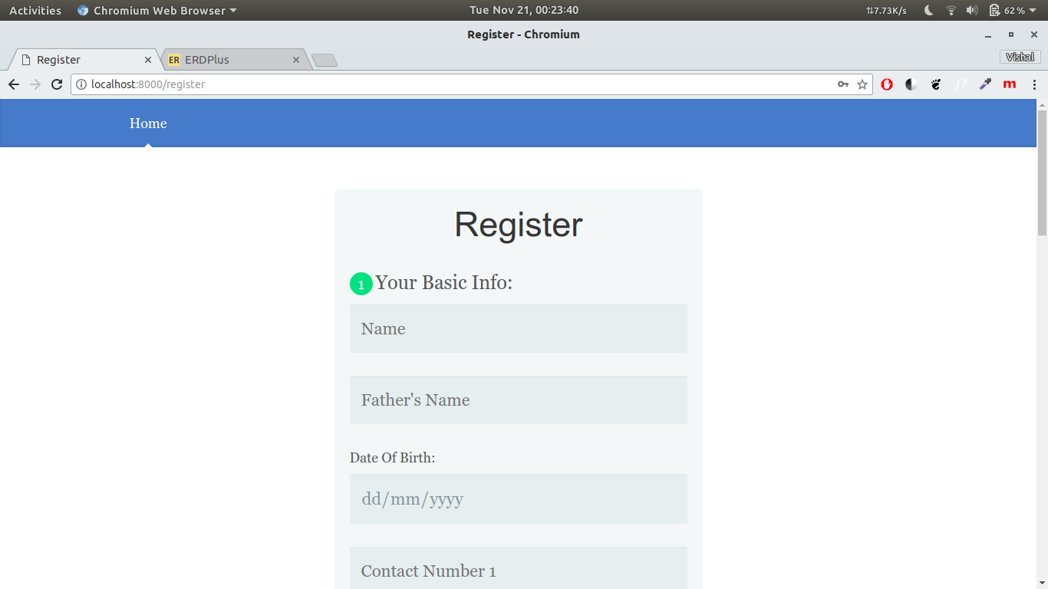

This is the homepage which the user encounters on logging in.

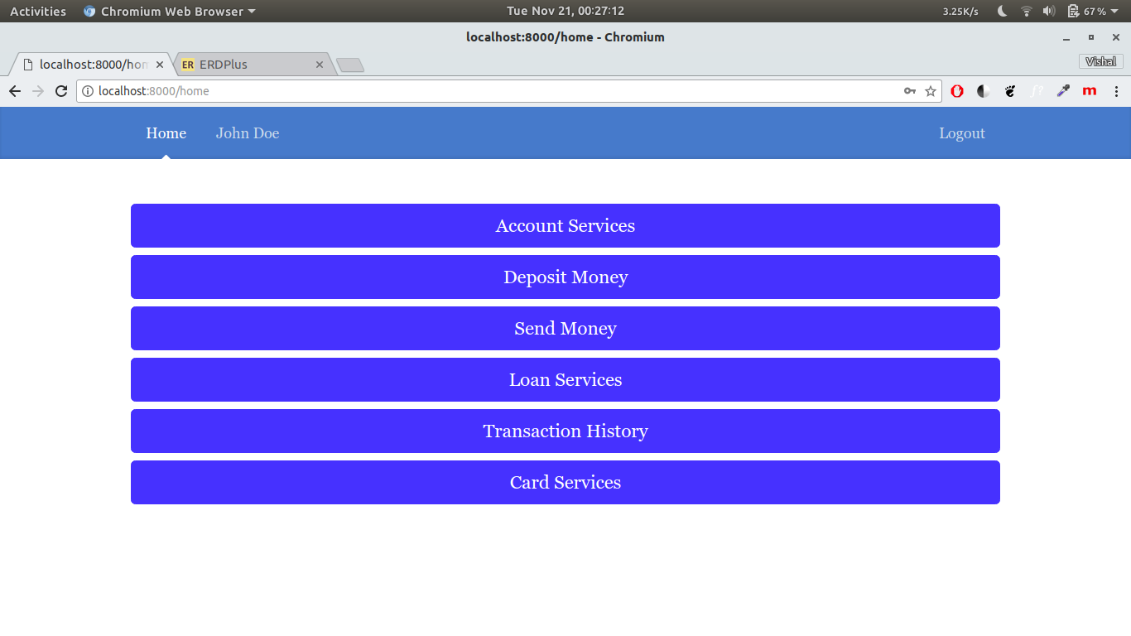
This is the account summary page where the details of the account of the authorised user are shown.

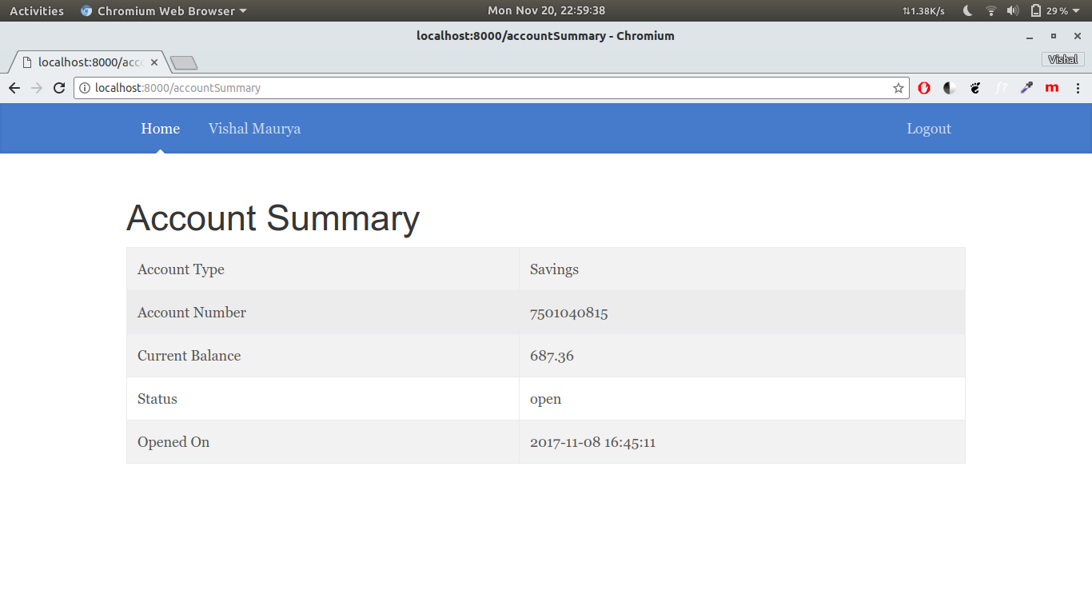

This is the deposit money page where the user deposits money into his bank account. The account balance would be updated as per the amount deposited.

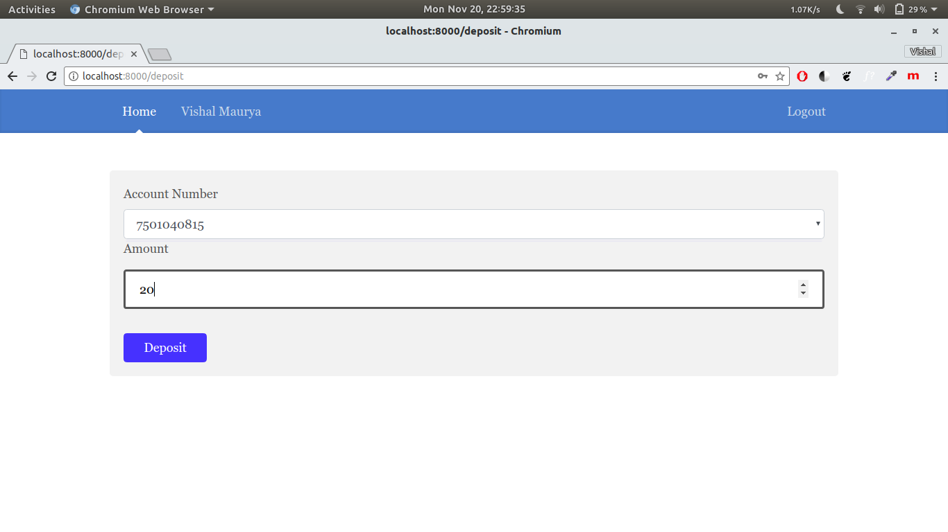

The user can send money to another person with a bank account already registered in this bank. If he tries to send money to a bank account not registered in this bank, the errors would be generated accordingly. His balance would be updated and the money would be added in the beneficiary’s account accordingly.

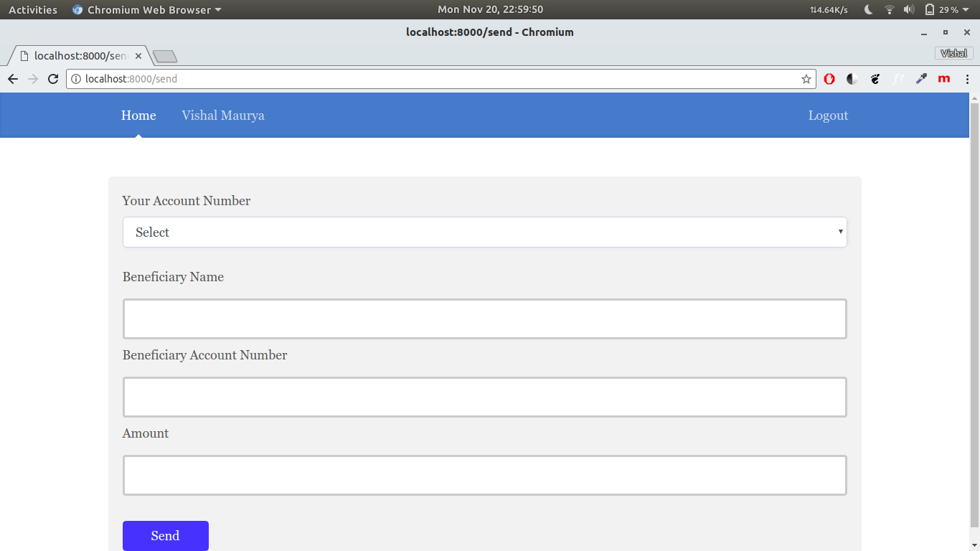

Here, the user can take a loan (Home/Car) and of a fixed period. The pending amount would be calculated based on the interest rate and his account would be credited with the amount of loan taken.
The user would also have to repay the loan he has taken and the amount would be specified by him. He can repay as much times as he wants till he repays it all.

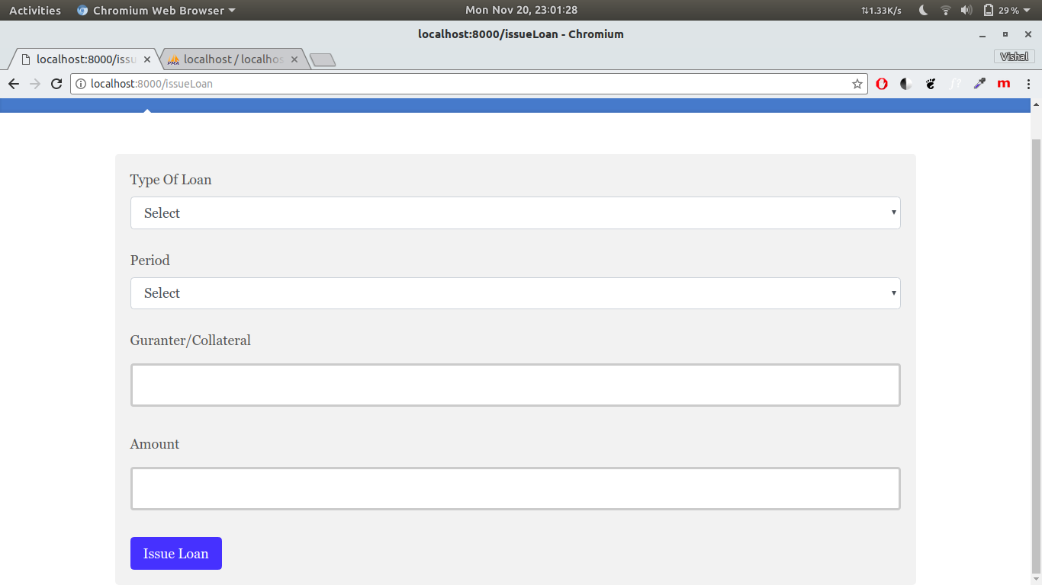

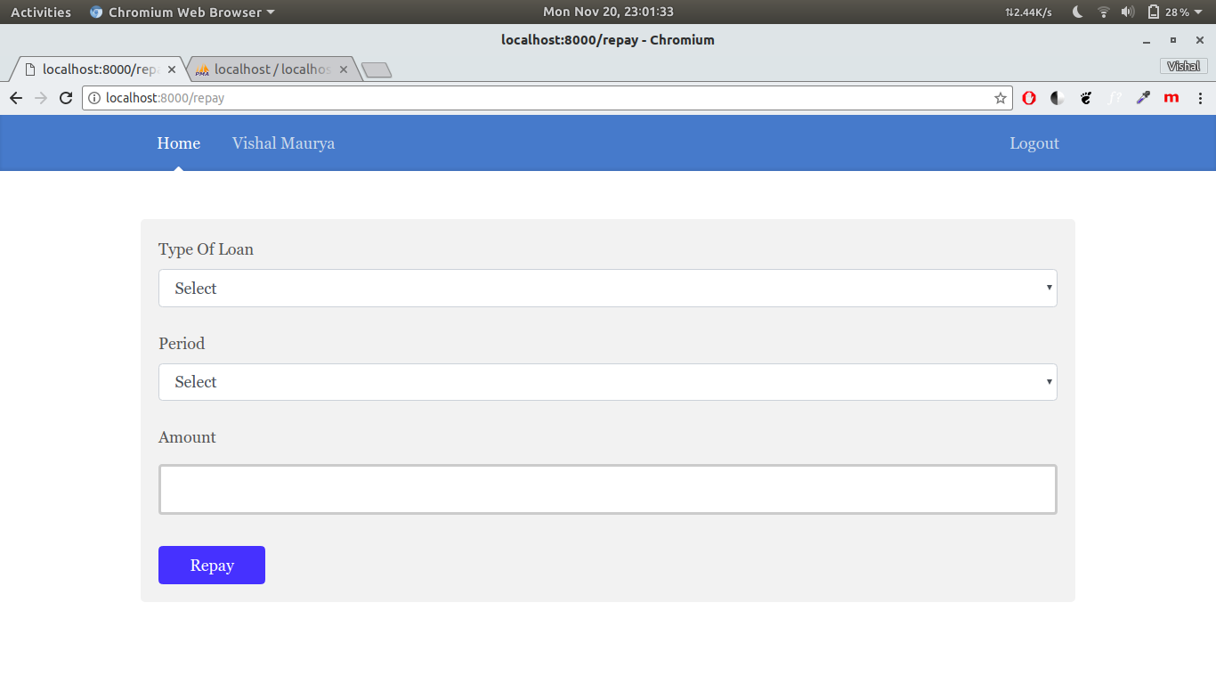

This is the transaction history page where all of his transactions would be shown till date.

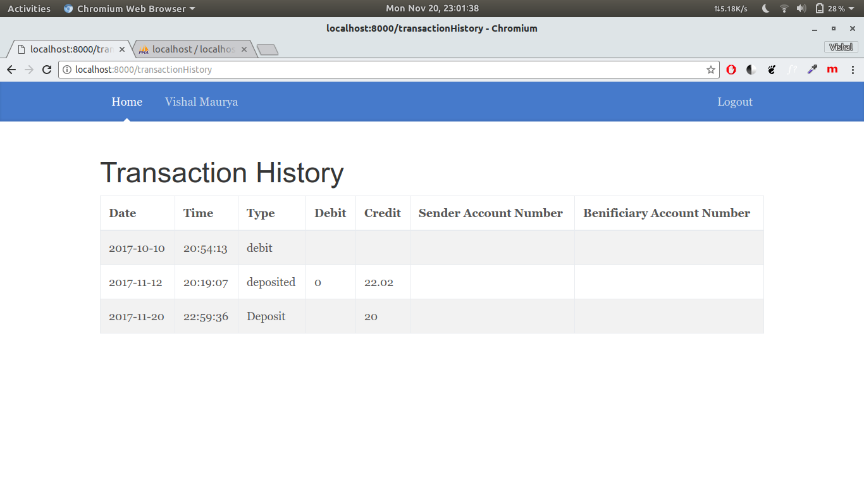

This is the Mini Statement page where the ten latest transactions have been shown.

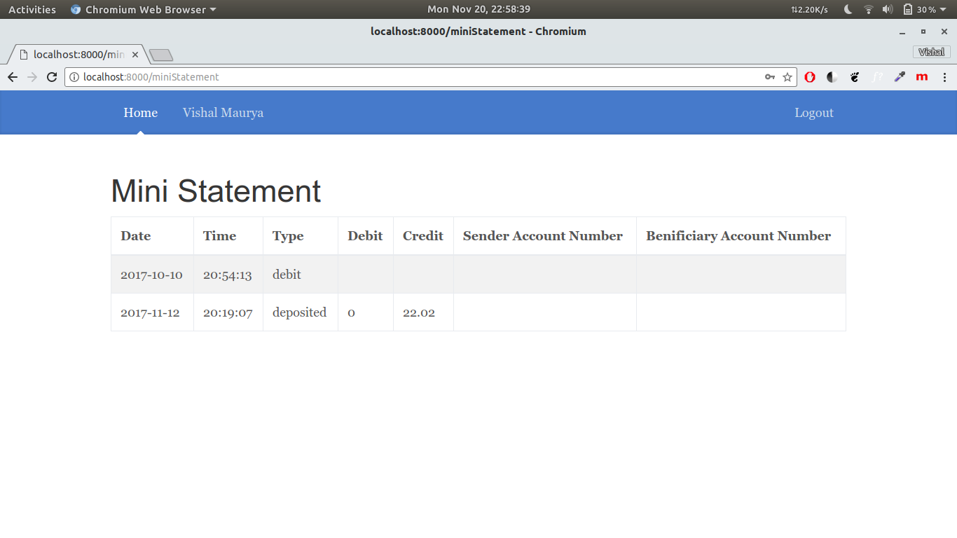
This is to generate a debit/credit card of the user as per his wish.
He can also block his card if it exists.
A user can have only a single card at a time.
He can view his card details here.

