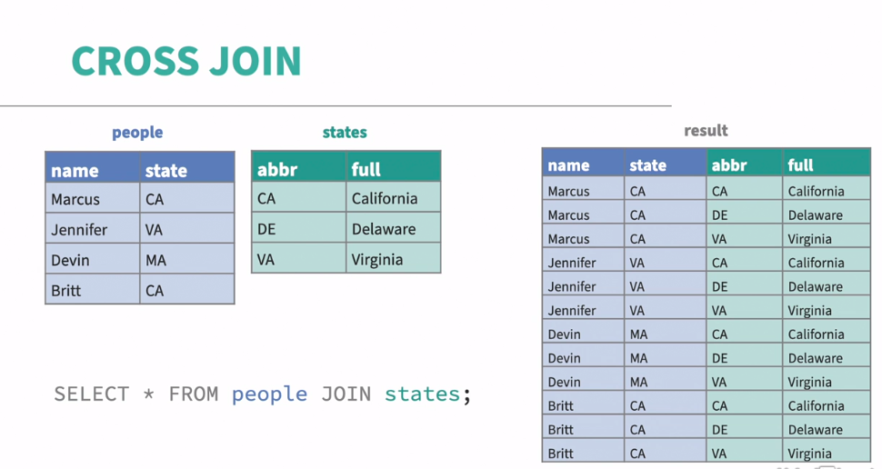

CROSS joins are not used most often. In SQL, the **CROSS JOIN** is used to merge each row of the first table with each row of the second table. It is also known as the **Cartesian join** since it returns the Cartesian product of the sets of rows from the joined tables.

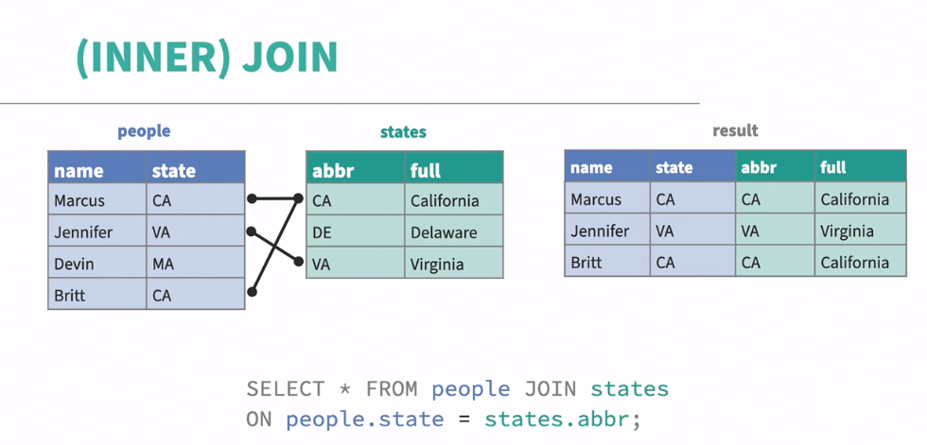

**INNER JOIN** is used to display records that match criteria in both tables. This is often referred to as a basic JOIN, the default type of join.

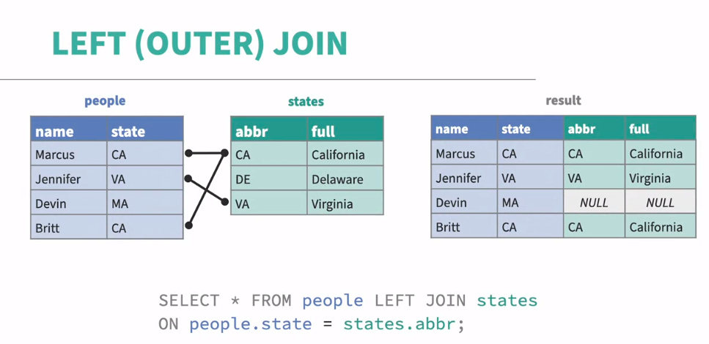

**LEFT (OUTER) JOIN** is used to get back all the records in the left table and the matched records from the right table. The final record table length would be same as the left table.

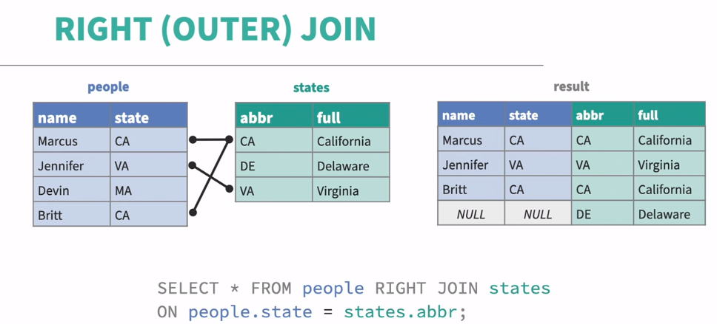

**RIGHT (OUTER) JOIN** keyword shows the records in the right table and the matched records from the left table. So, the rows with common values with the right tables, only those data will be joined from left table to the right one.

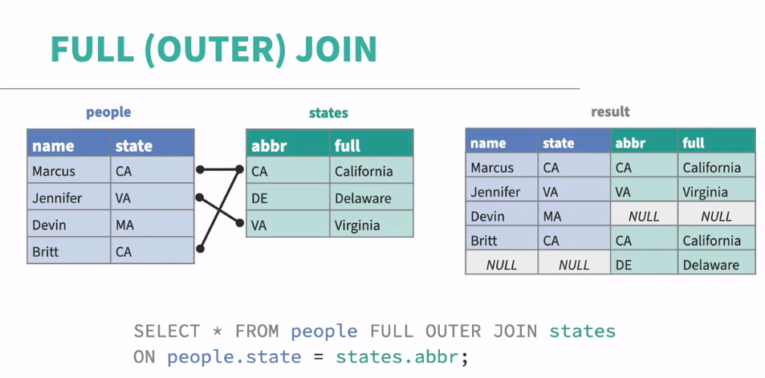

**FULL (OUTER) JOIN** keywordreturns all the matched and unmatched values from different tables, the values from left table and right table records.