BANK ACCOUNT MANAGEMENT SYSTEM
A DBMS Capstone Project Report submitted in partial fulfillment of the requirements for the award of the degree of
BACHELOR OF TECHNOLOGY
in
ARTIFICIAL INTELLIGENCE AND MACHINE LEARNING

Submitted By
BANDARU LAHARI NAIDU – 25B11AI091
SIRIPIREDDY VENKATA KARTHIK NADH REDDY – 25B11AIB28
KONA SUNANDAN BABU – 25B11A1560
PUVVADA RAVI KUMAR – 25B11A1994

Under the esteemed guidance of
Mr. T.Srinivasulu M.Tech, (Ph.D.)
Assistant Professor



DEPARTMENT OF ARTIFICIAL INTELLIGENCE AND MACHINE LEARNING
ADITYA UNIVERSITY
(Formerly Aditya Engineering College (A))
Aditya Nagar, ADB Road, Surampalem, Andhra Pradesh, India
2026 – 2027


Aditya Nagar, ADB Road, Surampalem, Andhra Pradesh, India
DEPARTMENT OF ARTIFICIAL INTELLIGENCE AND MACHINE LEARNING
CERTIFICATE
This is to certify that the DBMS Capstone Project report entitled “Bank Account Management System” is being submitted by Bandaru Lahari Naidu (Roll No. 25B11AI091), Siripireddy Venkata Karthik Nadh Reddy (Roll No. 25B11AIB28), Kona Sunandan Babu (Roll No. 25B11A1560) and Puvvada Ravi Kumar (Roll No. 25B11A1994) in partial fulfillment of the requirements for the award of the B.Tech. degree in Artificial Intelligence and Machine Learning. The work documented in this report was carried out as part of the Capstone Project for the course Database Management Systems (2501IT05) during the academic year 2026–2027, and records the database design, implementation, and documentation undertaken by the team.

Project Guide Head of the Department
Mr. T. Srinivasulu, M. Tech, (Ph.D.) Dr. K. Naga Bhargavi, M. Tech, Ph.D. Associate professor Associate Professor & HOD

External Examiner

DECLARATION
We hereby declare that the DBMS Capstone Project entitled “BANK ACCOUNT MANAGEMENT SYSTEM” is a genuine work carried out by us. The database design, SQL implementation, queries and documentation presented in this report are our own work, completed under the guidance of Mr. T. Srinivasulu, Department of Artificial Intelligence and Machine Learning, Aditya University, Surampalem. We further declare that this work has not been submitted, in full or in part, for the award of any degree of this or any other educational institution.

Project Associates
Bandaru Lahari Naidu (25B11AI091)
Siripireddy Venkata Karthik Nadh Reddy (25B11AIB28)
Kona Sunandan Babu (25B11A1560)
Puvvada Ravi Kumar (25B11A1994)

Date: ____________
Place: Surampalem

ACKNOWLEDGEMENT
It is with immense pleasure that we express our indebted gratitude to our project guide Mr. T. Srinivasulu, Department of Artificial Intelligence and Machine Learning, who guided us throughout the capstone project. We are thankful for the constant encouragement and valuable suggestions received at every review stage.
We are grateful to Dr. K. Naga Bhargavi, Head of the Department, for inspiring us and for arranging the facilities and resources needed for this project.
We extend our sincere thanks to the Management, Dr. M. Sreenivasa Reddy, Deputy Pro-Chancellor, Dr. M. B. Srinivas, Vice-Chancellor, and Dr. A. Ramesh, Pro Vice-Chancellor (Engineering & Sciences), for providing an excellent academic environment.
Not to forget, we thank the Teaching and Non-Teaching Staff, our parents and our friends, who have directly or indirectly supported us in completing this project on time.

Project Associates
Bandaru Lahari Naidu 25B11AI091
Siripireddy Venkata Karthik Nadh Reddy 25B11AIB28
Kona Sunandan Babu 25B11A1560
Puvvada Ravi Kumar 25B11A1994

ABSTRACT
Banks handle a large and continuous volume of interrelated data: customers, accounts, branches, employees, transactions, loans and beneficiaries. When this data is kept in manual registers or separate files, records are duplicated, balances and transaction histories are hard to trace, and even a simple question such as the total balance held in savings accounts needs manual compilation. The Bank Account Management System solves this problem by keeping all banking data in a single normalized relational database. Seven entities (Branch, Customer, Employee, Account, Transaction, Loan and Beneficiary) were identified, and one associative table, Transfer_To, resolves the many-to-many relationship between transactions and beneficiaries, giving eight tables in all. The design was drawn as an ER diagram, converted into a relational schema and normalized up to the Third Normal Form. It was implemented in PostgreSQL with primary key, foreign key, UNIQUE, NOT NULL, CHECK and DEFAULT constraints and populated with sample data. More than fifty SQL statements covering retrieval, joins, aggregate functions, GROUP BY with HAVING, nested and correlated subqueries, views, set operations, CRUD, DCL and TCL were executed. The resulting database prevents duplicate and orphan records, enforces valid balances and transaction types, and answers banking queries with a single SQL statement.

INDEX
Chapter | Title | Page No.
 | Certificate | i
 | Declaration | ii
 | Acknowledgement | iii
 | Abstract | iv
 | List of Figures | vii
 | List of Tables | vii
1 | Introduction | 1
 | 1.1 Introduction to the Domain | 1
 | 1.2 Problem Statement | 1
 | 1.3 Motivation and Need for a Database | 1
 | 1.4 Objectives of the Project | 2
 | 1.5 Scope of the Project | 2
 | 1.6 Organization of the Report | 2
2 | System Study and Tools | 3
 | 2.1 Existing System and Its Limitations | 3
 | 2.2 Proposed Database System | 3
 | 2.3 Tools and Technologies Used | 3
 | 2.4 Software and Hardware Requirements | 4
3 | Database Design (Review – I) | 5
 | 3.1 Identified Entities | 5
 | 3.2 Entity Attributes and Attribute Types | 5
 | 3.3 ER Diagram | 7
 | 3.4 Relationships and Cardinality | 7
 | 3.5 Relational Database Schema | 8
 | 3.6 Primary Keys and Foreign Keys | 11
 | 3.7 Normalization up to 3NF | 11
4 | Database Implementation (Review – II) | 13
 | 4.1 Database and Table Creation – DDL | 13
 | 4.2 Sample Data Insertion – DML | 14
 | 4.3 Constraints and Data Integrity | 16
 | 4.4 Data Validation Rules | 16
5 | SQL Operations and Queries | 18
 | 5.1 DQL – Basic Retrieval Queries | 18
 | 5.2 Join Operations | 18
 | 5.3 Aggregate Functions, GROUP BY and HAVING | 19
 | 5.4 Nested and Correlated Subqueries | 20
 | 5.5 Views and Relational Set Operations | 20
 | 5.6 DCL and TCL Operations | 22
 | 5.7 CRUD Operations (INSERT, UPDATE, DELETE) | 23
6 | Modules and Functionalities | 24
7 | Results – Sample Outputs and Screenshots | 25
8 | Testing and Data Validation | 28
9 | GitHub Repository and Team Contribution | 29
10 | Conclusion and Future Enhancements | 30
 | References | 31
 | Appendix A – Complete SQL Script | 32
 | Appendix B – Query Outputs | 39

LIST OF FIGURES
Figure No. | Title of the Figure | Page No.
Fig. 3.1 | ER Diagram of the Bank Account Management System | 7
Fig. 3.2 | Relational Schema Diagram | 10
Fig. 4.1 | Successful Creation of Tables | 14
Fig. 4.2 | Sample Data Inserted into the Tables | 16
Fig. 4.3 | Referential Integrity Enforced by the Database | 17
Fig. 7.1 | Customer and Account Details (Inner Join, Q6) | 25
Fig. 7.2 | Customer, Account and Branch (Three-table Join, Q32) | 25
Fig. 7.3 | Total Balance by Account Type (GROUP BY, Q17) | 25
Fig. 7.4 | Accounts Above the Average Balance (Nested Subquery, Q21) | 26
Fig. 7.5 | Accounts Above the Average of Their Own Type (Correlated Subquery, Q40) | 26
Fig. 7.6 | Balance Category using CASE (Q34) | 26
Fig. 7.7 | Rollback to Savepoint and Commit (TCL, Q49 and Q50) | 26
Fig. 7.8 | Row Count of Every Table (UNION ALL, Q51) | 27

LIST OF TABLES
Table No. | Title of the Table | Page No.
Table 2.1 | Tools and Technologies Used | 3
Table 2.2 | Software and Hardware Requirements | 4
Table 3.1 | Entities Identified for the Selected Domain | 5
Table 3.2 | Attributes of Each Entity | 5
Table 3.3 | Relationships and Cardinality | 7
Table 3.4 | Relational Database Schema | 8
Table 3.5 | Primary Key and Foreign Key Definitions | 11
Table 3.6 | Normalization Steps | 12
Table 4.1 | Sample Data Summary | 15
Table 4.2 | Constraints and Data Integrity Rules | 16
Table 5.1 | Basic Retrieval Queries | 18
Table 5.2 | Join Operations | 18
Table 5.3 | Aggregate, GROUP BY and HAVING Queries | 19
Table 5.4 | Subqueries | 20
Table 5.5 | Views and Set Operations | 21
Table 5.6 | DCL and TCL Operations | 22
Table 5.7 | CRUD Operations | 23
Table 6.1 | Modules and Their Functionalities | 24
Table 8.1 | Test Cases and Results | 28
Table 9.1 | Team Responsibilities | 29
Table 9.2 | Review-wise Progress Record | 29

CHAPTER 1: INTRODUCTION

1.1 Introduction to the Domain
A bank is a financial institution that accepts deposits, maintains customer accounts, processes deposits, withdrawals and fund transfers, and grants loans. Every one of these activities produces data, and the data items are strongly related: a customer belongs to a home branch and may own several accounts; every transaction belongs to exactly one account; a loan is taken by a customer and repaid through an account; and a transfer is made to a beneficiary registered by the customer.
The Bank Account Management System is a relational database designed to hold this data for one bank. It covers the branches of the bank, the employees working in them, the customers registered with them, the accounts opened by customers, the transactions carried out on those accounts, the loans issued to customers, and the beneficiaries to whom money is transferred.
Because banking data must always be accurate, consistent and quickly retrievable, a database management system is the natural tool for this domain. The project therefore focuses on designing a well-structured schema and implementing it with SQL.

1.2 Problem Statement
At present, small and medium banking operations often rely on manual registers or separate spreadsheet files. Customer details are maintained by one section, account balances by another and loan records by a third. This arrangement causes four recurring problems.
- Data redundancy: a customer's name, address and branch are re-entered in the account register, the transaction register and the loan register.
- Data inconsistency: when a phone number or an account status is corrected in one file, the other files continue to hold the old value.
- No integrity checking: nothing prevents a transaction being recorded against an account that does not exist, a negative balance, or a loan issued to an unregistered customer.
- Difficult retrieval: a question such as "what is the total balance of all savings accounts" or "which customers have an active loan" has to be compiled by hand from several files.
The proposed system stores each fact exactly once in a normalized table, links the tables through foreign keys so that invalid data is rejected by the database itself, and answers the above questions with a single SQL statement.

1.3 Motivation and Need for a Database
A spreadsheet can store rows, but it cannot enforce relationships. It will accept a duplicate customer ID, a negative account balance or a transaction pointing at an account that has been closed. A database management system enforces these rules at the point of insertion through PRIMARY KEY, UNIQUE, CHECK and FOREIGN KEY constraints, so bad data never enters the system.
A DBMS also allows several users to work on the same data at the same time, supports transactions so that a half-completed fund transfer can be rolled back, allows access to be controlled with GRANT and REVOKE, and provides a query language in which complex banking questions are expressed declaratively instead of being compiled by hand.

1.4 Objectives of the Project
The project has the following objectives, each of which is verified in the chapters that follow.
- To design a normalized relational database for bank account management with seven entities, and to represent the design as an ER diagram showing all attributes, relationships and cardinalities.
- To convert the ER design into a relational schema of eight tables and normalize it up to the Third Normal Form.
- To implement the schema in PostgreSQL with primary keys, foreign keys and NOT NULL, UNIQUE, CHECK and DEFAULT constraints, and to populate every table with sample data.
- To implement and execute SQL operations covering DDL, DML, DQL, joins, aggregate functions, subqueries, views, set operations, DCL and TCL.
- To verify data integrity by showing that the database rejects duplicate keys, invalid values and orphan records.

1.5 Scope of the Project
The database covers the core operations of a retail bank: branches, employees, customers, accounts (savings and current), deposit, withdrawal and transfer transactions, loans and beneficiaries. It supports many branches, many accounts per customer and many transactions per account.
The following are outside the scope of the present work: ATM and card management, internet-banking login and passwords, interest and EMI calculation engines, cheque clearing, foreign exchange, audit logs and any graphical front-end application. The project is a database design and implementation exercise and all interaction is through SQL.

1.6 Organization of the Report
This report is organized into ten chapters. Chapter 2 presents the system study and the tools used. Chapter 3 covers the complete database design including the ER diagram, relational schema and normalization. Chapter 4 describes the database implementation with DDL and sample data. Chapter 5 presents the SQL operations and queries executed. Chapter 6 explains the modules and functionalities. Chapter 7 presents the results with sample outputs. Chapter 8 covers testing and data validation. Chapter 9 details the GitHub repository and the contribution of each team member. Chapter 10 concludes the report and outlines future enhancements.

CHAPTER 2: SYSTEM STUDY AND TOOLS

2.1 Existing System and Its Limitations
The existing arrangement is largely manual or file based. Customer forms, account opening details, passbook entries and loan files are maintained in separate registers or spreadsheets, and information is copied from one to another. The limitations are:
- Repeated entry of the same customer and branch data, which wastes time and leads to spelling and value mismatches.
- No automatic validation, so an invalid account type, a negative balance or an unknown branch can be recorded.
- Balances have to be recalculated by hand from transaction entries, which is slow and error-prone.
- Searching or reporting (for example, all loans of one customer) requires opening several files.
- No controlled multi-user access and no way to undo a partly completed operation.

2.2 Proposed Database System
The proposed system is a relational database in which each entity is stored in its own table and related tables are linked by primary key and foreign key columns. Customers are linked to their home branch, accounts to their owners, transactions to accounts, loans to customers and repayment accounts, and transfers to beneficiaries through the associative table TRANSFER_TO.
Its advantages over the existing system are: (i) each fact is stored once, removing redundancy; (ii) constraints enforce valid data automatically; (iii) joins and aggregate functions give instant reports; (iv) views present customer-account and customer-loan information without exposing the base tables; and (v) transactions and DCL commands support safe, controlled updates.

2.3 Tools and Technologies Used
Table 2.1: Tools and Technologies Used
Category | Tool / Technology Used | Version / Remarks
Database Server | PostgreSQL | Relational DBMS used for all DDL, DML and queries
Query / Admin Tool | pgAdmin 4 / psql | Running the SQL script and viewing results
ER Diagram Tool | draw.io (diagrams.net) | ER diagram of the system (Fig. 3.1)
Schema Diagram Tool | Graphviz | Relational schema diagram (Fig. 3.2)
Front-end | Not used | All interaction is through SQL
Version Control | GitHub | Repository for the SQL script and project files
Documentation | MS Word and MS PowerPoint | Project report and review presentations

2.4 Software and Hardware Requirements
Table 2.2: Software and Hardware Requirements
Requirement Type | Specification
Operating System | Windows 10 / 11 (or Linux / macOS)
Database Software | PostgreSQL server
Client Tool | pgAdmin 4 or psql command-line client
Other Software | Web browser (draw.io, GitHub), MS Office
Processor | Intel Core i3 or equivalent, or higher
RAM | 4 GB minimum (8 GB recommended)
Storage | 1 GB of free disk space

CHAPTER 3: DATABASE DESIGN
(Deliverables of Review – I)

3.1 Identified Entities
Seven entities were identified for the bank domain. In addition, one associative table, TRANSFER_TO, is created during schema design to resolve the many-to-many relationship between TRANSACTION and BENEFICIARY, so the relational schema has eight tables.
Table 3.1: Entities Identified for the Selected Domain
S.No | Entity Name | Description
1 | CUSTOMER | Registered bank customers with personal and contact details; each belongs to a home branch.
2 | ACCOUNT | Savings or current accounts opened by customers, with balance and status.
3 | BRANCH | Bank branches with address, city, state, PIN code and IFSC code.
4 | EMPLOYEE | Bank staff (manager, cashier, clerk) working at a branch.
5 | TRANSACTION | Deposit, withdrawal and transfer records posted on an account (weak entity of ACCOUNT; table TRANSACTION_TABLE).
6 | LOAN | Loans taken by customers and repaid through an account.
7 | BENEFICIARY | Payees registered by a customer as targets of fund transfers.

3.2 Entity Attributes and Attribute Types
Every attribute is listed with its data type as declared in the PostgreSQL script. The key column shows PK, FK or a dash. Attribute types follow the ER diagram: Age is a derived attribute (computed from Date_Of_Birth and not stored), Address is composite (Address, City, PinCode) and Phone is multi-valued in the ER model; the implemented tables keep one primary phone number per row in a single column.
Table 3.2: Attributes of Each Entity
Entity | Attribute | Data Type | Key (PK / FK / —) | Attribute Type
CUSTOMER | Customer_ID | INT | PK | Simple
CUSTOMER | First_Name | VARCHAR(50) | — | Simple
CUSTOMER | Last_Name | VARCHAR(50) | — | Simple
CUSTOMER | Email | VARCHAR(100) | — | Simple
CUSTOMER | Phone | VARCHAR(15) | — | Multi-valued (ER)
CUSTOMER | Address | VARCHAR(200) | — | Composite
CUSTOMER | City | VARCHAR(50) | — | Simple
CUSTOMER | PinCode | VARCHAR(10) | — | Simple
CUSTOMER | Date_Of_Birth | DATE | — | Simple
CUSTOMER | Age | (not stored) | — | Derived
CUSTOMER | Branch_ID | INT | FK | Simple
ACCOUNT | Account_Number | BIGINT | PK | Simple
ACCOUNT | Account_Type | VARCHAR(30) | — | Simple
ACCOUNT | Balance | NUMERIC(12,2) | — | Simple
ACCOUNT | Open_Date | DATE | — | Simple
ACCOUNT | Status | VARCHAR(20) | — | Simple
ACCOUNT | Customer_ID | INT | FK | Simple
BRANCH | Branch_ID | INT | PK | Simple
BRANCH | Branch_Name | VARCHAR(100) | — | Simple
BRANCH | Branch_Address | VARCHAR(200) | — | Simple
BRANCH | City | VARCHAR(50) | — | Simple
BRANCH | State | VARCHAR(50) | — | Simple
BRANCH | PinCode | VARCHAR(10) | — | Simple
BRANCH | IFSCCode | VARCHAR(20) | — | Simple
EMPLOYEE | Employee_ID | INT | PK | Simple
EMPLOYEE | Employee_Name | VARCHAR(100) | — | Simple
EMPLOYEE | Phone | VARCHAR(15) | — | Multi-valued (ER)
EMPLOYEE | Email | VARCHAR(100) | — | Simple
EMPLOYEE | Position | VARCHAR(50) | — | Simple
EMPLOYEE | Branch_ID | INT | FK | Simple
TRANSACTION | Transaction_ID | INT | PK | Simple
TRANSACTION | Transaction_Date | DATE | — | Simple
TRANSACTION | Transaction_Time | TIME | — | Simple
TRANSACTION | Amount | NUMERIC(12,2) | — | Simple
TRANSACTION | Type | VARCHAR(20) | — | Simple
TRANSACTION | Description | VARCHAR(200) | — | Simple
TRANSACTION | Account_Number | BIGINT | FK | Simple
LOAN | Loan_ID | INT | PK | Simple
LOAN | Loan_Type | VARCHAR(50) | — | Simple
LOAN | Principle_Amount | NUMERIC(12,2) | — | Simple
LOAN | Interest_Rate | NUMERIC(5,2) | — | Simple
LOAN | Start_Date | DATE | — | Simple
LOAN | End_Date | DATE | — | Simple
LOAN | Status | VARCHAR(20) | — | Simple
LOAN | Customer_ID | INT | FK | Simple
LOAN | Account_Number | BIGINT | FK | Simple
BENEFICIARY | Beneficiary_ID | INT | PK | Simple
BENEFICIARY | Name | VARCHAR(100) | — | Simple
BENEFICIARY | Customer_ID | INT | FK | Simple
BENEFICIARY | Account_Number | BIGINT | FK | Simple
BENEFICIARY | Bank_Name | VARCHAR(100) | — | Simple

3.3 ER Diagram
The ER diagram of Fig. 3.1 was drawn in draw.io. Entities are rectangles (TRANSACTION is a double rectangle because it is a weak entity identified through ACCOUNT), attributes are ellipses with primary keys underlined, relationships are named diamonds, and the cardinality is marked on each relationship line.
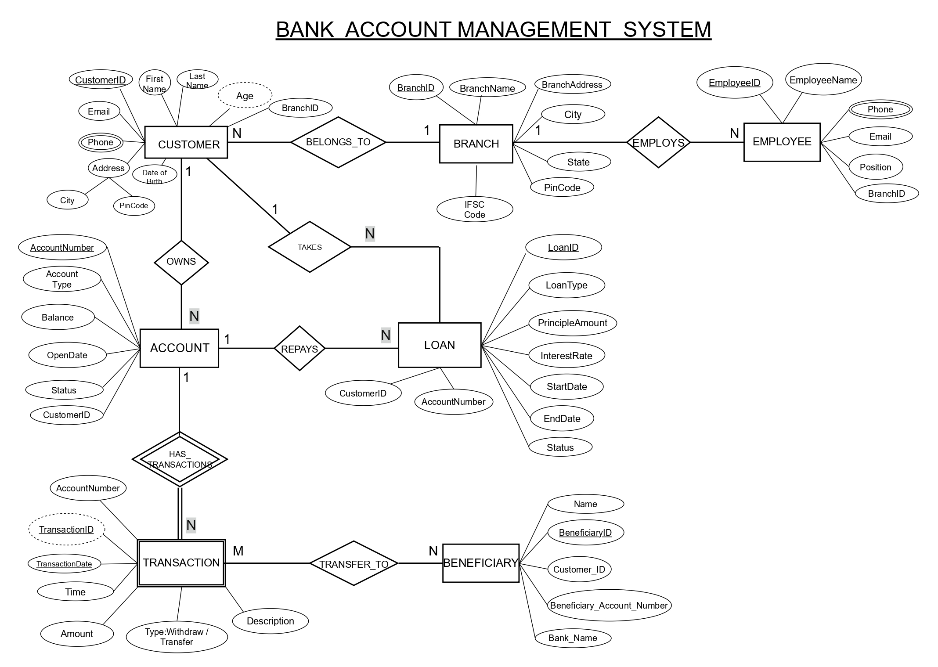
Fig. 3.1: ER Diagram of the Bank Account Management System

3.4 Relationships and Cardinality
Table 3.3: Relationships and Cardinality
Entity 1 | Relationship | Entity 2 | Cardinality (1:1 / 1:N / M:N) | Participation
CUSTOMER | BELONGS_TO | BRANCH | N : 1 | Customer: total; Branch: partial
BRANCH | EMPLOYS | EMPLOYEE | 1 : N | Branch: partial; Employee: total
CUSTOMER | OWNS | ACCOUNT | 1 : N | Customer: partial; Account: total
CUSTOMER | TAKES | LOAN | 1 : N | Customer: partial; Loan: total
ACCOUNT | REPAYS | LOAN | 1 : N | Account: partial; Loan: total
ACCOUNT | HAS_TRANSACTIONS | TRANSACTION | 1 : N | Account: partial; Transaction: total (weak entity)
TRANSACTION | TRANSFER_TO | BENEFICIARY | M : N | Both partial (only transfers use it)

3.5 Relational Database Schema
Each entity becomes a table, each 1 : N relationship becomes a foreign key on the N side, and the M : N relationship TRANSFER_TO becomes an associative table whose primary key is the pair (Transaction_ID, Beneficiary_ID). The constraints column lists every constraint declared in the CREATE TABLE statements.
Table 3.4: Relational Database Schema
Table Name | Column Name | Data Type | Key (PK / FK / —) | Constraints
BRANCH | Branch_ID | INT | PK | PRIMARY KEY
BRANCH | Branch_Name | VARCHAR(100) | — | NOT NULL
BRANCH | Branch_Address | VARCHAR(200) | — | —
BRANCH | City | VARCHAR(50) | — | —
BRANCH | State | VARCHAR(50) | — | —
BRANCH | PinCode | VARCHAR(10) | — | —
BRANCH | IFSCCode | VARCHAR(20) | — | UNIQUE
CUSTOMER | Customer_ID | INT | PK | PRIMARY KEY
CUSTOMER | First_Name | VARCHAR(50) | — | NOT NULL
CUSTOMER | Last_Name | VARCHAR(50) | — | —
CUSTOMER | Email | VARCHAR(100) | — | UNIQUE
CUSTOMER | Phone | VARCHAR(15) | — | —
CUSTOMER | Address | VARCHAR(200) | — | —
CUSTOMER | City | VARCHAR(50) | — | —
CUSTOMER | PinCode | VARCHAR(10) | — | —
CUSTOMER | Date_Of_Birth | DATE | — | —
CUSTOMER | Branch_ID | INT | FK | REFERENCES BRANCH
EMPLOYEE | Employee_ID | INT | PK | PRIMARY KEY
EMPLOYEE | Employee_Name | VARCHAR(100) | — | NOT NULL
EMPLOYEE | Phone | VARCHAR(15) | — | —
EMPLOYEE | Email | VARCHAR(100) | — | UNIQUE
EMPLOYEE | Position | VARCHAR(50) | — | —
EMPLOYEE | Branch_ID | INT | FK | REFERENCES BRANCH
ACCOUNT | Account_Number | BIGINT | PK | PRIMARY KEY
ACCOUNT | Account_Type | VARCHAR(30) | — | NOT NULL
ACCOUNT | Balance | NUMERIC(12,2) | — | DEFAULT 0.00; CHECK (Balance >= 0)
ACCOUNT | Open_Date | DATE | — | —
ACCOUNT | Status | VARCHAR(20) | — | DEFAULT 'Active'
ACCOUNT | Customer_ID | INT | FK | NOT NULL; REFERENCES CUSTOMER
TRANSACTION_TABLE | Transaction_ID | INT | PK | PRIMARY KEY
TRANSACTION_TABLE | Transaction_Date | DATE | — | NOT NULL
TRANSACTION_TABLE | Transaction_Time | TIME | — | —
TRANSACTION_TABLE | Amount | NUMERIC(12,2) | — | NOT NULL; CHECK (Amount > 0)
TRANSACTION_TABLE | Type | VARCHAR(20) | — | NOT NULL; CHECK IN ('Deposit','Withdraw','Transfer')
TRANSACTION_TABLE | Description | VARCHAR(200) | — | —
TRANSACTION_TABLE | Account_Number | BIGINT | FK | NOT NULL; REFERENCES ACCOUNT
LOAN | Loan_ID | INT | PK | PRIMARY KEY
LOAN | Loan_Type | VARCHAR(50) | — | NOT NULL
LOAN | Principle_Amount | NUMERIC(12,2) | — | NOT NULL; CHECK (> 0)
LOAN | Interest_Rate | NUMERIC(5,2) | — | CHECK (>= 0)
LOAN | Start_Date | DATE | — | —
LOAN | End_Date | DATE | — | —
LOAN | Status | VARCHAR(20) | — | —
LOAN | Customer_ID | INT | FK | NOT NULL; REFERENCES CUSTOMER
LOAN | Account_Number | BIGINT | FK | NOT NULL; REFERENCES ACCOUNT
BENEFICIARY | Beneficiary_ID | INT | PK | PRIMARY KEY
BENEFICIARY | Name | VARCHAR(100) | — | NOT NULL
BENEFICIARY | Customer_ID | INT | FK | NOT NULL; REFERENCES CUSTOMER
BENEFICIARY | Account_Number | BIGINT | FK | REFERENCES ACCOUNT
BENEFICIARY | Bank_Name | VARCHAR(100) | — | —
TRANSFER_TO | Transaction_ID | INT | PK, FK | Composite PK; REFERENCES TRANSACTION_TABLE
TRANSFER_TO | Beneficiary_ID | INT | PK, FK | Composite PK; REFERENCES BENEFICIARY

Schema Diagram
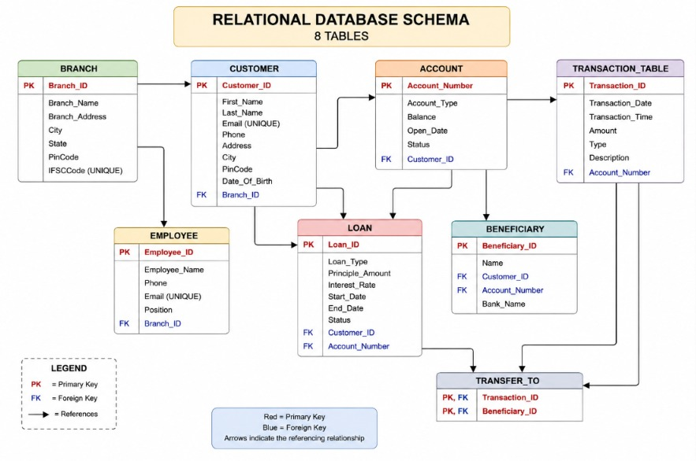
Fig. 3.2: Relational Schema Diagram (arrows run from each foreign key to the primary key it references)

3.6 Primary Keys and Foreign Keys
Table 3.5: Primary Key and Foreign Key Definitions
Table | Primary Key | Foreign Key | References (Table.Column)
BRANCH | Branch_ID | — | —
CUSTOMER | Customer_ID | Branch_ID | BRANCH.Branch_ID
EMPLOYEE | Employee_ID | Branch_ID | BRANCH.Branch_ID
ACCOUNT | Account_Number | Customer_ID | CUSTOMER.Customer_ID
TRANSACTION_TABLE | Transaction_ID | Account_Number | ACCOUNT.Account_Number
LOAN | Loan_ID | Customer_ID; Account_Number | CUSTOMER.Customer_ID; ACCOUNT.Account_Number
BENEFICIARY | Beneficiary_ID | Customer_ID; Account_Number | CUSTOMER.Customer_ID; ACCOUNT.Account_Number
TRANSFER_TO | (Transaction_ID, Beneficiary_ID) | Transaction_ID; Beneficiary_ID | TRANSACTION_TABLE.Transaction_ID; BENEFICIARY.Beneficiary_ID

3.7 Normalization up to 3NF
The normalization starts from a single unnormalized relation that holds everything the bank records about a customer. Curly braces mark repeating groups.
BANK_RECORD(Customer_ID, First_Name, Last_Name, Email, {Phone}, Address, City, PinCode, Date_Of_Birth, Branch_ID, Branch_Name, Branch_Address, Branch_City, State, Branch_PinCode, IFSCCode, {Account_Number, Account_Type, Balance, Open_Date, Status, {Transaction_ID, Transaction_Date, Transaction_Time, Amount, Type, Description, {Beneficiary_ID, Name, Bank_Name}}}, {Loan_ID, Loan_Type, Principle_Amount, Interest_Rate, Start_Date, End_Date, Loan_Status}, {Employee_ID, Employee_Name, Position})
Functional dependencies identified:
- Customer_ID → First_Name, Last_Name, Email, Phone, Address, City, PinCode, Date_Of_Birth, Branch_ID
- Branch_ID → Branch_Name, Branch_Address, City, State, PinCode, IFSCCode
- Account_Number → Account_Type, Balance, Open_Date, Status, Customer_ID
- Transaction_ID → Transaction_Date, Transaction_Time, Amount, Type, Description, Account_Number
- Loan_ID → Loan_Type, Principle_Amount, Interest_Rate, Start_Date, End_Date, Status, Customer_ID, Account_Number
- Employee_ID → Employee_Name, Phone, Email, Position, Branch_ID
- Beneficiary_ID → Name, Customer_ID, Account_Number, Bank_Name
- (Transaction_ID, Beneficiary_ID) is the key of TRANSFER_TO and has no non-key attribute
First Normal Form: the repeating groups (phones, accounts, transactions, loans, employees, beneficiaries) are removed into separate relations, each with its own key, and every column holds a single atomic value. Second Normal Form: no non-key attribute depends on only part of a composite key. When accounts were kept inside the customer relation the key would have been (Customer_ID, Account_Number) and Account_Type, Balance and Status would depend on Account_Number alone, so accounts were separated; the only composite key left is (Transaction_ID, Beneficiary_ID) in TRANSFER_TO, which has no other columns. Third Normal Form: transitive dependencies such as Customer_ID → Branch_ID → Branch_Name are removed by keeping branch details only in BRANCH and referring to them through Branch_ID.
Design note: LOAN stores both Customer_ID (the borrower) and Account_Number (the repayment account). These are treated as independent facts, because the repayment account may belong to a co-applicant, so no transitive dependency is assumed. The result is the eight tables of Table 3.4, each in 3NF.
UNF → 1NF → 2NF → 3NF
Table 3.6: Normalization Steps
Normal Form | Condition Satisfied | Anomaly Removed | Resulting Tables
UNF | Single relation with nested repeating groups and multi-valued Phone | Insertion, deletion and update anomalies; heavy redundancy of customer and branch data | BANK_RECORD
1NF | Atomic values; repeating groups moved to separate relations with their own keys | Repeating groups of accounts, transactions, loans, employees and beneficiaries | CUSTOMER, ACCOUNT, TRANSACTION, LOAN, EMPLOYEE, BENEFICIARY, BRANCH, TRANSFER_TO
2NF | No partial dependency on any part of a composite key | Account, transaction and loan details repeated for every (customer, account) combination | Same eight relations; only TRANSFER_TO has a composite key
3NF | No transitive dependency of a non-key attribute on the key | Branch details repeated for every customer and employee (Customer_ID → Branch_ID → Branch_Name) | BRANCH, CUSTOMER, EMPLOYEE, ACCOUNT, TRANSACTION_TABLE, LOAN, BENEFICIARY, TRANSFER_TO

CHAPTER 4: DATABASE IMPLEMENTATION
(Deliverables of Review – II)

4.1 Database and Table Creation – DDL
The complete set of CREATE TABLE statements is shown below. The tables are created in an order that respects the foreign keys: parent tables (BRANCH, CUSTOMER, ACCOUNT, TRANSACTION_TABLE, BENEFICIARY) before child tables. Because TRANSACTION is a reserved word in SQL, the table is named TRANSACTION_TABLE.
CREATE DATABASE bank_account_management;
\c bank_account_management

-- BRANCH
CREATE TABLE BRANCH (
Branch_ID INT PRIMARY KEY,
Branch_Name VARCHAR(100) NOT NULL,
Branch_Address VARCHAR(200),
City VARCHAR(50),
State VARCHAR(50),
PinCode VARCHAR(10),
IFSCCode VARCHAR(20) UNIQUE
);

-- CUSTOMER
CREATE TABLE CUSTOMER (
Customer_ID INT PRIMARY KEY,
First_Name VARCHAR(50) NOT NULL,
Last_Name VARCHAR(50),
Email VARCHAR(100) UNIQUE,
Phone VARCHAR(15),
Address VARCHAR(200),
City VARCHAR(50),
PinCode VARCHAR(10),
Date_Of_Birth DATE,
Branch_ID INT,
FOREIGN KEY (Branch_ID) REFERENCES BRANCH(Branch_ID)
);

-- EMPLOYEE
CREATE TABLE EMPLOYEE (
Employee_ID INT PRIMARY KEY,
Employee_Name VARCHAR(100) NOT NULL,
Phone VARCHAR(15),
Email VARCHAR(100) UNIQUE,
Position VARCHAR(50),
Branch_ID INT,
FOREIGN KEY (Branch_ID) REFERENCES BRANCH(Branch_ID)
);

-- ACCOUNT
CREATE TABLE ACCOUNT (
Account_Number BIGINT PRIMARY KEY,
Account_Type VARCHAR(30) NOT NULL,
Balance NUMERIC(12,2) DEFAULT 0.00,
Open_Date DATE,
Status VARCHAR(20) DEFAULT 'Active',
Customer_ID INT NOT NULL,
FOREIGN KEY (Customer_ID) REFERENCES CUSTOMER(Customer_ID),
CHECK (Balance >= 0)
);

-- TRANSACTION
CREATE TABLE TRANSACTION_TABLE (
Transaction_ID INT PRIMARY KEY,
Transaction_Date DATE NOT NULL,
Transaction_Time TIME,
Amount NUMERIC(12,2) NOT NULL,
Type VARCHAR(20) NOT NULL,
Description VARCHAR(200),
Account_Number BIGINT NOT NULL,
FOREIGN KEY (Account_Number) REFERENCES ACCOUNT(Account_Number),
CHECK (Amount > 0),
CHECK (Type IN ('Deposit', 'Withdraw', 'Transfer'))
);

-- LOAN
CREATE TABLE LOAN (
Loan_ID INT PRIMARY KEY,
Loan_Type VARCHAR(50) NOT NULL,
Principle_Amount NUMERIC(12,2) NOT NULL,
Interest_Rate NUMERIC(5,2),
Start_Date DATE,
End_Date DATE,
Status VARCHAR(20),
Customer_ID INT NOT NULL,
Account_Number BIGINT NOT NULL,
FOREIGN KEY (Customer_ID) REFERENCES CUSTOMER(Customer_ID),
FOREIGN KEY (Account_Number) REFERENCES ACCOUNT(Account_Number),
CHECK (Principle_Amount > 0),
CHECK (Interest_Rate >= 0)
);

-- BENEFICIARY
CREATE TABLE BENEFICIARY (
Beneficiary_ID INT PRIMARY KEY,
Name VARCHAR(100) NOT NULL,
Customer_ID INT NOT NULL,
Account_Number BIGINT,
Bank_Name VARCHAR(100),
FOREIGN KEY (Customer_ID) REFERENCES CUSTOMER(Customer_ID),
FOREIGN KEY (Account_Number) REFERENCES ACCOUNT(Account_Number)
);

-- TRANSFER_TO
CREATE TABLE TRANSFER_TO (
Transaction_ID INT,
Beneficiary_ID INT,
PRIMARY KEY (Transaction_ID, Beneficiary_ID),
FOREIGN KEY (Transaction_ID) REFERENCES TRANSACTION_TABLE(Transaction_ID),
FOREIGN KEY (Beneficiary_ID) REFERENCES BENEFICIARY(Beneficiary_ID)
);

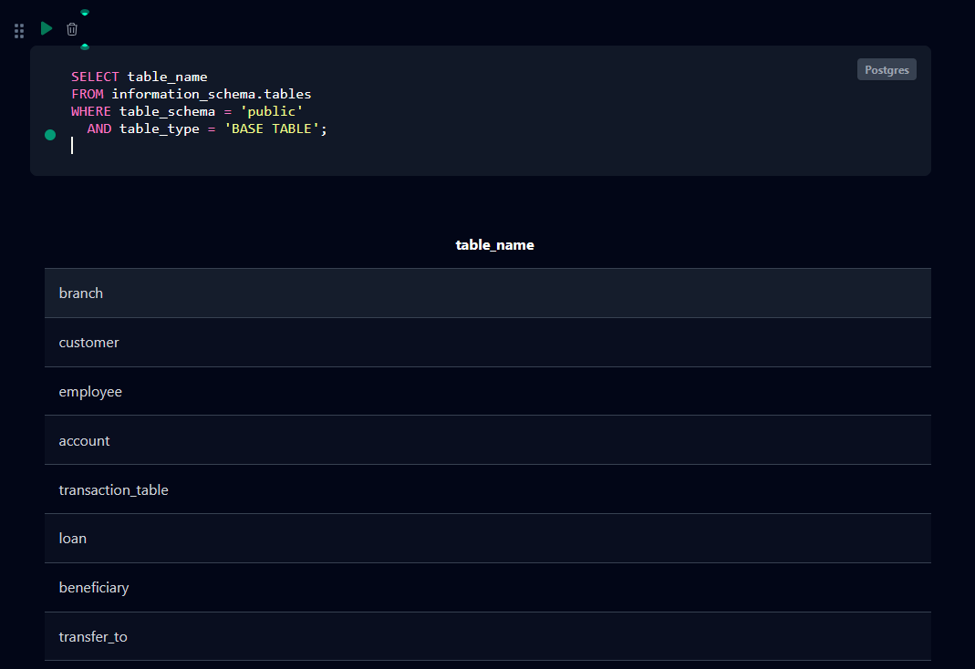

Fig. 4.1: Successful Creation of Tables (PostgreSQL returns CREATE TABLE for each of the eight statements)

4.2 Sample Data Insertion – DML
Every table was populated with sample data using INSERT statements (Table 4.1). UPDATE and DELETE operations on the sample data are listed in Section 5.7 (Q25 to Q30).
Table 4.1: Sample Data Summary
S.No | Table Name | No. of Records Inserted | Screenshot Reference
1 | BRANCH | 5 | Fig. 4.2
2 | CUSTOMER | 5 | Fig. 4.2
3 | EMPLOYEE | 5 | Fig. 4.2
4 | ACCOUNT | 5 | Fig. 4.2
5 | TRANSACTION_TABLE | 5 | Fig. 4.2
6 | LOAN | 5 | Fig. 4.2
7 | BENEFICIARY | 5 (4 after Q29) | Fig. 4.2
8 | TRANSFER_TO | 2 | Fig. 4.2

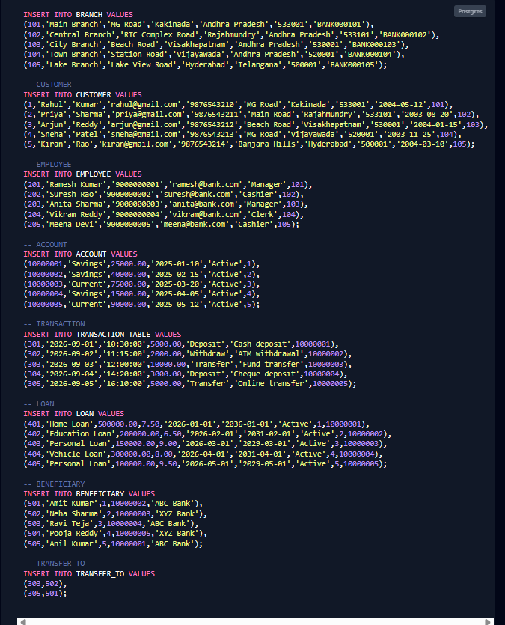

Fig. 4.2: Sample Data Inserted into the Tables

4.3 Constraints and Data Integrity
Table 4.2: Constraints and Data Integrity Rules
Constraint / Validation | Applied On (Table.Column) | Purpose | Evidence / Screenshot Ref.
PRIMARY KEY | All eight tables (TRANSFER_TO: composite) | Uniquely identifies each row; rejects duplicate IDs | Fig. 4.3; TC-01
FOREIGN KEY | CUSTOMER.Branch_ID, EMPLOYEE.Branch_ID, ACCOUNT.Customer_ID, TRANSACTION_TABLE.Account_Number, LOAN, BENEFICIARY, TRANSFER_TO | Prevents orphan records; keeps relationships valid | Fig. 4.3; TC-02, TC-07
NOT NULL | BRANCH.Branch_Name, CUSTOMER.First_Name, EMPLOYEE.Employee_Name, ACCOUNT.Account_Type and Customer_ID, TRANSACTION_TABLE.Transaction_Date, Amount, Type, Account_Number, LOAN.Loan_Type, Principle_Amount, BENEFICIARY.Name | Mandatory values must be supplied | TC-06
UNIQUE | BRANCH.IFSCCode, CUSTOMER.Email, EMPLOYEE.Email | No two rows share the same IFSC code or e-mail | TC-05
CHECK (Balance >= 0) | ACCOUNT.Balance | An account can never have a negative balance | TC-03
CHECK (Amount > 0) | TRANSACTION_TABLE.Amount | A transaction amount must be positive | TC-09
CHECK (Type IN ...) | TRANSACTION_TABLE.Type | Only Deposit, Withdraw or Transfer accepted | TC-04
CHECK (> 0), CHECK (>= 0) | LOAN.Principle_Amount, LOAN.Interest_Rate | Loan principal must be positive; rate cannot be negative | TC-10
DEFAULT | ACCOUNT.Balance (0.00), ACCOUNT.Status ('Active') | Supplies a value when none is given | TC-08

4.4 Data Validation Rules
Duplicate IDs are prevented by PRIMARY KEY and UNIQUE constraints, invalid values (negative balances, unknown transaction types, non-positive amounts) by CHECK constraints, missing mandatory values by NOT NULL, and orphan records by FOREIGN KEY constraints. The foreign keys also work in the opposite direction: a customer who still owns accounts cannot be deleted. Fig. 4.3 shows the error messages returned by PostgreSQL for four violations.
-- 1. Duplicate primary key
INSERT INTO CUSTOMER VALUES (1,'Test','User','t@x.com','9000000000','a','c','1','2000-01-01',101);
ERROR: duplicate key value violates unique constraint "customer_pkey"
DETAIL: Key (customer_id)=(1) already exists.

-- 2. Orphan row (customer 99 does not exist)
INSERT INTO ACCOUNT VALUES (10000006,'Savings',1000,'2026-09-10','Active',99);
ERROR: insert or update on table "account" violates foreign key constraint "account_customer_id_fkey"
DETAIL: Key (customer_id)=(99) is not present in table "customer".

-- 3. Negative balance
INSERT INTO ACCOUNT VALUES (10000006,'Savings',-500,'2026-09-10','Active',1);
ERROR: new row for relation "account" violates check constraint "account_balance_check"
DETAIL: Failing row contains (10000006, Savings, -500.00, 2026-09-10, Active, 1).

-- 4. Deleting a parent row that is still referenced
DELETE FROM CUSTOMER WHERE Customer_ID = 1;
ERROR: update or delete on table "customer" violates foreign key constraint "account_customer_id_fkey" on table "account"
DETAIL: Key (customer_id)=(1) is still referenced from table "account".
Fig. 4.3: Referential Integrity Enforced by the Database

CHAPTER 5: SQL OPERATIONS AND QUERIES
Queries are numbered Q1 to Q51 exactly as in the SQL script of Appendix A (V1 and V2 are the two views of the script). For every query the tables below give the purpose, the SQL statement and a reference to its output. The output of every query is reproduced in Appendix B and the key outputs are shown as figures in Chapter 7. Q36 to Q51 were added to cover natural, equi and outer joins, correlated subqueries, updatable and non-updatable views, set operations, DCL and TCL.

5.1 DQL – Basic Retrieval Queries
Table 5.1: Basic Retrieval Queries
Q.No | Purpose of the Query | SQL Statement | Output Ref.
Q1 | Display all customers | SELECT * FROM CUSTOMER; | App. B  Q1
Q2 | List active accounts | SELECT *  FROM ACCOUNT  WHERE Status = 'Active'; | App. B  Q2
Q3 | Accounts with balance above 30000 | SELECT *  FROM ACCOUNT  WHERE Balance > 30000; | App. B  Q3
Q4 | Accounts ordered by balance (highest first) | SELECT *  FROM ACCOUNT  ORDER BY Balance DESC; | App. B  Q4
Q5 | List all savings accounts | SELECT *  FROM ACCOUNT  WHERE Account_Type = 'Savings'; | App. B  Q5
Q34 | Categorise accounts by balance | SELECT Account_Number, Balance,  CASE  WHEN Balance >= 50000 THEN 'High Balance'  WHEN Balance >= 25000 THEN 'Medium Balance'  ELSE 'Low Balance'  END AS Balance_Category  FROM ACCOUNT; | Fig. 7.6

5.2 Join Operations
The joins cover inner join (Q6 to Q10), left outer join (Q31), right outer join (Q38), full outer join (Q39), natural join (Q36), equi join (Q37) and multi-table joins (Q32, Q33).
Table 5.2: Join Operations
Q.No | Type of Join | SQL Statement | Output Ref.
Q6 | Inner join  Customer with account details | SELECT C.Customer_ID, C.First_Name, C.Last_Name,  A.Account_Number, A.Account_Type, A.Balance  FROM CUSTOMER C  JOIN ACCOUNT A  ON C.Customer_ID = A.Customer_ID; | Fig. 7.1
Q7 | Inner join  Customer with branch details | SELECT C.Customer_ID, C.First_Name, C.Last_Name,  B.Branch_Name, B.City  FROM CUSTOMER C  JOIN BRANCH B  ON C.Branch_ID = B.Branch_ID; | App. B  Q7
Q8 | Inner join  Account with its transactions | SELECT A.Account_Number, A.Account_Type,  T.Transaction_ID, T.Amount, T.Type  FROM ACCOUNT A  JOIN TRANSACTION_TABLE T  ON A.Account_Number = T.Account_Number; | App. B  Q8
Q9 | Inner join  Customer with loan details | SELECT C.Customer_ID, C.First_Name, C.Last_Name,  L.Loan_ID, L.Loan_Type, L.Principle_Amount  FROM CUSTOMER C  JOIN LOAN L  ON C.Customer_ID = L.Customer_ID; | App. B  Q9
Q10 | Inner join  Employee with branch details | SELECT E.Employee_ID, E.Employee_Name, E.Position,  B.Branch_Name, B.City  FROM EMPLOYEE E  JOIN BRANCH B  ON E.Branch_ID = B.Branch_ID; | App. B  Q10
Q31 | Left outer join  All customers with or without accounts | SELECT C.Customer_ID, C.First_Name, C.Last_Name,  A.Account_Number, A.Balance  FROM CUSTOMER C  LEFT JOIN ACCOUNT A  ON C.Customer_ID = A.Customer_ID; | App. B  Q31
Q32 | Three-table join  Customer, account and branch together | SELECT C.Customer_ID, C.First_Name, C.Last_Name,  A.Account_Number, A.Balance, B.Branch_Name  FROM CUSTOMER C  JOIN ACCOUNT A  ON C.Customer_ID = A.Customer_ID  JOIN BRANCH B  ON C.Branch_ID = B.Branch_ID; | Fig. 7.2
Q33 | Multi-table join  Transfer transactions with beneficiaries | SELECT T.Transaction_ID, T.Amount, T.Type,  B.Beneficiary_ID, B.Name AS Beneficiary_Name, B.Bank_Name  FROM TRANSACTION_TABLE T  JOIN TRANSFER_TO TT  ON T.Transaction_ID = TT.Transaction_ID  JOIN BENEFICIARY B  ON TT.Beneficiary_ID = B.Beneficiary_ID; | App. B  Q33
Q36 | Natural join  Customer and account on the common column Customer_ID | SELECT Customer_ID, First_Name, Account_Number, Balance  FROM CUSTOMER NATURAL JOIN ACCOUNT; | App. B  Q36
Q37 | Equi join  Employees with their branch (WHERE-clause form) | SELECT E.Employee_Name, E.Position, B.Branch_Name  FROM EMPLOYEE E, BRANCH B  WHERE E.Branch_ID = B.Branch_ID; | App. B  Q37
Q38 | Right outer join  All beneficiaries, with transfers if any | SELECT B.Beneficiary_ID, B.Name, TT.Transaction_ID  FROM TRANSFER_TO TT  RIGHT JOIN BENEFICIARY B  ON TT.Beneficiary_ID = B.Beneficiary_ID; | App. B  Q38
Q39 | Full outer join  All accounts and all transactions | SELECT A.Account_Number, T.Transaction_ID, T.Amount  FROM ACCOUNT A  FULL OUTER JOIN TRANSACTION_TABLE T  ON A.Account_Number = T.Account_Number; | App. B  Q39

5.3 Aggregate Functions, GROUP BY and HAVING
Table 5.3: Aggregate, GROUP BY and HAVING Queries
Q.No | Function Used | SQL Statement | Output Ref.
Q11 | COUNT  Total number of customers | SELECT COUNT(*) AS Total_Customers  FROM CUSTOMER; | App. B  Q11
Q12 | SUM  Total balance held by the bank | SELECT SUM(Balance) AS Total_Balance  FROM ACCOUNT; | App. B  Q12
Q13 | AVG  Average account balance | SELECT ROUND(AVG(Balance), 2) AS Average_Balance  FROM ACCOUNT; | App. B  Q13
Q14 | MAX  Highest account balance | SELECT MAX(Balance) AS Highest_Balance  FROM ACCOUNT; | App. B  Q14
Q15 | MIN  Lowest account balance | SELECT MIN(Balance) AS Lowest_Balance  FROM ACCOUNT; | App. B  Q15
Q16 | COUNT + GROUP BY  Number of accounts by type | SELECT Account_Type, COUNT(*) AS Total_Accounts  FROM ACCOUNT  GROUP BY Account_Type; | App. B  Q16
Q17 | SUM + GROUP BY  Total balance by account type | SELECT Account_Type, SUM(Balance) AS Total_Balance  FROM ACCOUNT  GROUP BY Account_Type; | Fig. 7.3
Q18 | AVG + GROUP BY  Average balance by account type | SELECT Account_Type,  ROUND(AVG(Balance), 2) AS Average_Balance  FROM ACCOUNT  GROUP BY Account_Type; | App. B  Q18
Q19 | COUNT + GROUP BY  Number of customers in each branch | SELECT Branch_ID, COUNT(*) AS Total_Customers  FROM CUSTOMER  GROUP BY Branch_ID; | App. B  Q19
Q20 | GROUP BY + HAVING  Account types having more than one account | SELECT Account_Type, COUNT(*) AS Total_Accounts  FROM ACCOUNT  GROUP BY Account_Type  HAVING COUNT(*) > 1; | App. B  Q20

5.4 Nested and Correlated Subqueries
Table 5.4: Subqueries
Q.No | Type (Nested / Correlated) | SQL Statement | Output Ref.
Q21 | Nested  Accounts above the average balance | SELECT *  FROM ACCOUNT  WHERE Balance >  (SELECT AVG(Balance) FROM ACCOUNT); | Fig. 7.4
Q22 | Nested  Customer holding the highest balance | SELECT C.Customer_ID, C.First_Name, C.Last_Name, A.Balance  FROM CUSTOMER C  JOIN ACCOUNT A  ON C.Customer_ID = A.Customer_ID  WHERE A.Balance =  (SELECT MAX(Balance) FROM ACCOUNT); | App. B  Q22
Q23 | Nested  Accounts with balance above 50000 | SELECT *  FROM ACCOUNT  WHERE Balance > 50000; | App. B  Q23
Q24 | Nested (IN)  Customers having active loans | SELECT DISTINCT C.Customer_ID, C.First_Name, C.Last_Name  FROM CUSTOMER C  WHERE C.Customer_ID IN  (SELECT Customer_ID FROM LOAN  WHERE Status = 'Active'); | App. B  Q24
Q35 | Correlated (EXISTS)  Customers having an active loan | SELECT C.Customer_ID, C.First_Name, C.Last_Name  FROM CUSTOMER C  WHERE EXISTS  (SELECT 1 FROM LOAN L  WHERE L.Customer_ID = C.Customer_ID  AND L.Status = 'Active'); | App. B  Q35
Q40 | Correlated  Accounts above the average of their own account type | SELECT A.Account_Number, A.Account_Type, A.Balance  FROM ACCOUNT A  WHERE A.Balance >  (SELECT AVG(A2.Balance) FROM ACCOUNT A2  WHERE A2.Account_Type = A.Account_Type); | Fig. 7.5

5.5 Views and Relational Set Operations
V1 and V2 are non-updatable views because they join two tables. Q41 is an updatable view (a simple single-table view without aggregation, so an UPDATE on the view changes ACCOUNT) and Q42 is a non-updatable view (GROUP BY), which PostgreSQL refuses to update. Q43 to Q45 are the set operations UNION, INTERSECT and EXCEPT (called MINUS in Oracle) and Q51 is the final row-count verification using UNION ALL.
Table 5.5: Views and Set Operations
Q.No | View / Set Operation | SQL Statement | Output Ref.
Q41 | Updatable view  Simple single-table view; UPDATE passes through to ACCOUNT | CREATE VIEW Active_Account_View AS  SELECT Account_Number, Account_Type, Balance, Status  FROM ACCOUNT  WHERE Status = 'Active';  UPDATE Active_Account_View  SET Balance = Balance + 1000  WHERE Account_Number = 10000001;  SELECT * FROM Active_Account_View; | App. B  Q41
Q42 | Non-updatable view  Aggregate view; UPDATE is rejected | CREATE VIEW Branch_Summary_View AS  SELECT B.Branch_ID, B.Branch_Name,  COUNT(C.Customer_ID) AS Total_Customers  FROM BRANCH B  LEFT JOIN CUSTOMER C  ON B.Branch_ID = C.Branch_ID  GROUP BY B.Branch_ID, B.Branch_Name;  SELECT * FROM Branch_Summary_View;  UPDATE Branch_Summary_View  SET Total_Customers = 10  WHERE Branch_ID = 101; | App. B  Q42
Q43 | UNION  All customers and employees as one list | SELECT First_Name AS Person_Name, 'Customer' AS Role  FROM CUSTOMER  UNION  SELECT Employee_Name, 'Employee'  FROM EMPLOYEE  ORDER BY Role, Person_Name; | App. B  Q43
Q44 | INTERSECT  Accounts having a transfer and also a loan | SELECT Account_Number FROM TRANSACTION_TABLE  WHERE Type = 'Transfer'  INTERSECT  SELECT Account_Number FROM LOAN  ORDER BY Account_Number; | App. B  Q44
Q45 | EXCEPT (MINUS)  Accounts with no transfer transaction | SELECT Account_Number FROM ACCOUNT  EXCEPT  SELECT Account_Number FROM TRANSACTION_TABLE  WHERE Type = 'Transfer'  ORDER BY Account_Number; | App. B  Q45
Q51 | UNION ALL  Final verification - row count of every table | SELECT 'BRANCH' AS Table_Name, COUNT(*) AS Row_Count FROM BRANCH  UNION ALL  SELECT 'CUSTOMER', COUNT(*) FROM CUSTOMER  UNION ALL  SELECT 'EMPLOYEE', COUNT(*) FROM EMPLOYEE  UNION ALL  SELECT 'ACCOUNT', COUNT(*) FROM ACCOUNT  UNION ALL  SELECT 'TRANSACTION_TABLE', COUNT(*) FROM TRANSACTION_TABLE  UNION ALL  SELECT 'LOAN', COUNT(*) FROM LOAN  UNION ALL  SELECT 'BENEFICIARY', COUNT(*) FROM BENEFICIARY  UNION ALL  SELECT 'TRANSFER_TO', COUNT(*) FROM TRANSFER_TO; | Fig. 7.8
V1 | View (join)  Customer-account view (non-updatable, joins two tables) | CREATE VIEW Customer_Account_View AS  SELECT C.Customer_ID, C.First_Name, C.Last_Name,  A.Account_Number, A.Account_Type,  A.Balance, A.Status  FROM CUSTOMER C  JOIN ACCOUNT A  ON C.Customer_ID = A.Customer_ID;  SELECT * FROM Customer_Account_View; | App. B  V1
V2 | View (join)  Customer-loan view (non-updatable, joins two tables) | CREATE VIEW Customer_Loan_View AS  SELECT C.Customer_ID, C.First_Name, C.Last_Name,  L.Loan_ID, L.Loan_Type, L.Principle_Amount,  L.Interest_Rate, L.Status  FROM CUSTOMER C  JOIN LOAN L  ON C.Customer_ID = L.Customer_ID;  SELECT * FROM Customer_Loan_View; | App. B  V2

5.6 DCL and TCL Operations
GRANT and REVOKE (DCL) control what a role may do. COMMIT, SAVEPOINT and ROLLBACK (TCL) make a set of changes permanent or undo part of it. Q49 and Q50 form one transaction: the wrong credit made after the savepoint is rolled back and the correct credit is applied before COMMIT.
Table 5.6: DCL and TCL Operations
Q.No | Command | Purpose | SQL Statement | Output Ref.
Q46 | GRANT | Give a clerk role read and insert rights on transactions | CREATE ROLE clerk_role;  GRANT SELECT, INSERT  ON TRANSACTION_TABLE  TO clerk_role; | App. B  Q46
Q47 | REVOKE | Withdraw the insert right again | REVOKE INSERT  ON TRANSACTION_TABLE  FROM clerk_role; | App. B  Q47
Q48 | COMMIT | Make a fund transfer permanent | BEGIN;  UPDATE ACCOUNT SET Balance = Balance - 2000  WHERE Account_Number = 10000002;  UPDATE ACCOUNT SET Balance = Balance + 2000  WHERE Account_Number = 10000001;  COMMIT;  SELECT Account_Number, Balance FROM ACCOUNT  WHERE Account_Number IN (10000001, 10000002)  ORDER BY Account_Number; | App. B  Q48
Q49 | SAVEPOINT | Mark a point inside a running transaction | BEGIN;  UPDATE ACCOUNT SET Balance = Balance - 500  WHERE Account_Number = 10000003;  SAVEPOINT sp_after_debit;  UPDATE ACCOUNT SET Balance = Balance + 500  WHERE Account_Number = 10000005; -- wrong account | App. B  Q49
Q50 | ROLLBACK | Undo the wrong credit, then complete correctly | ROLLBACK TO SAVEPOINT sp_after_debit;  UPDATE ACCOUNT SET Balance = Balance + 500  WHERE Account_Number = 10000004;  COMMIT;  SELECT Account_Number, Balance FROM ACCOUNT  WHERE Account_Number IN (10000003, 10000004, 10000005)  ORDER BY Account_Number; | Fig. 7.7

5.7 CRUD Operations (INSERT, UPDATE, DELETE)
Table 5.7: CRUD Operations
Q.No | Type (Nested / Correlated) | SQL Statement | Output Ref.
Q25 | UPDATE  Change the phone number of customer 1 | UPDATE CUSTOMER  SET Phone = '9999999999'  WHERE Customer_ID = 1; | App. B  Q25
Q26 | SELECT  Verify the updated customer | SELECT *  FROM CUSTOMER  WHERE Customer_ID = 1; | App. B  Q26
Q27 | UPDATE  Mark account 10000004 as Inactive | UPDATE ACCOUNT  SET Status = 'Inactive'  WHERE Account_Number = 10000004; | App. B  Q27
Q28 | SELECT  Verify the updated account | SELECT *  FROM ACCOUNT  WHERE Account_Number = 10000004; | App. B  Q28
Q29 | DELETE  Remove beneficiary 505 | DELETE FROM BENEFICIARY  WHERE Beneficiary_ID = 505; | App. B  Q29
Q30 | SELECT  Verify the beneficiary is deleted | SELECT *  FROM BENEFICIARY  WHERE Beneficiary_ID = 505; | App. B  Q30

CHAPTER 6: MODULES AND FUNCTIONALITIES
The system is divided into eight modules. Table 6.1 lists the tables each module works on and a short paragraph below the table describes each module.
Table 6.1: Modules and Their Functionalities
S.No | Module Name | Functionality | Tables Involved
1 | Branch Management | Stores branch details and IFSC codes; lists the customers and employees of each branch. | BRANCH, CUSTOMER, EMPLOYEE
2 | Customer Management | Registers customers, updates contact details and links each customer to a home branch. | CUSTOMER, BRANCH
3 | Employee Management | Maintains staff records with position and branch. | EMPLOYEE, BRANCH
4 | Account Management | Opens savings and current accounts, maintains balance and status, and links accounts to owners. | ACCOUNT, CUSTOMER
5 | Transaction Management | Records deposits, withdrawals and transfers with date, time, amount and description. | TRANSACTION_TABLE, ACCOUNT
6 | Loan Management | Records loans with type, principal, interest rate, dates and status against a customer and repayment account. | LOAN, CUSTOMER, ACCOUNT
7 | Beneficiary and Fund Transfer | Registers beneficiaries and links transfer transactions to them (many-to-many). | BENEFICIARY, TRANSFER_TO, TRANSACTION_TABLE
8 | Reporting and Access Control | Views, aggregate reports, set operations, GRANT / REVOKE and transaction control. | Views over CUSTOMER, ACCOUNT, LOAN, BRANCH

Branch Management: each branch has a unique Branch_ID and IFSC code. Queries such as Q7 and Q10 list the customers and employees attached to a branch.
Customer Management: a customer is registered once with a unique e-mail address and belongs to exactly one home branch. The phone number can be corrected with an UPDATE (Q25).
Employee Management: employees are identified by Employee_ID and assigned to one branch with a position such as Manager, Cashier or Clerk.
Account Management: an account has a type, a balance that can never be negative, an open date and a status. Q27 changes an account to Inactive without deleting its history.
Transaction Management: every deposit, withdrawal or transfer is stored against one account. The type is restricted to Deposit, Withdraw or Transfer and the amount must be positive.
Loan Management: a loan is linked to the borrower and to the account used for repayment. Q24 and Q35 find customers with active loans.
Beneficiary and Fund Transfer: the associative table TRANSFER_TO connects a transfer transaction to the beneficiary who received the money (Q33).
Reporting and Access Control: Customer_Account_View and Customer_Loan_View present combined data, aggregate queries produce summaries, and GRANT and REVOKE restrict what a role may do.

CHAPTER 7: RESULTS – SAMPLE OUTPUTS AND SCREENSHOTS
The figures below show the query together with the output returned by PostgreSQL. The output of the remaining queries is given in Appendix B.
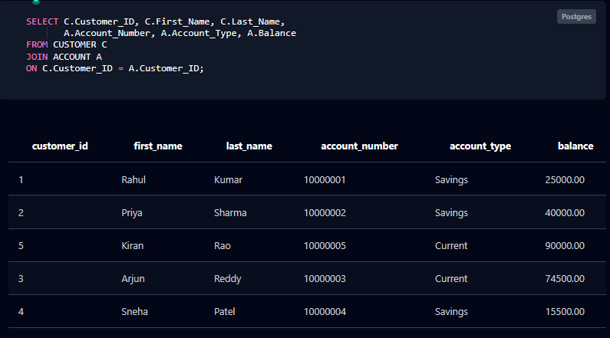

Fig. 7.1: Customer and Account Details (Inner Join, Q6)
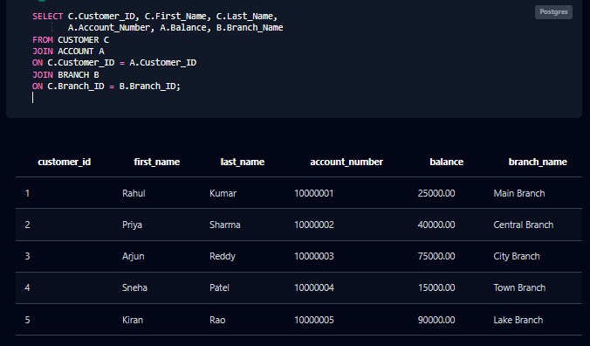

Fig. 7.2: Customer, Account and Branch (Three-table Join, Q32)
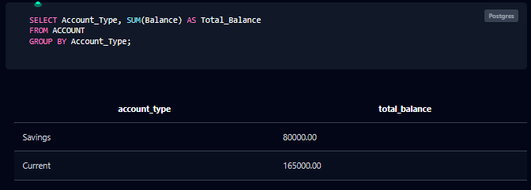

Fig. 7.3: Total Balance by Account Type (GROUP BY, Q17)
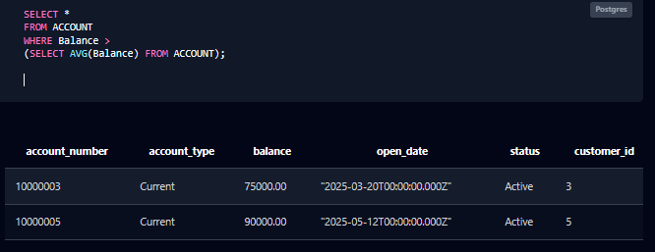

Fig. 7.4: Accounts Above the Average Balance (Nested Subquery, Q21)
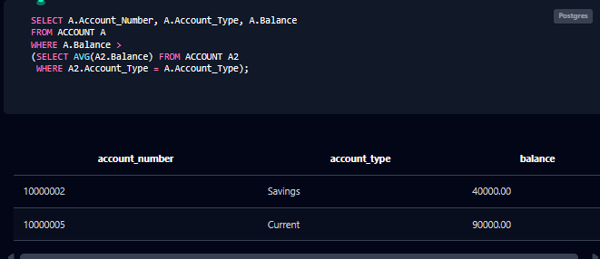

Fig. 7.5: Accounts Above the Average of Their Own Type (Correlated Subquery, Q40)
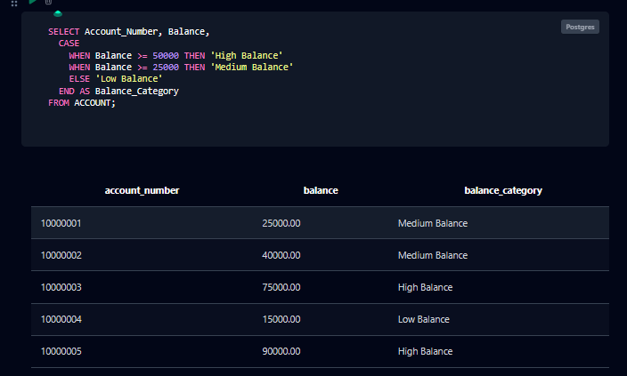

Fig. 7.6: Balance Category using CASE (Q34)
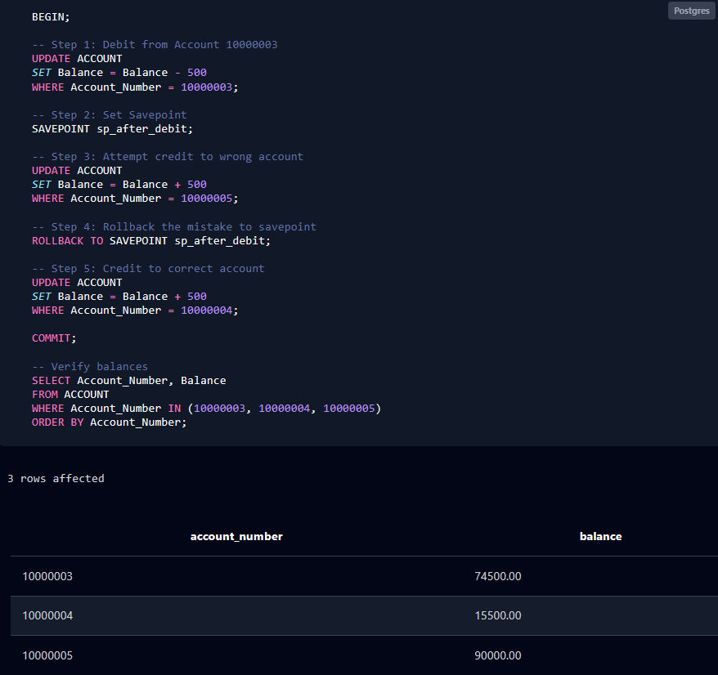

Fig. 7.7: Rollback to Savepoint and Commit (TCL, Q49 and Q50)
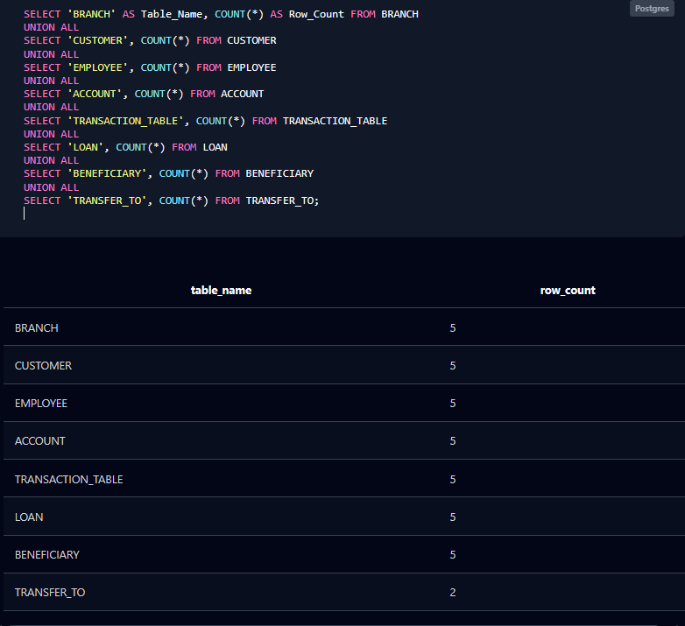

Fig. 7.8: Row Count of Every Table (UNION ALL, Q51)

CHAPTER 8: TESTING AND DATA VALIDATION
Test cases were run against the database to verify the constraints, referential integrity and the correctness of the queries. Error messages are those returned by PostgreSQL.
Table 8.1: Test Cases and Results
TC No. | Test Case Description | Input / Action | Expected Result | Actual Result | Status
TC-01 | Duplicate primary key | INSERT customer with Customer_ID 1 | Rejected | duplicate key value violates unique constraint "customer_pkey" | Pass
TC-02 | Foreign key on insert | INSERT account for Customer_ID 99 | Rejected | violates foreign key constraint "account_customer_id_fkey" | Pass
TC-03 | Negative balance | INSERT account with Balance = -500 | Rejected | violates check constraint "account_balance_check" | Pass
TC-04 | Invalid transaction type | INSERT transaction with Type = 'Cash' | Rejected | violates check constraint "transaction_table_type_check" | Pass
TC-05 | Duplicate e-mail | INSERT customer with e-mail rahul@gmail.com | Rejected | violates unique constraint "customer_email_key" | Pass
TC-06 | NOT NULL | INSERT customer with First_Name = NULL | Rejected | null value in column "first_name" violates not-null constraint | Pass
TC-07 | Delete referenced parent | DELETE customer 1 (owns an account) | Rejected | update or delete on table "customer" violates foreign key constraint | Pass
TC-08 | DEFAULT values | INSERT account giving only number, type, customer | Balance 0.00, Status Active | Balance = 0.00, Status = Active | Pass
TC-09 | Zero amount | INSERT transaction with Amount = 0 | Rejected | violates check constraint "transaction_table_amount_check" | Pass
TC-10 | Negative interest rate | INSERT loan with Interest_Rate = -1 | Rejected | violates check constraint "loan_interest_rate_check" | Pass
TC-11 | Total balance (Q12) | SUM(Balance) over 5 accounts | 245000.00 | 245000.00 | Pass
TC-12 | Group count (Q16) | Accounts grouped by type | Current 2, Savings 3 | Current 2, Savings 3 | Pass
TC-13 | Join correctness (Q6) | Join customer and account | 5 rows, one per customer | 5 rows | Pass
TC-14 | UPDATE (Q25, Q26) | Change phone of customer 1 | Phone = 9999999999 | Phone = 9999999999 | Pass
TC-15 | DELETE (Q29, Q30) | Delete beneficiary 505, query again | 0 rows | (0 rows) | Pass
TC-16 | Rollback to savepoint (Q49, Q50) | Wrong credit to 10000005 rolled back | Balance stays 90000.00 | 90000.00 | Pass
TC-17 | Non-updatable view (Q42) | UPDATE on aggregate view | Rejected | cannot update view "branch_summary_view" | Pass

CHAPTER 9: GITHUB REPOSITORY AND TEAM CONTRIBUTION

9.1 Repository Details
GitHub Repository Link: https://github.com/Sunandan-Kona/bank-account-management-system
The final SQL script (bank_account_management_system.sql), this report and the review presentations are pushed to the team repository.

9.2 Team Responsibilities and Contribution
Table 9.1: Team Responsibilities
S.No | Student Name | Roll Number | Role / Responsibility | Modules Contributed
1 | Bandaru Lahari Naidu | 25B11AI091 | Database design lead | Entities, attributes, ER diagram; Customer and Branch modules
2 | Siripireddy Venkata Karthik Nadh Reddy | 25B11AIB28 | Schema and normalization | Relational schema, keys, 3NF; Account and Transaction modules
3 | Kona Sunandan Babu | 25B11A1560 | Implementation | DDL, sample data and constraints; Loan and Beneficiary modules
4 | Puvvada Ravi Kumar | 25B11A1994 | Queries, testing and documentation | SQL queries, views, testing; report; Employee and Reporting modules

9.3 Review-wise Progress
Table 9.2: Review-wise Progress Record
Review | Date | Deliverables Presented | Remarks of the Guide
Review – I |  | Problem statement and objectives; entities and attributes; ER diagram; relationships and cardinality; primary and foreign keys; relational schema
Review – II |  | Normalization; table creation with constraints; sample data; SQL queries; integrity checks
Final Review |  | Complete documentation, GitHub repository and demonstration of the working database

CHAPTER 10: CONCLUSION AND FUTURE ENHANCEMENTS

10.1 Conclusion
The Bank Account Management System was successfully designed and implemented as a relational database. Seven entities (Branch, Customer, Employee, Account, Transaction, Loan and Beneficiary) were modelled in an ER diagram and converted into eight tables, including the associative table TRANSFER_TO. The design was normalized to the Third Normal Form and implemented in PostgreSQL with primary key, foreign key, UNIQUE, NOT NULL, CHECK and DEFAULT constraints.
Objective 1 was met by the ER diagram of Fig. 3.1 with seven entities. Objective 2 was met by the schema of Table 3.4 and the normalization in Section 3.7. Objective 3 was met by the DDL and sample data of Chapter 4. Objective 4 was met by the fifty-one queries and commands of Chapter 5, which cover DDL, DML, DQL, joins, aggregates, subqueries, views, set operations, DCL and TCL. Objective 5 was met by the integrity tests of Section 4.4 and Chapter 8, in which duplicate keys, invalid values and orphan records were all rejected.

10.2 Limitations of the Present Work
The present database is a design and implementation exercise. It does not calculate interest or EMI automatically, does not update account balances when a transaction is inserted (the balance is changed by explicit UPDATE statements), does not keep an audit trail, and the multi-valued Phone attribute of the ER model is stored as a single value. A customer has one home branch, so joint accounts are not represented.

10.3 Future Enhancements
Possible improvements are: stored procedures and triggers that post a transaction and update the balance in one step; automatic interest and EMI calculation; indexes on frequently searched columns; a separate phone table for multiple numbers; joint-account support; role-based security and audit logging; scheduled backup and recovery; and a web or mobile front-end with reporting dashboards.

REFERENCES
The following books and documentation were referred to while preparing this project.
- Abraham Silberschatz, Henry F. Korth and S. Sudarshan, “Database System Concepts”, 8th Edition, McGraw-Hill, ISBN: 978-1260230508.
- Raghurama Krishnan and Johannes Gehrke, “Database Management Systems”, 4th Edition, McGraw-Hill, ISBN: 978-1260091195.
- Ramez Elmasri and Shamkant B. Navathe, “Fundamentals of Database Systems”, 7th Edition, Pearson, ISBN: 978-0137504277.
- PostgreSQL Global Development Group, “PostgreSQL Documentation”, https://www.postgresql.org/docs/.
- draw.io (diagrams.net), “Diagram Software and Flowchart Maker”, https://www.drawio.com/.

APPENDIX A – COMPLETE SQL SCRIPT
The complete, final SQL script (CREATE, INSERT and all queries) is given below in execution order. The same script is supplied as bank_account_management_system.sql for the GitHub repository. Running it from top to bottom reproduces every output shown in this report.
-- =========================================================
-- BANK ACCOUNT MANAGEMENT SYSTEM
-- COMPLETE POSTGRESQL CODE
-- =========================================================

-- =========================================================
-- 1. CREATE TABLES
-- =========================================================
-- BRANCH
CREATE TABLE BRANCH (
Branch_ID INT PRIMARY KEY,
Branch_Name VARCHAR(100) NOT NULL,
Branch_Address VARCHAR(200),
City VARCHAR(50),
State VARCHAR(50),
PinCode VARCHAR(10),
IFSCCode VARCHAR(20) UNIQUE
);

-- CUSTOMER
CREATE TABLE CUSTOMER (
Customer_ID INT PRIMARY KEY,
First_Name VARCHAR(50) NOT NULL,
Last_Name VARCHAR(50),
Email VARCHAR(100) UNIQUE,
Phone VARCHAR(15),
Address VARCHAR(200),
City VARCHAR(50),
PinCode VARCHAR(10),
Date_Of_Birth DATE,
Branch_ID INT,
FOREIGN KEY (Branch_ID) REFERENCES BRANCH(Branch_ID)
);

-- EMPLOYEE
CREATE TABLE EMPLOYEE (
Employee_ID INT PRIMARY KEY,
Employee_Name VARCHAR(100) NOT NULL,
Phone VARCHAR(15),
Email VARCHAR(100) UNIQUE,
Position VARCHAR(50),
Branch_ID INT,
FOREIGN KEY (Branch_ID) REFERENCES BRANCH(Branch_ID)
);

-- ACCOUNT
CREATE TABLE ACCOUNT (
Account_Number BIGINT PRIMARY KEY,
Account_Type VARCHAR(30) NOT NULL,
Balance NUMERIC(12,2) DEFAULT 0.00,
Open_Date DATE,
Status VARCHAR(20) DEFAULT 'Active',
Customer_ID INT NOT NULL,
FOREIGN KEY (Customer_ID) REFERENCES CUSTOMER(Customer_ID),
CHECK (Balance >= 0)
);

-- TRANSACTION
CREATE TABLE TRANSACTION_TABLE (
Transaction_ID INT PRIMARY KEY,
Transaction_Date DATE NOT NULL,
Transaction_Time TIME,
Amount NUMERIC(12,2) NOT NULL,
Type VARCHAR(20) NOT NULL,
Description VARCHAR(200),
Account_Number BIGINT NOT NULL,
FOREIGN KEY (Account_Number) REFERENCES ACCOUNT(Account_Number),
CHECK (Amount > 0),
CHECK (Type IN ('Deposit', 'Withdraw', 'Transfer'))
);

-- LOAN
CREATE TABLE LOAN (
Loan_ID INT PRIMARY KEY,
Loan_Type VARCHAR(50) NOT NULL,
Principle_Amount NUMERIC(12,2) NOT NULL,
Interest_Rate NUMERIC(5,2),
Start_Date DATE,
End_Date DATE,
Status VARCHAR(20),
Customer_ID INT NOT NULL,
Account_Number BIGINT NOT NULL,
FOREIGN KEY (Customer_ID) REFERENCES CUSTOMER(Customer_ID),
FOREIGN KEY (Account_Number) REFERENCES ACCOUNT(Account_Number),
CHECK (Principle_Amount > 0),
CHECK (Interest_Rate >= 0)
);

-- BENEFICIARY
CREATE TABLE BENEFICIARY (
Beneficiary_ID INT PRIMARY KEY,
Name VARCHAR(100) NOT NULL,
Customer_ID INT NOT NULL,
Account_Number BIGINT,
Bank_Name VARCHAR(100),
FOREIGN KEY (Customer_ID) REFERENCES CUSTOMER(Customer_ID),
FOREIGN KEY (Account_Number) REFERENCES ACCOUNT(Account_Number)
);

-- TRANSFER_TO
CREATE TABLE TRANSFER_TO (
Transaction_ID INT,
Beneficiary_ID INT,
PRIMARY KEY (Transaction_ID, Beneficiary_ID),
FOREIGN KEY (Transaction_ID) REFERENCES TRANSACTION_TABLE(Transaction_ID),
FOREIGN KEY (Beneficiary_ID) REFERENCES BENEFICIARY(Beneficiary_ID)
);

-- =========================================================
-- 2. INSERT SAMPLE DATA
-- =========================================================
-- BRANCH
INSERT INTO BRANCH VALUES
(101,'Main Branch','MG Road','Kakinada','Andhra Pradesh','533001','BANK000101'),
(102,'Central Branch','RTC Complex Road','Rajahmundry','Andhra Pradesh','533101','BANK000102'),
(103,'City Branch','Beach Road','Visakhapatnam','Andhra Pradesh','530001','BANK000103'),
(104,'Town Branch','Station Road','Vijayawada','Andhra Pradesh','520001','BANK000104'),
(105,'Lake Branch','Lake View Road','Hyderabad','Telangana','500001','BANK000105');

-- CUSTOMER
INSERT INTO CUSTOMER VALUES
(1,'Rahul','Kumar','rahul@gmail.com','9876543210','MG Road','Kakinada','533001','2004-05-12',101),
(2,'Priya','Sharma','priya@gmail.com','9876543211','Main Road','Rajahmundry','533101','2003-08-20',102),
(3,'Arjun','Reddy','arjun@gmail.com','9876543212','Beach Road','Visakhapatnam','530001','2004-01-15',103),
(4,'Sneha','Patel','sneha@gmail.com','9876543213','MG Road','Vijayawada','520001','2003-11-25',104),
(5,'Kiran','Rao','kiran@gmail.com','9876543214','Banjara Hills','Hyderabad','500001','2004-03-10',105);

-- EMPLOYEE
INSERT INTO EMPLOYEE VALUES
(201,'Ramesh Kumar','9000000001','ramesh@bank.com','Manager',101),
(202,'Suresh Rao','9000000002','suresh@bank.com','Cashier',102),
(203,'Anita Sharma','9000000003','anita@bank.com','Manager',103),
(204,'Vikram Reddy','9000000004','vikram@bank.com','Clerk',104),
(205,'Meena Devi','9000000005','meena@bank.com','Cashier',105);

-- ACCOUNT
INSERT INTO ACCOUNT VALUES
(10000001,'Savings',25000.00,'2025-01-10','Active',1),
(10000002,'Savings',40000.00,'2025-02-15','Active',2),
(10000003,'Current',75000.00,'2025-03-20','Active',3),
(10000004,'Savings',15000.00,'2025-04-05','Active',4),
(10000005,'Current',90000.00,'2025-05-12','Active',5);

-- TRANSACTION
INSERT INTO TRANSACTION_TABLE VALUES
(301,'2026-09-01','10:30:00',5000.00,'Deposit','Cash deposit',10000001),
(302,'2026-09-02','11:15:00',2000.00,'Withdraw','ATM withdrawal',10000002),
(303,'2026-09-03','12:00:00',10000.00,'Transfer','Fund transfer',10000003),
(304,'2026-09-04','14:20:00',3000.00,'Deposit','Cheque deposit',10000004),
(305,'2026-09-05','16:10:00',5000.00,'Transfer','Online transfer',10000005);

-- LOAN
INSERT INTO LOAN VALUES
(401,'Home Loan',500000.00,7.50,'2026-01-01','2036-01-01','Active',1,10000001),
(402,'Education Loan',200000.00,6.50,'2026-02-01','2031-02-01','Active',2,10000002),
(403,'Personal Loan',150000.00,9.00,'2026-03-01','2029-03-01','Active',3,10000003),
(404,'Vehicle Loan',300000.00,8.00,'2026-04-01','2031-04-01','Active',4,10000004),
(405,'Personal Loan',100000.00,9.50,'2026-05-01','2029-05-01','Active',5,10000005);

-- BENEFICIARY
INSERT INTO BENEFICIARY VALUES
(501,'Amit Kumar',1,10000002,'ABC Bank'),
(502,'Neha Sharma',2,10000003,'XYZ Bank'),
(503,'Ravi Teja',3,10000004,'ABC Bank'),
(504,'Pooja Reddy',4,10000005,'XYZ Bank'),
(505,'Anil Kumar',5,10000001,'ABC Bank');

-- TRANSFER_TO
INSERT INTO TRANSFER_TO VALUES
(303,502),
(305,501);

-- =========================================================
-- 3. QUERIES AND OPERATIONS (Q1 - Q51, in execution order)
-- =========================================================

-- QUERY 1: Display all customers
SELECT * FROM CUSTOMER;

-- QUERY 2: List active accounts
SELECT *
FROM ACCOUNT
WHERE Status = 'Active';

-- QUERY 3: Accounts with balance above 30000
SELECT *
FROM ACCOUNT
WHERE Balance > 30000;

-- QUERY 4: Accounts ordered by balance (highest first)
SELECT *
FROM ACCOUNT
ORDER BY Balance DESC;

-- QUERY 5: List all savings accounts
SELECT *
FROM ACCOUNT
WHERE Account_Type = 'Savings';

-- QUERY 6: Customer with account details
SELECT C.Customer_ID, C.First_Name, C.Last_Name,
A.Account_Number, A.Account_Type, A.Balance
FROM CUSTOMER C
JOIN ACCOUNT A
ON C.Customer_ID = A.Customer_ID;

-- QUERY 7: Customer with branch details
SELECT C.Customer_ID, C.First_Name, C.Last_Name,
B.Branch_Name, B.City
FROM CUSTOMER C
JOIN BRANCH B
ON C.Branch_ID = B.Branch_ID;

-- QUERY 8: Account with its transactions
SELECT A.Account_Number, A.Account_Type,
T.Transaction_ID, T.Amount, T.Type
FROM ACCOUNT A
JOIN TRANSACTION_TABLE T
ON A.Account_Number = T.Account_Number;

-- QUERY 9: Customer with loan details
SELECT C.Customer_ID, C.First_Name, C.Last_Name,
L.Loan_ID, L.Loan_Type, L.Principle_Amount
FROM CUSTOMER C
JOIN LOAN L
ON C.Customer_ID = L.Customer_ID;

-- QUERY 10: Employee with branch details
SELECT E.Employee_ID, E.Employee_Name, E.Position,
B.Branch_Name, B.City
FROM EMPLOYEE E
JOIN BRANCH B
ON E.Branch_ID = B.Branch_ID;

-- QUERY 11: Total number of customers
SELECT COUNT(*) AS Total_Customers
FROM CUSTOMER;

-- QUERY 12: Total balance held by the bank
SELECT SUM(Balance) AS Total_Balance
FROM ACCOUNT;

-- QUERY 13: Average account balance
SELECT ROUND(AVG(Balance), 2) AS Average_Balance
FROM ACCOUNT;

-- QUERY 14: Highest account balance
SELECT MAX(Balance) AS Highest_Balance
FROM ACCOUNT;

-- QUERY 15: Lowest account balance
SELECT MIN(Balance) AS Lowest_Balance
FROM ACCOUNT;

-- QUERY 16: Number of accounts by type
SELECT Account_Type, COUNT(*) AS Total_Accounts
FROM ACCOUNT
GROUP BY Account_Type;

-- QUERY 17: Total balance by account type
SELECT Account_Type, SUM(Balance) AS Total_Balance
FROM ACCOUNT
GROUP BY Account_Type;

-- QUERY 18: Average balance by account type
SELECT Account_Type,
ROUND(AVG(Balance), 2) AS Average_Balance
FROM ACCOUNT
GROUP BY Account_Type;

-- QUERY 19: Number of customers in each branch
SELECT Branch_ID, COUNT(*) AS Total_Customers
FROM CUSTOMER
GROUP BY Branch_ID;

-- QUERY 20: Account types having more than one account
SELECT Account_Type, COUNT(*) AS Total_Accounts
FROM ACCOUNT
GROUP BY Account_Type
HAVING COUNT(*) > 1;

-- QUERY 21: Accounts above the average balance
SELECT *
FROM ACCOUNT
WHERE Balance >
(SELECT AVG(Balance) FROM ACCOUNT);

-- QUERY 22: Customer holding the highest balance
SELECT C.Customer_ID, C.First_Name, C.Last_Name, A.Balance
FROM CUSTOMER C
JOIN ACCOUNT A
ON C.Customer_ID = A.Customer_ID
WHERE A.Balance =
(SELECT MAX(Balance) FROM ACCOUNT);

-- QUERY 23: Accounts with balance above 50000
SELECT *
FROM ACCOUNT
WHERE Balance > 50000;

-- QUERY 24: Customers having active loans
SELECT DISTINCT C.Customer_ID, C.First_Name, C.Last_Name
FROM CUSTOMER C
WHERE C.Customer_ID IN
(SELECT Customer_ID FROM LOAN
WHERE Status = 'Active');

-- QUERY 25: Change the phone number of customer 1
UPDATE CUSTOMER
SET Phone = '9999999999'
WHERE Customer_ID = 1;

-- QUERY 26: Verify the updated customer
SELECT *
FROM CUSTOMER
WHERE Customer_ID = 1;

-- QUERY 27: Mark account 10000004 as Inactive
UPDATE ACCOUNT
SET Status = 'Inactive'
WHERE Account_Number = 10000004;

-- QUERY 28: Verify the updated account
SELECT *
FROM ACCOUNT
WHERE Account_Number = 10000004;

-- QUERY 29: Remove beneficiary 505
DELETE FROM BENEFICIARY
WHERE Beneficiary_ID = 505;

-- QUERY 30: Verify the beneficiary is deleted
SELECT *
FROM BENEFICIARY
WHERE Beneficiary_ID = 505;

-- QUERY 31: All customers with or without accounts
SELECT C.Customer_ID, C.First_Name, C.Last_Name,
A.Account_Number, A.Balance
FROM CUSTOMER C
LEFT JOIN ACCOUNT A
ON C.Customer_ID = A.Customer_ID;

-- QUERY 32: Customer, account and branch together
SELECT C.Customer_ID, C.First_Name, C.Last_Name,
A.Account_Number, A.Balance, B.Branch_Name
FROM CUSTOMER C
JOIN ACCOUNT A
ON C.Customer_ID = A.Customer_ID
JOIN BRANCH B
ON C.Branch_ID = B.Branch_ID;

-- QUERY 33: Transfer transactions with beneficiaries
SELECT T.Transaction_ID, T.Amount, T.Type,
B.Beneficiary_ID, B.Name AS Beneficiary_Name, B.Bank_Name
FROM TRANSACTION_TABLE T
JOIN TRANSFER_TO TT
ON T.Transaction_ID = TT.Transaction_ID
JOIN BENEFICIARY B
ON TT.Beneficiary_ID = B.Beneficiary_ID;

-- QUERY 34: Categorise accounts by balance
SELECT Account_Number, Balance,
CASE
WHEN Balance >= 50000 THEN 'High Balance'
WHEN Balance >= 25000 THEN 'Medium Balance'
ELSE 'Low Balance'
END AS Balance_Category
FROM ACCOUNT;

-- QUERY 35: Customers having an active loan
SELECT C.Customer_ID, C.First_Name, C.Last_Name
FROM CUSTOMER C
WHERE EXISTS
(SELECT 1 FROM LOAN L
WHERE L.Customer_ID = C.Customer_ID
AND L.Status = 'Active');

-- VIEW 1: Customer-account view (non-updatable, joins two tables)
CREATE VIEW Customer_Account_View AS
SELECT C.Customer_ID, C.First_Name, C.Last_Name,
A.Account_Number, A.Account_Type,
A.Balance, A.Status
FROM CUSTOMER C
JOIN ACCOUNT A
ON C.Customer_ID = A.Customer_ID;

SELECT * FROM Customer_Account_View;

-- VIEW 2: Customer-loan view (non-updatable, joins two tables)
CREATE VIEW Customer_Loan_View AS
SELECT C.Customer_ID, C.First_Name, C.Last_Name,
L.Loan_ID, L.Loan_Type, L.Principle_Amount,
L.Interest_Rate, L.Status
FROM CUSTOMER C
JOIN LOAN L
ON C.Customer_ID = L.Customer_ID;

SELECT * FROM Customer_Loan_View;

-- QUERY 36: Customer and account on the common column Customer_ID
SELECT Customer_ID, First_Name, Account_Number, Balance
FROM CUSTOMER NATURAL JOIN ACCOUNT;

-- QUERY 37: Employees with their branch (WHERE-clause form)
SELECT E.Employee_Name, E.Position, B.Branch_Name
FROM EMPLOYEE E, BRANCH B
WHERE E.Branch_ID = B.Branch_ID;

-- QUERY 38: All beneficiaries, with transfers if any
SELECT B.Beneficiary_ID, B.Name, TT.Transaction_ID
FROM TRANSFER_TO TT
RIGHT JOIN BENEFICIARY B
ON TT.Beneficiary_ID = B.Beneficiary_ID;

-- QUERY 39: All accounts and all transactions
SELECT A.Account_Number, T.Transaction_ID, T.Amount
FROM ACCOUNT A
FULL OUTER JOIN TRANSACTION_TABLE T
ON A.Account_Number = T.Account_Number;

-- QUERY 40: Accounts above the average of their own account type
SELECT A.Account_Number, A.Account_Type, A.Balance
FROM ACCOUNT A
WHERE A.Balance >
(SELECT AVG(A2.Balance) FROM ACCOUNT A2
WHERE A2.Account_Type = A.Account_Type);

-- QUERY 41: Simple single-table view; UPDATE passes through to ACCOUNT
CREATE VIEW Active_Account_View AS
SELECT Account_Number, Account_Type, Balance, Status
FROM ACCOUNT
WHERE Status = 'Active';

UPDATE Active_Account_View
SET Balance = Balance + 1000
WHERE Account_Number = 10000001;

SELECT * FROM Active_Account_View;

-- QUERY 42: Aggregate view; UPDATE is rejected
CREATE VIEW Branch_Summary_View AS
SELECT B.Branch_ID, B.Branch_Name,
COUNT(C.Customer_ID) AS Total_Customers
FROM BRANCH B
LEFT JOIN CUSTOMER C
ON B.Branch_ID = C.Branch_ID
GROUP BY B.Branch_ID, B.Branch_Name;

SELECT * FROM Branch_Summary_View;

UPDATE Branch_Summary_View
SET Total_Customers = 10
WHERE Branch_ID = 101;
-- Expected: ERROR - views containing GROUP BY are not updatable

-- QUERY 43: All customers and employees as one list
SELECT First_Name AS Person_Name, 'Customer' AS Role
FROM CUSTOMER
UNION
SELECT Employee_Name, 'Employee'
FROM EMPLOYEE
ORDER BY Role, Person_Name;

-- QUERY 44: Accounts having a transfer and also a loan
SELECT Account_Number FROM TRANSACTION_TABLE
WHERE Type = 'Transfer'
INTERSECT
SELECT Account_Number FROM LOAN
ORDER BY Account_Number;

-- QUERY 45: Accounts with no transfer transaction
SELECT Account_Number FROM ACCOUNT
EXCEPT
SELECT Account_Number FROM TRANSACTION_TABLE
WHERE Type = 'Transfer'
ORDER BY Account_Number;

-- QUERY 46: Give a clerk role read and insert rights on transactions
CREATE ROLE clerk_role;

GRANT SELECT, INSERT
ON TRANSACTION_TABLE
TO clerk_role;

-- QUERY 47: Withdraw the insert right again
REVOKE INSERT
ON TRANSACTION_TABLE
FROM clerk_role;

-- QUERY 48: Make a fund transfer permanent
BEGIN;
UPDATE ACCOUNT SET Balance = Balance - 2000
WHERE Account_Number = 10000002;
UPDATE ACCOUNT SET Balance = Balance + 2000
WHERE Account_Number = 10000001;
COMMIT;

SELECT Account_Number, Balance FROM ACCOUNT
WHERE Account_Number IN (10000001, 10000002)
ORDER BY Account_Number;

-- QUERY 49: Mark a point inside a running transaction
BEGIN;
UPDATE ACCOUNT SET Balance = Balance - 500
WHERE Account_Number = 10000003;
SAVEPOINT sp_after_debit;
UPDATE ACCOUNT SET Balance = Balance + 500
WHERE Account_Number = 10000005; -- wrong account

-- QUERY 50: Undo the wrong credit, then complete correctly
ROLLBACK TO SAVEPOINT sp_after_debit;
UPDATE ACCOUNT SET Balance = Balance + 500
WHERE Account_Number = 10000004;
COMMIT;

SELECT Account_Number, Balance FROM ACCOUNT
WHERE Account_Number IN (10000003, 10000004, 10000005)
ORDER BY Account_Number;

-- QUERY 51: Final verification - row count of every table
SELECT 'BRANCH' AS Table_Name, COUNT(*) AS Row_Count FROM BRANCH
UNION ALL
SELECT 'CUSTOMER', COUNT(*) FROM CUSTOMER
UNION ALL
SELECT 'EMPLOYEE', COUNT(*) FROM EMPLOYEE
UNION ALL
SELECT 'ACCOUNT', COUNT(*) FROM ACCOUNT
UNION ALL
SELECT 'TRANSACTION_TABLE', COUNT(*) FROM TRANSACTION_TABLE
UNION ALL
SELECT 'LOAN', COUNT(*) FROM LOAN
UNION ALL
SELECT 'BENEFICIARY', COUNT(*) FROM BENEFICIARY
UNION ALL
SELECT 'TRANSFER_TO', COUNT(*) FROM TRANSFER_TO;

APPENDIX B – QUERY OUTPUTS
Output of every query and command of Chapter 5, in the format returned by the psql client. Column names are shown in lower case because PostgreSQL folds unquoted identifiers to lower case.
Q1 – Display all customers
customer_id | first_name | last_name | email | phone | address | city | pincode | date_of_birth | branch_id
-------------+------------+-----------+-----------------+------------+---------------+---------------+---------+---------------+-----------
1 | Rahul | Kumar | rahul@gmail.com | 9876543210 | MG Road | Kakinada | 533001 | 2004-05-12 | 101
2 | Priya | Sharma | priya@gmail.com | 9876543211 | Main Road | Rajahmundry | 533101 | 2003-08-20 | 102
3 | Arjun | Reddy | arjun@gmail.com | 9876543212 | Beach Road | Visakhapatnam | 530001 | 2004-01-15 | 103
4 | Sneha | Patel | sneha@gmail.com | 9876543213 | MG Road | Vijayawada | 520001 | 2003-11-25 | 104
5 | Kiran | Rao | kiran@gmail.com | 9876543214 | Banjara Hills | Hyderabad | 500001 | 2004-03-10 | 105
(5 rows)
Q2 – List active accounts
account_number | account_type | balance | open_date | status | customer_id
----------------+--------------+----------+------------+--------+-------------
10000001 | Savings | 25000.00 | 2025-01-10 | Active | 1
10000002 | Savings | 40000.00 | 2025-02-15 | Active | 2
10000003 | Current | 75000.00 | 2025-03-20 | Active | 3
10000004 | Savings | 15000.00 | 2025-04-05 | Active | 4
10000005 | Current | 90000.00 | 2025-05-12 | Active | 5
(5 rows)
Q3 – Accounts with balance above 30000
account_number | account_type | balance | open_date | status | customer_id
----------------+--------------+----------+------------+--------+-------------
10000002 | Savings | 40000.00 | 2025-02-15 | Active | 2
10000003 | Current | 75000.00 | 2025-03-20 | Active | 3
10000005 | Current | 90000.00 | 2025-05-12 | Active | 5
(3 rows)
Q4 – Accounts ordered by balance (highest first)
account_number | account_type | balance | open_date | status | customer_id
----------------+--------------+----------+------------+--------+-------------
10000005 | Current | 90000.00 | 2025-05-12 | Active | 5
10000003 | Current | 75000.00 | 2025-03-20 | Active | 3
10000002 | Savings | 40000.00 | 2025-02-15 | Active | 2
10000001 | Savings | 25000.00 | 2025-01-10 | Active | 1
10000004 | Savings | 15000.00 | 2025-04-05 | Active | 4
(5 rows)
Q5 – List all savings accounts
account_number | account_type | balance | open_date | status | customer_id
----------------+--------------+----------+------------+--------+-------------
10000001 | Savings | 25000.00 | 2025-01-10 | Active | 1
10000002 | Savings | 40000.00 | 2025-02-15 | Active | 2
10000004 | Savings | 15000.00 | 2025-04-05 | Active | 4
(3 rows)
Q6 – Customer with account details
customer_id | first_name | last_name | account_number | account_type | balance
-------------+------------+-----------+----------------+--------------+----------
1 | Rahul | Kumar | 10000001 | Savings | 25000.00
2 | Priya | Sharma | 10000002 | Savings | 40000.00
3 | Arjun | Reddy | 10000003 | Current | 75000.00
4 | Sneha | Patel | 10000004 | Savings | 15000.00
5 | Kiran | Rao | 10000005 | Current | 90000.00
(5 rows)
Q7 – Customer with branch details
customer_id | first_name | last_name | branch_name | city
-------------+------------+-----------+----------------+---------------
1 | Rahul | Kumar | Main Branch | Kakinada
2 | Priya | Sharma | Central Branch | Rajahmundry
3 | Arjun | Reddy | City Branch | Visakhapatnam
4 | Sneha | Patel | Town Branch | Vijayawada
5 | Kiran | Rao | Lake Branch | Hyderabad
(5 rows)
Q8 – Account with its transactions
account_number | account_type | transaction_id | amount | type
----------------+--------------+----------------+----------+----------
10000001 | Savings | 301 | 5000.00 | Deposit
10000002 | Savings | 302 | 2000.00 | Withdraw
10000003 | Current | 303 | 10000.00 | Transfer
10000004 | Savings | 304 | 3000.00 | Deposit
10000005 | Current | 305 | 5000.00 | Transfer
(5 rows)
Q9 – Customer with loan details
customer_id | first_name | last_name | loan_id | loan_type | principle_amount
-------------+------------+-----------+---------+----------------+------------------
1 | Rahul | Kumar | 401 | Home Loan | 500000.00
2 | Priya | Sharma | 402 | Education Loan | 200000.00
3 | Arjun | Reddy | 403 | Personal Loan | 150000.00
4 | Sneha | Patel | 404 | Vehicle Loan | 300000.00
5 | Kiran | Rao | 405 | Personal Loan | 100000.00
(5 rows)
Q10 – Employee with branch details
employee_id | employee_name | position | branch_name | city
-------------+---------------+----------+----------------+---------------
201 | Ramesh Kumar | Manager | Main Branch | Kakinada
202 | Suresh Rao | Cashier | Central Branch | Rajahmundry
203 | Anita Sharma | Manager | City Branch | Visakhapatnam
204 | Vikram Reddy | Clerk | Town Branch | Vijayawada
205 | Meena Devi | Cashier | Lake Branch | Hyderabad
(5 rows)
Q11 – Total number of customers
total_customers
-----------------
5
(1 row)
Q12 – Total balance held by the bank
total_balance
---------------
245000.00
(1 row)
Q13 – Average account balance
average_balance
-----------------
49000.00
(1 row)
Q14 – Highest account balance
highest_balance
-----------------
90000.00
(1 row)
Q15 – Lowest account balance
lowest_balance
----------------
15000.00
(1 row)
Q16 – Number of accounts by type
account_type | total_accounts
--------------+----------------
Current | 2
Savings | 3
(2 rows)
Q17 – Total balance by account type
account_type | total_balance
--------------+---------------
Current | 165000.00
Savings | 80000.00
(2 rows)
Q18 – Average balance by account type
account_type | average_balance
--------------+-----------------
Current | 82500.00
Savings | 26666.67
(2 rows)
Q19 – Number of customers in each branch
branch_id | total_customers
-----------+-----------------
101 | 1
102 | 1
103 | 1
104 | 1
105 | 1
(5 rows)
Q20 – Account types having more than one account
account_type | total_accounts
--------------+----------------
Current | 2
Savings | 3
(2 rows)
Q21 – Accounts above the average balance
account_number | account_type | balance | open_date | status | customer_id
----------------+--------------+----------+------------+--------+-------------
10000003 | Current | 75000.00 | 2025-03-20 | Active | 3
10000005 | Current | 90000.00 | 2025-05-12 | Active | 5
(2 rows)
Q22 – Customer holding the highest balance
customer_id | first_name | last_name | balance
-------------+------------+-----------+----------
5 | Kiran | Rao | 90000.00
(1 row)
Q23 – Accounts with balance above 50000
account_number | account_type | balance | open_date | status | customer_id
----------------+--------------+----------+------------+--------+-------------
10000003 | Current | 75000.00 | 2025-03-20 | Active | 3
10000005 | Current | 90000.00 | 2025-05-12 | Active | 5
(2 rows)
Q24 – Customers having active loans
customer_id | first_name | last_name
-------------+------------+-----------
1 | Rahul | Kumar
2 | Priya | Sharma
3 | Arjun | Reddy
4 | Sneha | Patel
5 | Kiran | Rao
(5 rows)
Q25 – Change the phone number of customer 1
UPDATE 1
Q26 – Verify the updated customer
customer_id | first_name | last_name | email | phone | address | city | pincode | date_of_birth | branch_id
-------------+------------+-----------+-----------------+------------+---------+----------+---------+---------------+-----------
1 | Rahul | Kumar | rahul@gmail.com | 9999999999 | MG Road | Kakinada | 533001 | 2004-05-12 | 101
(1 row)
Q27 – Mark account 10000004 as Inactive
UPDATE 1
Q28 – Verify the updated account
account_number | account_type | balance | open_date | status | customer_id
----------------+--------------+----------+------------+----------+-------------
10000004 | Savings | 15000.00 | 2025-04-05 | Inactive | 4
(1 row)
Q29 – Remove beneficiary 505
DELETE 1
Q30 – Verify the beneficiary is deleted
beneficiary_id | name | customer_id | account_number | bank_name
----------------+------+-------------+----------------+-----------
(0 rows)
Q31 – All customers with or without accounts
customer_id | first_name | last_name | account_number | balance
-------------+------------+-----------+----------------+----------
1 | Rahul | Kumar | 10000001 | 25000.00
2 | Priya | Sharma | 10000002 | 40000.00
3 | Arjun | Reddy | 10000003 | 75000.00
4 | Sneha | Patel | 10000004 | 15000.00
5 | Kiran | Rao | 10000005 | 90000.00
(5 rows)
Q32 – Customer, account and branch together
customer_id | first_name | last_name | account_number | balance | branch_name
-------------+------------+-----------+----------------+----------+----------------
1 | Rahul | Kumar | 10000001 | 25000.00 | Main Branch
2 | Priya | Sharma | 10000002 | 40000.00 | Central Branch
3 | Arjun | Reddy | 10000003 | 75000.00 | City Branch
4 | Sneha | Patel | 10000004 | 15000.00 | Town Branch
5 | Kiran | Rao | 10000005 | 90000.00 | Lake Branch
(5 rows)
Q33 – Transfer transactions with beneficiaries
transaction_id | amount | type | beneficiary_id | beneficiary_name | bank_name
----------------+----------+----------+----------------+------------------+-----------
303 | 10000.00 | Transfer | 502 | Neha Sharma | XYZ Bank
305 | 5000.00 | Transfer | 501 | Amit Kumar | ABC Bank
(2 rows)
Q34 – Categorise accounts by balance
account_number | balance | balance_category
----------------+----------+------------------
10000001 | 25000.00 | Medium Balance
10000002 | 40000.00 | Medium Balance
10000003 | 75000.00 | High Balance
10000004 | 15000.00 | Low Balance
10000005 | 90000.00 | High Balance
(5 rows)
Q35 – Customers having an active loan
customer_id | first_name | last_name
-------------+------------+-----------
1 | Rahul | Kumar
2 | Priya | Sharma
3 | Arjun | Reddy
4 | Sneha | Patel
5 | Kiran | Rao
(5 rows)
Q36 – Customer and account on the common column Customer_ID
customer_id | first_name | account_number | balance
-------------+------------+----------------+----------
1 | Rahul | 10000001 | 25000.00
2 | Priya | 10000002 | 40000.00
3 | Arjun | 10000003 | 75000.00
4 | Sneha | 10000004 | 15000.00
5 | Kiran | 10000005 | 90000.00
(5 rows)
Q37 – Employees with their branch (WHERE-clause form)
employee_name | position | branch_name
---------------+----------+----------------
Ramesh Kumar | Manager | Main Branch
Suresh Rao | Cashier | Central Branch
Anita Sharma | Manager | City Branch
Vikram Reddy | Clerk | Town Branch
Meena Devi | Cashier | Lake Branch
(5 rows)
Q38 – All beneficiaries, with transfers if any
beneficiary_id | name | transaction_id
----------------+-------------+----------------
502 | Neha Sharma | 303
501 | Amit Kumar | 305
503 | Ravi Teja |
504 | Pooja Reddy |
(4 rows)
Q39 – All accounts and all transactions
account_number | transaction_id | amount
----------------+----------------+----------
10000001 | 301 | 5000.00
10000002 | 302 | 2000.00
10000003 | 303 | 10000.00
10000004 | 304 | 3000.00
10000005 | 305 | 5000.00
(5 rows)
Q40 – Accounts above the average of their own account type
account_number | account_type | balance
----------------+--------------+----------
10000002 | Savings | 40000.00
10000005 | Current | 90000.00
(2 rows)
Q41 – Simple single-table view; UPDATE passes through to ACCOUNT
CREATE VIEW
UPDATE 1
account_number | account_type | balance | status
----------------+--------------+----------+--------
10000001 | Savings | 26000.00 | Active
10000002 | Savings | 40000.00 | Active
10000003 | Current | 75000.00 | Active
10000005 | Current | 90000.00 | Active
(4 rows)
Q42 – Aggregate view; UPDATE is rejected
CREATE VIEW
branch_id | branch_name | total_customers
-----------+----------------+-----------------
101 | Main Branch | 1
102 | Central Branch | 1
103 | City Branch | 1
104 | Town Branch | 1
105 | Lake Branch | 1
(5 rows)

ERROR: cannot update view "branch_summary_view"
DETAIL: Views containing GROUP BY are not automatically updatable.
HINT: To enable updating the view, provide an INSTEAD OF UPDATE trigger or an unconditional ON UPDATE DO INSTEAD rule.
Q43 – All customers and employees as one list
person_name | role
--------------+----------
Arjun | Customer
Kiran | Customer
Priya | Customer
Rahul | Customer
Sneha | Customer
Anita Sharma | Employee
Meena Devi | Employee
Ramesh Kumar | Employee
Suresh Rao | Employee
Vikram Reddy | Employee
(10 rows)
Q44 – Accounts having a transfer and also a loan
account_number
----------------
10000003
10000005
(2 rows)
Q45 – Accounts with no transfer transaction
account_number
----------------
10000001
10000002
10000004
(3 rows)
Q46 – Give a clerk role read and insert rights on transactions
CREATE ROLE
GRANT
Q47 – Withdraw the insert right again
REVOKE
Q48 – Make a fund transfer permanent
BEGIN
UPDATE 1
UPDATE 1
COMMIT
account_number | balance
----------------+----------
10000001 | 28000.00
10000002 | 38000.00
(2 rows)
Q49 – Mark a point inside a running transaction
BEGIN
UPDATE 1
SAVEPOINT
UPDATE 1
Q50 – Undo the wrong credit, then complete correctly
ROLLBACK
UPDATE 1
COMMIT
account_number | balance
----------------+----------
10000003 | 74500.00
10000004 | 15500.00
10000005 | 90000.00
(3 rows)
Q51 – Final verification - row count of every table
table_name | row_count
-------------------+-----------
BRANCH | 5
CUSTOMER | 5
EMPLOYEE | 5
ACCOUNT | 5
TRANSACTION_TABLE | 5
LOAN | 5
BENEFICIARY | 4
TRANSFER_TO | 2
(8 rows)
V1 – Customer-account view (non-updatable, joins two tables)
CREATE VIEW
customer_id | first_name | last_name | account_number | account_type | balance | status
-------------+------------+-----------+----------------+--------------+----------+----------
1 | Rahul | Kumar | 10000001 | Savings | 25000.00 | Active
2 | Priya | Sharma | 10000002 | Savings | 40000.00 | Active
3 | Arjun | Reddy | 10000003 | Current | 75000.00 | Active
4 | Sneha | Patel | 10000004 | Savings | 15000.00 | Inactive
5 | Kiran | Rao | 10000005 | Current | 90000.00 | Active
(5 rows)
V2 – Customer-loan view (non-updatable, joins two tables)
CREATE VIEW
customer_id | first_name | last_name | loan_id | loan_type | principle_amount | interest_rate | status
-------------+------------+-----------+---------+----------------+------------------+---------------+--------
1 | Rahul | Kumar | 401 | Home Loan | 500000.00 | 7.50 | Active
2 | Priya | Sharma | 402 | Education Loan | 200000.00 | 6.50 | Active
3 | Arjun | Reddy | 403 | Personal Loan | 150000.00 | 9.00 | Active
4 | Sneha | Patel | 404 | Vehicle Loan | 300000.00 | 8.00 | Active
5 | Kiran | Rao | 405 | Personal Loan | 100000.00 | 9.50 | Active
(5 rows)

