SAFETY SIGNAL
REVIEW CAPSTONE
Pharmacovigilance | Synthetic adverse-reaction dataset

Project detail | Value
Dataset | adverse_drug_reactions_sample.csv
Records reviewed | 8
Data type | Synthetic training data; not for real safety reporting
Prepared | 23 October 2026
Scope | Descriptive review and hypothesis generation only

Important: This small dataset has no exposure denominator, comparator group, verified medical records, or reporting dates. Findings cannot estimate incidence or establish causality.

1. Executive Summary
This review covers 8 synthetic reports involving eight different suspected products. Three reports recorded hospitalization as an outcome, and one report was labelled life-threatening. The dataset has no separate formal seriousness assessment field; outcome and severity should not be treated as interchangeable.
Potential pattern for follow-up: two reports describe bleeding-related reactions—“Gastric Ulcer Bleed” with ibuprofen (ADR-9004) and “Uncontrolled Hemorrhage” with warfarin (ADR-9007). Both warrant case-level review, but this is hypothesis-generating only, not evidence that either product caused the event or that a shared signal is established.
Measure | Observed result | Interpretation
Reports | 8 | Small descriptive sample
Severity labels | 3 mild; 2 moderate; 2 severe; 1 life-threatening | Recorded intensity labels
Outcomes | 3 recovered; 1 recovering; 3 hospitalized; 1 not recovered | Not equivalent to seriousness
Reaction onset | 1–30 days; median 8.5 | Onset timing, not reporting trend
Potential pattern | 2 bleeding-related reports | Needs verification and context

2. Dataset and Method
Source: user-provided synthetic CSV with ReportID, PatientAge, PatientGender, SuspectedDrug, Indication, AdverseReaction, ReactionOnsetDays, Severity, Outcome, and ReporterType. All eight rows were included; no rows were removed or imputed.
Method: descriptive counts and proportions, onset range and median, and a qualitative review of reaction terms for a possible recurring clinical theme. No statistical testing, disproportionality analysis, causal inference, or incidence estimation was performed.
Data-quality check | Result
Rows / columns | 8 / 10
Missing values | 0 cells missing
Unique report IDs | 8 of 8
Unique suspected products | 8 of 8
Reporting dates | Not supplied
Exposure denominator / comparator | Not supplied

3. Descriptive Findings

Severity labels
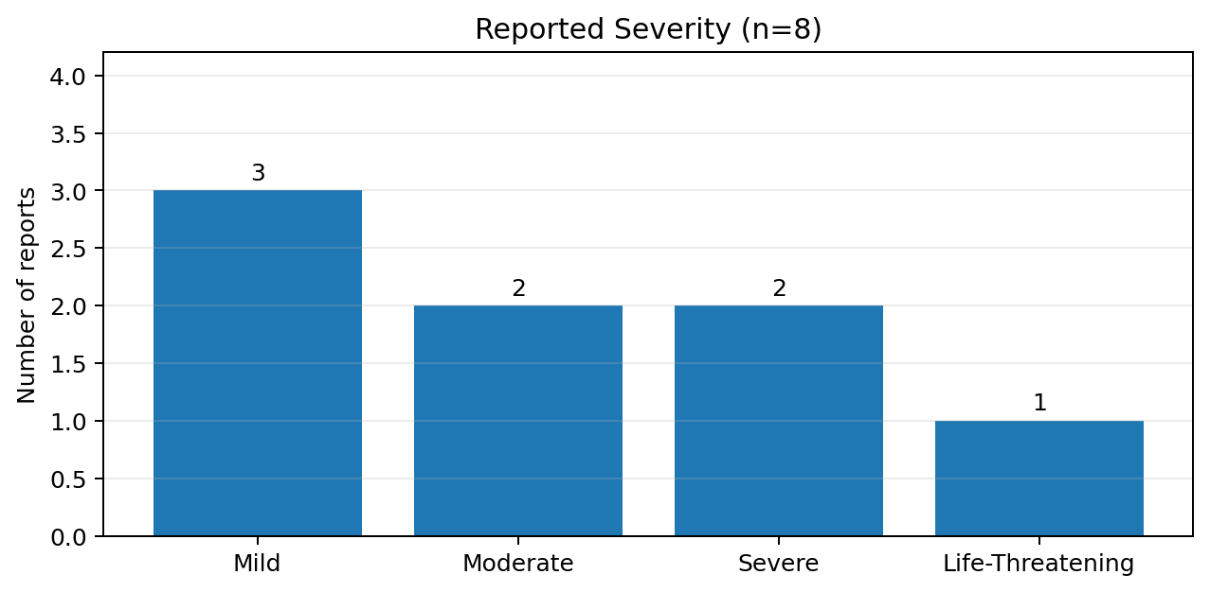
Three reports were labelled mild, two moderate, two severe, and one life-threatening. Severity is the recorded intensity label; regulatory seriousness requires separate assessment.

Recorded outcomes
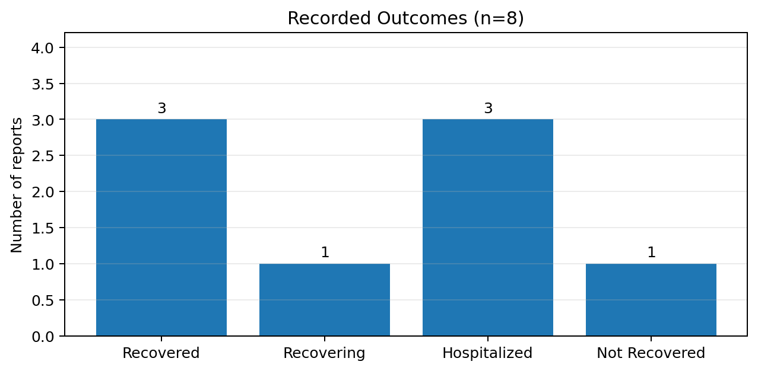
Three reports recorded hospitalization, three recovery, one recovering, and one not recovered. The dataset does not provide enough detail to independently validate every seriousness criterion.

4. Reaction-Onset Timing and Case Listing
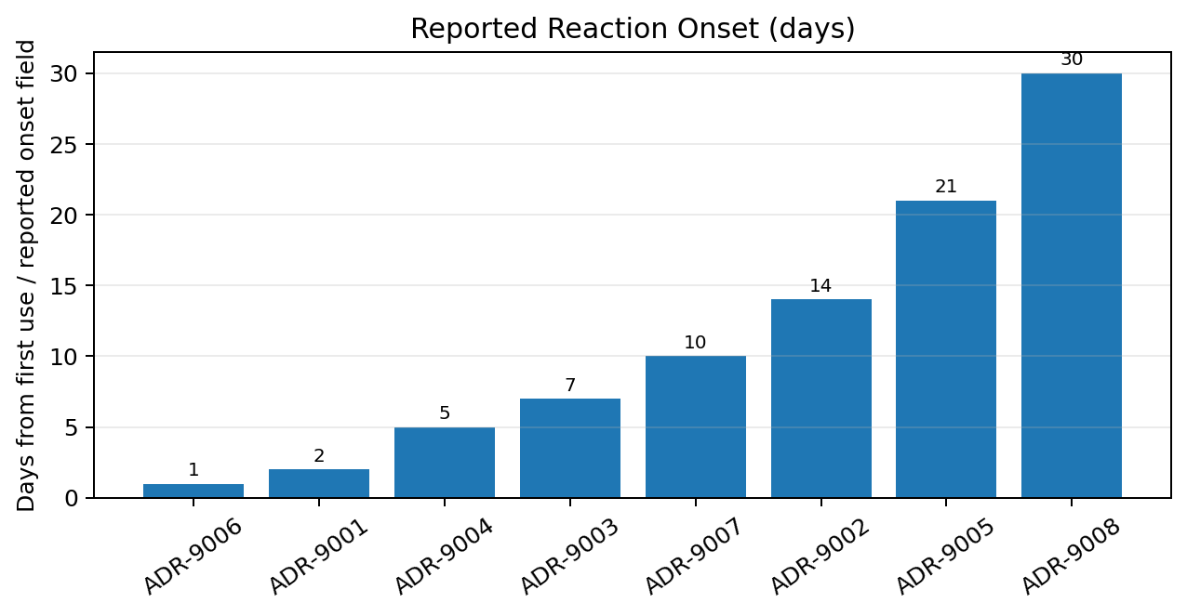
Reported onset ranges from 1 to 30 days, with median 8.5 days. No report dates or longitudinal time series are supplied, so a calendar reporting trend cannot be assessed.
Report ID | Suspected drug | Reaction | Onset (days) | Severity | Outcome
ADR-9001 | Amoxicillin | Skin Rash & Hives | 2 | Mild | Recovered
ADR-9002 | Atorvastatin | Severe Muscle Myalgia | 14 | Moderate | Recovering
ADR-9003 | Ciprofloxacin | Tendonitis | 7 | Severe | Hospitalized
ADR-9004 | Ibuprofen | Gastric Ulcer Bleed | 5 | Severe | Hospitalized
ADR-9005 | Lisinopril | Persistent Dry Cough | 21 | Mild | Recovered
ADR-9006 | Metformin | Nausea & Diarrhea | 1 | Mild | Recovered
ADR-9007 | Warfarin | Uncontrolled Hemorrhage | 10 | Life-Threatening | Hospitalized
ADR-9008 | Paclitaxel | Peripheral Neuropathy | 30 | Moderate | Not Recovered

Case listing reproduces supplied fields and does not independently validate diagnoses, exposure, or causality.

5. Potential Signal Assessment
Observation: two reports contain bleeding-related terms: ADR-9004 (ibuprofen; “Gastric Ulcer Bleed”; severe; hospitalized) and ADR-9007 (warfarin; “Uncontrolled Hemorrhage”; life-threatening; hospitalized). ADR-9007 is the highest-priority individual record based on supplied severity and outcome fields.

Why this is not a confirmed signal
- Only two bleeding-related reports appear in this selected eight-record sample.
- The reports involve different suspected products and different indications.
- No exposure denominator, comparator, background rate, or reporting-period information is available.
- Concomitant medicines, dose, duration, medical history, laboratory results, and verified diagnoses are not supplied.
- The label “SuspectedDrug” does not establish causality.

Alternative explanations to investigate
- Underlying condition or comorbidities may contribute to the event.
- Concomitant products or interactions may be relevant.
- Dose, duration, adherence, overdose, or medication-use error may be relevant.
- The reported event term may need clarification or clinical confirmation.
- Selection and reporting effects may explain why these cases appear in this small sample.
Dimension | Assessment
Potential signal | Bleeding-related reports warrant follow-up review
Evidence strength | Very limited; descriptive observation only
Causality | Cannot be determined from this dataset
Status | Hypothesis for further evaluation; not confirmed

6. Follow-up Evidence and Questions
Priority | Information to request | Purpose
High | Confirm event details, diagnosis, dates, clinical course, and outcome for ADR-9007 and ADR-9004. | Verify reported events
High | Relevant medical history, indication details, and prior bleeding/GI history. | Assess alternatives
High | Concomitant medicines, OTC products, supplements, and recent changes. | Explore co-exposures
High | Dose, route, start/stop dates, adherence, medication errors, and overdose information. | Clarify exposure
High | Relevant laboratory results and clinical findings, if available. | Support interpretation
Medium | Dechallenge/rechallenge details; keep absent data as unknown. | Clarify chronology
Medium | Sufficient reporter/source details for follow-up under privacy procedures. | Improve completeness

Risk-minimization questions
- Do verified case details suggest preventable medication-use factors?
- Are current product information and local risk communications appropriate for the verified evidence?
- Would targeted education or a prescribing/dispensing safeguard be justified after expert review?
- What measurable outcome would show whether any action is working?
Any action should be based on verified evidence, applicable product information, and qualified pharmacovigilance/medical review—not this training sample alone.

7. Limitations and Responsible Interpretation
- Synthetic, very small dataset (n=8); not representative of a real population.
- No exposure denominator, comparator group, or background event rates.
- No report dates; reporting trends over time cannot be assessed.
- No separate seriousness field; hospitalization is an outcome label, not a complete seriousness assessment by itself.
- No case narratives, source documents, concomitant medicines, laboratory data, dechallenge/rechallenge, or verified diagnoses.
- One report per suspected product; product-level comparisons are not meaningful.
- Descriptive counts cannot establish causality, incidence, relative risk, or a confirmed safety signal.

8. Conclusion
The eight-record synthetic dataset contains three hospitalization outcomes and one life-threatening severity label. Two reports describe bleeding-related events and merit focused case-level follow-up as a hypothesis-generating pattern. The dataset is too small and lacks clinical, exposure, comparator, and reporting-time information needed to confirm a signal or infer causation.
Recommended next step: verify the two bleeding-related case records, obtain missing clinical and medication-use context, and reassess only after evidence review.

9. Resume-Ready Project Description
Pharmacovigilance Practice Project | Safety Signal Review
Self-directed training project using synthetic data
- Reviewed an 8-record synthetic adverse-reaction dataset and summarized severity labels, outcomes, and reaction-onset timing using descriptive analysis.
- Created charts and case-level tables to communicate safety-data patterns and data limitations.
- Flagged two bleeding-related reports for follow-up assessment while documenting alternative explanations and missing evidence.
- Applied cautious pharmacovigilance reasoning by distinguishing severity from seriousness and avoiding unsupported causality claims.

Suggested ATS keywords
Pharmacovigilance • Adverse Event Review • Safety Signal Detection (training) • Case Triage • Seriousness vs Severity • Descriptive Data Analysis • Safety Data Interpretation • Follow-up Questions • Risk Minimization • Data Quality Review • Report Writing

10. References and Scope Note
Primary source: EdVyro “Safety Signal Review Capstone” brief and the supplied adverse-reaction aggregate CSV. This report uses synthetic data only and is not medical advice or a real safety report.
- ICH E2A: Clinical Safety Data Management — https://database.ich.org/sites/default/files/E2A_Guideline.pdf
- WHO–UMC causality assessment system — https://who-umc.org/media/u4gjgxvv/who-umc-causality-assessment_new-logo.pdf
- FDA: What is a Serious Adverse Event? — https://www.fda.gov/safety/reporting-serious-problems-fda/what-serious-adverse-event

