## TASK: Create a VPC with 2 subnets and 2 route tables, create internet gateway and launch 1 Instance attach with EBS

* Create a VPC
* Click on search bar enter vpc see like below (pic-1)

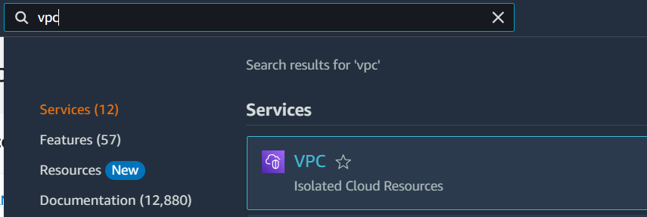

(pic-1)

* Open VPC and click on create VPC

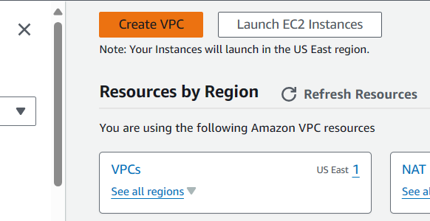

(pic-2)

* Now create a VPC, my VPC name (VPC-1) see on (pic-3)
* IPv4 CIDR given as 20.0.0.0/16
* Now click on create VPC

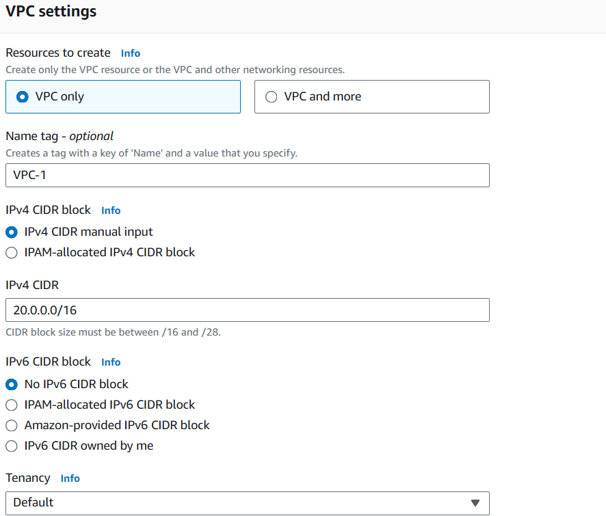

(pic-3)

* Our VPC created see in (pic-4)



(pic-4)

* Create 2 subnets 1 public subnet and another 1 private subnet
* Click on subnet and now we can see create subnet option click the create subnet option

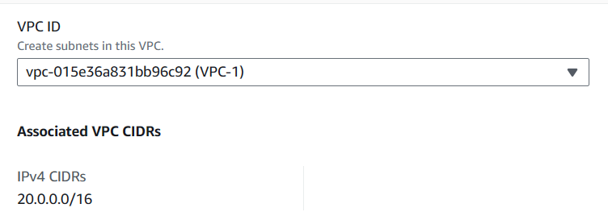

(pic-5)

* Selected VPC id (VPC-1) we can see in (pic-5)
* Now give subnet name and select availability zone, I created 1st subnet as (public-subnet) and selected availability zone us-east-1a
* IPv4 subnet CIDR given as 20.0.0.0/24 see in (pic-6)
* Now click on create subnet

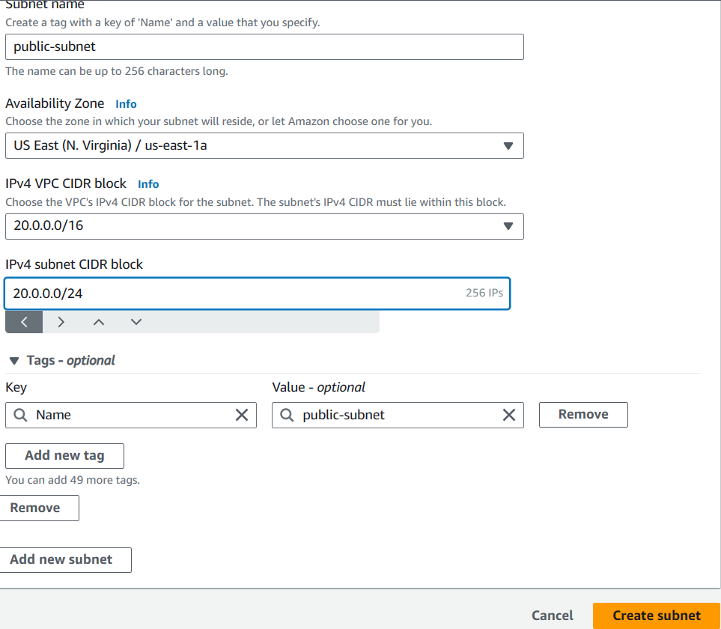

(pic-6)

* Now we can see (pic-7) our public-subnet activated



(pic-7)

* Now we create a private subnet as (private-subnet)
* Selected our VPC-1 and availability zone selected (us-east-1b)
* IPv4 subnet CIDR given as 20.0.2.0/24
* Now click on create subnet
* we can see our private-subnet in (pic-8)



(pic-9)

* Create Internet gateway
* Click on internet gateway and click on create internet gateway see in (pic-10)

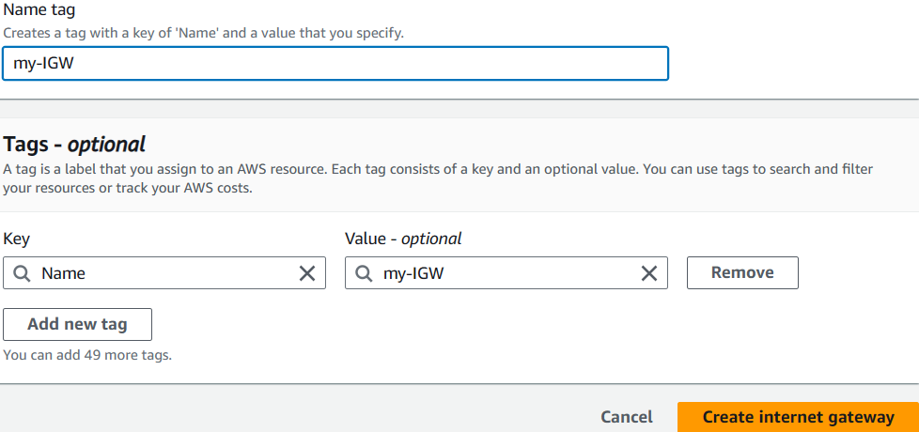

(pic-10)

* Now we created internet gateway as (my-IGW)
* Select internet gateway (my-IGW) click action and click attach to VPC
* Select our vpc (VPC-1) and click on attach internet gateway see (pic-11)

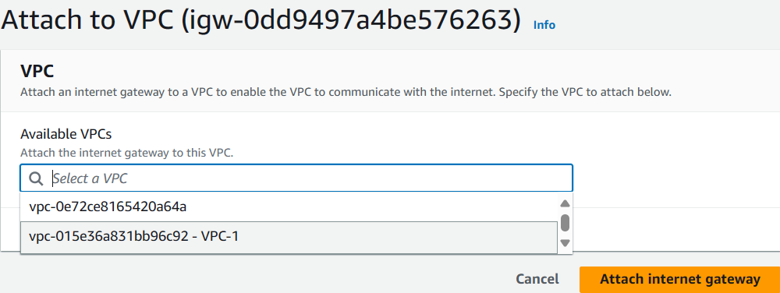

(pic-11)

* Create 2 route tables as 1 public and another 1 private
* Click on route table and choose the option create route table

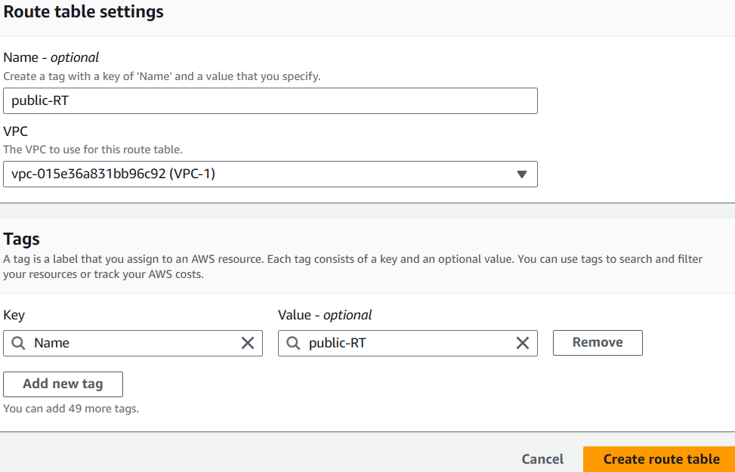

(pic-12)

* See in (pic-12) my route table name given as (public-RT), selected our VPC-1 and created public route table
* Now select public-RT and go to action option and choose edit route option see in pic-13

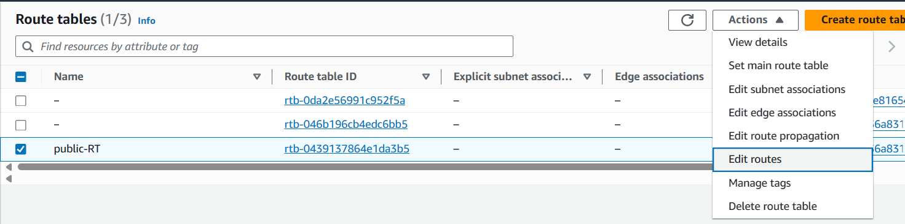

(pic-13)

* Click on edit route option, click on add route option and now select internet gateway option give internet gateway id and select destination as 0.0.0.0/0 see pic-14

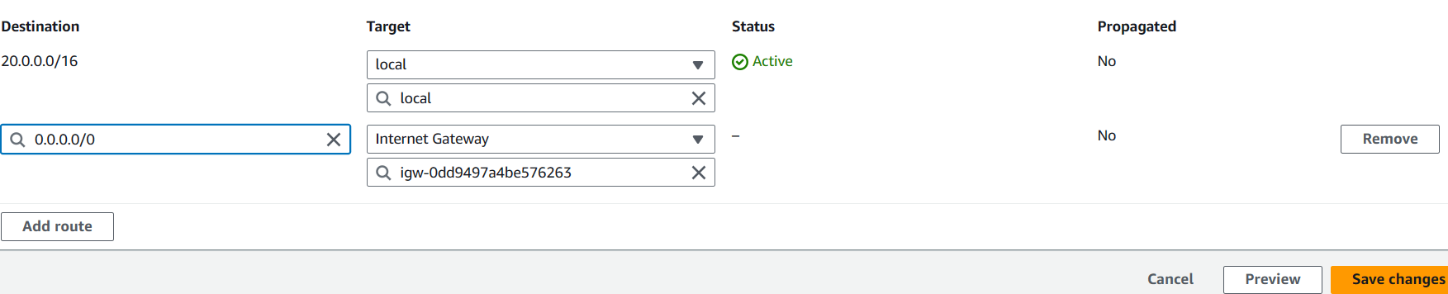

(pic-14)

* Click on save changes
* Now select subnet association and click on edit subnet association
* Select our public subnet and click on save association see pic-15no

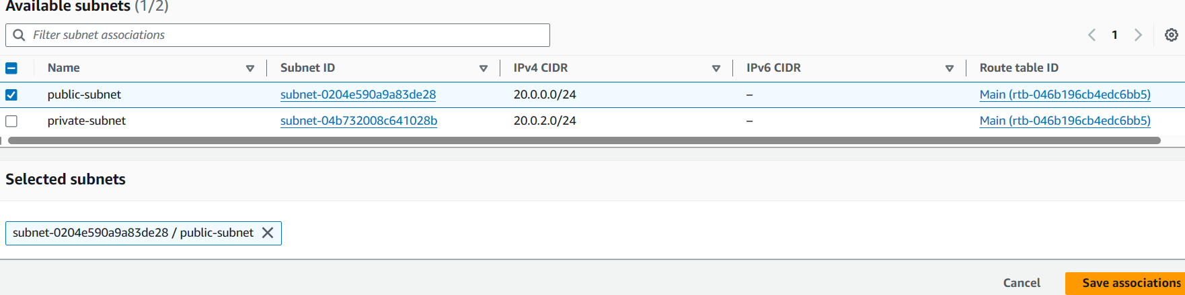

(pic-15)

* Now same way to create our private route table but in private subnet we don’t give internet gateway only we give subnet association
* Private route table (private-RT), selected our VPC-1, created our private route table
* Select private-RT route table and click on subnet association select private-subnet, click on save association
* Now we can see our 2 route tables in pic-16



(pic-16)

* Create EBS volume
* Go to search bar for ec2 see in pic-17

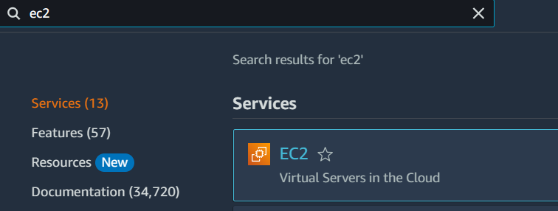

(pic-17)

* Click on EC2 now we can see launch instance option click it
* Give server name (EBS-1)
* Select OS option, I selected amazon Linux, see pic-18

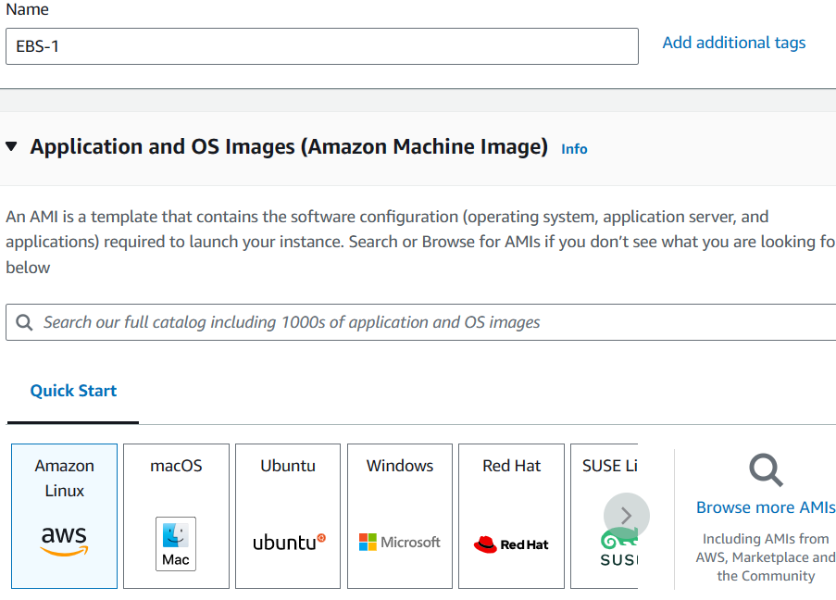

(pic-18)

* Click on create key pair
* Give key pair name (EBS-key), click on create key pair see pic-19

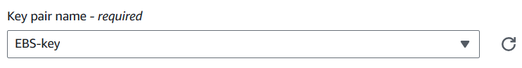

(pic-19)

* Now click on edit option
* Select VPC (VPC-1), click on launch instance see pic-20

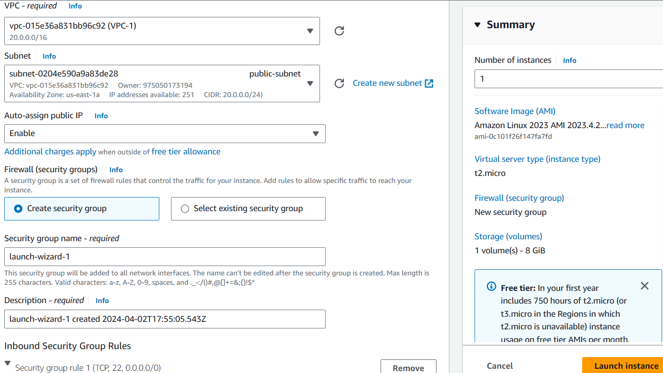

(pic-20)

* Now click on instances we can see our instance (EBS-1) see in pic-21



(pic-21)

* Now we create a new volume
* Click on volumes see in pic-22

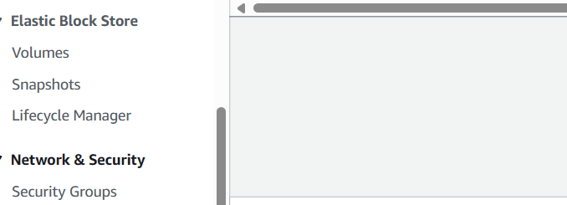

(pic-22)

* Choose the create volume option

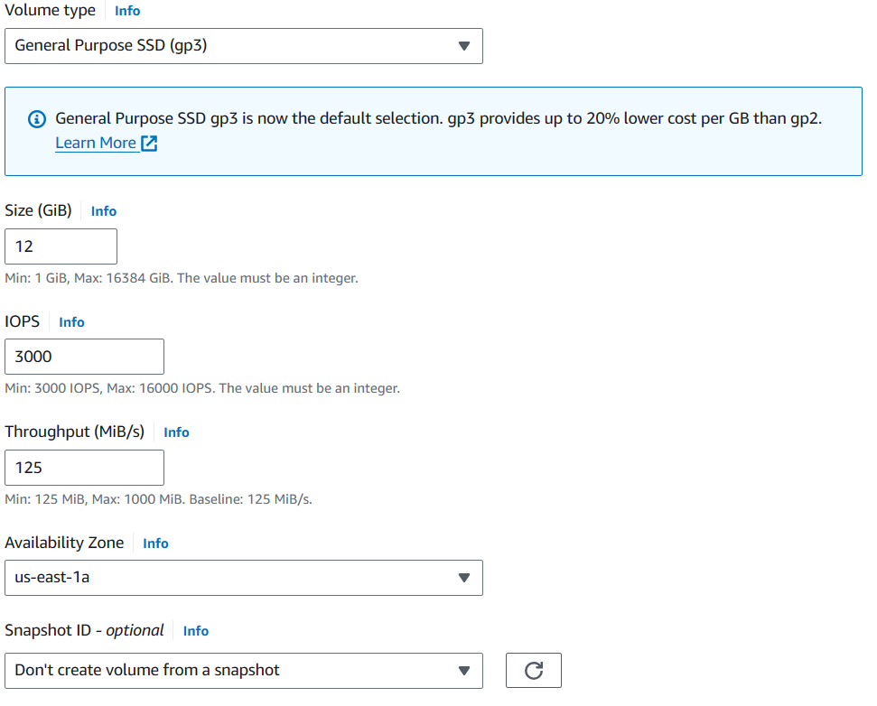

(pic-23)

* Now see the pic-24, our volume was created



(pic-24)

* Select our volume click on action option and click on attach volume see pic-25

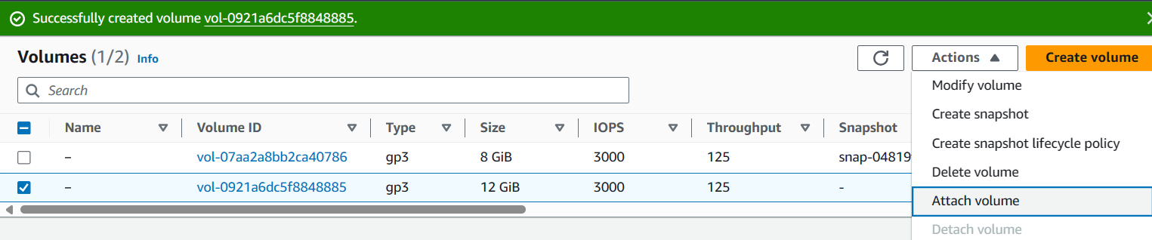

(pic-25)

* Choose our instance and select device name as /dev/sdb see in pic-26
* Click on attach volume

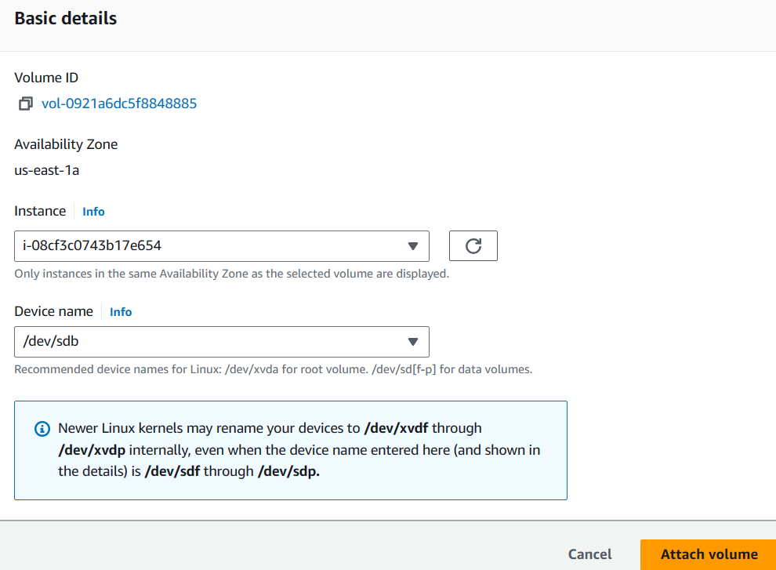

(pic-26)

* Now go to our instance and select instance, click on connect option see pic-27

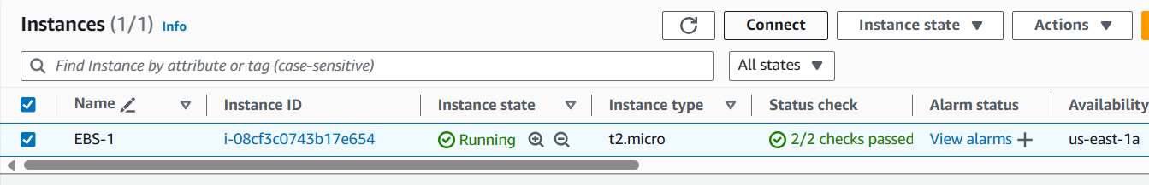

(pic-27)

* Click on connect

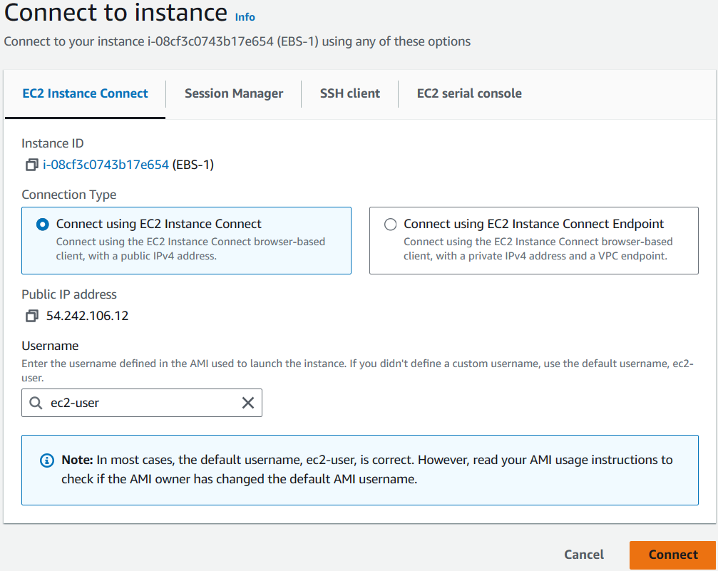

(pic-28)

* Now instance connected with our web server see pic-29

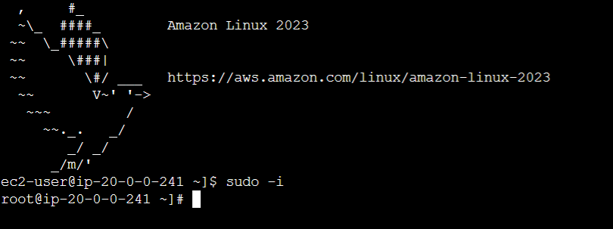

(pic-29)

* Use command df -h check disc space

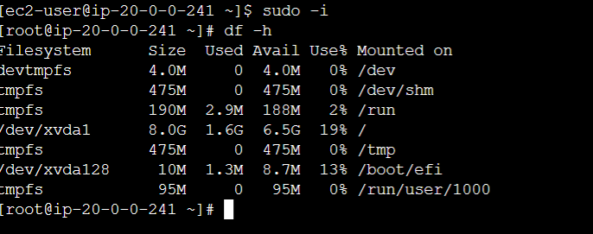

(pic-30)

* Now use command lsblk for block devices list
* Now we can see our block device is xvdb

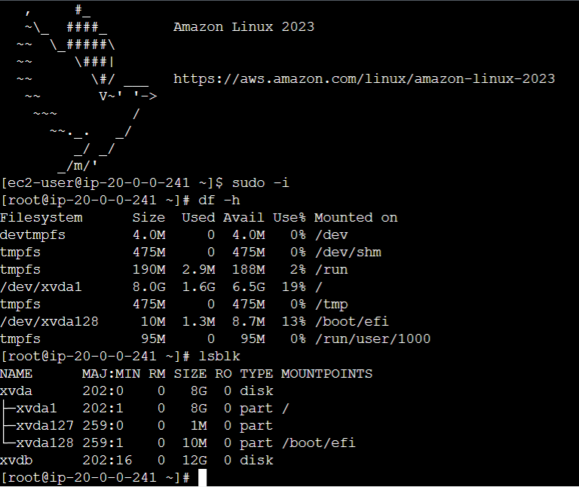

(pic-31)

* Use command file -s /dev/xvdb to check any file in this system see pic-32

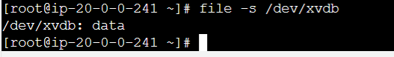

(pic-32)

* Don’t have any file in this system
* Now create a file using below command and check we have file system or not see pic-33
* Make file system command mkfs -t xfs /dev/xvdb

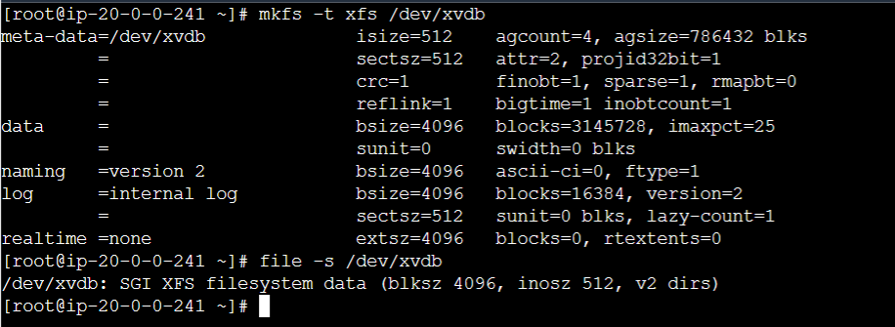

(pic-33)

* Now we have file system
* Create a nested directory to our volume
* Use command mkdir -p ganesh/anil
* Use mount command
* mount /dev/xvdb ganesh/anil

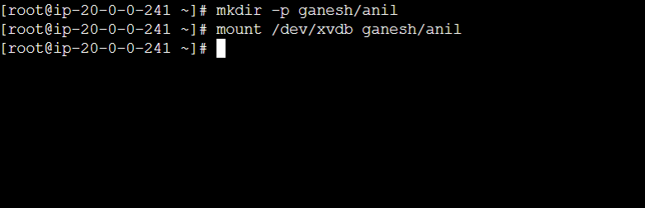

(pic-34)

* now check our volume attached or not
* use command df -h

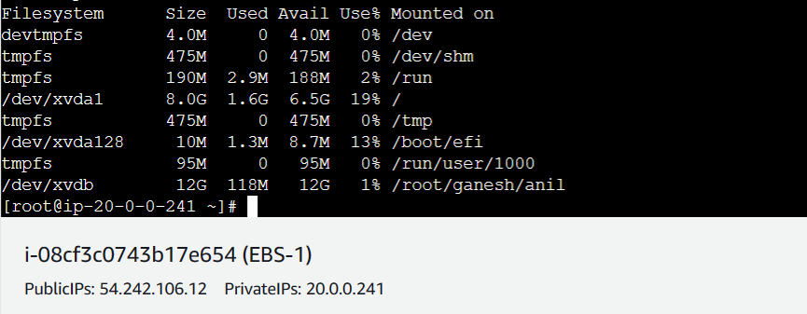

(pic-35)

* we can see above pic we have /dev/xvdb with size 12G so successfully attached our EBS-1 volume.