# Task: Create three VPC’s and connect the three VPC’s using transit gateway

* Create 3 VPCs
* Search for VPC in aws home page search bar, click on VPC

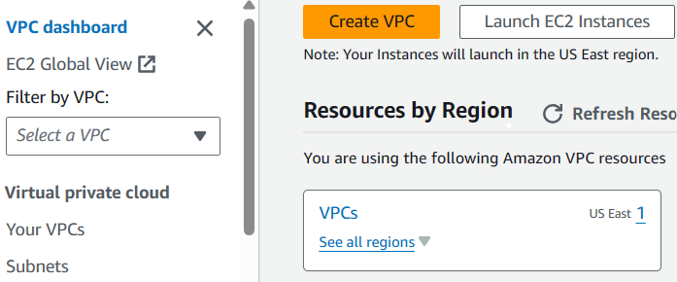

* Click on create VPC

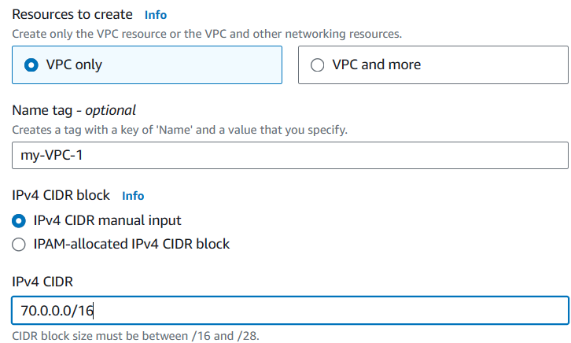

* Select VPC only, create the vpc name (my-VPC-1) and IPv4 CIDR is 70.0.0.0/16

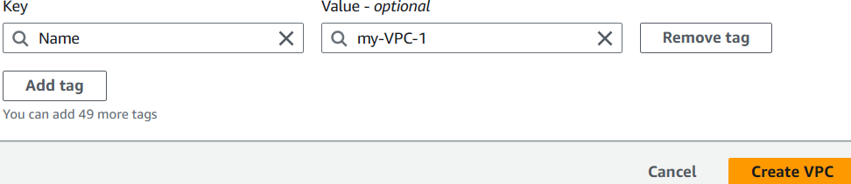

* Click on create VPC and our 1st VPC created successfully



* Now create two more VPC’s same way 2nd VPC (name is my-VPC-2, give CIDR as 80.0.0.0/16)
* 3rd VPC (name is my-VPC-3, give CIDR as 90.0.0.0/16)
* Now go to your VPCs you can see our 3 VPC’s

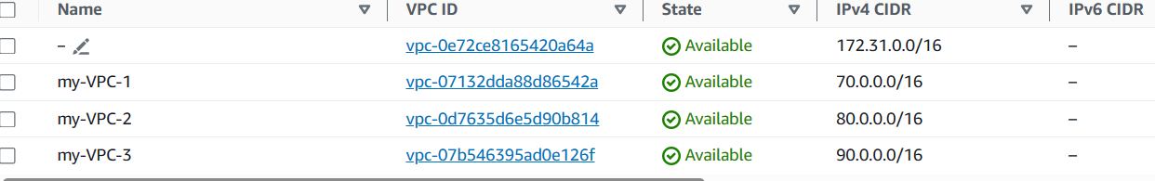

* See the below pic, select subnets option and create 3 subnets

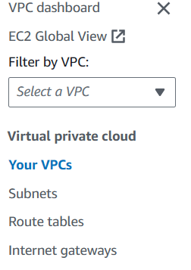

* Select the create subnet option see below



* Click on create subnet and select the 1st VPC id (my-VPC-1)

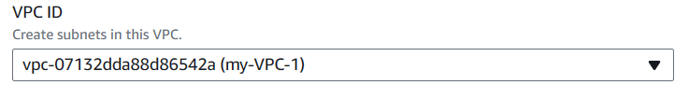

* After we can see below pic, give subnet name as my-SUBNET-1
* In availability zone select the zone as (us-east-1a)
* IPv4 subnet CIDR block is 70.0.0.0/24

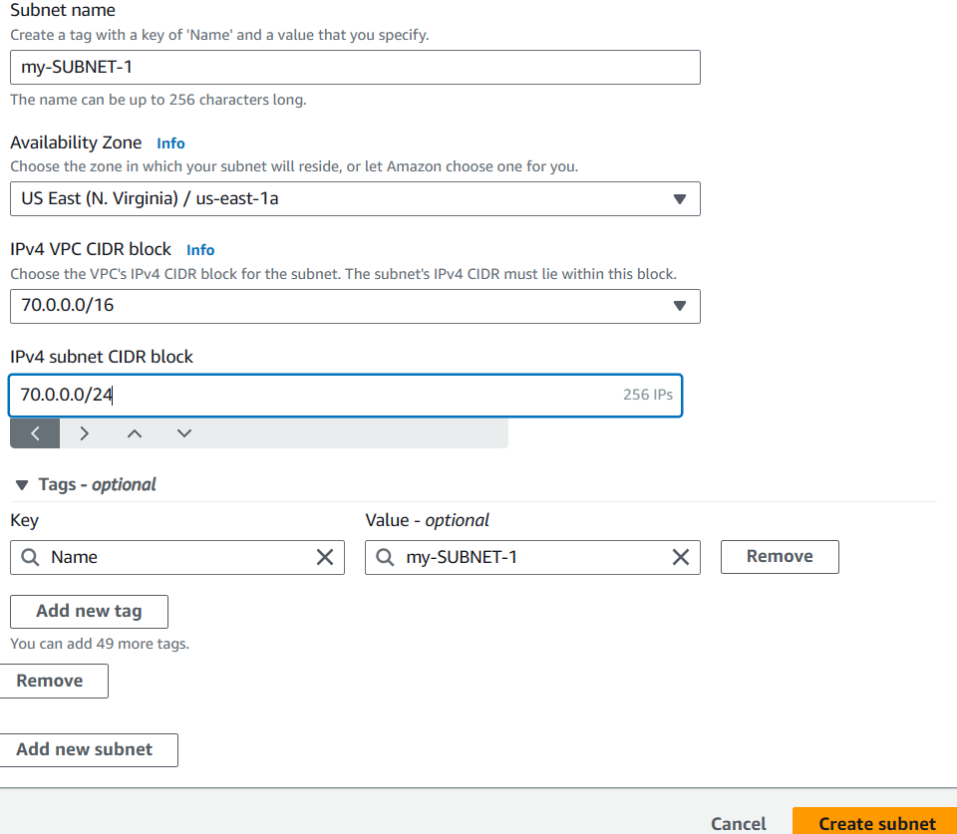

* After the process created subnet id, see below pic



* Same process to create another 2 subnets
* Create 2nd subnet give VPC id as (my-VPC-2), subnet name as (my-SUBNET-2)
* Give availability zone (us-east-1b) and IPv4 subnet CIDR is 80.0.0.0/24
* Create 3rd subnet give VPC id as (my-VPC-3), subnet name (my-SUBNET-3)
* Availability zone (us-east-1c) and IPv4 subnet CIDR is 90.0.0.0/24, click on create subnet
* Now we can see three subnets in below pic

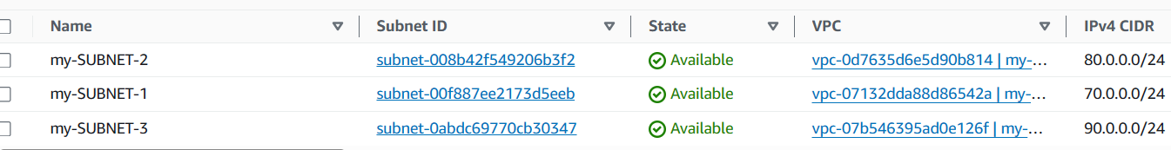

* Now create three Internet gateways

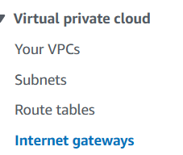

* Now we can see the internet gateways option and open it
* Choose the create internet gateway option

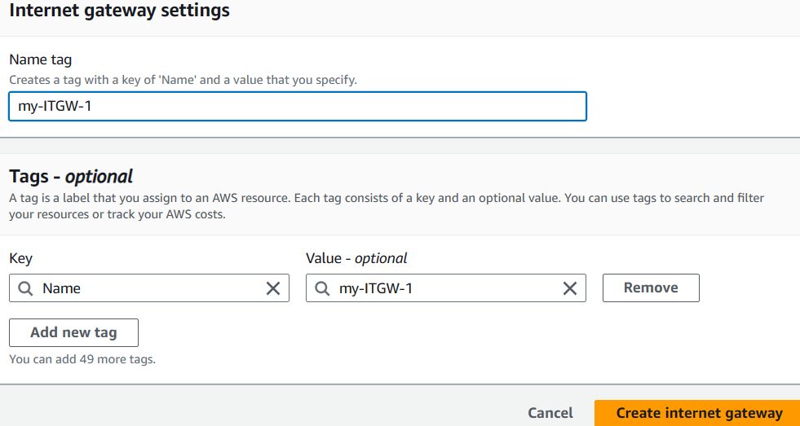

* Given name as (my-ITGW-1), click on create internet gateway option

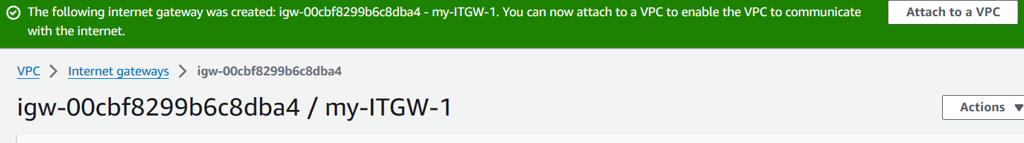

* After created internet gateway we can see the option Attach to a VPC, now click on attach to a VPC
* Now we can see in below pic available VPCs and now select my-VPC-1 option

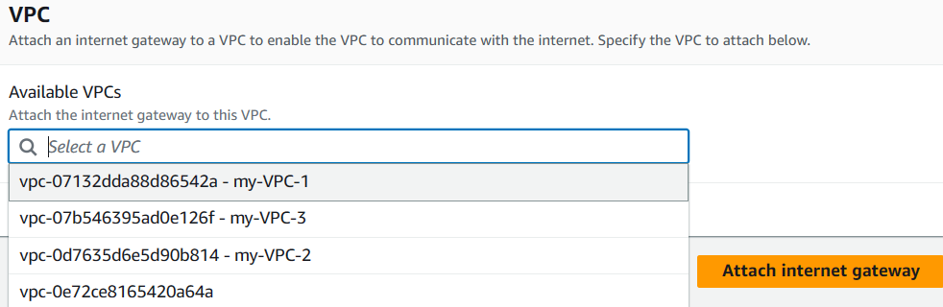

* Now click on attach internet gateway, after click the internet gateway was attached to my-VPC-1, we can see below pic



* Now same way to create another 2 internet gateways
* 2nd internet gateway id created name as (my-ITGW-2), after created 2nd internet gateway attached to (my-VPC-2) id
* 3rd internet gateway id created name as (my-ITGW-3), after created 3rd internet gateway attached to (my-VPC-3) ID
* Now we can see all 3 internet gateway in below pic

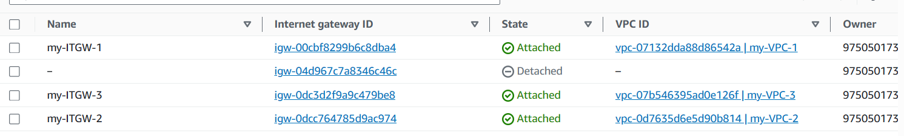

* Create 3 route tables, choose the route table option and open it



* now click on create route table

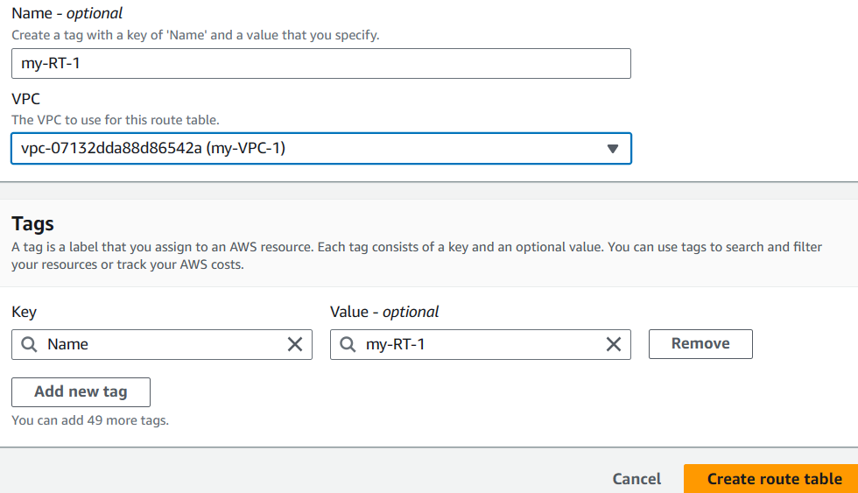

* given name as (my-RT-1) and choose the vpc option select the 1st VPC as (my-VPC-1)
* click on create route table
* now route table was created see below pic, select the route table and go to actions option, choose edit route

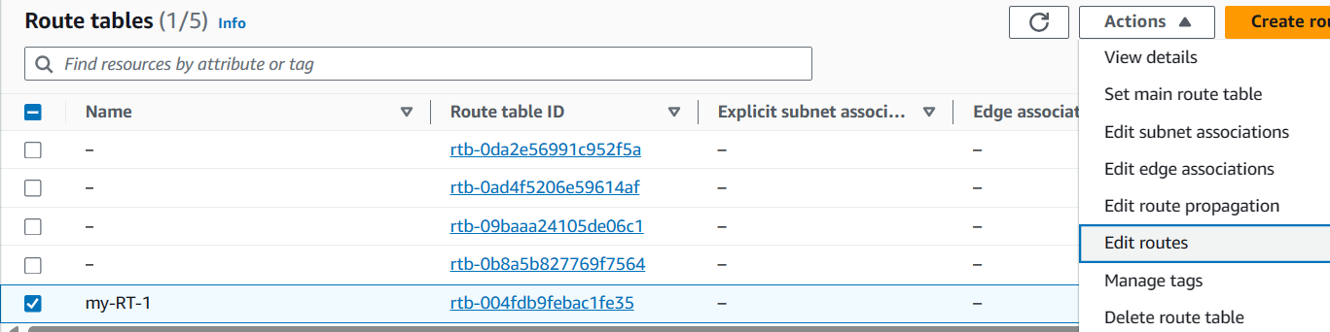

* select the option add route see below pic, select internet gateway option, give 1st internet gateway as (my-ITGW-1), in destination box select 0.0.0.0/0 and click on save changes

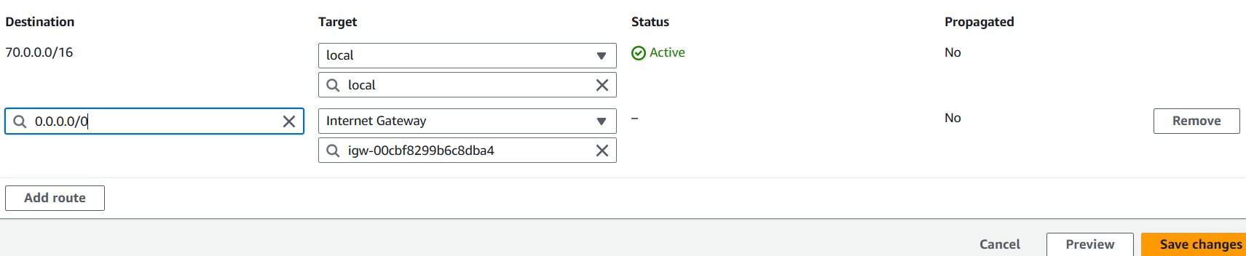

* now select the subnet association see the below pic

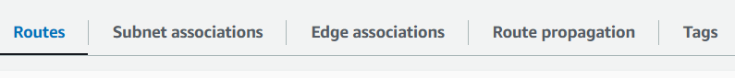

* select edit subnet association and click on my-SUBNET-1 select the subnet, click on save association

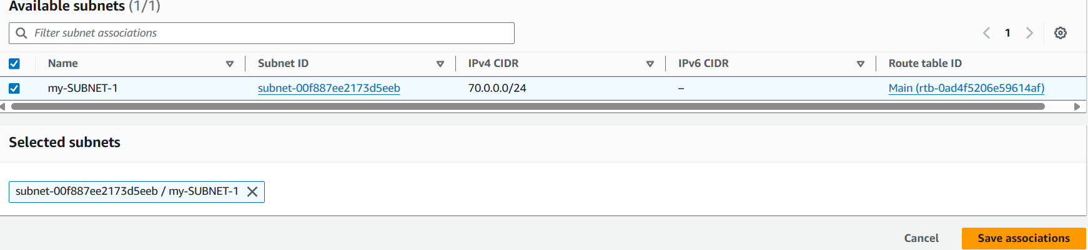

* now same process to another 2 route tables
* 2nd route table name as (my-RT-2), choose the VPC option, select 2nd VPC (my-VPC-2) now click on create route table
* Now select the (my-RT-2) click on action, choose edit route option, click on add route option select the internet gateway option, select (my-ITGW-2), in destination box select 0.0.0.0/0 and click on save association
* Select my-RT-2 and go subnet association option, select my-SUBNET-2 click on save association
* Now created 3rd route table as (my-RT-3), choose the VPC option, select 3rd VPC (my-VPC-3) and click on create route table
* Now select the (my-RT-3) click on action, choose edit route option, click on add route option select the internet gateway option, select (my-ITGW-3), in destination box select 0.0.0.0/0 and click on save association
* Select route table (my-RT-3), go subnet association option, select (my-SUBNET-3) click on save association
* Now see below pic all 3 route tables are created

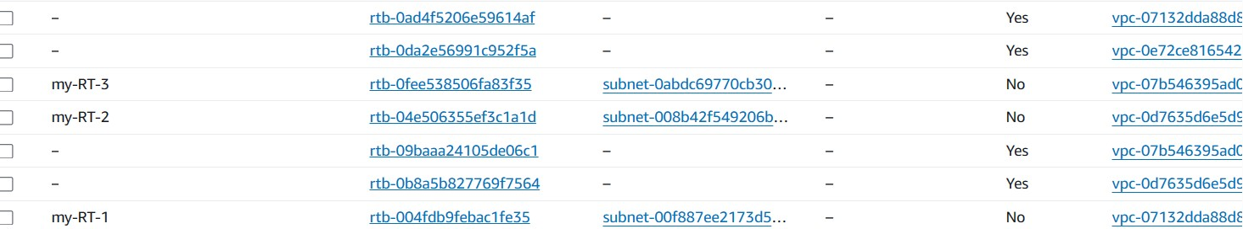

* Now create transit gateway
* Click on search bar for search Transit gateway, click on transit gateway and choose the option create transit gateway
* Now we created transit gateway name as (my-TGW1), see below

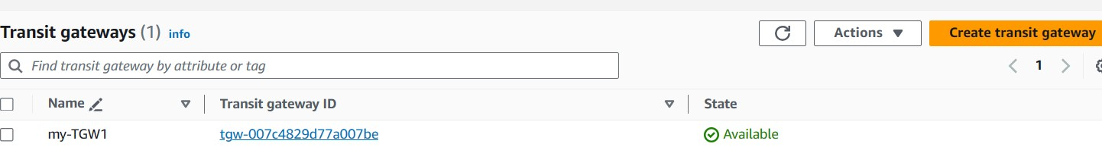

* Now create 3 transit gateway attachment
* Go to search bar and search for transit gateway attachment, click it

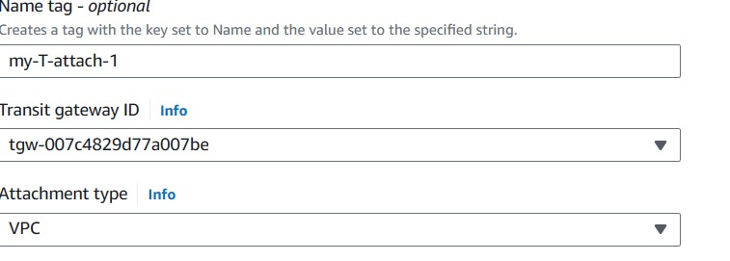

* given transit gateway attachment name as (my-T-attach-1), selected transit gateway as(my-TGW1), attachment type select VPC
* select 1st vpc id (my-VPC-1), we can see subnet ids zone automatically as us-east-1a
* now click on create transit gateway attachment, see below

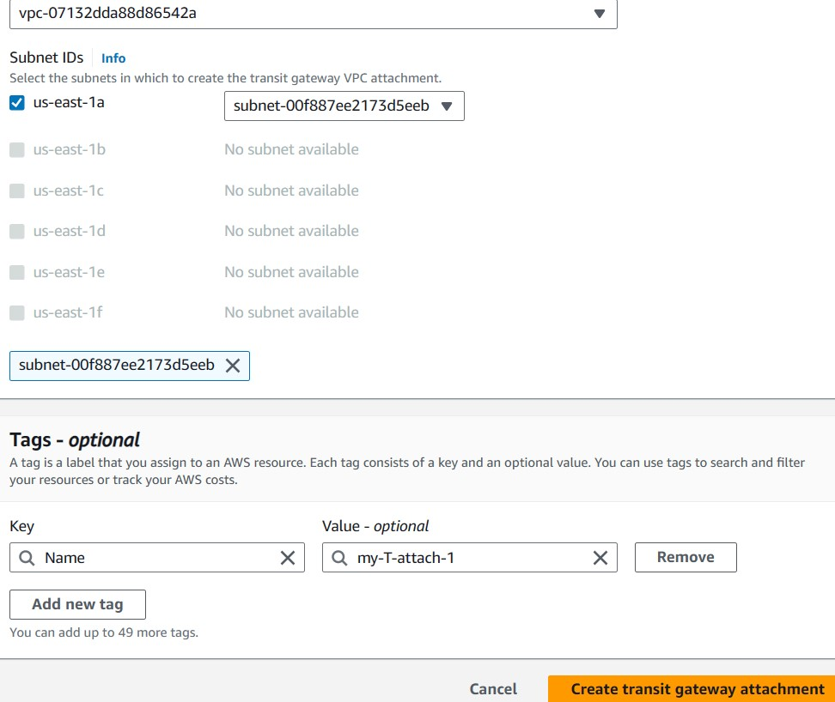

* created transit gateway attachment as (my-T-attach-1) see below

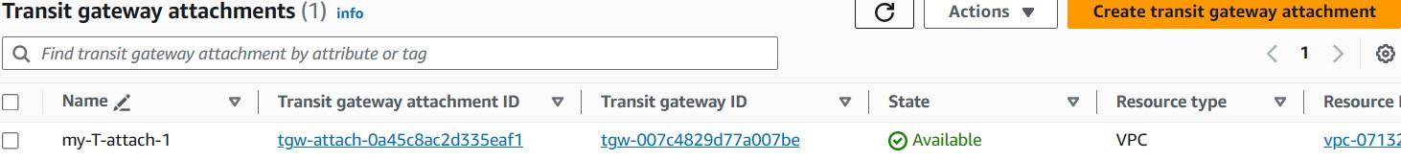

* now same way to create 2 more transit gateway attachment
* created 2nd transit gateway attachment as (my-T-attach-2), select transit gateway id (my-TGW1), select our 2nd vpc (my-VPC-2) now we can see subnet ids zone automatically updated as us-east-1b
* created 3rd transit gateway attachment (my-T-attach-3), now add transit gateway id (my-TGW1) and select our 3rd VPC (my-VPC-3) now we can see subnet ids zone automatically updated as us-east-1c
* now we can see below all the 3 transit gateway attachments

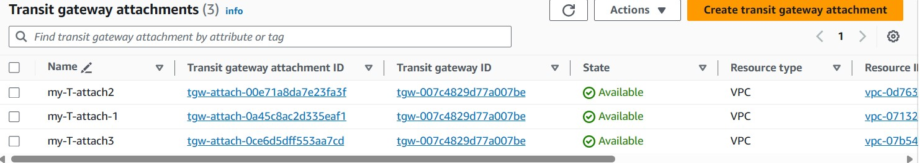

* now go to select route table option, click on edit route and select add route option
* In target box select transit gateway option and choose 1st transit gateway attachment (my-T-attach-1), destination box give our 2nd  VPCs CIDR 80.0.0.0/16
* click on add route again, select transit gateway option and choose 1st transit gateway attachment (my-T-attach-1), in destination box give our 3rd VPCs CIDR 90.0.0.0/16 now we can see below

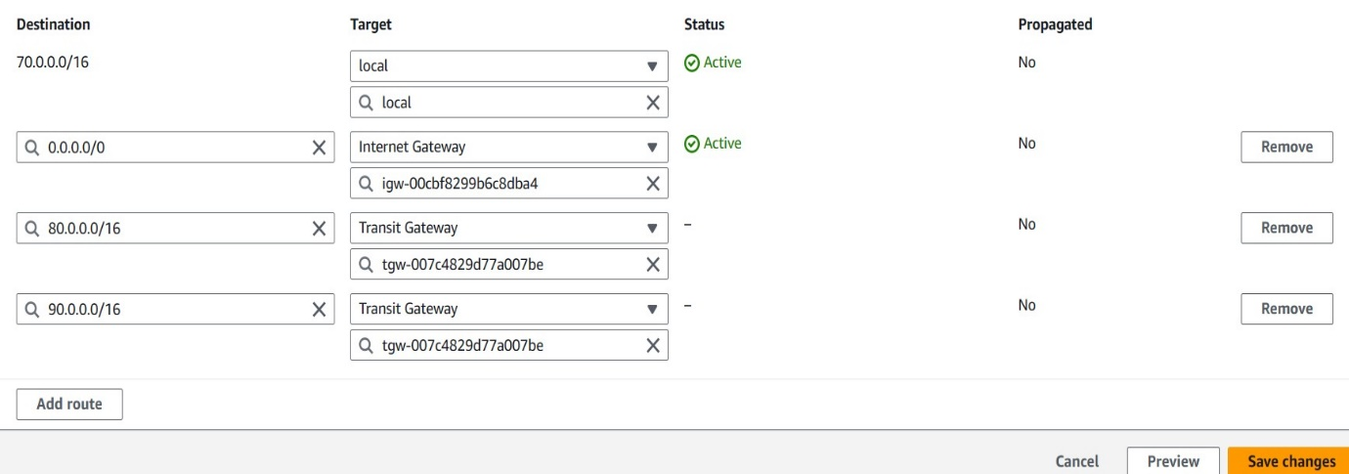

* now see below our routes are activated successfully

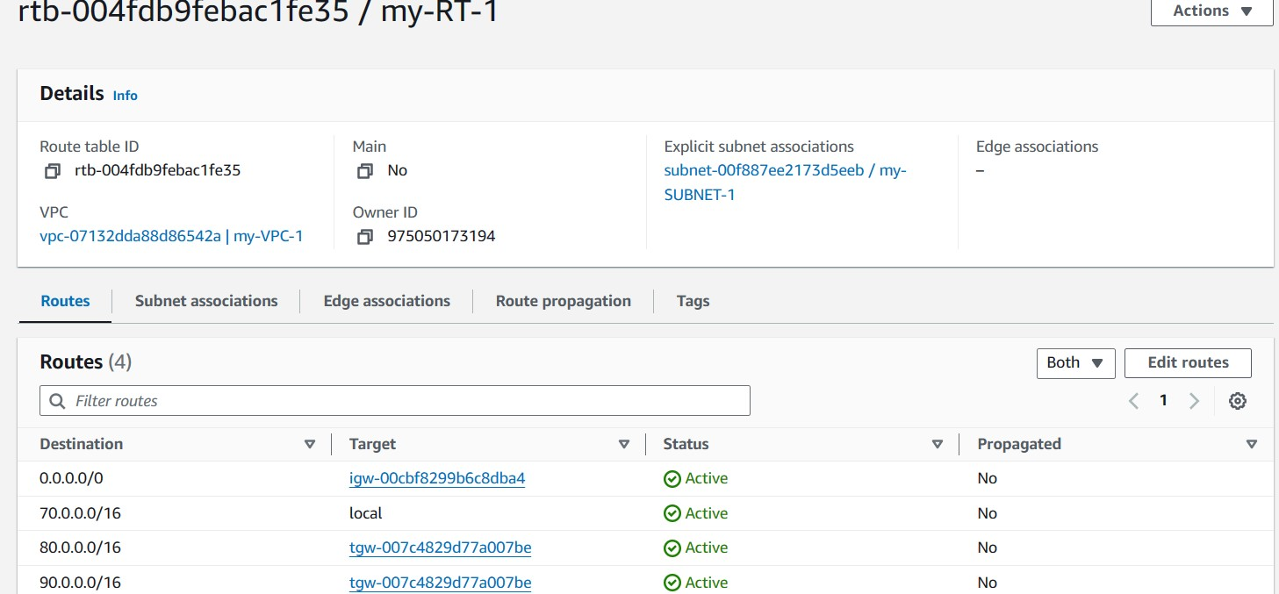

* same way to edit other 2 route tables
* now select 2nd route table (my-RT-2), go to edit option and select add route option
* In target box select transit gateway option and choose 2nd transit gateway attachment (my-T-attach-2), destination box give our 1st  VPCs CIDR 70.0.0.0/16
* click on add route again, select transit gateway option and choose 2nd transit gateway attachment (my-T-attach-2), in destination box give our 3rd VPCs CIDR 90.0.0.0/16
* now select 3rd route table (my-RT-3), go to edit option and select add route option
* In target box select transit gateway option and choose 3rd transit gateway attachment (my-T-attach-3), destination box give our 1st  VPCs CIDR 70.0.0.0/16
* Target box select transit gateway option and choose 3rd transit gateway attachment (my-T-attach-3), destination box give our 2nd VPCs CIDR 80.0.0.0/16
* Now we can launch 3 EC2 instances

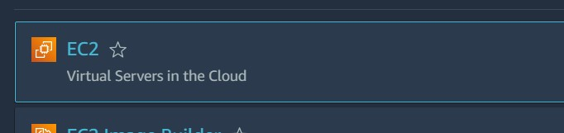

* Go to search bar search for EC2, now click on EC2 option, click on instances and select the option launch instance
* Given instance name as (my-EC2-1) see as below

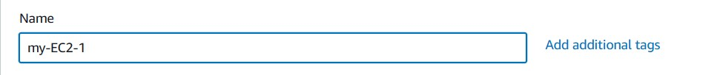

* Now click on create key pair, key pair name (my-KEY1) and see below

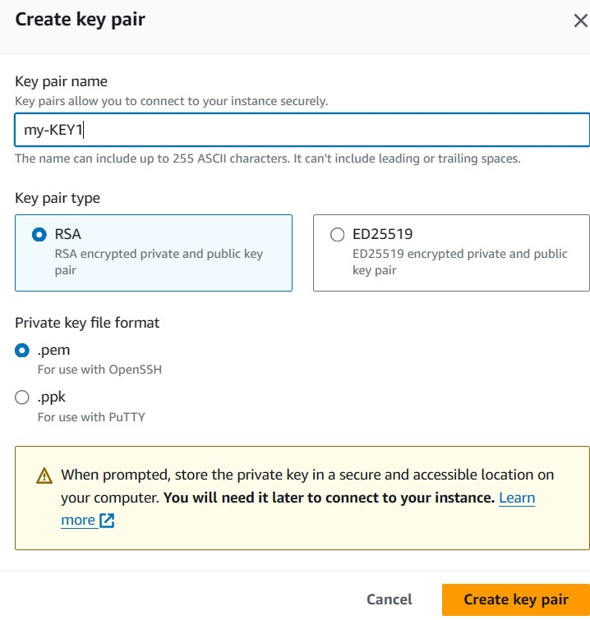

* Click on edit option, select the 1st VPC id (my-VPC-1), select 1st subnet (my-SUBNET-1) and enable the option in auto-assign public IP now see below

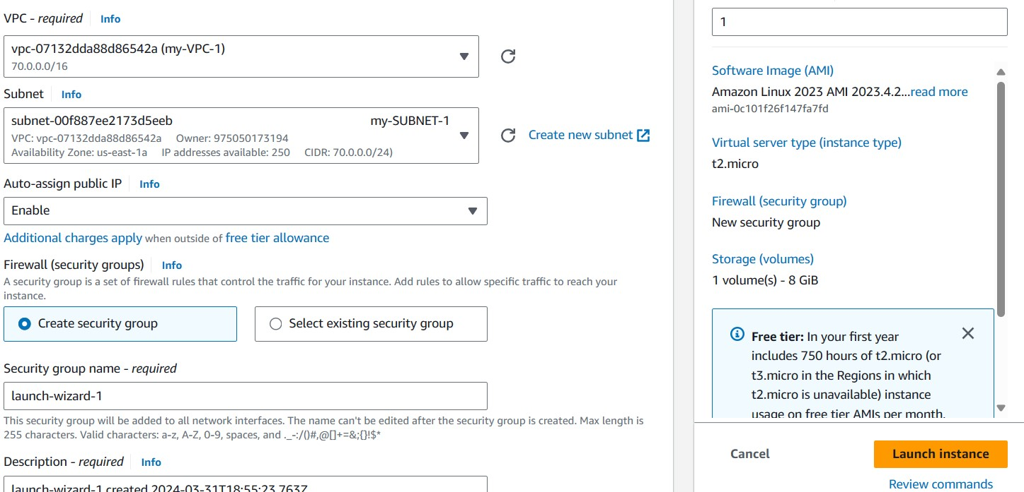

* Now click on launch instance, created our 1st instance (my-EC2-1) and select instance now you can see below click on security

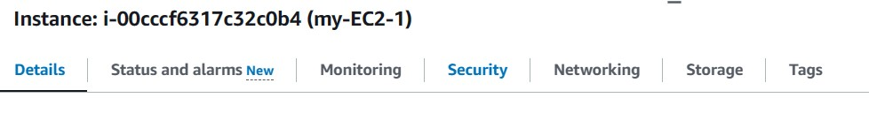

* Click on security groups see below

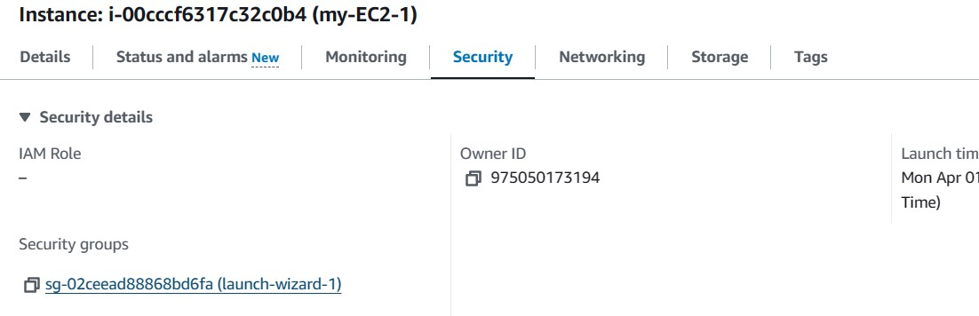

* Now we can see edit inbound rules click it
* We can see in the pic SSH is default
* Click on add rule select HTTP and give 2nd VPCs CIDR is 80.0.0.0/24, again select HTTP and give 3rd VPCs CIDR 90.0.0.0/24
* Click on add rule again and select All traffic and 0.0.0.0/0 see below

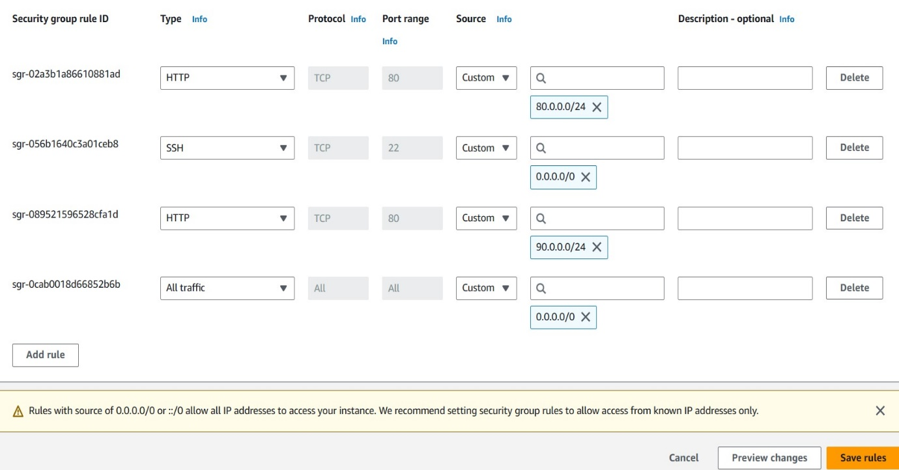

* Now click on save rules our 1st instance done
* We create our 2nd EC2 instance name as (my-EC2-2), select on amazon linux see as below

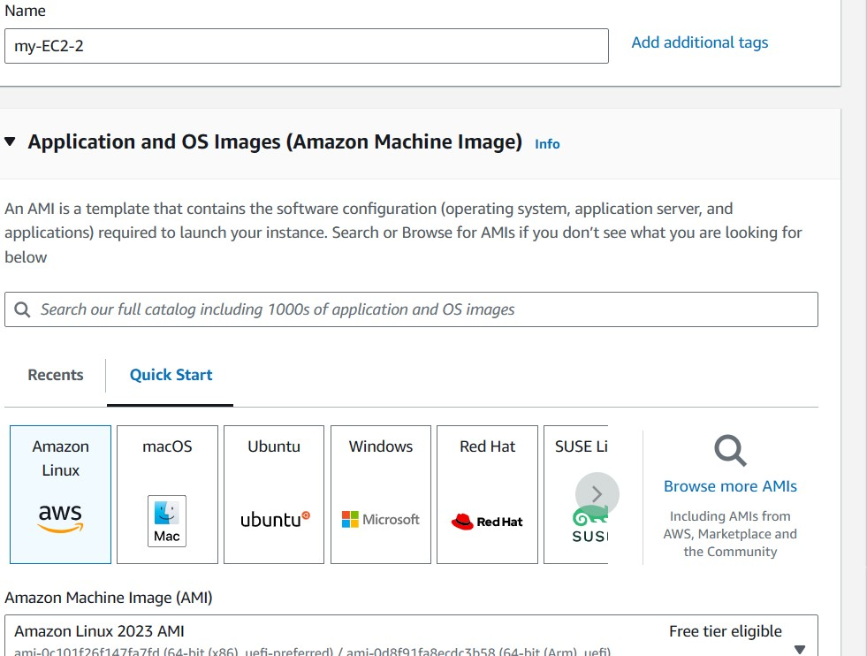

* Now select key pair as (my-KEY1), click on VPCs and select our 2nd VPCs (my-VPC-2), now automatic our 2nd subnet (my-SUBNET-2) see below

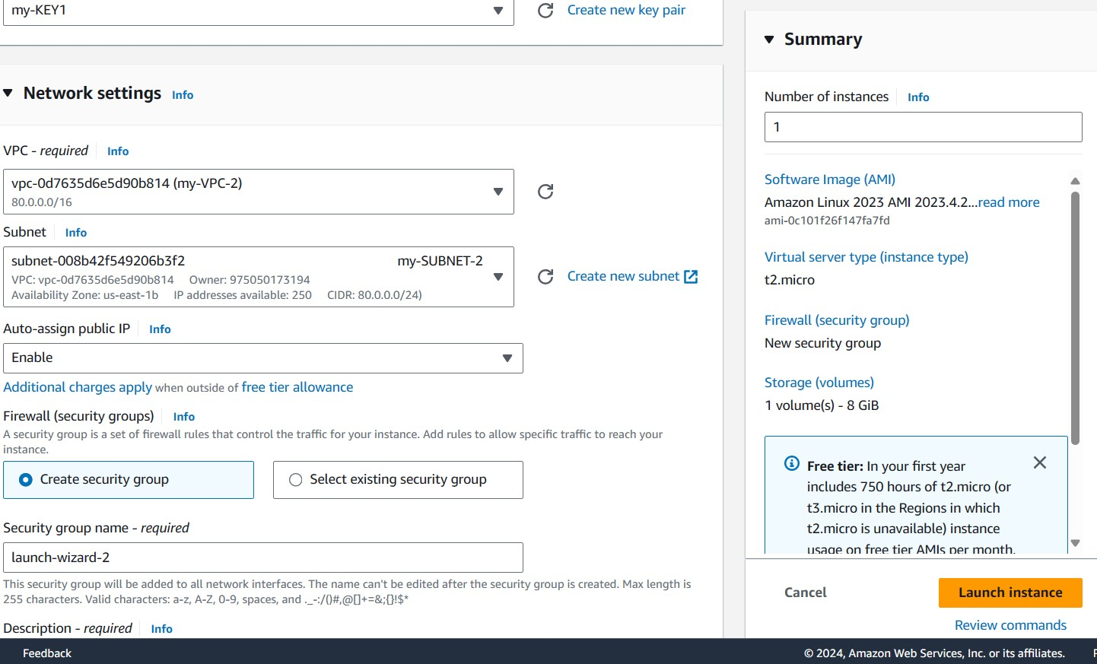

* Enable the auto-assign public IP
* Click on launch instance option and our 2nd EC2 instance (my-EC2-2) created
* Select our 2nd EC2 instance (my-EC2-2), open security option and click on security groups
* We can see edit inbound rules option click it
* We can see in the pic SSH is default
* Click on add rule, select HTTP and give our 1st VPCs CIDR 70.0.0.0/24
* Click on add rule again select HTTP and give our 3rd VPCs CIDR 90.0.0.0/24
* Click on add rule and select All traffic option, CIDR 0.0.0.0/0 and see below

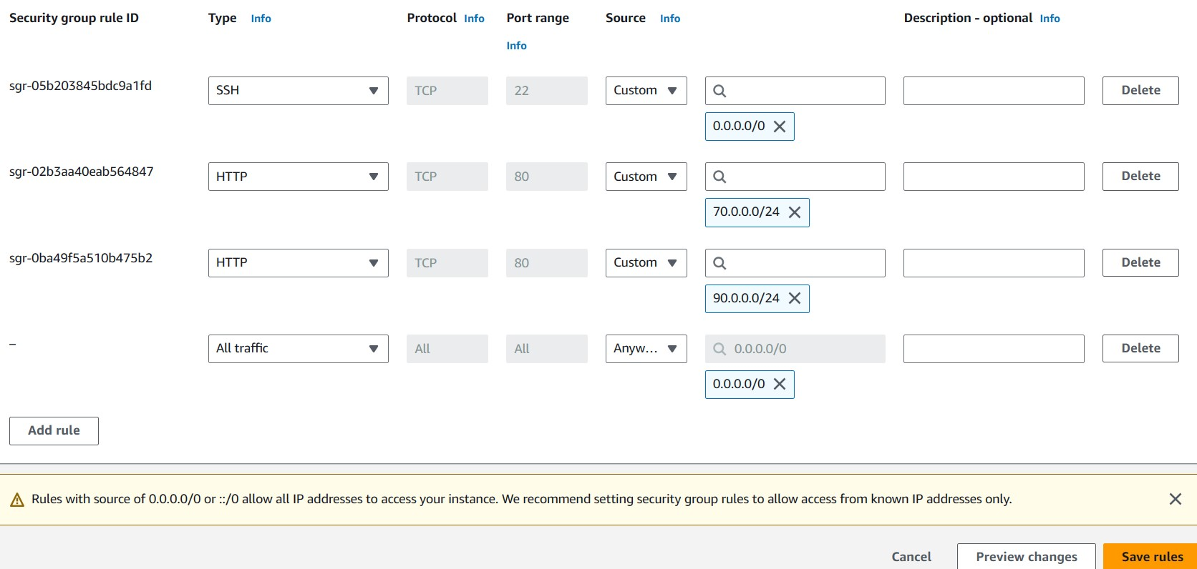

* Click on save rules and our 2nd EC2(my-EC2-2) instance and security groups are done
* Now create our 3rd EC2 instance as (my-EC2-3), select key pair (my-KEY1)
* Select our 3rd VPC (my-VPC-3) also select our 3rd subnet (my-SUBNET-3) and enable the auto-assign public IP
* Click on launch instance, now created our 3rd EC2 instance (my-EC2-3)
* Select our 3rd EC2 instance (my-EC2-3), open security option and click on security groups
* We can see edit inbound rules option click it
* We can see in the pic SSH is default
* Click on add rule, select HTTP and give our 1st VPCs CIDR 70.0.0.0/24
* Click on add rule again select HTTP and give our 2nd VPCs CIDR 80.0.0.0/24
* Click on add rule and select All traffic option, CIDR 0.0.0.0/0 and see below

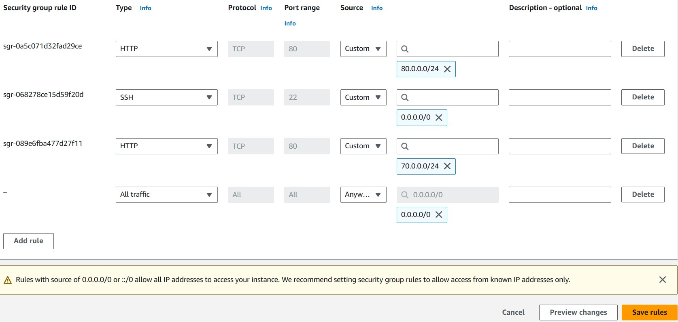

* Click on save rules our 3rd EC2 instance (my-EC2-3) and security groups are done
* We can see our 3 ec2 instances below

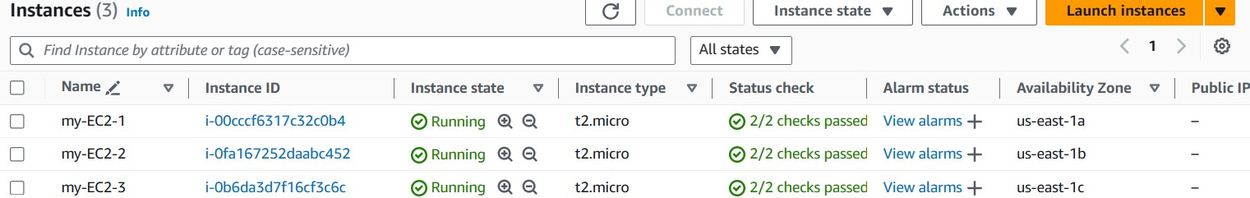

* Now we connect the 3 instances one by one
* Select our 1st EC2 instance (my-EC2-1) and choose the connect option on top

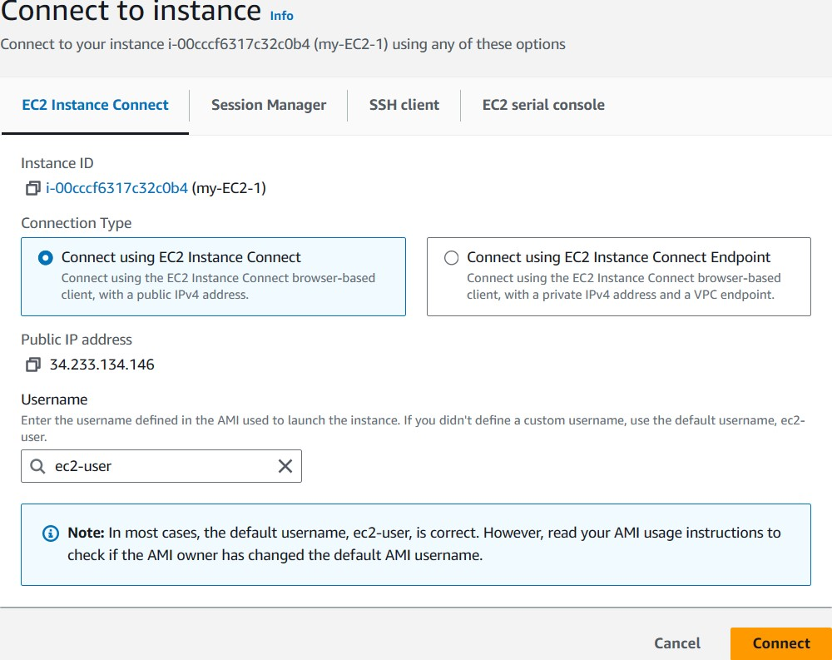

* Click on connect option
* now our 1st EC2 instance (my-EC2-1) is connected see below

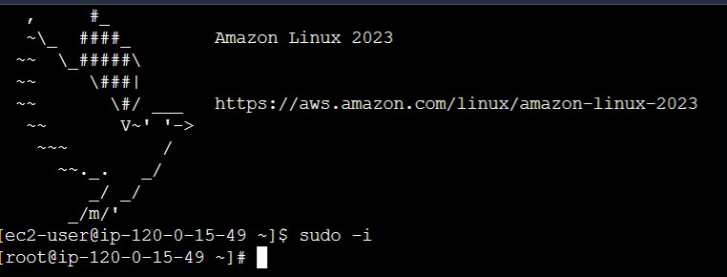

* our instance connected with webpage
* now install nginx in connected server
* sudo -i
* yum update -y
* yum install nginx -y



* installed the nginx see below

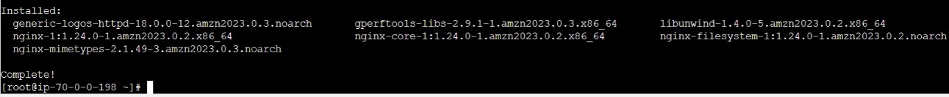

* go to cd /usr/share/nginx/html path, we have a index.html file remove this file using command rm index.html see below

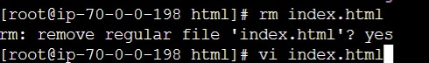

* after remove file use command
* vi index.html

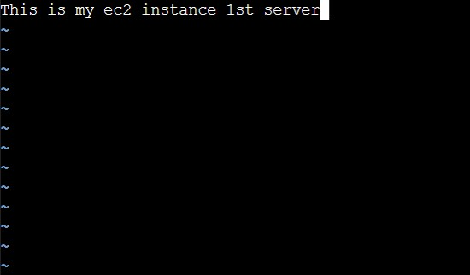

* now restart nginx with below command
* systemctl restart nginx
* now use curl command with IP see below
* curl 34.233.134.146:80

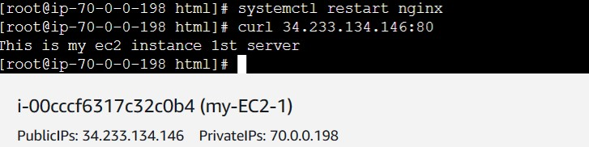

* now connect 2nd EC2 instance (my-EC2-2) same way and same commands
* but in index.html type (This is my ec2 2nd instance)
* see result below of our 2nd EC2 instance (my-EC2-2)

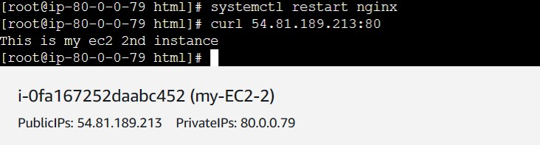

* now connect 3rd EC2 instance (my-EC2-3) same way and same commands
* but in index.html type (This is my 3rd ec2 instance)
* see result below of our 2nd EC2 instance (my-EC2-3)

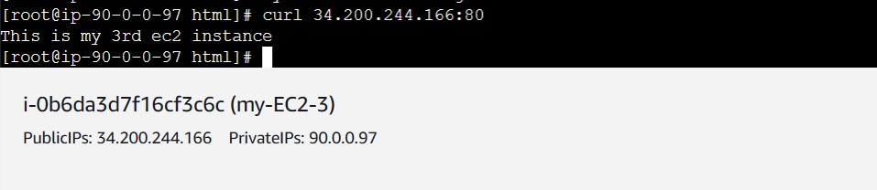

* now copy the private IP in any instance and paste in another connected instance
* can you see below pic I copied private IP of 1st EC2 instance and pasted in 3rd EC2 instance with using curl command, see the successful results below we got (This is my ec2 instance 1st server) content in 3rd EC2 instance (my-EC2-3)

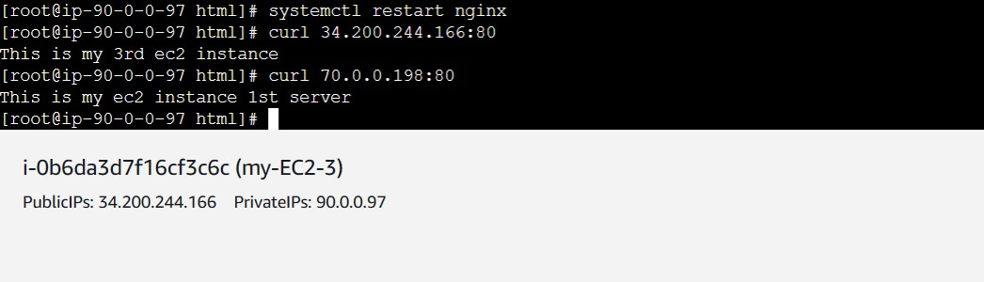

* our task is successfully completed