Create an VPC attach to Lambda and attach RDS to that Lambda

* Cerate 1 VPC
* Open VPC and VPC name (VPC), IPv4 CIDR given as 30.0.0.0/16

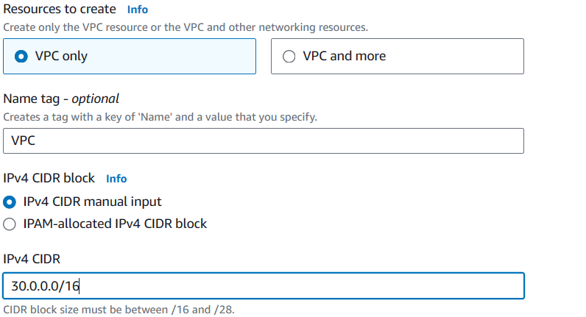

* Now create two subnets
* Subnet name given as (subnet), Availability Zone is “us-west-1a”
* IPv4 subnet CIDR block given as 30.0.0.0/20

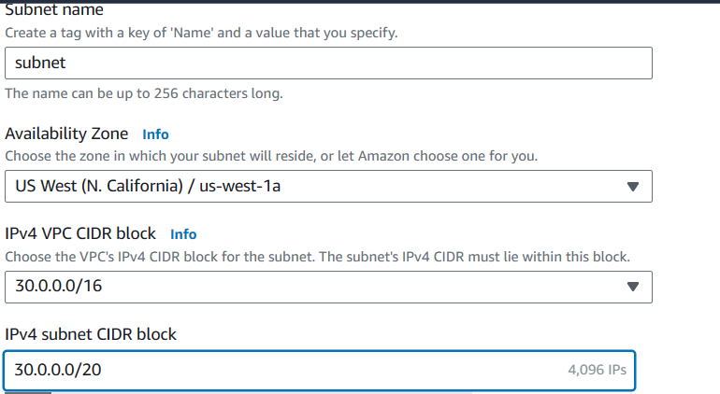

* Cerate our 2nd subnet (subnet-2) and Availability zone is us-west-1c
* IPv4 subnet CIDR block given as 30.0.30.0/24

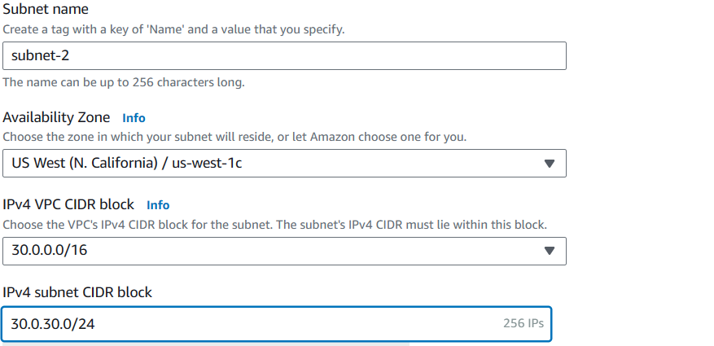

* Now our two subnets created
* Create one internet gateway (Internet-gateway)

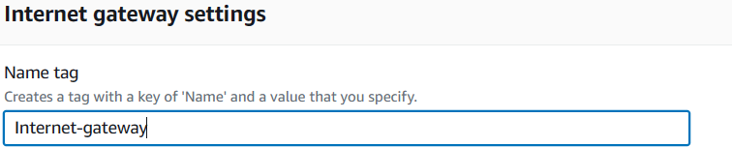

* Our VPC attached to internet gateway

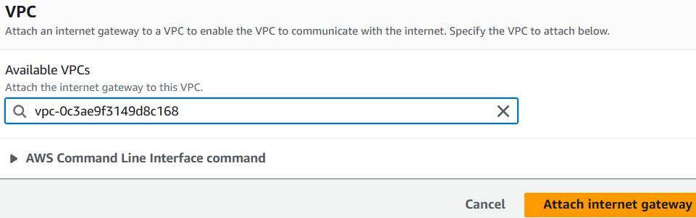

* Create one route table
* Name given as RT and select our VPC

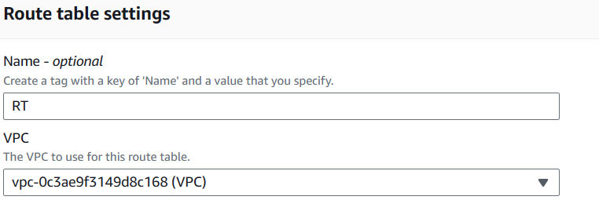

* Select our route table and click on subnet association
* Select our 2 subnets and click on save association

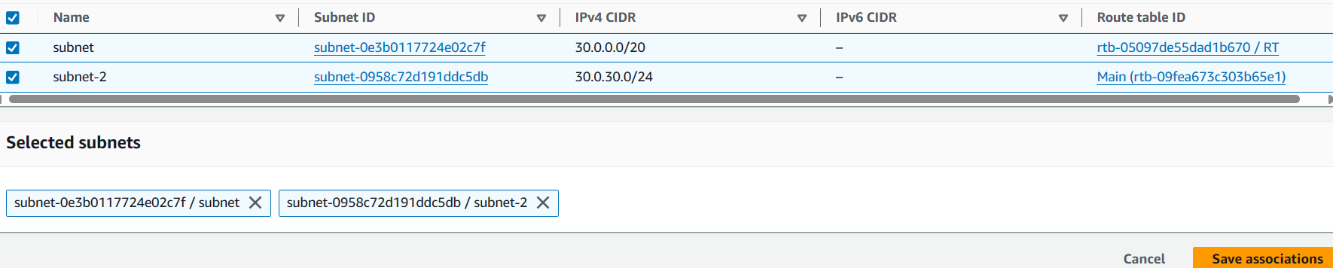

* Select our route table and click on edit route
* In target box select our internet gateway and add our internet gateway id, in destination box select 0.0.0.0/0

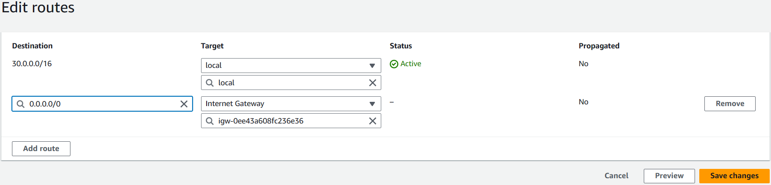

* Create a lambda function name given as (lambda-1)
* In runtime box selected Amazon Linux 2023

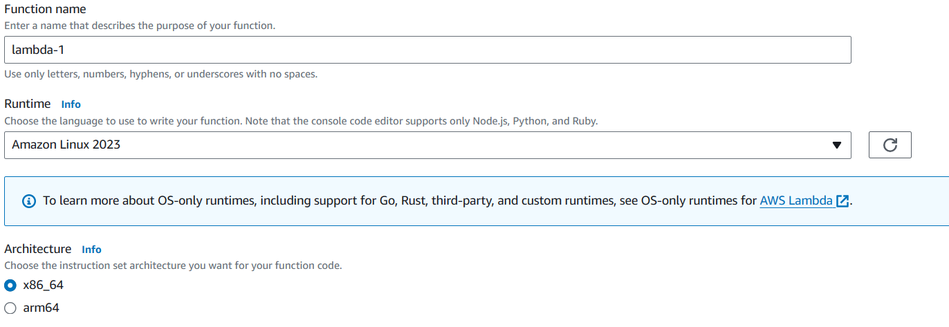

* Now create one database
* Engine type selected as MySQL

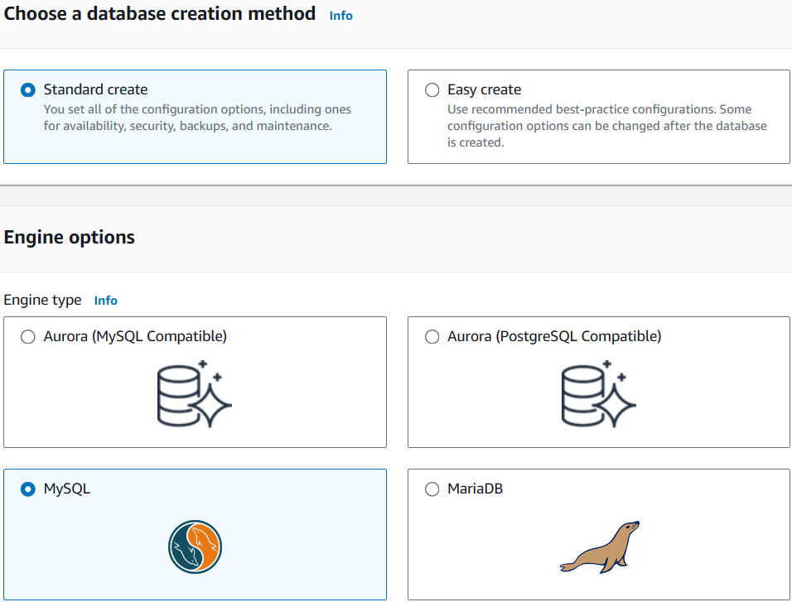

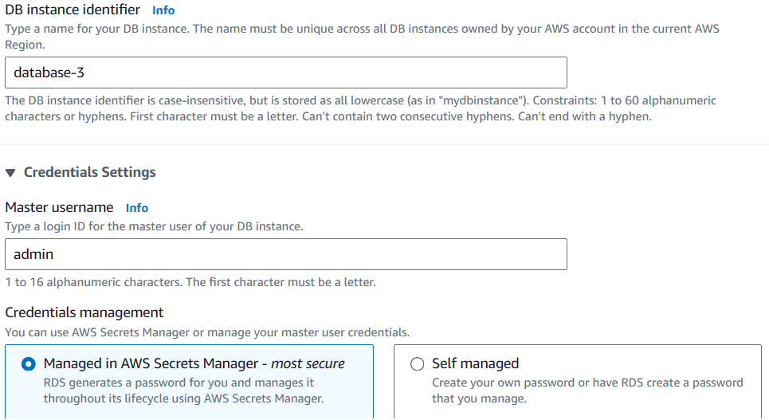

* Selected our VPC

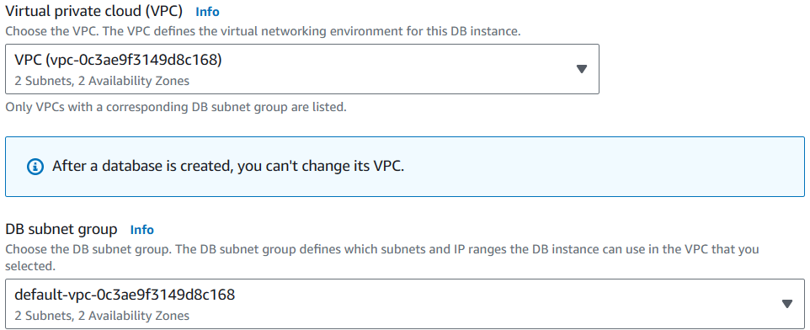

* Our database is successfully created

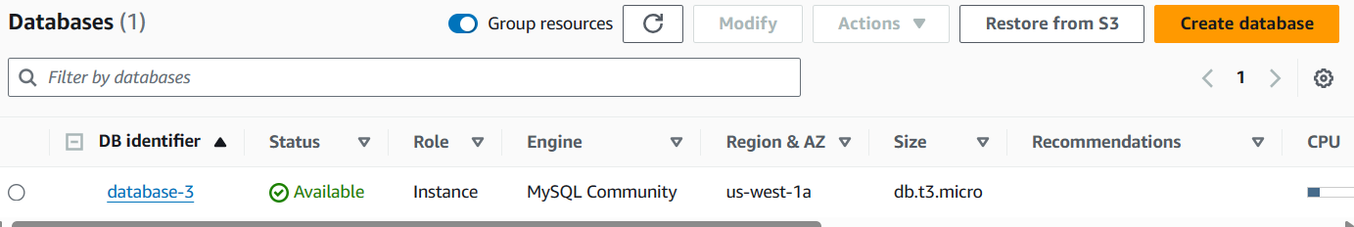

* Create a Proxy
* Selected engine family type is MariaDB and MySQL
* Proxy name given as proxy-3

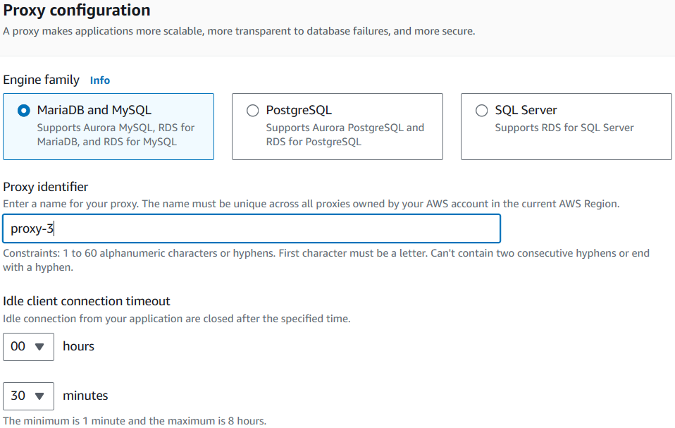

* Selected our database-3

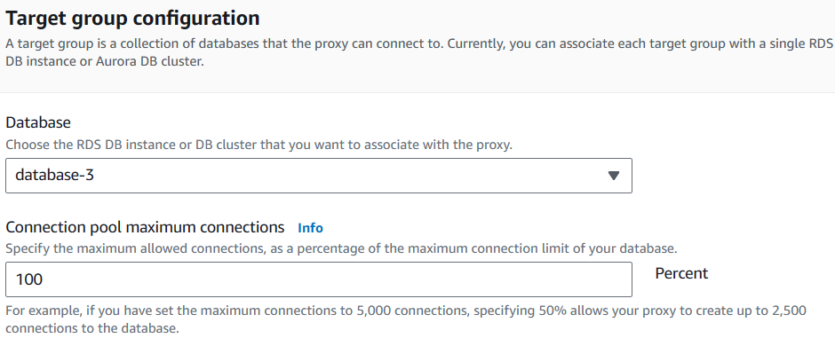

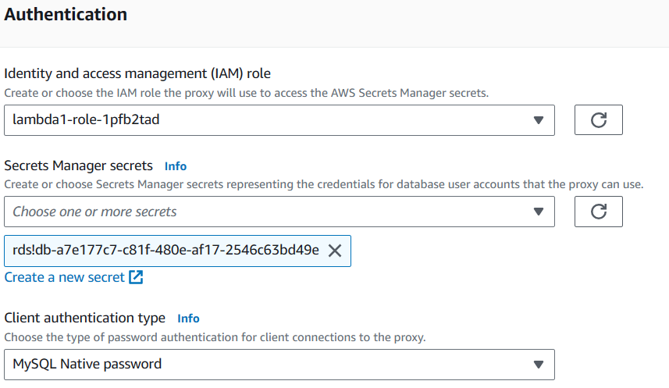

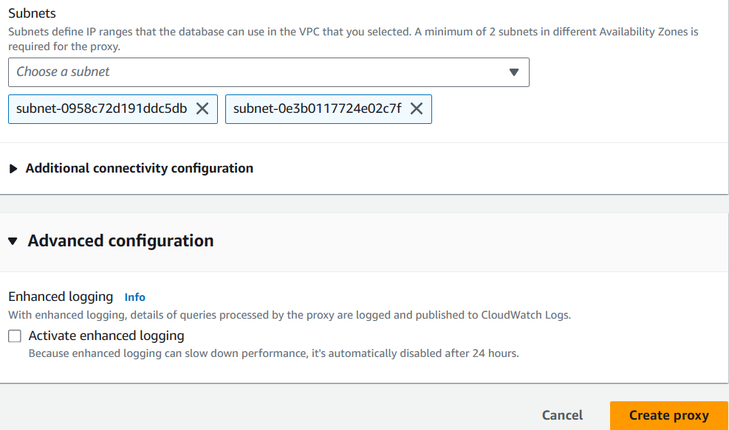

* Created our Proxy see below image

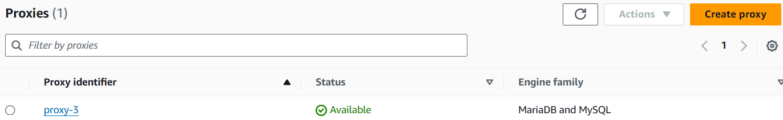

* Now open lambda, click on configuration and choose RDS databases option
* Click on connect to RDS database
* Select “Use an existing database”
* In RDS database box select our database (database-3) and click on create

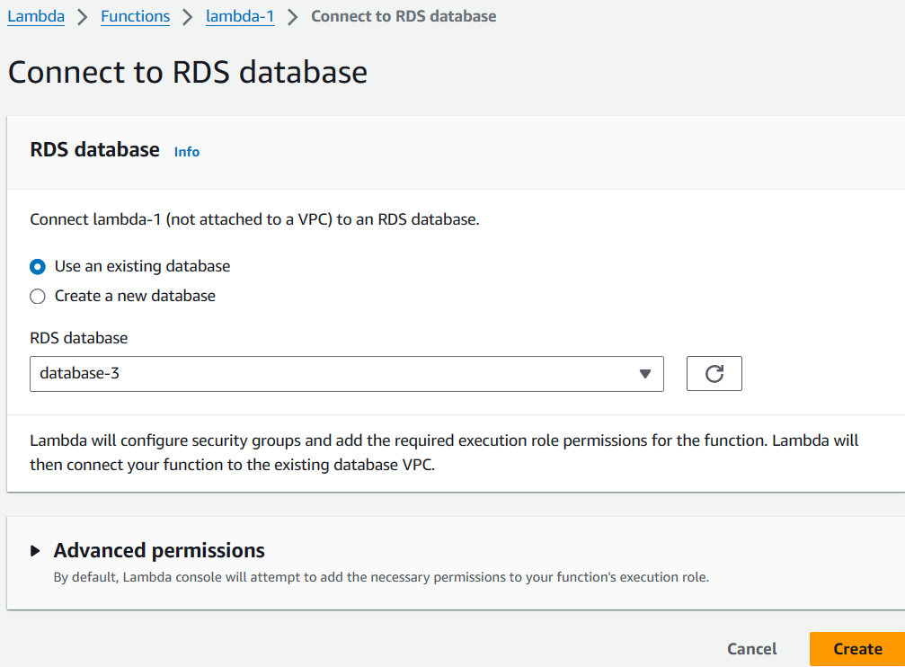

* Successfully connected Lambda to RDS database see below pic

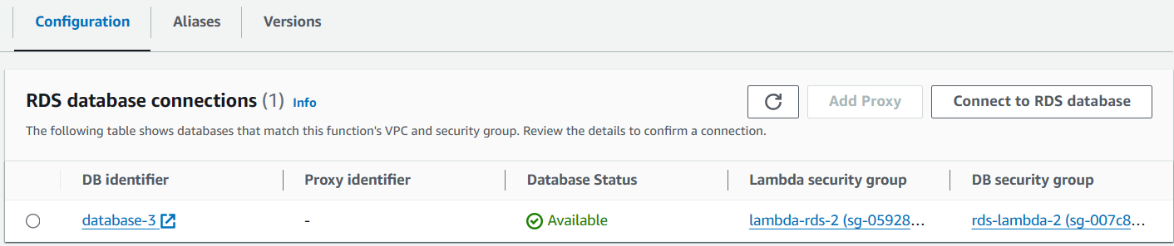

* Now select database-3 and click on add proxy
* Select “choose on existing database proxy” and select our proxy (proxy-3), click on add

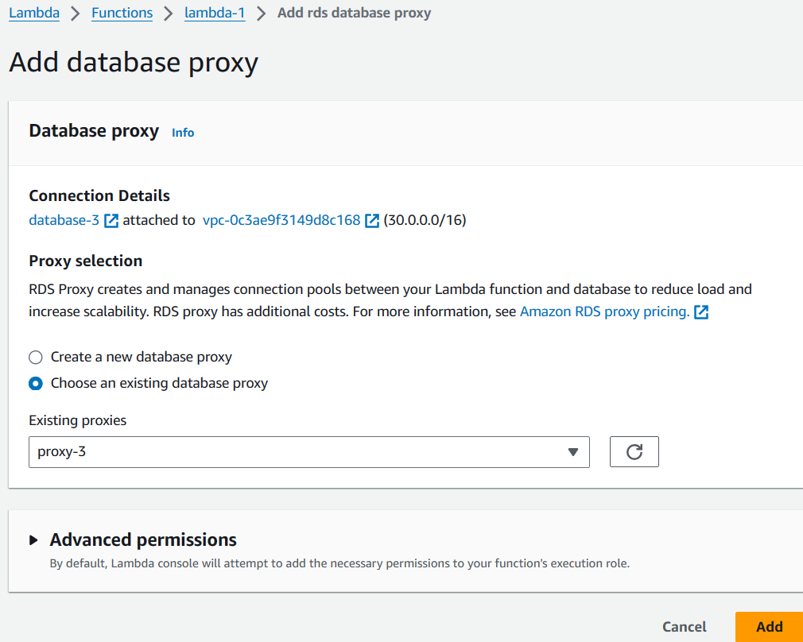

* Our proxy also added
* Now we can see below image our Lambda is connected to database and proxy

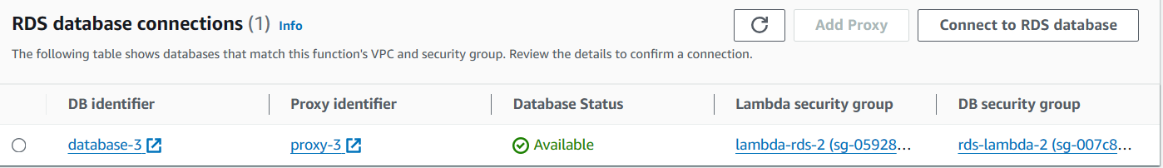

* Successfully completed our task