Create two S3 buckets in different regions, upload a file in one S3 bucket and transfer the same file from one S3 bucket to another S3 bucket.

* Click on search bar for S3 and open it

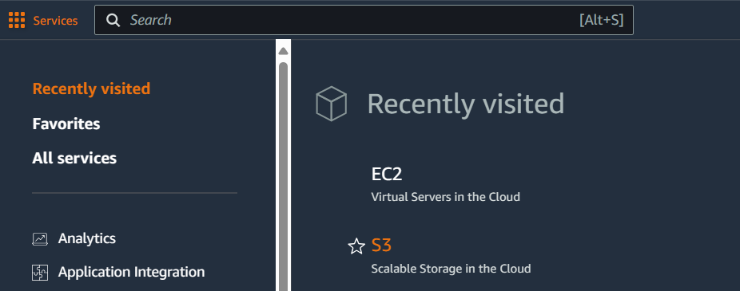

* Now cerate two S3 buckets in different regions
* Selected region Sydney to our 1st storage bucket
* 1st bucket name given as (s3-bckt-1)

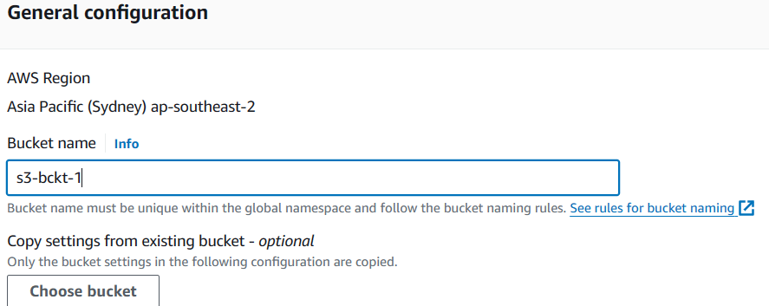

* Give bucket versioning is Enable

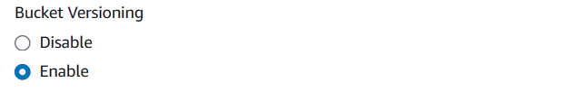

* Now click on create bucket
* 2nd S3 bucket region selected California
* Create our 2nd storage bucket, given name as (s3-bckt-2)

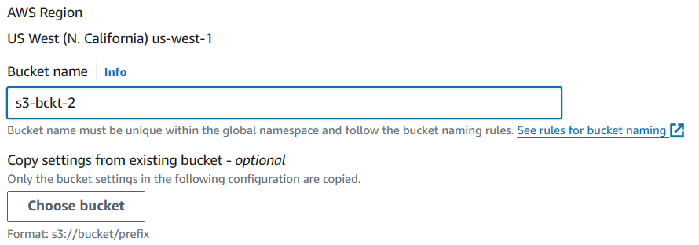

* Click on Enable option for bucket versioning

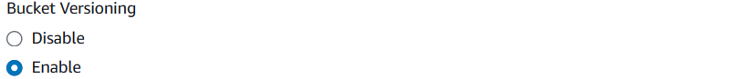

* Now we can see our 2 S3 storage buckets in below image



* Open our 1st S3 bucket and click on upload option

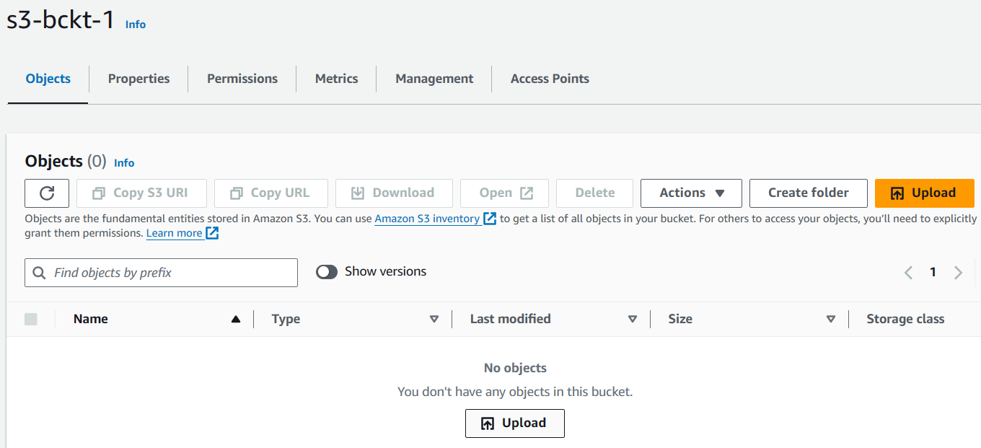

* Now we can select a file from our device
* I selected a file is PRGT1
* Click on upload option

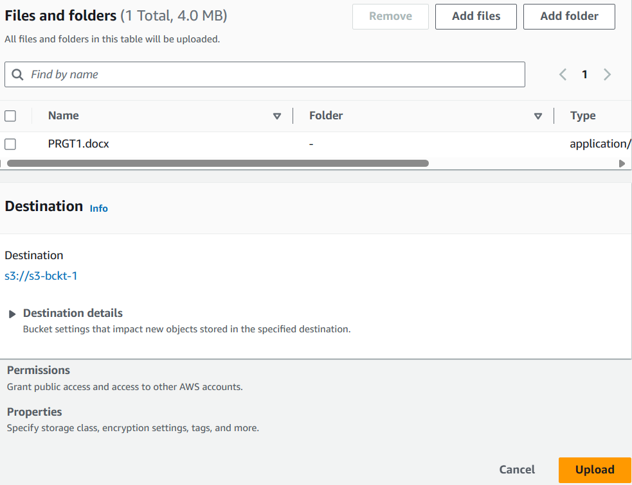

* Now click on management option

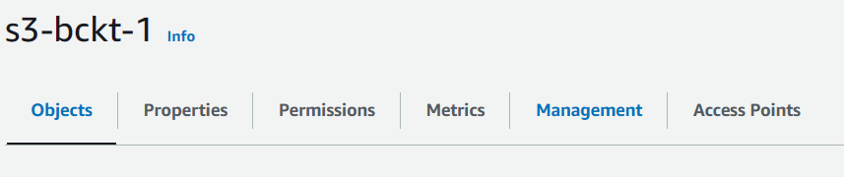

* In prefix box we can give uploaded file name (PRGT1)

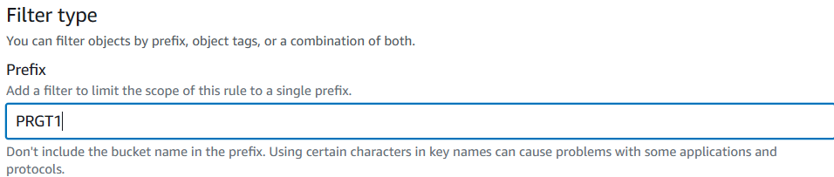

* Now click on browse S3 option

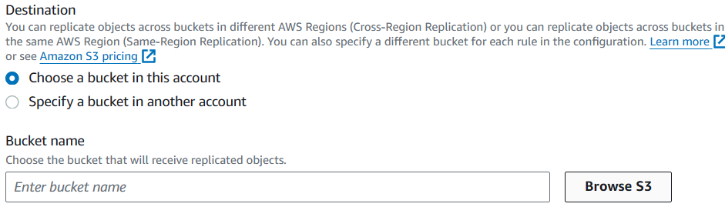

* Choose 2nd S3 bucket and click on choose path option

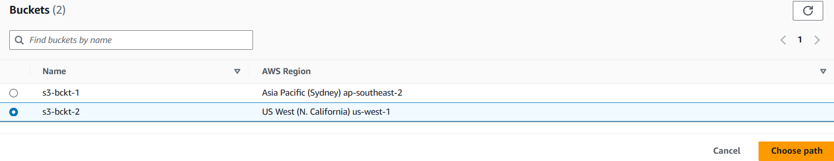

* In IAM role select create new role option

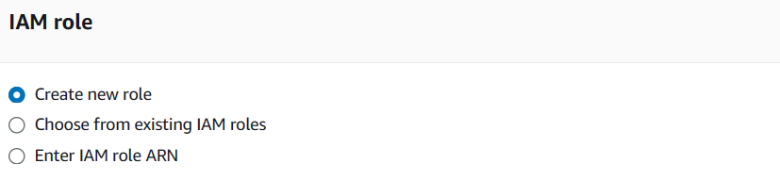

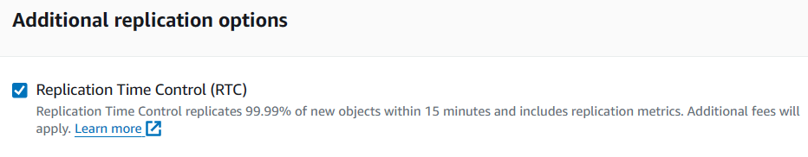

* Replicate existing objects select 2nd option
* Click on submit option

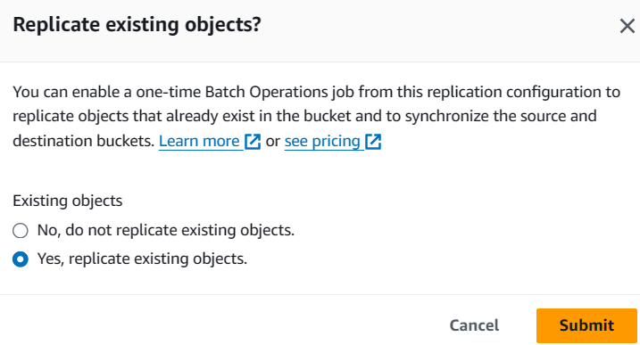

* Now select our destination 2nd S3 bucket, click on choose path

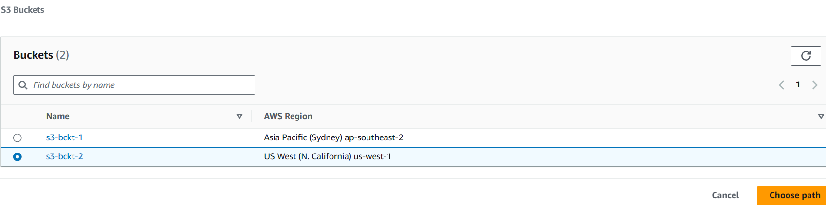

* Now click on save option
* We can see below image our job ID is successfully activated

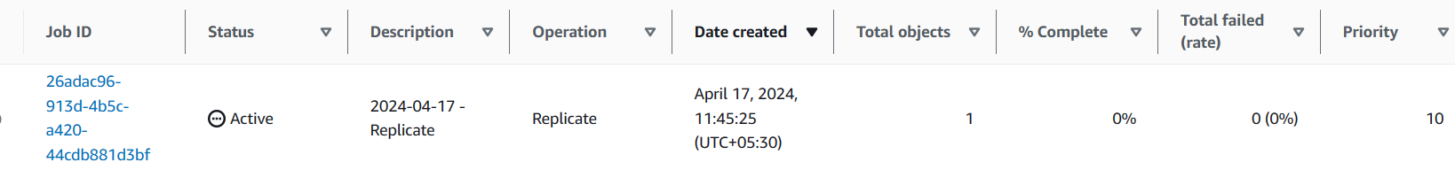

* Now click on 2nd S3 bucket
* We can see below image our uploaded file

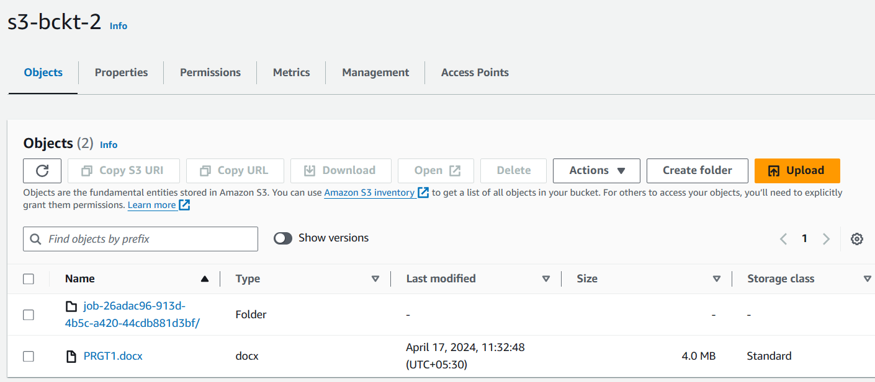

* Our task is successfully completed