**Documentation**

**Problem Statement :** Police Feedback System

**Problem**

Getting feedback on police operations is difficult due to outdated methods and privacy concerns. Traditional ways like inspections and calls to complainants are restricted and lack inclusivity. This hampers understanding community feelings and addressing policing issues effectively.

**Solution**

**1. Bulk SMS Tool:**

* **Objective:**
  + Gather quick feedback from the community regarding their experiences with the police.
* **Implementation:**
  + Integrate a Bulk SMS Tool that sends out brief messages to community members asking them to rate their recent interactions as "Happy" or "Not Happy."
  + Responses will be automatically recorded in the system for further analysis.
* **User Experience:**
  + Simple and straightforward SMS prompts.
  + User-friendly options for responding with a single keyword.

**2. Auto Chatbot:**

* **Objective:**
  + Engage users in a conversational manner to collect more detailed feedback.
* **Implementation:**
  + Developed an Auto Chatbot capable of asking users open-ended questions about their experiences and concerns.
  + Utilize natural language processing to compile and categorize responses in real-time.
* **User Experience:**
  + Interactive and conversational interactions.
  + Progressive questioning to gather comprehensive feedback.

**3. Online Portal:**

* **Objective:**
  + Record detailed comments and provide a holistic view for comprehensive analysis.
* **Implementation:**
  + Creating a user-friendly online portal accessible via web and mobile devices.
  + Allowed users to log in securely, providing a platform for submitting detailed comments, suggestions, or complaints.
* **User Experience:**
  + Intuitive interface with fields for different aspects of the feedback.
  + Submission tracking and confirmation for users.

**4. Social Media Platform:**

* **Objective:**
  + Foster community engagement and allow users to share their experiences.
* **Implementation:**
  + Developed a platform where users can post and share their experiences in a social media format (like threads, twitter(x)).
  + Implementing tagging functionalities for specific locations or incidents, facilitating easy categorization.
* **User Experience:**
  + Familiar social media features (likes, comments, shares).
  + Tagging options for identifying specific incidents or locations.

**5. General Features:**

* **Multi-Lingual Support:**
  + Ensure that the system supports multiple languages to accommodate the diverse linguistic landscape of the community.
* **Mobile Optimization:**
  + All components (SMS, Chatbot, Portal, Social Platform) should be optimized for mobile use, considering the prevalence of mobile devices.
* **Cost-Effective Measures:**
  + Explored cost-effective technologies and cloud solutions to keep the overall implementation cost within the specified budget range.
* **Data Security and Privacy:**
  + Implement robust data security measures to ensure the confidentiality and privacy of user feedback.
* **Automated Data Entry:**
  + Set up automated processes for data entry to ensure that feedback is consistently and regularly collected.

**Software and Technology**

1. **Programming Language :**

* JavaScript

1. **Frameworks :**

***Frontend :*** React JS, Next JS

***Backend :*** ExpressJs, NodeJS

1. **Cloud Services :**

* MySQL

1. **Mobile Application :**

* React Native

**Team Members & Responsibilities**

Sunasara Husenahmad :- Create Online Portal

Basan Nofal :- Create Mobile Application

Patel Aamil :- Create UI/UX Design

Padarwala Ahmad :- Analysis

**Data Flow Diagram**

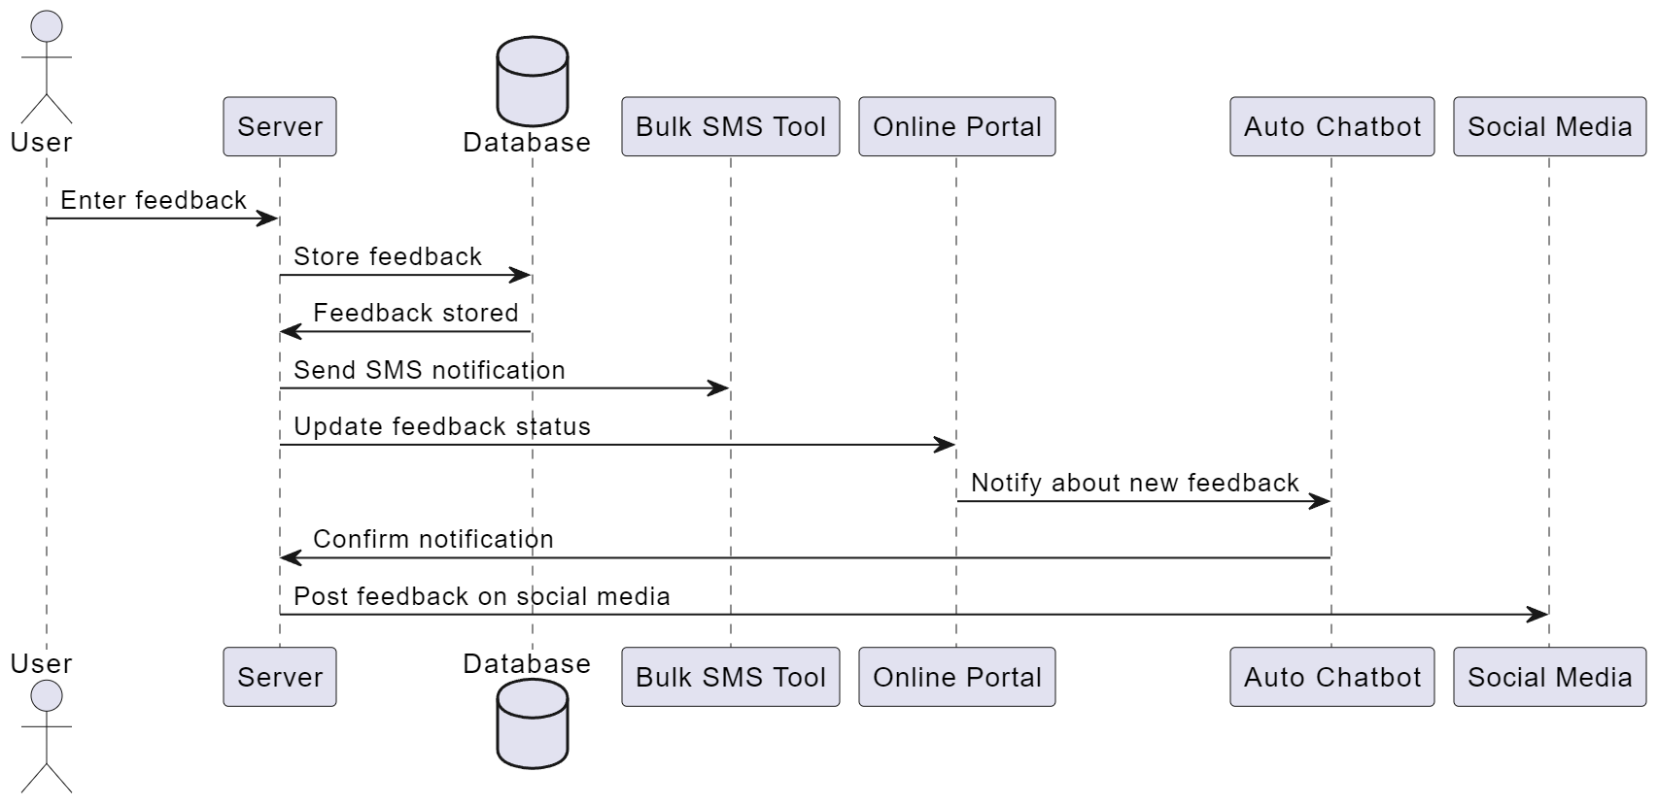

**Product Status**

60% product built completed and further build is on progress. Design and Other Fields process are next to be undergone.

**SCREENSHOT OF THE PROJECTS**

**Dashboard of the Feedbacks**

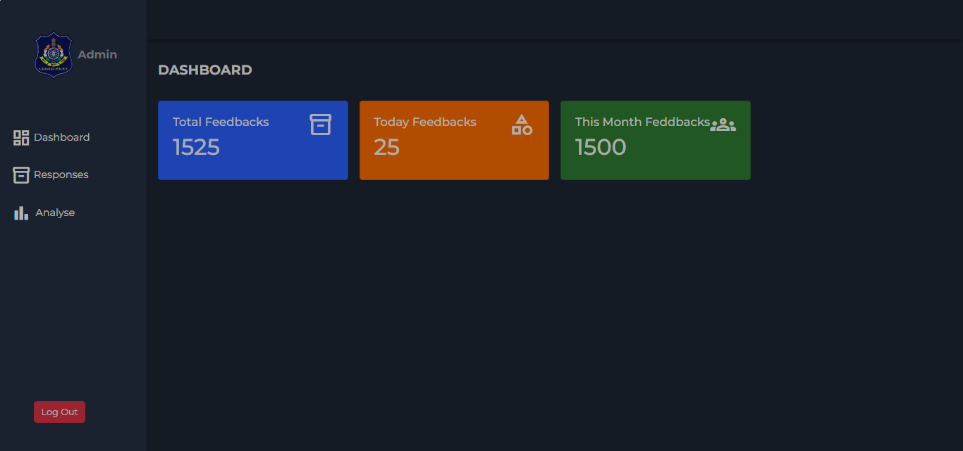

**Response of the Feedbacks**

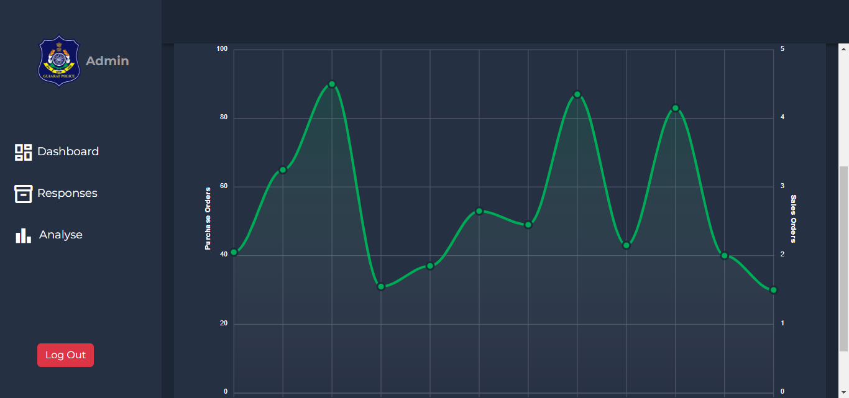

**City Wise Feedbacks**

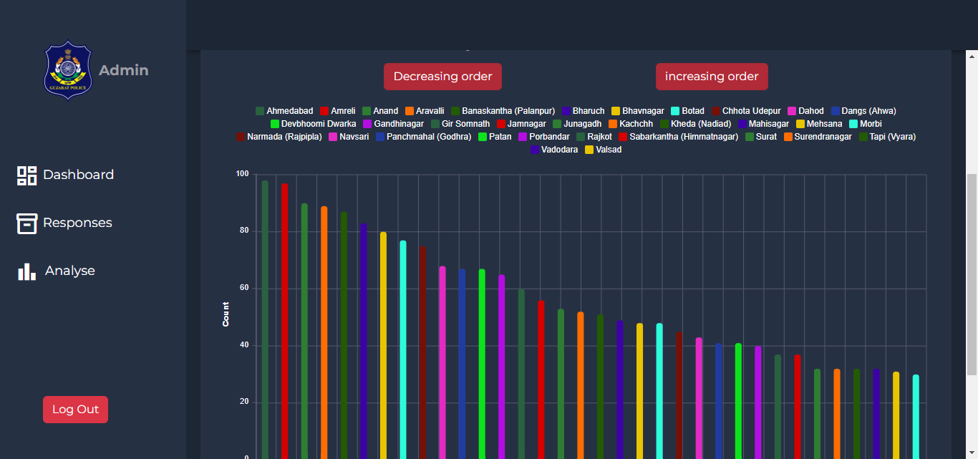

**Analyze Feedbacks**

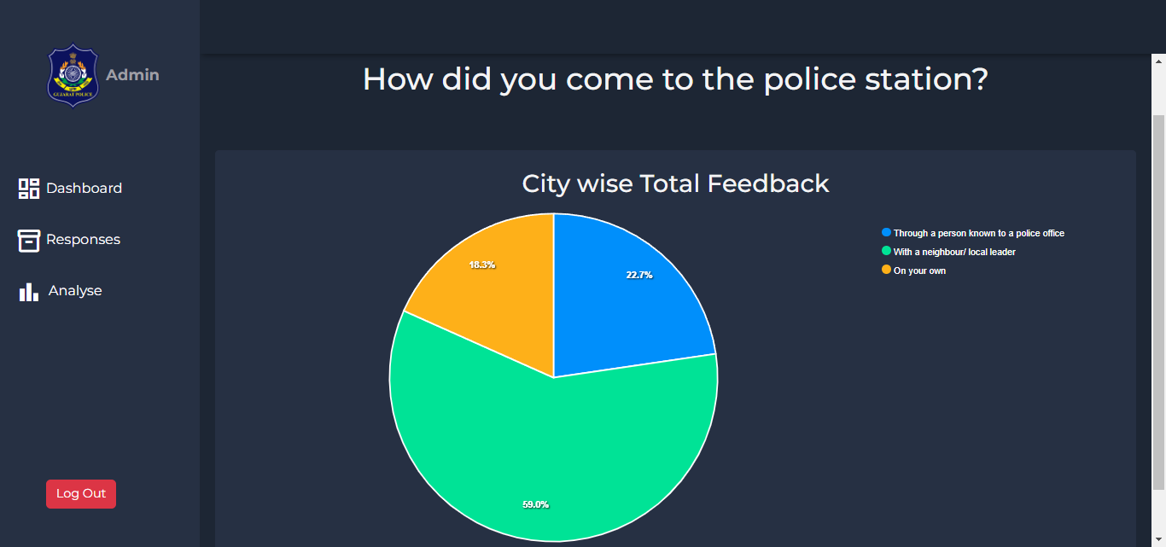

**Smart Chat boat**

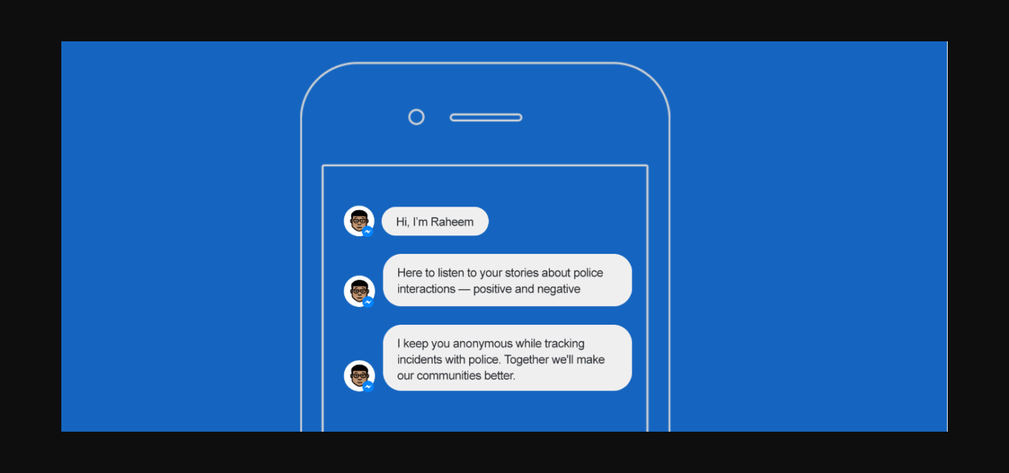

User Easily track the Feedback Status

