Lab 1: OpenMP

Name: Sunat Praphawong ID: 6088130 Sec: 1C

Rename your file to “lab1_u5xxxxxxx.docx” and upload it to Mycourses website

**Lab: 3.5.** helloomp.c

Result

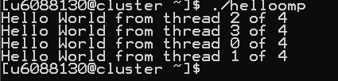

**Lab: 4.** ompsum.c

(with -fopenmp)

Result



(without -fopenmp)

Result:

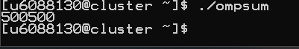

**Lab: 5.** omprace.c

(with #pragma omp critical)

Result



(without #pragma omp critical)

Result



**Lab: 6.**

Source Code

#include <stdio.h>

#include <omp.h>

int main()

{

int i;

int sum = 0;

#pragma omp parallel for reduction(+:sum)

for (i=0; i <= 1000; i+=2)

sum = sum + i;

printf("%d\n",sum);

}

Result

