**Part A. WiFi**

**A1. Scanning Access Points**

**Upload The1stAP.ino and capture the output from Serial Monitor then put it below.**

**A2. Web Server**

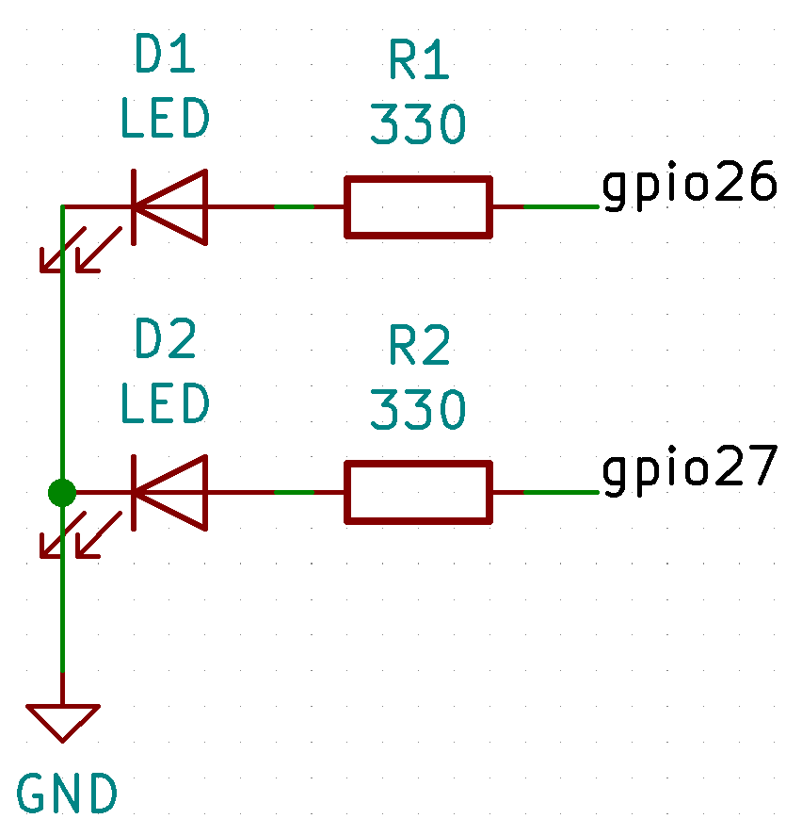

**Upload The1stWebServer.ino. Join your laptop and ESP32 to your access point (can be your phone hotspot). From laptop access to ESP32 via its IP address on a web browser. Then try controlling 2 LEDs by using the 2 buttongs on the webpage. Take a picture of the webpage and your ESP32 with the LEDs (arrange them in 1 picture) when an LED is turned on and the other one is turned off. Put the picture below.**

**Part B. Network Time Protocol (NTP) and Real Time Clock (RTC)**

**Wire up the RTC as shown below.**

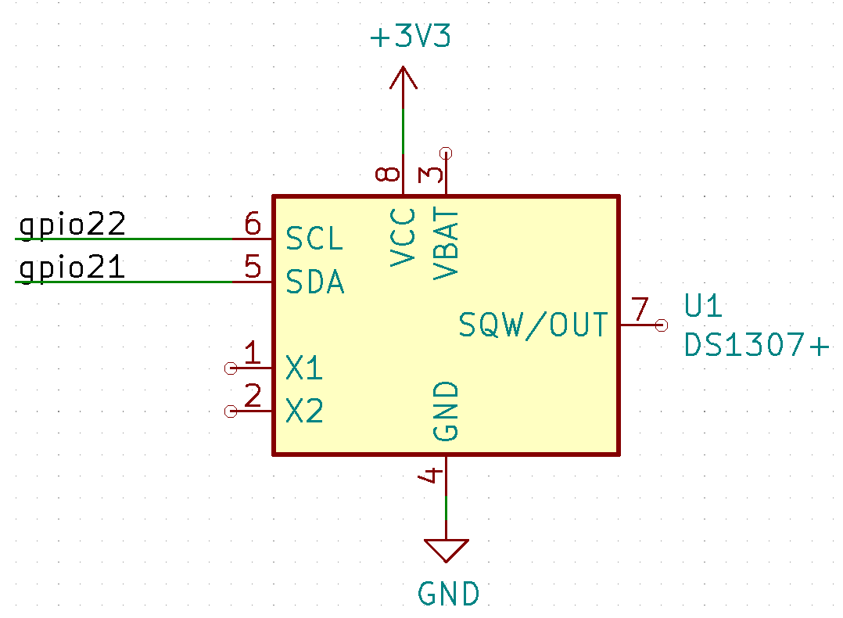

**B1. Upload DS1307_M_Adjust.ino and capture the Serial Monitor after resetting ESP32, then put the picture below.**

**B2. Upload ntp.ino and capture the Serial Monitor after resetting ESP32, then put the picture below.**

**B3. Write a new program that sets the time on DS1307 to the current time from NTP server. Then every second print out the time from DS1307. Put your source code below.**