1).

Functional requirements:

Admin can create (add new users) to system.

Admin can delete users from the system.

Admin can update users details from the system.

Admin can list the users form the system.

Admin can manage user accounts.

Nonfunctional requirements:

System should be available to users ensuring operations run smoothly and uptime of the system.

System should perform fast and run efficiently and users should be able to understand easily.

System should be able to scalable number of users with the information could able to handle without efficient issue when number of users increases.

Use case diagram: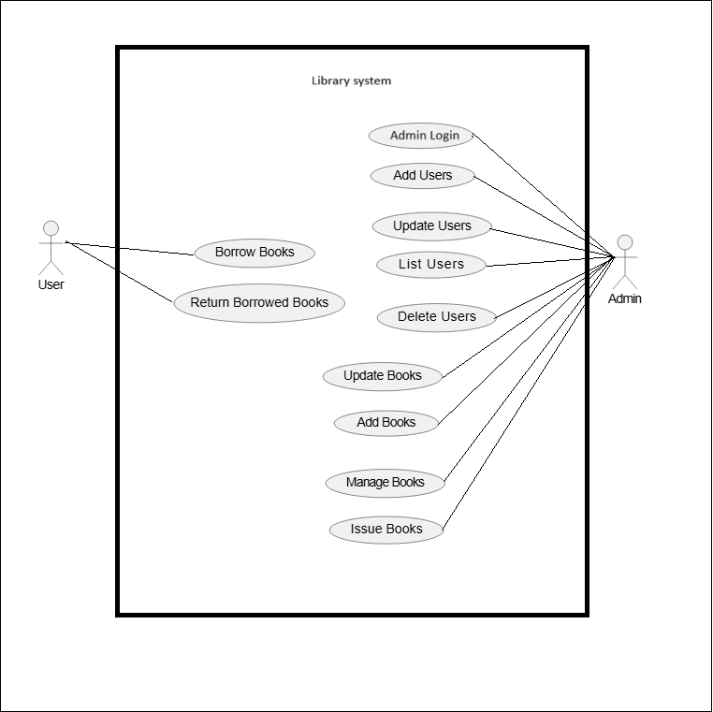

ER diagram:

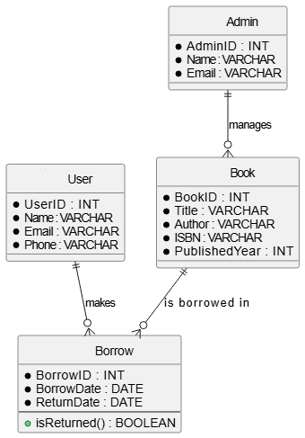

Data base is in .sql extention at ‘part1\sql_DB_tables_import’