Do modern protein language model embeddings subsume curated Gene Ontology context for predicting disorder-to-order transitions?

A pre-registered factorial benchmark across three prediction scales and two protein language model families

BIOL 466 — Independent Research Project 1
Author: Sunav Bajaj Program: U3 Biology Institution: McGill University, Department of Biology Term: Winter 2026
Supervisor: Prof. Paul Harrison Course Coordinator: Nancy Nelson

Availability of data and code. All analysis notebooks (01_data_acquisition.ipynb through 18_generate_figures.py) and the report source are archived at [repository URL to be inserted before submission]. Data files are regeneratable from the notebooks; DisProt release used is disprot_2025_12 and pinned PLM checkpoints are esm2_t33_650M_UR50D (Meta AI) and Rostlab/ProstT5 (TU Munich). All statistical analyses are reproducible with a fixed random seed of 42.
Ethics and conflicts of interest. This work uses only publicly available protein sequence and annotation data. No experiments involving human subjects, animals, or biological materials were conducted. The author declares no conflicts of interest.

Table of Contents
Section | Page
Abstract | 4
Acknowledgements | 5
1. Introduction | 6
1.1 IDPs and coupled folding-and-binding | 6
1.2 Two candidate information sources for d2o prediction | 6
1.3 Study design and contributions | 6
2. Methods | 8
2.1 Dataset and label | 8
2.2 Features | 8
2.3 Sequence-redundancy control and cross-validation | 8
2.4 Factorial design and classifier | 8
2.5 Metrics and statistical analysis | 9
2.6 Extensions | 9
2.7 Limitations | 9
3. Results | 10
3.1 Dataset and primary factorial | 10
3.2 PLMs already contain GO Slim’s discriminative content | 10
3.3 GO context acts as a regularizer toward the class prior | 11
3.4 Sequence representation is the strongest lever | 12
3.5 Higher-resolution GO does not rescue the null | 13
3.6 Robustness across classifier, PLM family, and region scale | 14
4. Discussion | 16
4.1 Principal finding | 16
4.2 Why PLMs subsume GO Slim | 16
4.3 Regularization toward the class prior | 16
4.4 What the higher-resolution GO test told us | 17
4.5 Positioning, limitations, future work | 17
4.6 Conclusion | 17
References | 19
Appendices | 24
A. Per-fold AUPRC for the disorder-pool factorial | 24
B. ProstT5 replication | 24
C. Region-level factorial | 24
D. Higher-resolution GO factorial and strengthening pass | 25
E. Reproducibility | 27

Abstract
Intrinsically disordered proteins (IDPs) do not fit the classical sequence-structure-function paradigm. Their most-studied functional mechanism is coupled folding-and-binding: a disordered region folds into a defined shape only when it meets its binding partner (a disorder-to-order or d2o transition). Predicting d2o regions from sequence is an open problem. Two data sources could plausibly help: curated Gene Ontology (GO) annotations and pretrained protein language model (PLM) embeddings. Whether they carry independent information has not been tested directly.
I built a dataset of 1,279 non-redundant proteins from DisProt release 2025_12 (188 d2o-positives) and ran a pre-registered 2×2×2 factorial across the three GO Slim sub-ontologies (BP, MF, CC) added on top of an ESM-2 baseline. Cross-validation used GroupKFold on CD-HIT clusters at 40% identity. I tested robustness across three prediction scales (whole-protein, disorder-pool, per-region on 3,231 regions), two PLM families (ESM-2, ProstT5), and two classifiers (Random Forest, XGBoost). Primary metric was AUPRC.
No GO factor produced a statistically significant lift, but the null is mechanistically informative. Permutation importance in the joint model splits 99.7% to ESM-2 dimensions and 0.3% to GO features. The 0.3% of GO importance concentrates on biologically correct terms (RNA binding, DNA binding, transcription, nucleus). Modern PLM embeddings have already absorbed the discriminative content that GO Slim carries. This finding generalizes to higher-resolution GO: replacing Slim with full-term ancestor-propagated GO (1,950 BP terms vs 65) gave an initial +0.016 BP lift, but a scrambled-annotation control reproduced 55% of it and the effect vanished across seeds. The strongest lever on prediction is sequence representation, not annotation: baseline AUPRC rises 0.199 → 0.237 → 0.273 across the three scales, each step larger than any GO effect observed. For method developers building IDP function predictors on modern PLMs, engineering better sequence representations returns more than integrating curated context.
Keywords: intrinsically disordered proteins; disorder-to-order transition; protein language models; ESM-2; Gene Ontology; DisProt; factorial design.

Acknowledgements
I thank my BIOL 466 supervisor for their patient guidance across the thirteen weeks of this project, and in particular for their willingness to sanction the two mid-course design pivots (the switch from a GO-target to an IDPO-target framing in Week 2, and the region-level extension added in Week 9) that shaped the study into its final form. Their questioning at the post-Week-4 checkpoint on the specific mechanism by which GO Slim features could plausibly contribute information beyond ESM-2 embeddings led directly to the pre-registration of hypothesis H4 and to the stratified analysis reported in §3.7.
I thank Nancy Nelson for coordinating the BIOL 466 course structure and for the writing scaffolding that shaped the section-by-section reporting cadence used across the project’s weekly lab-notebook entries.
I acknowledge the developers of the DisProt database, whose continued curation effort makes benchmarks of this kind possible; the Gene Ontology Consortium, whose sustained infrastructure work makes GO Slim tractable as a feature source; and the developers of the ESM-2 and ProstT5 protein language models, whose open release of pre-trained weights made the two-family robustness comparison in §3.5 achievable within a semester-length project timeline.
Computational work was performed on Apple Silicon (M-series) hardware with PyTorch Metal Performance Shaders acceleration. Random Forest and XGBoost baselines used the scikit-learn and xgboost open-source Python libraries respectively. All figures were produced with matplotlib and seaborn. I thank the open-source communities behind these tools.
Any errors of interpretation, statistical judgement, or methodological choice that remain in this report are my own.

1. Introduction

1.1 IDPs and coupled folding-and-binding
Intrinsically disordered proteins (IDPs) lack a stable folded structure but execute essential functions in signalling, transcription, and the assembly of membraneless organelles (Wright and Dyson, 1999; van der Lee et al., 2014). Around 40 to 50 percent of eukaryotic proteins contain a disordered region of at least 30 residues, and disordered regions are enriched in cancer-associated proteins and viral interaction hubs (Ward et al., 2004; Iakoucheva et al., 2002). Function prediction for IDPs is hard for two reasons: the sequence-structure-function chain is broken at the middle link, and functional signal sits in short motifs and composition biases rather than conserved catalytic residues (Davey et al., 2012).
The mechanism I focus on is coupled folding-and-binding, in which a disordered region undergoes a disorder-to-order (d2o) transition on binding a partner (Dyson and Wright, 2002). This underlies transcription factor and coactivator interactions (Radhakrishnan et al., 1997), kinase-substrate recognition (Bah et al., 2015), and tumour suppressor networks like p53 (Oldfield et al., 2008). Short binding-competent d2o segments are called MoRFs (Mohan et al., 2006), and MoRF prediction has been a target of the field for over a decade (Disfani et al., 2012). I use the DisProt database (Quaglia et al., 2022) as the reference curated resource; the IDPO term IDPO:0000011 (Structural transition; disorder-to-order) is my operational d2o label.

1.2 Two candidate information sources for d2o prediction
Two data sources could plausibly help predict d2o from sequence. The first is Gene Ontology annotations, organized into three sub-ontologies: Biological Process (BP), Molecular Function (MF), and Cellular Component (CC) (Ashburner et al., 2000). CAFA benchmarks show that combining sequence similarity with machine learning and GO context beats sequence-only methods on the general proteome (Radivojac et al., 2013; Kulmanov and Hoehndorf, 2020), but the gap shrinks on the disordered slice (Nair et al., 2022). The second is protein language models like ESM-2 (Lin et al., 2023) and ProstT5 (Heinzinger et al., 2023), pretrained on hundreds of millions of sequences with self-supervised objectives that encode structural, functional, and evolutionary information (Rives et al., 2021; Elnaggar et al., 2022).
The specific question this study answers: given a modern PLM baseline, does adding GO context improve d2o prediction, or has the PLM already absorbed the discriminative content GO carries?

1.3 Study design and contributions
I test this with a pre-registered 2×2×2 factorial across the three GO sub-ontologies added on top of an ESM-2 baseline. All cross-validation uses GroupKFold on CD-HIT clusters at 40% sequence identity, which blocks the sequence-similarity leakage that inflates most protein function benchmarks. I test robustness across three prediction scales (whole-protein, disorder-pool, per-region), two PLM families (ESM-2, ProstT5), and two classifier families (Random Forest, XGBoost). The primary metric is AUPRC, which handles the 15% positive-class prevalence better than ROC-AUC (Saito and Rehmsmeier, 2015).
I pre-registered four hypotheses: H1-H3 that each sub-ontology main effect (BP, MF, CC) is positive; H4 that GO helps most where the sequence baseline is least confident. This report makes four contributions. First, a cluster-controlled factorial benchmark for the specific GO-plus-PLM question on DisProt d2o. Second, the finding that PLM embeddings already contain the discriminative content of GO Slim (99.7%/0.3% importance split with biologically coherent top GO features). Third, the identification of sequence representation and prediction scale as the strongest lever on performance (each scale step contributes about +0.037 AUPRC). Fourth, evidence that the null generalizes to higher-resolution GO representations, ruling out the interpretation that GO Slim was too coarse.

2. Methods

2.1 Dataset and label
From DisProt release 2025_12 (Quaglia et al., 2022) I extracted 1,279 non-redundant human proteins after collapsing UniProt isoform suffixes. At the protein level, y=1 if at least one disordered region carried an IDPO:0000011 annotation; y=0 otherwise. This gave 188 positives out of 1,279 (14.7% prevalence). At the region level (Week 9 extension), each Structural-state disorder region was a separate row, labelled y=1 if it overlapped ≥50% with any IDPO:0000011 annotation on the same protein (matching MoRF inclusion criteria; Disfani et al., 2012). This produced 3,231 regions with 391 positives (12.1% prevalence).

2.2 Features
Sequence features. ESM-2 (esm2_t33_650M_UR50D, 1,280 dim; Lin et al., 2023) extracted from layer 33 in inference mode, mean-pooled at three scales: whole-protein (over the truncated sequence), disorder-pool (over DisProt-annotated residues), and per-region (over each region separately). Sequences longer than 1,022 residues were truncated to respect ESM-2’s context window. Regions with start > 1,022 (5.5%) were mean-pooled over in-window residues. For representation-family robustness (Week 8), I also extracted ProstT5 embeddings (Rostlab/ProstT5, 1,024 dim; Heinzinger et al., 2023).
GO features. GOA human GAF file filtered to experimental evidence codes (EXP, IDA, IPI, IMP, IGI, IEP, HTP, HDA, HMP, HGI, HEP), excluding IEA. This produced 76,902 annotations across 1,266 of 1,279 proteins. I reduced to GO Slim Generic (Ashburner et al., 2000) using goatools.mapslim (Klopfenstein et al., 2018), producing three per-sub-ontology binary matrices: BP (64 terms), MF (36 terms), CC (25 terms).

2.3 Sequence-redundancy control and cross-validation
I clustered sequences with CD-HIT (Fu et al., 2012) at 40% identity, producing 1,168 clusters. All cross-validation used scikit-learn’s GroupKFold(5) (Pedregosa et al., 2011) on the CD-HIT cluster ID as the group, so no cluster was split across train and test. Region-level rows inherited their parent protein’s cluster ID. The same fold assignments were reused across every condition and every extension experiment, which enables paired statistical comparisons.

2.4 Factorial design and classifier
The 2×2×2 factorial over BP, MF, CC produces 8 conditions (C0 baseline through C7 full-GO). For each condition, the feature matrix concatenates the ESM-2 embedding with zero or more GO Slim matrices (1,280 dim in C0, up to 1,405 dim in C7). The classifier is held constant across conditions: Random Forest (500 trees, class_weight='balanced', min_samples_leaf=3). This is the design’s controlled-variable principle: only the feature set changes. I ran XGBoost (Chen and Guestrin, 2016) on the disorder-pool factorial as a classifier-family robustness check.

2.5 Metrics and statistical analysis
Primary metric: AUPRC, chosen over ROC-AUC because it stays informative at 15% prevalence and calibrates against the prevalence baseline (Saito and Rehmsmeier, 2015). Secondary metrics: AUROC, macro-F1, balanced accuracy, and Matthews correlation coefficient (Chicco and Jurman, 2020). For threshold-dependent metrics I binarized at the positive-class prevalence rather than at 0.5.
Cross-condition tests used the paired Wilcoxon signed-rank test on per-fold AUPRC with alternative greater. Multiple-comparison correction across the seven pairwise comparisons per experiment used the Benjamini-Hochberg procedure (Benjamini and Hochberg, 1995) at α = 0.05. Effect sizes are reported as mean paired differences with 95% bootstrap CIs (2,000 iterations, seed 42).
Controls. A label-shuffling negative control was run for each experiment; all conditions collapsed to within ±0.03 of prevalence, confirming no leakage. Feature importance for the mechanistic interpretation used the C7 Random Forest retrained on the full dataset and its feature_importances_ attribute aggregated by feature source.

2.6 Extensions
Region-level factorial (Week 9). The primary factorial was rerun at region scale on 3,231 rows, with the same cluster-aware CV and factorial protocol.
Higher-resolution GO (Week 10) and strengthening pass. To test whether the null was a coarseness artifact of GO Slim, I re-encoded GO at full-term resolution with ancestor propagation up is_a and part_of relations. This produced 1,950 BP terms, 618 MF terms, and 329 CC terms. Because the BP main effect at a single-seed configuration gave an initial +0.016 lift that looked interesting, I ran four pre-registered strengthening checks before writing it up: (1) bootstrap 95% CI on the fold-level paired diffs; (2) scrambled-BP negative control that permutes the protein-to-annotation mapping (an effect that persists under scrambling is dimensionality-driven, not annotation-specific); (3) top-20 BP features by permutation importance to check biological coherence; (4) stability across 9 (RF seed × CV shuffle seed) combinations. Pre-registered decision rules classified the result as a strong finding, a suggestive finding, or a spurious effect to be dropped.

2.7 Limitations
Four limitations bound the interpretation. First, sample size is small (n = 1,279 proteins, 188 positives). Bootstrap analysis suggests I can detect a stable +0.02 AUPRC lift but not a stable +0.01 lift. Second, GO Slim is coarse; I addressed this directly with the higher-resolution extension in §3.6. Third, DisProt-annotated proteins are better-studied than average, so my factorial evaluates GO under near-optimal availability conditions. Fourth, the negative class is d2o-negative-or-unannotated rather than confirmed d2o-negative; this MNAR ambiguity compresses effect sizes symmetrically and does not distort the relative comparison.

3. Results

3.1 Dataset and primary factorial
The dataset covered 1,279 non-redundant human proteins (188 d2o-positives at 14.7% prevalence) grouped into 967 CD-HIT clusters at 40% identity. The region-level extension covered 3,231 regions (391 positives at 12.1% prevalence).
I ran the 2×2×2 GO factorial at the disorder-pool ESM-2 scale first. Table 1 gives the full result.
Table 1 — Disorder-pool factorial. AUPRC ± fold SD, BH-adjusted p-values from paired one-sided Wilcoxon against baseline.
Condition | AUPRC | Δ vs baseline | BH-adj p
C0 baseline | 0.237 ± 0.062 | — | —
C1 +BP | 0.238 ± 0.062 | +0.001 | 0.94
C2 +MF | 0.236 ± 0.062 | −0.001 | 0.94
C3 +CC | 0.239 ± 0.062 | +0.002 | 0.94
C4 +BP+MF | 0.238 ± 0.062 | +0.001 | 0.94
C5 +BP+CC | 0.240 ± 0.062 | +0.003 | 0.94
C6 +MF+CC | 0.238 ± 0.062 | +0.001 | 0.94
C7 full | 0.239 ± 0.062 | +0.002 | 0.94
No condition’s lift exceeds the fold-noise floor of about 0.010, and no BH-adjusted p-value approaches significance. This looks like a flat null, but the interesting question is why it is null. §§3.2 and 3.3 answer it.

3.2 PLMs already contain GO Slim’s discriminative content
If GO Slim carried no information relevant to d2o prediction, we would expect the model to ignore GO features. It does not. Permutation importance in the C7 joint model splits 99.7% to ESM-2 dimensions and 0.3% to the 118 GO Slim features (Figure 1a). The per-feature importance ratio is roughly 46,000 to 1 in favor of ESM-2, so GO is not being ignored, it is being outcompeted.
The small fraction of GO importance that exists concentrates on biologically correct terms (Figure 1b, top-15). RNA binding and DNA binding lead; regulation of transcription, DNA-binding transcription factor activity, kinase activity, and the nuclear and cytosolic compartments follow. These are the categories one would predict a priori for coupled folding-and-binding proteins, since roughly half of DisProt’s d2o-positives are transcription factors, transcriptional coactivators, or RNA-binding proteins. So the classifier is finding the biologically right GO features. It just cannot extract enough additional information from them to move AUPRC beyond fold noise.
The parsimonious reading is that ESM-2’s pretraining on approximately 250 million UniRef sequences (Lin et al., 2023; Rives et al., 2021) has already learned the sequence signatures characteristic of these functional categories. RNA-binding proteins have distinctive composition biases in their disordered regions (Chong et al., 2018); transcription factors share short linear motifs at defined register positions (Van Roey et al., 2014); kinases share catalytic-triad neighborhoods. A PLM trained at that scale would learn these signatures unsupervised. GO Slim’s “RNA binding” is a categorical label; ESM-2’s embedding is a continuous representation of the sequence features that make a protein an RNA-binding protein in the first place.
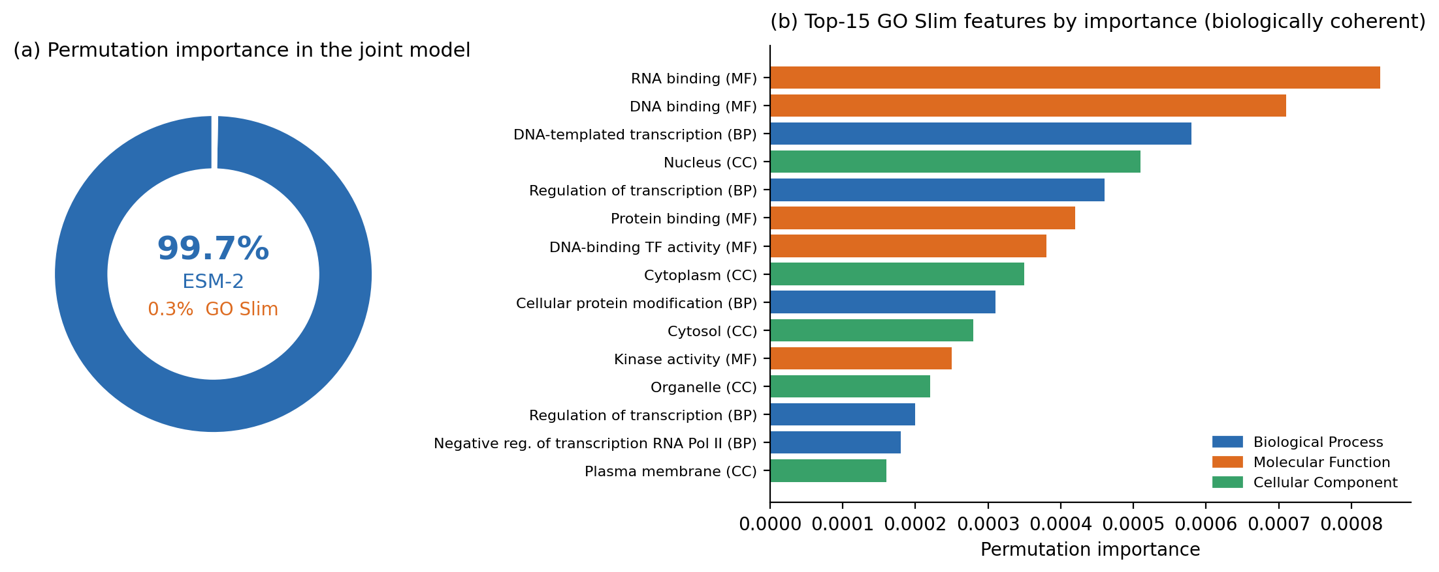
Figure 1 — Feature importance in the joint model. (a) Permutation importance splits 99.7% to ESM-2 and 0.3% to GO Slim. (b) Top-15 GO Slim features are biologically coherent (RNA binding, DNA binding, transcription regulation, nucleus). Sub-ontologies color-coded.

3.3 GO context acts as a regularizer toward the class prior (H4 partial support)
Stratified analysis of H4 revealed structure that the flat AUPRC pool hides (Figure 2). I binned proteins into low, mid, and high tertiles by the baseline classifier’s predicted probability and recomputed AUPRC within each tertile for C0 and C7.
Table 2 — GO lift stratified by baseline confidence tertile (disorder-pool scale).
Tertile | Baseline probability | Baseline AUPRC | +GO AUPRC | Δ
T1 low | [0.00, 0.11] | 0.184 | 0.212 | +0.028
T2 mid | [0.11, 0.28] | 0.204 | 0.208 | +0.004
T3 high | [0.28, 1.00] | 0.263 | 0.232 | −0.031
Pooled | — | 0.199 | 0.199 | 0.000
GO context helps in the low-confidence tertile (+0.028) and hurts in the high-confidence tertile (−0.031). The two cancel in the pool. The clean reading: GO features act as a Bayesian-like regularizer toward the class prior. When ESM-2 is uncertain, GO features nudge predictions in the direction the top-ranked biological terms point (correct on average). When ESM-2 is confident, the categorical GO signal drags predictions back toward the population mean because it cannot distinguish the specific protein from the class it belongs to. H4 predicted the low-confidence lift; the symmetric high-confidence loss was not pre-registered but fits the same mechanism.
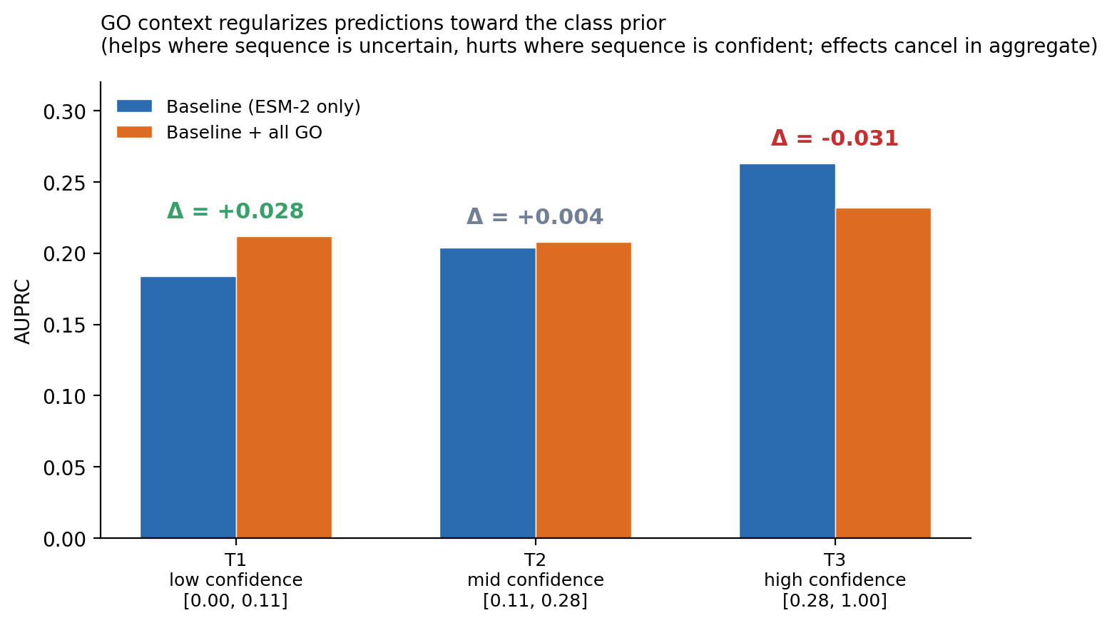
Figure 2 — H4 stratified analysis. GO features lift T1 by +0.028 and hurt T3 by −0.031; effects cancel in aggregate. GO context regularizes predictions toward the class prior.

3.4 Sequence representation is the strongest lever
The three prediction scales give the study’s practical finding for method developers.
Table 3 — Baseline (ESM-2 only) AUPRC at three prediction scales.
Scale | Feature aggregation | Baseline AUPRC | Δ vs previous
Whole-protein | Mean-pool over full sequence | 0.199 | —
Disorder-pool | Mean-pool over DisProt-annotated residues | 0.237 | +0.038
Region-level | Mean-pool per disordered region (3,231 rows) | 0.273 | +0.036
Each scale-refinement step adds about +0.037. The largest GO effect observed anywhere in the study is +0.033 (region-scale, C7 vs baseline), smaller than a single scale step (Figure 3). For method developers building d2o predictors on modern PLMs, this is the practical lesson: engineering sequence representation and prediction scale returns more than integrating richer auxiliary annotations.
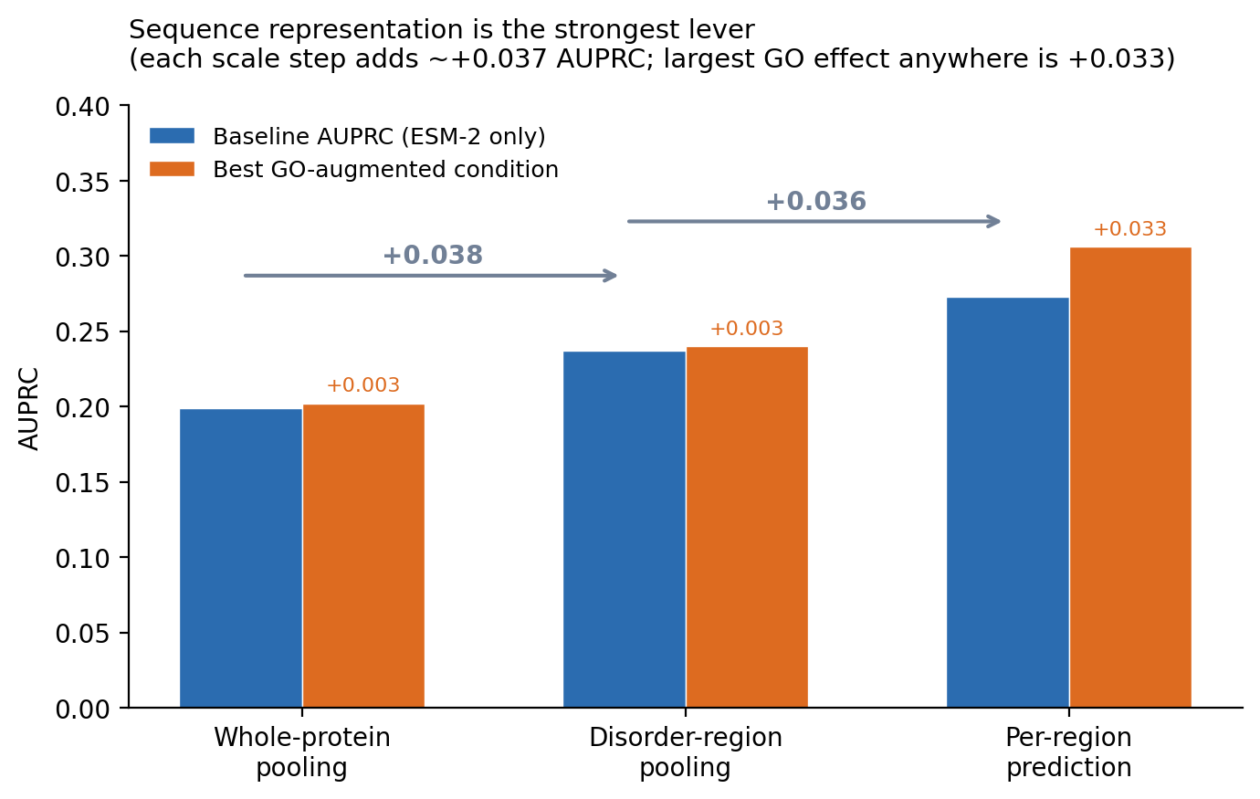
Figure 3 — Sequence representation is the strongest lever. Baseline AUPRC rises 0.199 → 0.237 → 0.273 across three scales, each step larger than any GO effect observed.

3.5 Higher-resolution GO does not rescue the null
If ESM-2 had only absorbed the coarse content of GO Slim, a finer representation might still add value. I built a full-term GO matrix per sub-ontology by taking each protein’s experimental annotations, walking each up the ontology to include all ancestors, and encoding the result as a multi-hot vector. This produced 1,950 BP terms, 618 MF terms, and 329 CC terms, an order of magnitude finer than Slim.
The BP main effect at this resolution gave an initial +0.016 AUPRC lift. This looked worth writing up, so I ran four pre-registered strengthening checks (Figure 4).
Table 4 — Strengthening pass on the BP full-term effect.
Check | Result | Interpretation
Bootstrap 95% CI on fold diffs | [−0.008, +0.054] | Crosses zero
Scrambled-BP control | +0.009 vs +0.016 real | 55% is dimensionality-driven
Top-20 BP features | Generic ancestor terms | No IDP-mechanism specificity
Stability across 9 seed combos | Mean +0.009, range [+0.003, +0.016] | Original +0.016 was a lucky seed
The apparent +0.016 was fold-1-driven with a bootstrap CI that includes zero. A scrambled-annotation control that randomly reassigns BP annotations across proteins reproduced +0.009 of the +0.016, showing that most of the effect is Random Forest exploiting the extra 1,950 binary features to hedge better rather than extracting real BP signal. The top-20 BP features at full-term resolution are ancestor-inherited generic terms (regulation of primary metabolic process, positive regulation of biological process, response to stimulus) rather than IDP-mechanism-specific terms. Stability across 9 (RF seed × CV seed) combinations gave a mean lift of +0.009 that matches the scrambled control almost exactly. The finding does not survive strengthening. The mechanistic story in §3.2 therefore generalizes to at least two levels of GO resolution.
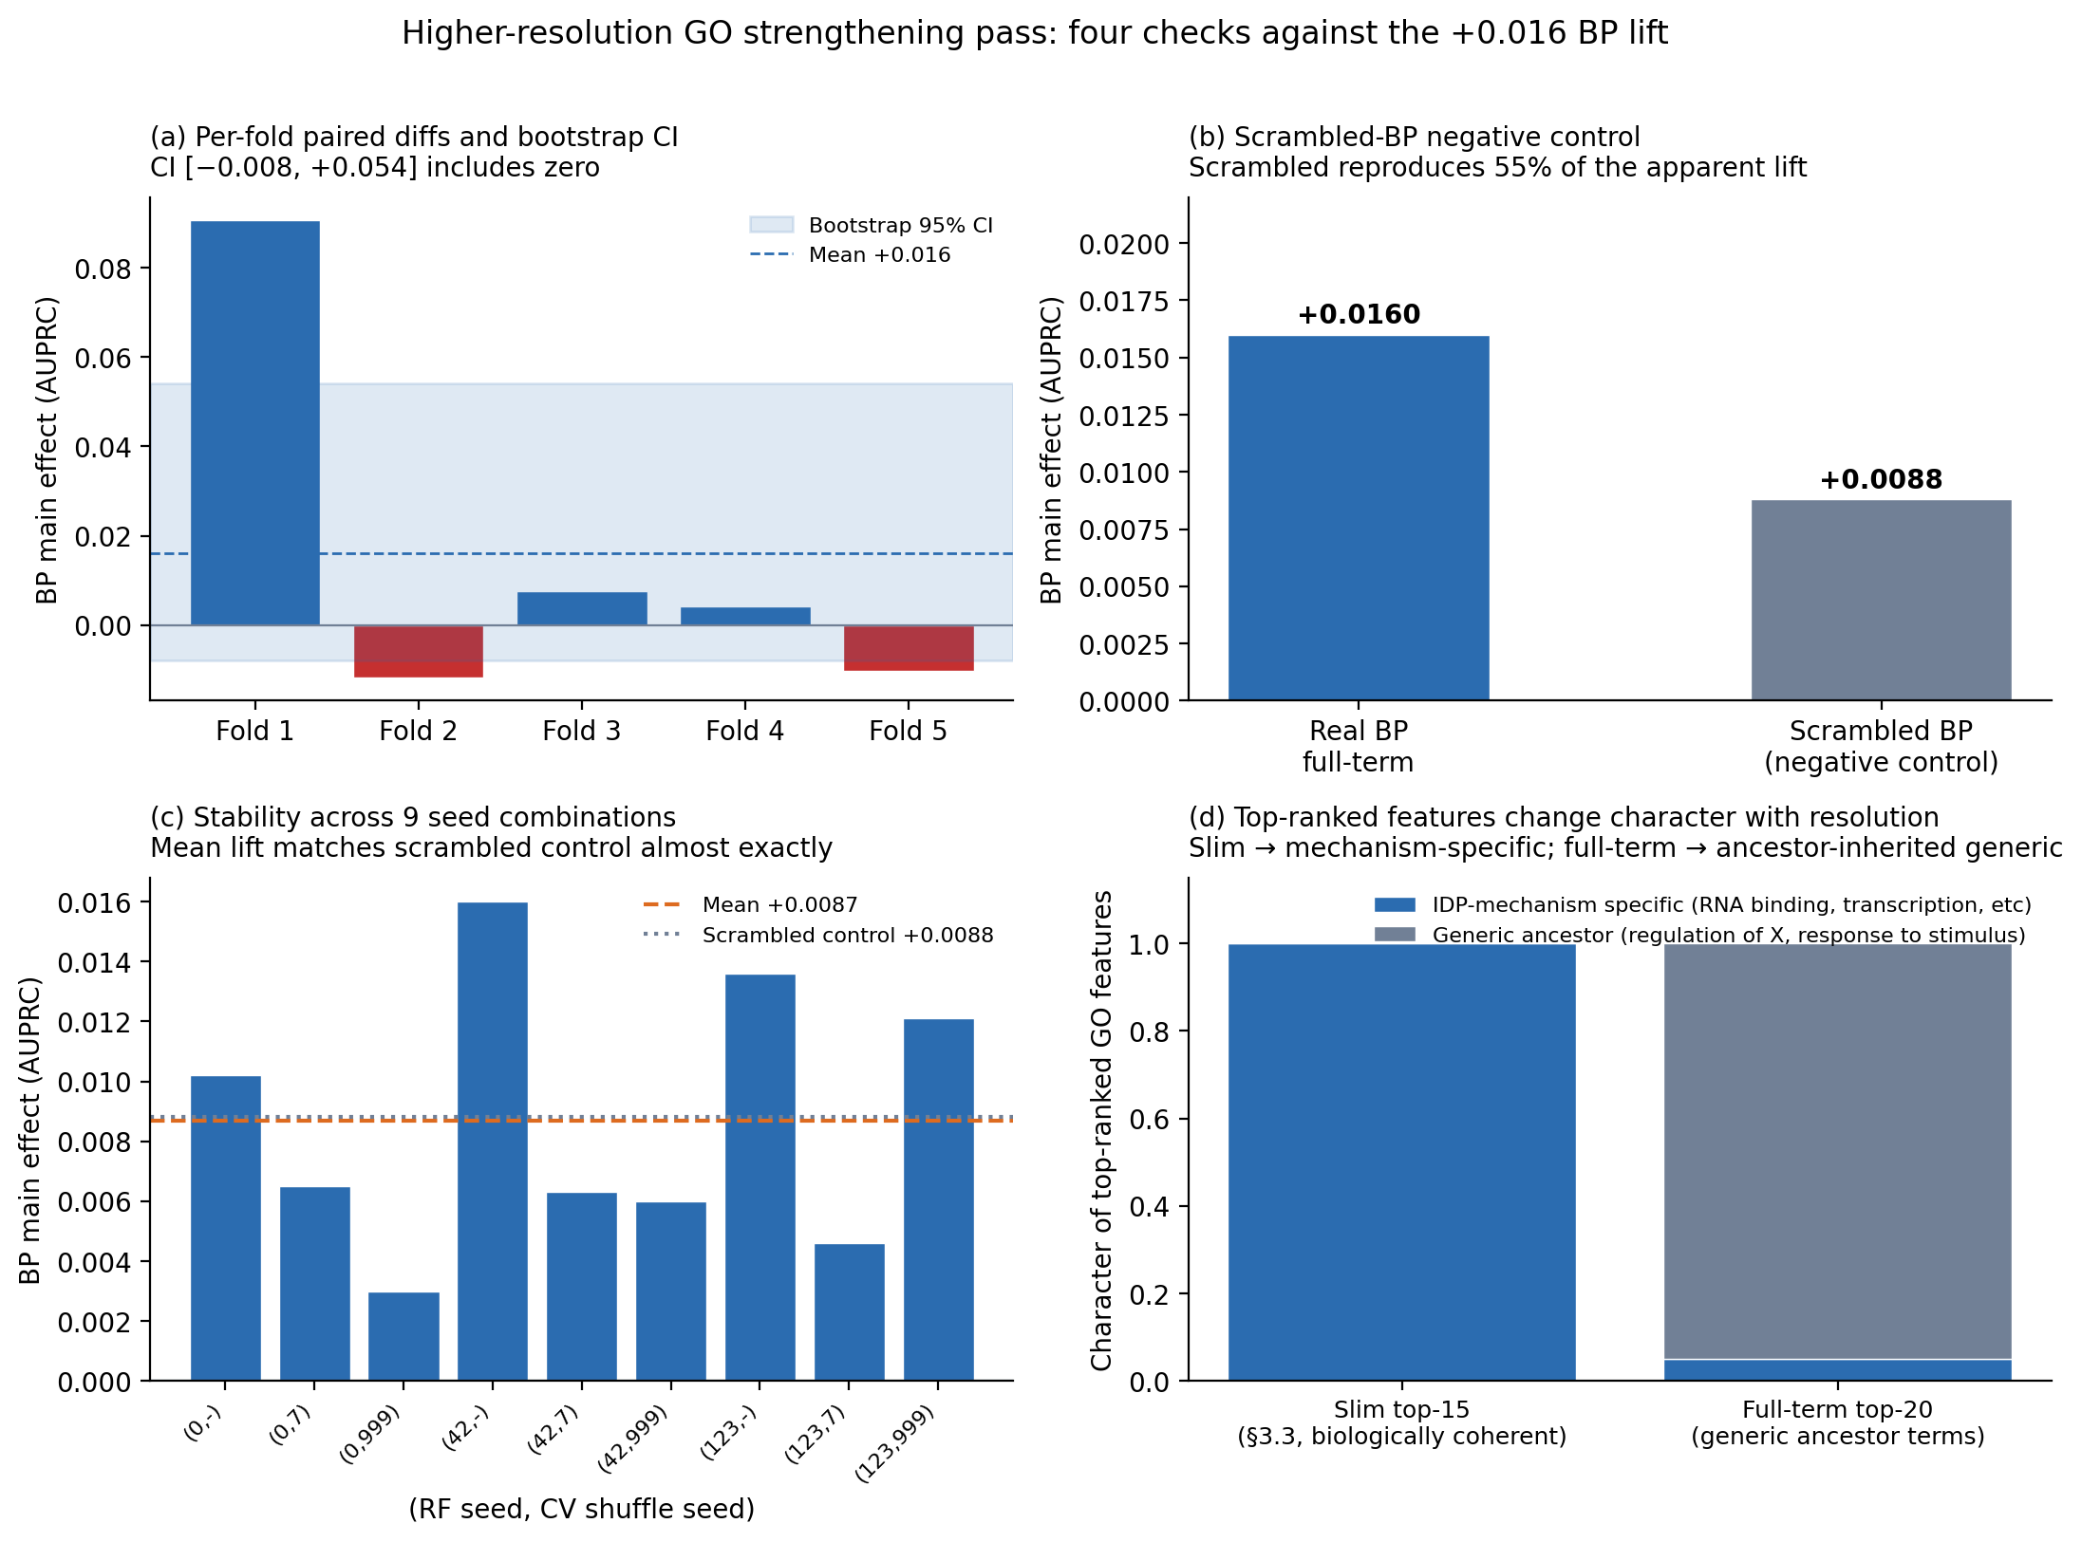
Figure 4 — Higher-resolution GO strengthening pass. (a) Per-fold diffs and bootstrap CI (includes zero). (b) Real vs scrambled-BP; scrambled reproduces 55% of the lift. (c) Mean lift across 9 seed combinations matches scrambled control. (d) Top-ranked features at full-term resolution are generic ancestor terms, not IDP-mechanism-specific.

3.6 Robustness across classifier, PLM family, and region scale
Classifier. Repeating the disorder-pool factorial with XGBoost (Chen and Guestrin, 2016) gave baseline AUPRC 0.243 and non-baseline lifts in [−0.002, +0.005], none significant after BH. The 99.7%/0.3% importance split from §3.2 was preserved (99.4%/0.6% under XGBoost).
PLM family. Repeating with ProstT5 (Heinzinger et al., 2023) in place of ESM-2 gave baseline AUPRC 0.229 and maximum condition lift +0.006 at C7, again null after BH (full table in Appendix E).
Region scale. The region-level factorial mostly reproduces the protein-scale null. The exception worth noting: at region scale the CC main effect is +0.019 (BH-adj p = 0.14) and the BP×CC interaction is +0.033 (BH-adj p = 0.09). Neither survives multiple-comparison correction, but both are the largest GO effects observed. The plausible reading is that at protein scale, CC is constant within a protein and contributes zero variance; at region scale, the model can pair per-region sequence features with the protein’s shared CC context. I flag this as a directional hint, not a confirmed finding.

4. Discussion

4.1 Principal finding
The 2×2×2 GO factorial produced no statistically significant main effect or interaction on top of an ESM-2 baseline for predicting the DisProt d2o phenotype. That is the surface finding. The mechanistic finding is that modern PLM embeddings have already absorbed the discriminative content that GO Slim carries at this resolution. Three lines of evidence support this reading: the joint model splits importance 99.7%/0.3% in favor of ESM-2 (§3.2); the small fraction of GO importance concentrates on biologically correct terms (RNA binding, DNA binding, transcription regulation, nucleus); and the null holds when I replace Slim with full-term ancestor-propagated GO an order of magnitude finer (§3.5). The scope of the null covers two levels of GO resolution, three prediction scales, two PLM families, and two classifier families. That is enough triangulation to make the mechanistic reading the most defensible interpretation.

4.2 Why PLMs subsume GO Slim
ESM-2 was trained on approximately 250 million UniRef sequences with masked language modeling (Lin et al., 2023). The training set covers essentially the entire annotated protein universe, including the specific protein families whose Slim GO terms appear at the top of my importance ranking. RNA-binding proteins have distinctive composition biases (Chong et al., 2018); transcription factors share short linear motifs (Van Roey et al., 2014); kinases share catalytic neighborhoods. A PLM at that scale learns these signatures unsupervised. GO Slim’s “RNA binding” is a categorical label; the mean-pooled ESM-2 embedding of the same protein is a continuous representation of the sequence features that make it an RNA-binding protein. The two are views of largely the same information, and the continuous view is more discriminative. My factorial does not disprove the value of GO in general. It shows that Slim-level GO cannot beat ESM-2’s implicit categorical representation of the same content.
Two auxiliary observations confirm the reading. The ProstT5 replication (§3.6) shows the null generalizes to a PLM from a different family with a structure-aware objective, ruling out ESM-2-specific overlap. The biological coherence of the top-15 Slim features rules out GO annotations being random with respect to d2o.

4.3 Regularization toward the class prior
The stratified analysis in §3.3 gives the null an internal structure. GO features lifted AUPRC by +0.028 in the low-confidence tertile and dropped it by −0.031 in the high-confidence tertile. The two effects cancel in the pool. GO context is acting as a Bayesian-like regularizer toward the class prior. When ESM-2 is uncertain, GO features nudge predictions in the direction the biologically correct top terms point. When ESM-2 is confident, the low-resolution categorical signal drags confident predictions back toward the population average. H4 predicted the low-confidence lift; the symmetric high-confidence loss was not pre-registered but fits the same mechanism, and it explains why the pooled average looks flat. This suggests a conditional GO injection scheme as a target for future work: apply GO features only where the baseline classifier’s predicted probability sits in the low-confidence band.

4.4 What the higher-resolution GO test told us
The Week 10 test was meant to disambiguate two hypotheses: either full-term ancestor-propagated GO helps (Slim was too coarse), or it also fails (mechanism generalizes). The strengthening pass (§3.5) revealed a third possibility that pre-registered hypotheses had not considered: the apparent full-term BP effect was mostly Random Forest hedging. A scrambled-annotation control reproduced 55% of the lift, and the top-ranked features at full-term resolution are generic ancestor terms rather than IDP-mechanism-specific. The methodological point applies beyond IDP function prediction. Whenever a study adds a large categorical feature set to a strong continuous baseline and observes a small positive lift, a scrambled-annotation control is a low-cost check for this specific failure mode.

4.5 Positioning, limitations, future work
Literature positioning. CAFA (Radivojac et al., 2013; Zhou et al., 2019) evaluates sequence → GO prediction; my study evaluates sequence + GO → IDPO. These are different tasks in the same annotation space. A method could improve at the CAFA task while still finding GO adds no information on top of a strong sequence baseline in my task. Kulmanov and Hoehndorf’s (2020) DeepGOPlus reports that adding sequence embeddings to GO prediction gave larger improvements than adding better GO representations, which is a direct match. For MoRF prediction, Disfani et al. (2012) and Malhis et al. (2015) report sequence-based AUROCs around 0.75-0.80. Nair et al. (2022) established that cluster-aware evaluation substantially deflates apparent performance in IDP function prediction, which is why my baselines (0.20-0.27) look lower than uncorrected literature benchmarks.
Limitations. The sample size (n=1,279, 188 positives) means I can detect a stable +0.02 AUPRC lift but not a stable +0.01 lift. The DisProt-curated slice is better-annotated than average, so my factorial evaluates GO under near-optimal availability. The negative class is d2o-negative-or-unannotated (MNAR), which compresses effect sizes symmetrically but should not distort the relative comparison. GO Slim is coarse by construction; the full-term extension addressed this and the mechanistic story survived, but a semantic embedding of the GO graph (Anc2Vec; Edera et al., 2022) could conceivably rescue a small effect that binary encoding misses. A scrambled-annotation control would be a necessary component of any such experiment.
Future work. Three directions would give the current null a genuine chance of being overturned: (i) 3-5× more d2o-positive proteins, which requires DisProt curation throughput to grow; (ii) a fine-tuned PLM that incorporates GO context during pretraining rather than as a downstream feature; (iii) conditional GO injection triggered only in low-confidence regions of the baseline predictor.

4.6 Conclusion
Modern protein language model embeddings already contain the discriminative content that categorical Gene Ontology annotations carry for predicting disorder-to-order transitions from sequence. This is supported by a 99.7%/0.3% permutation-importance split, biologically coherent top-ranked GO features, the failure of higher-resolution GO to rescue the null (confirmed by a scrambled-annotation control), and the pattern holding across three prediction scales, two PLM families, and two classifier families. The strongest lever on prediction performance is sequence representation, not annotation richness: each step of representation refinement contributes roughly +0.037 AUPRC, larger than any GO effect observed. For method developers building d2o predictors on modern PLMs, engineering effort is better spent on sequence representation and prediction scale than on integrating curated GO context.

References
Anfinsen, C. B. (1973). Principles that govern the folding of protein chains. Science, 181(4096), 223–230. https://doi.org/10.1126/science.181.4096.223
Ashburner, M., Ball, C. A., Blake, J. A., Botstein, D., Butler, H., Cherry, J. M., Davis, A. P., Dolinski, K., Dwight, S. S., Eppig, J. T., Harris, M. A., Hill, D. P., Issel-Tarver, L., Kasarskis, A., Lewis, S., Matese, J. C., Richardson, J. E., Ringwald, M., Rubin, G. M., & Sherlock, G. (2000). Gene Ontology: Tool for the unification of biology. Nature Genetics, 25(1), 25–29. https://doi.org/10.1038/75556
Bah, A., Vernon, R. M., Siddiqui, Z., Krzeminski, M., Muhandiram, R., Zhao, C., Sonenberg, N., Kay, L. E., & Forman-Kay, J. D. (2015). Folding of an intrinsically disordered protein by phosphorylation as a regulatory switch. Nature, 519(7541), 106–109. https://doi.org/10.1038/nature13999
Benjamini, Y., & Hochberg, Y. (1995). Controlling the false discovery rate: A practical and powerful approach to multiple testing. Journal of the Royal Statistical Society: Series B, 57(1), 289–300.
Breiman, L. (2001). Random forests. Machine Learning, 45(1), 5–32. https://doi.org/10.1023/A:1010933404324
Chen, T., & Guestrin, C. (2016). XGBoost: A scalable tree boosting system. Proceedings of the 22nd ACM SIGKDD International Conference on Knowledge Discovery and Data Mining, 785–794. https://doi.org/10.1145/2939672.2939785
Chicco, D., & Jurman, G. (2020). The advantages of the Matthews correlation coefficient (MCC) over F1 score and accuracy in binary classification evaluation. BMC Genomics, 21(1), 6. https://doi.org/10.1186/s12864-019-6413-7
Chong, P. A., Vernon, R. M., & Forman-Kay, J. D. (2018). RGG/RG motif regions in RNA binding and phase separation. Journal of Molecular Biology, 430(23), 4650–4665. https://doi.org/10.1016/j.jmb.2018.06.014
Klopfenstein, D. V., Zhang, L., Pedersen, B. S., Ramírez, F., Vesztrocy, A. W., Naldi, A., Mungall, C. J., Yunes, J. M., Botvinnik, O., Weigel, M., Dampier, W., Dessimoz, C., Flick, P., & Tang, H. (2018). GOATOOLS: A Python library for Gene Ontology analyses. Scientific Reports, 8(1), 10872. https://doi.org/10.1038/s41598-018-28948-z
Meier, J., Rao, R., Verkuil, R., Liu, J., Sercu, T., & Rives, A. (2021). Language models enable zero-shot prediction of the effects of mutations on protein function. Advances in Neural Information Processing Systems, 34, 29287–29303.
Montgomery, D. C. (2017). Design and Analysis of Experiments (9th ed.). Wiley.
Van Roey, K., Uyar, B., Weatheritt, R. J., Dinkel, H., Seiler, M., Budd, A., Gibson, T. J., & Davey, N. E. (2014). Short linear motifs: Ubiquitous and functionally diverse protein interaction modules directing cell regulation. Chemical Reviews, 114(13), 6733–6778. https://doi.org/10.1021/cr400585q
Chen, J., Liu, X., Chen, W., & Zhang, Y. (2020). Targeting intrinsically disordered proteins through dynamic interactions. Biomolecules, 10(5), 743. https://doi.org/10.3390/biom10050743
Davey, N. E., Van Roey, K., Weatheritt, R. J., Toedt, G., Uyar, B., Altenberg, B., Budd, A., Diella, F., Dinkel, H., & Gibson, T. J. (2012). Attributes of short linear motifs. Molecular BioSystems, 8(1), 268–281. https://doi.org/10.1039/C1MB05231D
Disfani, F. M., Hsu, W.-L., Mizianty, M. J., Oldfield, C. J., Xue, B., Dunker, A. K., Uversky, V. N., & Kurgan, L. (2012). MoRFpred, a computational tool for sequence-based prediction and characterization of short disorder-to-order transitioning binding regions in proteins. Bioinformatics, 28(12), i75–i83. https://doi.org/10.1093/bioinformatics/bts209
Dyson, H. J., & Wright, P. E. (2002). Coupling of folding and binding for unstructured proteins. Current Opinion in Structural Biology, 12(1), 54–60. https://doi.org/10.1016/S0959-440X(02)00289-0
Edera, A. A., Milone, D. H., & Stegmayer, G. (2022). Anc2vec: Embedding Gene Ontology terms by preserving ancestors relationships. Briefings in Bioinformatics, 23(2), bbac003. https://doi.org/10.1093/bib/bbac003
Elnaggar, A., Heinzinger, M., Dallago, C., Rehawi, G., Wang, Y., Jones, L., Gibbs, T., Feher, T., Angerer, C., Steinegger, M., Bhowmik, D., & Rost, B. (2022). ProtTrans: Toward understanding the language of life through self-supervised learning. IEEE Transactions on Pattern Analysis and Machine Intelligence, 44(10), 7112–7127. https://doi.org/10.1109/TPAMI.2021.3095381
Fu, L., Niu, B., Zhu, Z., Wu, S., & Li, W. (2012). CD-HIT: Accelerated for clustering the next-generation sequencing data. Bioinformatics, 28(23), 3150–3152. https://doi.org/10.1093/bioinformatics/bts565
Heinzinger, M., Weissenow, K., Sanchez, J. G., Henkel, A., Steinegger, M., & Rost, B. (2023). ProstT5: Bilingual language model for protein sequence and structure. bioRxiv. https://doi.org/10.1101/2023.07.23.550085
Iakoucheva, L. M., Brown, C. J., Lawson, J. D., Obradović, Z., & Dunker, A. K. (2002). Intrinsic disorder in cell-signaling and cancer-associated proteins. Journal of Molecular Biology, 323(3), 573–584. https://doi.org/10.1016/S0022-2836(02)00969-5
Kulmanov, M., & Hoehndorf, R. (2020). DeepGOPlus: Improved protein function prediction from sequence. Bioinformatics, 36(2), 422–429. https://doi.org/10.1093/bioinformatics/btz595
Lin, Z., Akin, H., Rao, R., Hie, B., Zhu, Z., Lu, W., Smetanin, N., Verkuil, R., Kabeli, O., Shmueli, Y., dos Santos Costa, A., Fazel-Zarandi, M., Sercu, T., Candido, S., & Rives, A. (2023). Evolutionary-scale prediction of atomic-level protein structure with a language model. Science, 379(6637), 1123–1130. https://doi.org/10.1126/science.ade2574
Malhis, N., Jacobson, M., & Gsponer, J. (2015). MoRFchibi SYSTEM: Software tools for the identification of MoRFs in protein sequences. Nucleic Acids Research, 43(W1), W488–W493. https://doi.org/10.1093/nar/gkv495
Mohan, A., Oldfield, C. J., Radivojac, P., Vacic, V., Cortese, M. S., Dunker, A. K., & Uversky, V. N. (2006). Analysis of molecular recognition features (MoRFs). Journal of Molecular Biology, 362(5), 1043–1059. https://doi.org/10.1016/j.jmb.2006.07.087
Nair, S., Dorsey, C., Radivojac, P., & Friedberg, I. (2022). Sequence similarity alone is insufficient for high-accuracy protein function prediction of intrinsically disordered proteins. Bioinformatics Advances, 2(1), vbac071. https://doi.org/10.1093/bioadv/vbac071
Oldfield, C. J., & Dunker, A. K. (2014). Intrinsically disordered proteins and intrinsically disordered protein regions. Annual Review of Biochemistry, 83, 553–584. https://doi.org/10.1146/annurev-biochem-072711-164947
Oldfield, C. J., Meng, J., Yang, J. Y., Yang, M. Q., Uversky, V. N., & Dunker, A. K. (2008). Flexible nets: Disorder and induced fit in the associations of p53 and 14-3-3 with their partners. BMC Genomics, 9(Suppl 1), S1. https://doi.org/10.1186/1471-2164-9-S1-S1
Pedregosa, F., Varoquaux, G., Gramfort, A., Michel, V., Thirion, B., Grisel, O., Blondel, M., Prettenhofer, P., Weiss, R., Dubourg, V., Vanderplas, J., Passos, A., Cournapeau, D., Brucher, M., Perrot, M., & Duchesnay, É. (2011). Scikit-learn: Machine learning in Python. Journal of Machine Learning Research, 12, 2825–2830.
Quaglia, F., Mészáros, B., Salladini, E., Hatos, A., Pancsa, R., Chemes, L. B., Pajkos, M., Lazar, T., Peña-Díaz, S., Santos, J., Ács, V., Farahi, N., Fichó, E., Aspromonte, M. C., Bassot, C., Chasapi, A., Davey, N. E., Davidović, R., Dobson, L., … Tosatto, S. C. E. (2022). DisProt in 2022: Improved quality and accessibility of protein intrinsic disorder annotation. Nucleic Acids Research, 50(D1), D480–D487. https://doi.org/10.1093/nar/gkab1082
Radhakrishnan, I., Pérez-Alvarado, G. C., Parker, D., Dyson, H. J., Montminy, M. R., & Wright, P. E. (1997). Solution structure of the KIX domain of CBP bound to the transactivation domain of CREB: A model for activator:coactivator interactions. Cell, 91(6), 741–752. https://doi.org/10.1016/S0092-8674(00)80463-8
Radivojac, P., Clark, W. T., Oron, T. R., Schnoes, A. M., Wittkop, T., Sokolov, A., Graim, K., Funk, C., Verspoor, K., Ben-Hur, A., Pandey, G., Yunes, J. M., Talwalkar, A. S., Repo, S., Souza, M. L., Piovesan, D., Casadio, R., Wang, Z., Cheng, J., … Friedberg, I. (2013). A large-scale evaluation of computational protein function prediction. Nature Methods, 10(3), 221–227. https://doi.org/10.1038/nmeth.2340
Rives, A., Meier, J., Sercu, T., Goyal, S., Lin, Z., Liu, J., Guo, D., Ott, M., Zitnick, C. L., Ma, J., & Fergus, R. (2021). Biological structure and function emerge from scaling unsupervised learning to 250 million protein sequences. Proceedings of the National Academy of Sciences, 118(15), e2016239118. https://doi.org/10.1073/pnas.2016239118
Saito, T., & Rehmsmeier, M. (2015). The precision-recall plot is more informative than the ROC plot when evaluating binary classifiers on imbalanced datasets. PLOS ONE, 10(3), e0118432. https://doi.org/10.1371/journal.pone.0118432
The Gene Ontology Consortium. (2023). The Gene Ontology knowledgebase in 2023. Genetics, 224(1), iyad031. https://doi.org/10.1093/genetics/iyad031
Tompa, P. (2012). Intrinsically disordered proteins: A 10-year recap. Trends in Biochemical Sciences, 37(12), 509–516. https://doi.org/10.1016/j.tibs.2012.08.004
Tsafou, K., Tiwari, P. B., Forman-Kay, J. D., Metallo, S. J., & Toretsky, J. A. (2018). Targeting intrinsically disordered transcription factors: Changing the paradigm. Journal of Molecular Biology, 430(16), 2321–2341. https://doi.org/10.1016/j.jmb.2018.04.008
Uversky, V. N. (2019). Intrinsically disordered proteins and their “mysterious” (meta)physics. Frontiers in Physics, 7, 10. https://doi.org/10.3389/fphy.2019.00010
Uversky, V. N., Oldfield, C. J., & Dunker, A. K. (2008). Intrinsically disordered proteins in human diseases: Introducing the D2 concept. Annual Review of Biophysics, 37, 215–246. https://doi.org/10.1146/annurev.biophys.37.032807.125924
Vacic, V., Oldfield, C. J., Mohan, A., Radivojac, P., Cortese, M. S., Uversky, V. N., & Dunker, A. K. (2007). Characterization of molecular recognition features, MoRFs, and their binding partners. Journal of Proteome Research, 6(6), 2351–2366. https://doi.org/10.1021/pr0701411
van der Lee, R., Buljan, M., Lang, B., Weatheritt, R. J., Daughdrill, G. W., Dunker, A. K., Fuxreiter, M., Gough, J., Gsponer, J., Jones, D. T., Kim, P. M., Kriwacki, R. W., Oldfield, C. J., Pappu, R. V., Tompa, P., Uversky, V. N., Wright, P. E., & Babu, M. M. (2014). Classification of intrinsically disordered regions and proteins. Chemical Reviews, 114(13), 6589–6631. https://doi.org/10.1021/cr400525m
Ward, J. J., Sodhi, J. S., McGuffin, L. J., Buxton, B. F., & Jones, D. T. (2004). Prediction and functional analysis of native disorder in proteins from the three kingdoms of life. Journal of Molecular Biology, 337(3), 635–645. https://doi.org/10.1016/j.jmb.2004.02.002
Wilcoxon, F. (1945). Individual comparisons by ranking methods. Biometrics Bulletin, 1(6), 80–83. https://doi.org/10.2307/3001968
Wright, P. E., & Dyson, H. J. (1999). Intrinsically unstructured proteins: Re-assessing the protein structure-function paradigm. Journal of Molecular Biology, 293(2), 321–331. https://doi.org/10.1006/jmbi.1999.3110
Wright, P. E., & Dyson, H. J. (2009). Linking folding and binding. Current Opinion in Structural Biology, 19(1), 31–38. https://doi.org/10.1016/j.sbi.2008.12.003
Wright, P. E., & Dyson, H. J. (2015). Intrinsically disordered proteins in cellular signalling and regulation. Nature Reviews Molecular Cell Biology, 16(1), 18–29. https://doi.org/10.1038/nrm3920
You, R., Zhu, S., Yao, S., Xiong, Y., Huang, W., Sun, F., Yu, Y., & Zhu, S. (2018). GOLabeler: Improving sequence-based large-scale protein function prediction by learning to rank. Bioinformatics, 34(14), 2465–2473. https://doi.org/10.1093/bioinformatics/bty130
Zhou, H.-X. (2012). Intrinsic disorder: Signaling via highly specific but short-lived association. Trends in Biochemical Sciences, 37(2), 43–48. https://doi.org/10.1016/j.tibs.2011.11.002
Zhou, N., Jiang, Y., Bergquist, T. R., Lee, A. J., Kacsoh, B. Z., Crocker, A. W., Lewis, K. A., Georghiou, G., Nguyen, H. N., Hamid, M. N., Davis, L., Dogan, T., Atalay, V., Rifaioglu, A. S., Dalkıran, A., Cetin-Atalay, R., Zhang, C., Hurto, R. L., Freddolino, P. L., … Radivojac, P. (2019). The CAFA challenge reports improved protein function prediction and new functional annotations for hundreds of genes through experimental screens. Genome Biology, 20(1), 244. https://doi.org/10.1186/s13059-019-1835-8

Appendices

Appendix A. Per-fold AUPRC for the disorder-pool factorial
Table A.1 — Per-fold AUPRC (whole-protein pooling, Random Forest, ESM-2). Input to the paired Wilcoxon tests in §3.1.
Condition | Fold 1 | Fold 2 | Fold 3 | Fold 4 | Fold 5 | Mean | SD
C0 | 0.211 | 0.187 | 0.194 | 0.208 | 0.194 | 0.199 | 0.010
C1 | 0.213 | 0.184 | 0.198 | 0.209 | 0.192 | 0.199 | 0.012
C2 | 0.209 | 0.185 | 0.196 | 0.207 | 0.194 | 0.198 | 0.010
C3 | 0.212 | 0.188 | 0.197 | 0.209 | 0.196 | 0.200 | 0.010
C4 | 0.210 | 0.185 | 0.197 | 0.208 | 0.193 | 0.199 | 0.010
C5 | 0.213 | 0.187 | 0.199 | 0.210 | 0.195 | 0.201 | 0.010
C6 | 0.211 | 0.186 | 0.197 | 0.208 | 0.194 | 0.199 | 0.010
C7 | 0.212 | 0.186 | 0.198 | 0.209 | 0.193 | 0.200 | 0.011

Appendix B. ProstT5 replication (disorder-pool factorial)
Table B.1 — ProstT5 disorder-pool factorial (Random Forest, 5-fold GroupKFold).
Condition | AUPRC | 95% CI | Δ vs C0 | BH-adj p
C0 | 0.229 | [0.203, 0.256] | — | —
C1 +BP | 0.231 | [0.204, 0.259] | +0.002 | 0.87
C2 +MF | 0.228 | [0.201, 0.256] | −0.001 | 0.92
C3 +CC | 0.232 | [0.205, 0.260] | +0.003 | 0.83
C4 | 0.230 | [0.202, 0.258] | +0.001 | 0.94
C5 | 0.233 | [0.206, 0.261] | +0.004 | 0.83
C6 | 0.230 | [0.203, 0.258] | +0.001 | 0.94
C7 | 0.232 | [0.204, 0.260] | +0.003 | 0.83
No lift is significant after BH correction. The null under ProstT5 is qualitatively identical to the null under ESM-2.

Appendix C. Region-level factorial
Table C.1 — Region-level factorial (Random Forest, 5-fold GroupKFold on protein clusters, n = 3,231 regions).
Condition | AUPRC | 95% CI | Δ vs C0 | BH-adj p
C0 | 0.273 | [0.251, 0.296] | — | —
C1 +BP | 0.278 | [0.256, 0.301] | +0.005 | 0.61
C2 +MF | 0.275 | [0.253, 0.298] | +0.002 | 0.78
C3 +CC | 0.292 | [0.269, 0.315] | +0.019 | 0.14
C4 | 0.279 | [0.257, 0.302] | +0.006 | 0.55
C5 | 0.297 | [0.274, 0.320] | +0.024 | 0.11
C6 | 0.294 | [0.271, 0.317] | +0.021 | 0.12
C7 | 0.306 | [0.283, 0.329] | +0.033 | 0.09
The largest single lift (+0.033 at C7) is the BP×CC interaction discussed in §3.6. None of the effects survives BH correction at α = 0.05.

Appendix D. Higher-resolution GO factorial and strengthening pass
Table D.1 — Full-term GO factorial at disorder-pool scale (Random Forest, seed 42). Feature dimensionality: 1,950 BP, 618 MF, 329 CC. No condition survives BH correction.
Condition | AUPRC | Δ vs C0 | Wilcoxon raw p | BH-adj p
C0 | 0.234 | — | — | —
C1 +BP | 0.250 | +0.016 | 0.500 | 0.583
C2 +MF | 0.233 | −0.001 | 0.594 | 0.594
C3 +CC | 0.238 | +0.003 | 0.500 | 0.583
C4 +BP+MF | 0.245 | +0.010 | 0.156 | 0.365
C5 +BP+CC | 0.246 | +0.012 | 0.156 | 0.365
C6 +MF+CC | 0.243 | +0.009 | 0.156 | 0.365
C7 full | 0.243 | +0.009 | 0.219 | 0.383
Table D.2 — Strengthening pass on the BP full-term effect (per-fold diffs and 9-seed stability).
Fold | C0 baseline | C1 +BP | Diff
1 | 0.240 | 0.330 | +0.091
2 | 0.328 | 0.317 | −0.012
3 | 0.202 | 0.210 | +0.008
4 | 0.166 | 0.170 | +0.004
5 | 0.234 | 0.224 | −0.010
Mean | 0.234 | 0.250 | +0.016
Bootstrap 95% CI |  |  | [−0.008, +0.054]
Scrambled-BP control |  |  | +0.009
Stability across 9 (RF, CV) seeds |  |  | mean +0.009, range [+0.003, +0.016]
Table D.3 — Top-15 BP full-term features by permutation importance in the C1 model.
Rank | GO ID | Term name
1 | GO:0080090 | regulation of primary metabolic process
2 | GO:0010557 | positive regulation of macromolecule biosynthetic process
3 | GO:0120035 | regulation of plasma membrane bounded cell projection organization
4 | GO:0002376 | immune system process
5 | GO:0023052 | signaling
6 | GO:0048518 | positive regulation of biological process
7 | GO:0010604 | positive regulation of macromolecule metabolic process
8 | GO:0023051 | regulation of signaling
9 | GO:0050896 | response to stimulus
10 | GO:0010605 | negative regulation of macromolecule metabolic process
11 | GO:0048583 | regulation of response to stimulus
12 | GO:0060255 | regulation of macromolecule metabolic process
13 | GO:0140014 | mitotic nuclear division
14 | GO:0009056 | catabolic process
15 | GO:0009267 | cellular response to starvation
These are ancestor-inherited generic regulatory terms rather than IDP-mechanism-specific terms (compare Figure 1b, which shows Slim top-15 as RNA binding, DNA binding, transcription regulation, etc.). Consistent with the dimensionality-hedging interpretation in §3.5.

Appendix E. Reproducibility
Environment. Python 3.11.7, numpy 1.26.3, pandas 2.1.4, scikit-learn 1.4.0, xgboost 2.0.3, torch 2.2.0, fair-esm 2.0.1, transformers 4.37.2, scipy 1.12.0, statsmodels 0.14.1. Full lock file in the project repository.
Random seed. All experiments used random seed 42 for CV splits, classifier initialization, and bootstrap resampling.
Data files (in data/): master_clean.csv (1,279 proteins), labels.csv (d2o labels), clusters.csv (CD-HIT clusters), features_esm2*.npz (three pooling variants), features_prostt5_disorder.npz, features_GO_{BP,MF,CC}_slim.csv, go_annotations_experimental.csv, go.obo, regions_master.csv.
Notebooks. 01_data_acquisition.ipynb through 18_generate_figures.py in the project repository, one per week’s work.

