Contents

Chapter 1 2

Introduction 2

Problem Definition 2

Features 2

Scope 3

Aims 3

Objectives 3

Development Methodology 3

Chapter 2 5

Project Plan 5

Work Breakdown Structure 5

Milestone 7

Scheduling 7

Chapter 3 9

Risk Management 9

Chapter 4 10

Configuration Management 10

Chapter 5 11

Conclusion 11

References 12

# Chapter 1

## Introduction

In today’s world, people wants everything simple in their day to day life where internet has become the medium for it. Its rather easy for an individual to do something from where they are rather than to reach somewhere to perform their certain task weather it is business things or something else. Online business has been trend for the people but what must be focused is the type of service provided by the one. Looking forward to these, “Cake Time” is a medium sized bakery service provider through online. It is not actually a store but provides the services online to the customer. The Bakery has just planned to start their business for which they want attractive and featured website to attract the customers towards their bakery. They are certain to provide the best service with reasonable prices. The website allows the customers to register and place and order, view the products.

The system will be developed using php, html, CSS, JavaScript and jQuery. MySQL database server will be used to store the information.

## Problem Definition

As the bakery has no specific store and provides only online service, customers might be uncertain about the quality and taste of the products so we have facility of home delivery where customer can taste the piece and decide whether to accept or deny their order. It is actually time consuming for a customer to visit the store and choose and order for something. With this system they can stay home and order online. Has it been a store it might have fixed opening and closing time but with the system, customers can place their order anytime and leave the date to be delivered.

## Features

* Customer can order the cakes for different occasions and bakery goods as well through the web-based application.
* One can also join for the classes for which the form is provided online and we could contact later.
* All the details of different types of product will be provided in the application.
* Customer can cancel the order within a day or they cannot cancel after the order has been finalized.
* Customer cannot exchange or return once they are delivered.
* Easy and user-friendly interface will be developed so that customers can easily use the application.

## Scope

The scope of this project is to create an easy user interface that can be accessed and used by any user with or without technical knowledge and experience. Different system roles such as admins and general user will be created and roles with permission will be assigned accordingly.

The online transactions for the website will not be provided in the system so customers have to do cash on delivery.

## Aims

* To enhance the online business of bakery through web application by providing the detailed information of the products including price and types.
* To make buyer and seller easy to shop.

## Objectives

* Develop the system with the use of php, html, CSS, jQuery, Bootstrap etc.
* Gather the user requirements from the owner for the system.
* Planning of the project.
* Design of simple and user-friendly system for easy use by customer.
* Coding.
* Testing the system to make sure its bug free.
* Evaluation of the system over other system available over the market.
* System Implementation.
* Preparing the necessary document during system development.

## Development Methodology

The system will be developed using “Waterfall Model”. This method is easy to understand and is cost effective as well. While using this methodology, each and every step should be undertaken before moving to another phase without any overlapping or iterative steps. I think it would be appropriate for my project to go with this methodology as this type of method is used for small projects.

The reasons to choose this methodology over other methodology for the project are listed below:

* User involvement is less as compare to other so that technical aspects can be more focused.
* The project is delivered to the client after the overall development of the system.
* Since the project is small it can be easily handled by waterfall approach.
* It is easy to measure progress by referring to the objectives defined for each step.
* As each should be completed, it will ensure that each step has been undertaken.

Requirement

Implementation

Verification

Design

Testing/Maintenance

Fig: Waterfall Model

# Chapter 2

## Project Plan

## Work Breakdown Structure

Dividing complex projects to simpler and manageable tasks is the process identified as Work Breakdown Structure (WBS).

Usually, the project managers use this method for simplifying the project execution. In WBS, much larger tasks are broken down to manageable chunks of work. These chunks can be easily supervised and estimated. (Anon., 2017)

Reporting

Proposal

Submission Report

Final Report

User Manual

Integration Testing

Unit Testing

Design Specification

Coding

User Interface

Sequence Diagram

Class Diagram

Analysis Specification

Use case Diagram 

Requirement Analysis

Requirement Gathering

Proposal submission

Monitoring

Planning

Scoping

Online Bakery System

Testing

Design

Analysis

Fig: Work Breakdown Structure

## Milestone

|  |  |
| --- | --- |
| Milestone | Date |
| Proposal Submission | Jan 14, 2018 |
| Analysis | Jan 28, 2018 |
| Design | Feb 25, 2018 |
| Coding | March 22, 2018 |
| Testing | April 7, 2018 |
| Final Report | April 15, 2018 |

## Scheduling

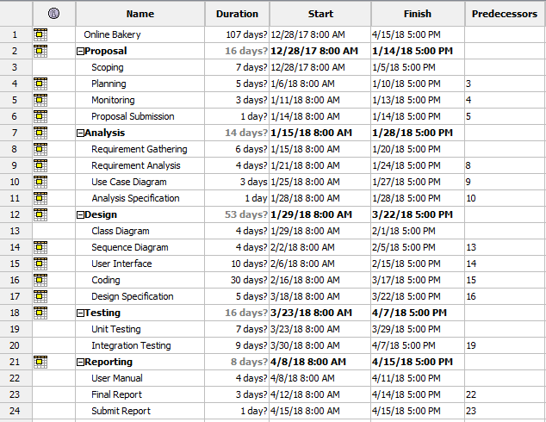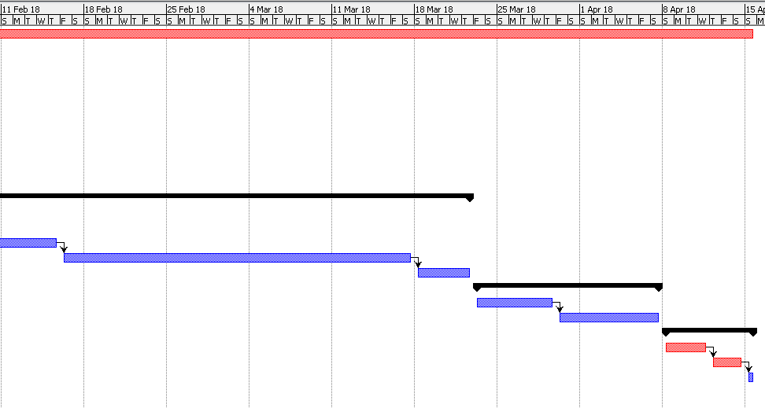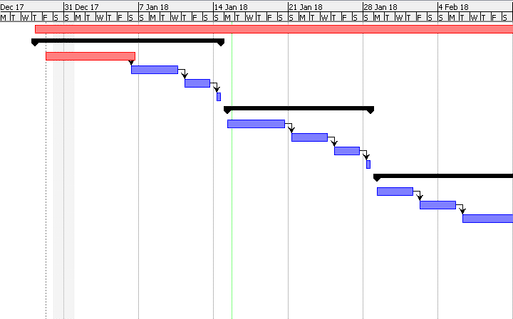Gantt Chart

# Chapter 3

## Risk Management

Risk management is the process of identification, analysis and acceptance or mitigation of uncertainty in investment decisions. (Anon., 2017)

|  |  |  |  |  |
| --- | --- | --- | --- | --- |
| Risk | Consequences(C) | Likelihood(L) | Impact (C * L) | Action |
| Time Limitation | 4 | 2 | 8 | Each step should be completed before moving ahead with time. |
| Network Failure | 5 | 2 | 10 | Updating the system on a regular basis. |
| Crash of Hard disk | 3 | 3 | 9 | Files are to be stored on different location and on devices like hard drives and more for backup |
| Power Instabilities | 3 | 2 | 6 | External power like UPS, etc. can be used to stop the system from shutting down. |
| Natural Calamities | 4 | 1 | 4 | The components of the project should be kept at a safe place. |
| Error on coding | 4 | 2 | 8 | While writing the codes, it should be done with different precautions. |

# Chapter 4

## Configuration Management

The directory of the project where all the data and information has been saved is called Configuration Management. It is a process for establishing and maintaining consistency of a product’s performance. All the files related to the project will be kept in Git hub in organized way so it will be easy to access and find any folder we need. Git hub is a web-based project hosting service. It is a best place to build software together. After the completion of project, the final report will be made to give detail information about how it is done and this document is kept in the final report folder. (management, 2016-2017)

For online backup I will be storing my project in the GitHub and upgrade it time and again so that I may not have to bear the loss even if I will be losing my offline backup of the project.  
<https://github.com/Sunayana98> is my GitHub Id.

The tree structure of the online bakery is shown below. I have made a separate folder for offline backup of the project so that I can recover if incase necessary. It is actually for maintaining the integrity over a time.

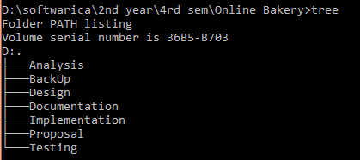

Fig: Tree structure of project

# Chapter 5

Conclusion  
Since the web application called online bakery will be using PHP .The online bakery needs to be well maintained to decrease the human errors and to increase the efficiency . This system will be developed to make customers easy to shop bakery goods online.

The main focus of this project is to make human effort easy and encourage online purchase.

# References

Anon., 2017. *Investopedia.* [Online]   
Available at: https://www.investopedia.com/terms/r/riskmanagement.asp  
[Accessed 30 12 2017].

Anon., 2017. *turorialsPoint.* [Online]   
Available at: http://www.tutorialspoint.com/management_concepts/work_breakdown_structure.htm  
[Accessed 29 12 2017].

Anon., n.d. [Online]   
Available at: http://istqbexamcertification.com/what-is-waterfall-model-advantages-disadvantages-and-when-to-use-it/  
[Accessed 29 12 2017].

management, C., 2016-2017. *techtarget.* [Online]   
Available at: http://searchitoperations.techtarget.com/definition/configuration-management-CM  
[Accessed 30 12 2017].